***ISRAEL BIBLICAL STUDY PROGRAM***

***MAY 3-17, 2018***

***INTEREST FORM***

***I AM DEFINITELY INTERESTED and would like to be included in the meeting on April 30, 2017, Noonish, Myers Conference Room, to consider the options. I understand that this is NOT formal commitment, but that a definite commitment will be required early in the Summer of 2017. If you are travelling as a couple, each person needs to complete a form.***

Passport name _______________________________

Address _______________________________________

City ___________________________ State __________

Zip __________ Phone __________________________

Email __________________________________________

Passport # ____________________________________

Date of expiration ____________________________

Signature _____________________________________

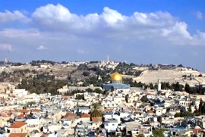

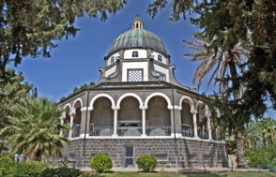

*Church of the Beatitudes*

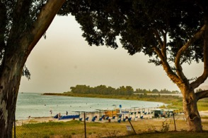

*Beach at Sea of Galilee, Ein Gev*

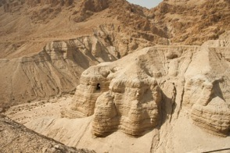

*Qumran Caves*

**Israel 2018**

**May 3-17, 2018**

Meeting, Sunday 4/30/17 Noon

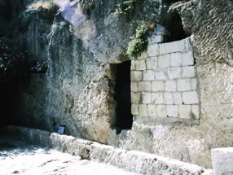

*Garden Tomb*

See the **birthplace,** the **crucifixion** place and the **tomb** of Jesus. Enter the Gate of **Shechem** where Abraham actually saw the land God promised. Swim in the **Sea of Galilee.** Float in the **Dead Sea**. Look across the real **Valley of Armageddon**. Be amazed.

All this and more awaits us as we travel the land of Bible to learn how the land and the Bible amplify our understanding. This will be a study trip. Bibles, notebooks and field manuals will be as needed as cameras.

Dr. James C. Martin will be our teacher. He has spent a lifetime of study in the Middle East. Pastor Jim Tony is facilitating the planning. *But each participant is responsible for himself or herself.*

***Details***

Cost expected to be about $2700.00. Included are hotels, breakfast & dinner, transfers, bus transportation, entry fees and tip.

**This price does NOT include airfare** which each participant will self-arrange in cooperation with the group so that we arrive and depart at the same time. NOTE: prices and plans are tentative and subject to change as costs, the situation on the ground and availability also shift.

We have no sponsoring organization or travel company. This gives us the advantage of flexibility and a voice in planning. But it also means each person accepts responsibility for him or her self.

All accommodations are clean and attractive. In the Galilee region we stay at a seaside resort run as a Kibbutz. It’s terrific. In the south we may have the option of staying at Tantur Ecumenical Institute, a Roman Catholic study center in Bethlehem a few miles south of Jerusalem. This depends on space. Otherwise a centrally located and attractive hotel in West Jerusalem. Check <http://tantur.org> . The group may have a choice to make.

***MEETING PLANNED for SUNDAY, APRIL 30, 2017, Noon, the Myers Conference Room. Anyone interested is invited. More details will be provided.***

***Proposed Itinerary***

**DAY 1** Depart USA. ***May 3, 2018***

**DAY 2** Arrive Tel Aviv and transfer to hotel or Tantur Institute.

**DAY 3** **THEME: THE PATRIARCHS AND EXODUS**. Sites will include Hebron (burial place of Abraham and Sarah), Negev and Arad, the Wilderness of Zin.

**DAY 4** **THE HOUSE OF DAVID.** Taybeh and authentic first century house, Shepherds fields, Bethlehem, the Herodium, the Elah Valley where David met Goliath.

**DAY 5 JOSHUA AND THE CONQUEST.** Shiloh, Jacob’s well, Samaria, Mt. Gerazim and Shechem. Joshua’s entrance to the Promised Land.**DAY 6** **ANCIENT JERUSALEM.** Explore ancient Jerusalem—Abraham, Nehemiah, Temple Mount excavations, City of David, Western Wall, Kidron & Hinnom Valleys. Visit Israel Museum, Dead Sea Scrolls and Model of Jerusalem in AD 66.

**DAY 7 JERICHO TO JERUSALEM.** Morning: Old & New Testament Jericho, Place of Jesus’ Baptism & Temptation in the Wilderness of Judea. Afternoon: Walk over the Mt of Olives from Bethany to Kidron Valley and on to Holy Sepulcher and Garden Tomb.

**DAY 8 THE PLACE OF REFUGE.** Wilderness of Judea as place of defense and refuge. Masada, Ein Gedi & Qumran. Optional “swim” in the Dead Sea. Travel to Galilee to **stay at Ein Gev** where we will overnight each night until departure. 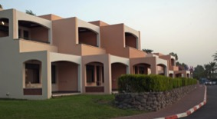

***Ein Gev***

**DAY 9** **GALILEE OF THE NATIONS (N.T.)** Travel through the Galilee Region including Arbel, Nazareth, Mt. Tabor, Mt. Gilboa and Beth Shean. **DAY 10** **THE NORTHERN REGIONS.** Upper Galilee region: Hazor, Dan, Caesarea Philippi & the road to Damascus. **DAY 11 JESUS AND THE GALILEE.** Boat across the Sea of Galilee to sites and actions of ministry of Jesus around the Sea. Mt. of Beatitudes, Tabgha, Capernaum and Chorizin.**DAY 12 THE INTERNATIONAL COASTAL HIGHWAY.** Investigate the import of the Coastal Highway region: Megiddo, Mt. Carmel and Herod’s Caesarea Maritima.

**A 13th DAY: Built in is a “day off” — Group will discuss where and how to use this “extra” day.DAY 14**  **ARRIVE USA**