**WELCOME TO HOLY SPIRIT LUTHERAN CHURCH**

A Member of the Evangelical Lutheran Church in America, New Jersey Synod

1220 Bayshore Rd., Villas, NJ 08251

609-886-2414

holyspiritlutheran@comcast.net

holyspiritvillas.com

facebook.com/holyspiritvillas

Vicar Vince Piekarski can be contacted at any time through call or text at

412-225-0287 or through email at vpie8282@gmail.com.

**20TH SUNDAY AFTER PENTECOST**

**SUNDAY, OCTOBER 6TH, 2024**

**10:30AM WORSHIP SERVICE WITH HOLY COMMUNION**



**MISSION STATEMENT**

We, the Evangelical Lutheran Church of the Holy Spirit, are People of God, who

are called by the Holy Spirit to pray, worship, joyfully proclaim Jesus Christ,

and compassionately witness and serve others in Christian Love.



**AN ESPECIALLY WARM WELCOME TO OUR VISITORS**

We are glad that you joined us for Worship today! Thank you for enriching our time together! We would like to get to know you better, and we would like for you to get to know us better too. Brochures, welcome gifts, prayer shawls, Bibles, and other items are available at our welcome areas. Church members are happy to show you around and share about our ministries. Please don’t hesitate to speak up and ask questions. Please make sure you sign-in on our clipboard on the podium in the lobby.



**CONFERENCE CALL INFORMATION**

We continue conducting our Worship Services in coordination with our Conference Call. Join us at our # 657-390-7423. If that does not allow you to gain access, please utilize our other # 701-802-5170 and access code 8221190, then hit the # key. You may need to dial 1 first, depending on your phone plan. After you log-in, please announce your name. Feel free to talk with others until we start our service.



**ARE YOU INTERESTED IN CANDLE MEMORIALS?**

Candles cost $10 each, and can be dedicated in memory of someone.

The Sign-up sheets are located on the bulletin board between the church offices.

Please feel free to see Vicar Vince with any questions.

**SANCTUARY CANDLE**

The month of October’s is given to the Glory of God & in memory of

JOAN NASH by Jean Zimmerman.

**ALTAR CANDLES**

The month of October’s are given to the Glory of God & in memory of

ADA & ROBERT STITT & JIM by Leon M. Stitt.

**CONFERENCE CALL CHECK-IN**

(Roll Call and Attendance)

**WELCOME & ANNOUNCEMENTS**

(Offered by Pastor, Assistant, and Congregation.)

**INTRODUCTION**

A. Today’s gospel combines a saying that makes many of us uncomfortable with a

story we find comforting. Jesus’ saying on divorce is another of his rejections of

human legislation in favor of the original intent of God’s law. Jesus’ rebuke of the

disciples who are fending off the children should challenge us as well. What does

it mean to receive the kingdom of God as a child does?

**PRELUDE**

(Music offered by our Organist before the start of our Worship Service.)

**Let Us Plead for Faith Alone**

**CHIMES**

(Music offered by our Organist before the start of our Worship Service.)

**Faith of Our Fathers**

P. We invite you to stand if you are able.

**CONFESSION & FORGIVENESS**

(All may make the sign of the cross, the sign that is marked at baptism,

as the presiding minister begins.)

P. Blessed be the holy Trinity, ☩ one God,

who forgives all our sin,

whose mercy endures forever.

**C. Amen.**

P. Let us confess our sin and come to God for healing.

(Silence is kept for reflection.)

P. Gracious God,

**C. have mercy on us.**

**We confess that we have honored you with our lips,**

**but have harmed our neighbors with our tongues.**

**The cravings at war within us**

**cause conflicts and disputes.**

**In our desire to be first**

**we make distinctions among ourselves.**

**We place the needs of the poor and the suffering last.**

**In your great mercy, forgive us our sins.**

**Draw near to us with grace in time of need,**

**and turn us to follow in the way of Jesus Christ,**

**our Savior and Lord.**

**Amen.**

P. God promises to forgive our iniquity

and to remember our sin no more.

By grace you have been saved.

In the name of ☩ Jesus Christ,

the source of eternal healing,

your sins are forgiven.

**C. Amen.**

(We invite you to remain standing if you are able.)

**GATHERING HYMN**

(We invite you to sing along with the music offered by our Organist.)

Lutheran Book of Worship—Green Book

**561—For the Beauty of the Earth**

**(4 Verses)**



**APOSTOLIC GREETING**

P. May the grace of our Lord Jesus Christ, the love of God,

and the communion of the Holy Spirit be with you all.

**C. And also with you.**

**KYRIE**

P. In peace, let us pray to the Lord.

**C. Lord, have mercy.**

P. For the peace from above, and for our salvation, let us pray to the Lord.

**C. Lord, have mercy.**

P. For the peace of the whole world, for the well-being of the church of God,

and for the unity of all, let us pray to the Lord.

**C. Lord, have mercy.**

P. For this holy house, and for all who offer here their worship and praise,

let us pray to the Lord.

**C. Lord, have mercy.**

P. Help, save, comfort, and defend us, gracious Lord.

**C. Amen.**

**HYMN OF PRAISE**

C:\Users\vpie8\Downloads\LBW Setting Two Glory (Melody).tif



**PRAYER OF THE DAY**

P. The Lord be with you.

**C. And also with you.**

P. Let us pray,

Sovereign God, you have created us to live in loving community with one

another. Form us for life that is faithful and steadfast, and teach us to trust like

little children, that we may reflect the image of your Son, Jesus Christ, our Savior

and Lord.

**C. Amen.**

P. We invite you to be seated for our Readings and Psalm.

**FIRST READING**

Genesis 2 stresses that people are not meant to live in isolation but in

relationship. Out of love for humanity, God creates them male and female, to

provide companionship for each other and to become with each other “one flesh.”

The Hebrew words used here are ish (man) and ishshah (woman).

R. Our First Reading is from the 2nd Chapter of Genesis (Verses 18-24).

R. 18The Lord God said, “It is not good that the man should be alone; I will make

him a helper as his partner.” 19So out of the ground the Lord God formed every

animal of the field and every bird of the air, and brought them to the man to see

what he would call them; and whatever the man called every living creature, that

was its name. 20The man gave names to all cattle, and to the birds of the air, and

to every animal of the field; but for the man there was not found a helper as his

partner. 21So the Lord God caused a deep sleep to fall upon the man, and he

slept; then he took one of his ribs and closed up its place with flesh. 22And the rib

that the Lord God had taken from the man he made into a woman and brought

her to the man. 23Then the man said,

  “This at last is bone of my bones

   and flesh of my flesh;

  this one shall be called Woman,

   for out of Man this one was taken.”

24Therefore a man leaves his father and his mother and clings to his wife, and

they become one flesh.

R. This is the Word of the Lord.

**C. Thanks be to God.**

**PSALM**

R. Our Responsorial Psalm is from the 8th Psalm.

**C.** **You crown us with glory and honor.** (Ps. 8:5)

R. 1O Lord our Lord,

   how majestic is your name in all the earth!—

  2you whose glory is chanted above the heavens out of the

mouths of infants and children;

   you have set up a fortress against your enemies,

to silence the foe and avenger.

  3When I consider your heavens, the work of your fingers,

   the moon and the stars you have set in their courses,

  4what are mere mortals that you should be mindful of them,

   human beings that you should care for them?

**C. You crown us with glory and honor.** (Ps. 8:5)

R. 5Yet you have made them little less than divine;

   with glory and honor you crown them.

  6You have made them rule over the works of your hands;

   you have put all things under their feet:

  7all flocks and cattle,

   even the wild beasts of the field,

  8the birds of the air, the fish of the sea,

   and whatever passes along the paths of the sea.

  9O Lord our Lord,

   how majestic is your name in all the earth!

**C. You crown us with glory and honor.** (Ps. 8:5)

**SECOND READING**

Quoting from the psalms, this passage from Hebrews emphasizes that Jesus, the

one through whom God created everything and who sits at God’s right hand, is

also the one who experienced human suffering and death in order to blaze the

path of salvation for us.

R. Our Second Reading is from the 1st & 2nd Chapters of Hebrews (1:1-4; 2:5-12).

R. 1Long ago God spoke to our ancestors in many and various ways by the

prophets, 2but in these last days he has spoken to us by a Son, whom he

appointed heir of all things, through whom he also created the worlds. 3He is the

reflection of God’s glory and the exact imprint of God’s very being, and he

sustains all things by his powerful word. When he had made purification for sins,

he sat down at the right hand of the Majesty on high, 4having become as much

superior to angels as the name he has inherited is more excellent than theirs.

2:5Now God did not subject the coming world, about which we are speaking, to

angels. 6But someone has testified somewhere,

  “What are human beings that you are mindful of them,

   or mortals, that you care for them?

  7You have made them for a little while lower than the angels;

   you have crowned them with glory and honor,

   8subjecting all things under their feet.”

Now in subjecting all things to them, God left nothing outside their control. As it is,

we do not yet see everything in subjection to them,9but we do see Jesus, who for

a little while was made lower than the angels, now crowned with glory and honor

because of the suffering of death, so that by the grace of God he might taste

death for everyone.

10It was fitting that God, for whom and through whom all things exist, in bringing

many children to glory, should make the pioneer of their salvation perfect through

sufferings. 11For the one who sanctifies and those who are sanctified all have

one Father. For this reason Jesus is not ashamed to call them brothers and

sisters, 12saying,

  “I will proclaim your name to my brothers and sisters,

   in the midst of the congregation I will praise you.”

R. This is the Word of the Lord.

**C. Thanks be to God.**

P. We invite you to stand if you are able, and I invite you to announce the Gospel

Acclamation with me.

**GOSPEL ACCLAMATION**

**C. Alleluia. If we love one another, God lives in us and God’s love is perfected**

**in us. Alleluia.** (1 John 4:12)

**GOSPEL READING**

Jesus announced and enacted in history the new reality of God’s surprising

activity. These two stories demonstrate this new reality: Women and children are

accepted and valued, not dismissed as inferior to adult men.

P. The Holy Gospel According to St. Mark, the 10th Chapter (Verses 2-16).

**C. Glory to you, O Lord.**

P. 2Some Pharisees came, and to test [Jesus] they asked, “Is it lawful for a man to

divorce his wife?” 3He answered them, “What did Moses command you?” 4They

said, “Moses allowed a man to write a certificate of dismissal and to divorce her.”

5But Jesus said to them, “Because of your hardness of heart he wrote this

commandment for you. 6But from the beginning of creation, ‘God made them

male and female.’ 7‘For this reason a man shall leave his father and mother and

be joined to his wife, 8and the two shall become one flesh.’ So they are no longer

two, but one flesh. 9Therefore what God has joined together, let no one

separate.”

10Then in the house the disciples asked him again about this matter. 11He said

to them, “Whoever divorces his wife and marries another commits adultery

against her; 12and if she divorces her husband and marries another, she

commits adultery.”

13People were bringing little children to him in order that he might touch them;

and the disciples spoke sternly to them. 14But when Jesus saw this, he was

indignant and said to them, “Let the little children come to me; do not stop them;

for it is to such as these that the kingdom of God belongs. 15Truly I tell you,

whoever does not receive the kingdom of God as a little child will never enter it.”

16And he took them up in his arms, laid his hands on them, and blessed them.

P. This is the Gospel of the Lord,

**C. Praise to you, O Christ.**

(We invite you to be seated.)

**SERMON**

(Delivered by Pastor David Jones.)

(We invite you to stand if you are able.)

**HYMN OF THE DAY**

(We invite you to sing along with the music offered by our Organist.)

With One Voice—Blue Book

**748—Bind Us Together**

**APOSTLES’ CREED**

P. God has made us his people through our Baptism into Christ. Living together in

trust and hope let us confess our faith together using the Apostles’ Creed.

**C. I believe in God, the Father almighty,**

**creator of heaven and earth.**

**I believe in Jesus Christ, God’s only Son, our Lord,**

**who was conceived by the Holy Spirit,**

**born of the Virgin Mary,**

**suffered under Pontius Pilate,**

**was crucified, died, and was buried;**

**he descended to the dead.\***

**On the third day he rose again;**

**he ascended into heaven,**

**he is seated at the right hand of the Father,**

**and he will come to judge the living and the dead.**

**I believe in the Holy Spirit,**

**the holy catholic church,**

**the communion of saints,**

**the forgiveness of sins,**

**the resurrection of the body,**

**and the life everlasting. Amen.**

**PRAYERS OF INTERCESSION**

(The prayers are prepared locally for each occasion.)

P. Challenged by God’s Word in Christ, let us pray for the church, the world, and the

whole creation.

(A brief silence.)

A. God of our ancestors, we give thanks for the church in all times. May we listen for

the prophets of this age who bear messages that stir the church toward renewal

and justice. God of grace,

**C. hear our prayer.**

A. Creator of every creature on earth, direct our lives toward the renewal and

sustaining of cattle, birds of the air, animals of the field, and those who share our

homes. Reveal the ways we can work alongside creation for the health and

well-being of all. God of grace,

**C. hear our prayer.**

A. Sovereign God, we give thanks that you are mindful and benevolent to even us,

mere mortals. Accompany us when hardness of heart gets in the way of justice

between people and nations. Endow leaders with minds for justice and hearts for

compassion. God of grace,

**C. hear our prayer.**

A. Restoring Lord, grant healing and wholeness to those who are sick and suffering;

especially:

Betty Lang (Church Member)

BettyAnn Rich-White (Church Member)

Chip Hand (Church Member)

Del McKenna (Church Member)

Evie Coyle (Church Member)

Lynn Bargstadt (Church Member)

Frank Brunner (Church Member)

Audrey Kinka (Church Member)

Sharon Ford (Church Member)

Carol Amundsen (Church Family)

Kim McGinley (Church Family)

Joan Sommerman (Church Family)

Gary Waltz (Church Family)

Megan Pratz (Betty Lang’s Friend)

Patty Cioce (Betty Lang’s Friend)

Carla Wagner (Betty Lang’s Family)

Tom McNamara (Audrey Kinka’s Family)

Beth & Bill Knapp (Betty Lang’s Family)

Bill Kanass (Betty Lang's Family)

Ed Borse (Betty Lang’s Friend)

James Kershaw (Audrey Kinka’s Friend)

Kali Poe (Betty Lang's Family)

Linda Dressic (Carol Detweiler's Family)

Suzie Clark (Rose Lang's Friend)

Evy (Betty Lang's Friend)

Amelia Skyrm (Audrey Kinka's Family)

Cindy Irana (Betty Lang’s Friend)

Ed Watson (Betty Lang's Friend)

Francis Clock (Dianna DeNote’s Family)

Andrew Hudak (Rose Lang’s Friend)

Fred Lang (Betty Lang’s Family)

Viena Murtha (Bob Fritsch’s Friend)

Christine Schneider (Audrey Kinka’s Family)

Jackie Churchman (Audrey Kinka’s Family)

Sharon Waicus (Skip & Bonnie Millard's Friend)

Karen O'Brien (Paul Bowker's Friend)

Dustin Irizzary (Mary Melnicoff's Family)

Linda Smith (Rose Lang's Friend)

Joan Brown (Betty Lang's Friend)

Donna Bradley (Betty Lang's Friend)

Theresa Marioti (Betty Lang's Friend)

The Bryan Family (Wanda Bryan's Family)

Ernie Kinzler (Marie Hand & Doreen Kinzler’s Family)

Craig Brearey (Judy Brannan & Mary Melnicoff's Friend)

Sarah Dutton (Frank & Sharon Ford's Family)

Christina McNasby (Fran Green’s Family)

The Kinkson Family (Judy Brannan's Friends)

Mark Stephen Dennis (Diana DeNote's Family)

Cathy Snyder (Audrey Kinka's Family)

Dellie Valcourt (Skip & Bonnie Millard's Family)

Joyce (Betty Lang's Family)

Hannah (Betty Lang's Family)

Donna Lee (Betty Lang's Friend)

Bill Lodge (Skip & Bonnie Millard's Friend)

Patrick & Denise Brannan (Judy Brannan's Family)

Joseph Sheretta (Fran Green's Friend)

Ernie Rink (Fran Green's Friend)

Ron Anderson (Bill Kelly's Friend)

Jerry P (Wanda Bryan's Friend)

Pat Labrae (Kathy Poehler's Friend)

Bud Brearey (Judy Brannan & Mary Melnicoff's Friend)

Mary Skain (Kathy Poehler's Friend)

Jorge Martin (Kathy Poehler's Family)

Bill Rand (Wayne & Eleanor Rand's Family)

Thomas Mieluchowski (Philomena Noak's Family)

Harold Snell (Fran Green's Friend)

Frances Woolbert (Heather Piekarski"s Friend)

Kevin Naylor (Vicki Rinier's Friend)

Robert Chaplin (Mary Melnicoff's Friend)

Joseph C (Mary Melnicoff's Friend)

Marie Hand (Church Member)

Eric Dishman (Church Family)

Frank Ford (Church Member)

Pam Fulk (Carol Amundsen's Family)

Rob Fox (Carol Amundsen's Family)

Nicole Kinzler (Doreen Kinzler & Marie Hand’s Family)

(Additional Names Added Prior to the Worship Service.)

A. Work through medical professionals to diagnose, ease pain, and give life to all

who seek their wisdom and experience. God of grace,

**C. hear our prayer.**

A. Unifying God, humans were created for relationship with the earth, its creatures,

and one another. Forgive us when division threatens companionship, mutual

support, and unity among us. May your love inspire us to build supportive

communities of faith where all are cherished. God of grace,

**C. hear our prayer.**

A. God of resurrection, you prepare a place in the kingdom through Christ’s death

and resurrection. We give thanks for the saints who have taken their place at

your heavenly banquet. God of grace,

**C. hear our prayer.**

(Here other intercessions may be offered.)

P. Watch over all of us who are worried and suffering, and especially those whose

names we now say aloud or within our hearts (extended pause). God of grace,

**C. hear our prayer.**

P. Into your hands, O God, we commend all for whom we pray, trusting in the saving

grace you freely give, both now and forever.

**C. Amen.**

**SHARING OF THE PEACE**

P. May the peace of the Lord be with you always.

**C. And also with you.**

P. Let us share God’s Peace with one another.

(Please remain in your pews and offer the sign of peace with a peace sign or wave.)

P. We invite you to be seated.

**ANTHEM**

(Special Music for Everyone to Enjoy.)

**Here I Am, Lord**

**OFFERING**

P. We now worship God with our tithes and offerings, wine and bread for use in holy

communion, and monetary gifts to support our ministry for service in God’s name.

Our Ushers will be around to your pews to pass the Offering Plates.

(Ushers come forward to get the Offering Plates from the Assistant.)

(Pastor and Assistant prepare the Altar for Communion.)

**OFFERING SONG**

(We invite you to sing along with the music offered by our Organist.)

C:\Users\HSLC\AppData\Local\Temp\Temp1_STANZA_1343 Melody.zip\What Have We to Offer (Melody).tif

(Usher(s) brings the Tithes and Offerings up front to the Assistant.)

P. We invite you to stand if you are able.

**OFFERING PRAYER**

P. Let us pray,

Blessed are you, O God,

source of every gift of your creation.

By these gifts and with our lives,

help us to serve one another and all in need,

through Jesus Christ, our Savior and Lord.

**C. Amen.**

**GREAT THANKSGIVING**

P. The Lord be with you.

**C. And also with you.**

P. Lift up your hearts.

**C. We lift them to the Lord.**

P. Let us give thanks to the Lord our God.

**C. It is right to give him thanks and praise.**

P. It is indeed right and salutary that we should at all times and in all places offer

thanks and praise to you, O Lord, holy Father, through Christ our Lord; who rose

beyond the bounds of death and, as he promised, poured out your Spirit of life

and power upon the chosen disciples. At this the whole earth exults in boundless

joy. And so, with the Church on earth and the hosts of heaven, we praise your

name and join their unending hymn:

**SANCTUS**

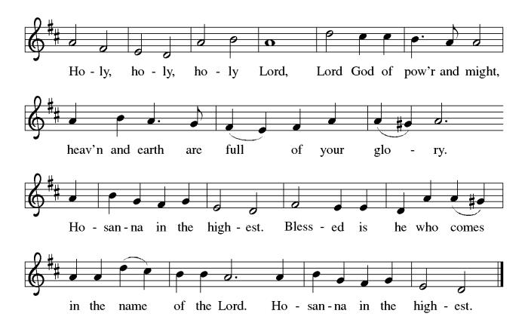

**THE EUCHARISTIC PRAYER**

P. Blessed are you, Lord of heaven and earth, in mercy for our fallen world you gave

your only Son, that all those who believe in Him should not perish, but have

eternal life. We give thanks to you for the salvation you have prepared for us

through Jesus Christ. Send now your Holy Spirit into our hearts that we may

receive our Lord with a living faith as He comes to us in His holy supper.

**C. Amen. Come, Lord Jesus.**

P. In the night in which he was betrayed our Lord Jesus took bread,

he gave thanks; broke it, and gave it to his disciples, saying:

*Take and eat; this is my body, given for you.*

*Do this for the remembrance of me.*



P. Again, after supper, He took the cup, he gave thanks,

and gave it for all to drink, saying:

*This cup is the new covenant in my blood,*

*shed for you and for all people for the forgiveness of sin.*

*Do this for the remembrance of me.*



**THE LORD’S PRAYER**

(We ring the bell throughout the Lord’s Prayer at all services to

invite those in the community to join in praying the Lord’s Prayer.)

P. May we now join with one another and pray together as Jesus has taught us.

**C. Our Father, who art in heaven, hallowed be thy name, thy kingdom come,**

**thy will be done, on earth as it is in heaven. Give us this day our daily**

**bread; and forgive us our trespasses, as we forgive those who trespass**

**against us; and lead us not into temptation, but deliver us from evil. For**

**thine is the kingdom, and the power, and the glory, forever and ever.**

**Amen.**

**LAMB OF GOD**

**C:\Users\Vince and Heather\Downloads\Lamb of God, ELW Setting Four (Melody).tif**

P. We invite you to be seated.

**HOLY COMMUNION**

P. All who believe in Jesus Christ are welcome at this very table. We utilize bread or

wafers, and we also have the option of individually wrapped gluten free wafers.

We have pre-filled red wine or white grape juice cups in the Communion Tray to

choose from.

The Usher will offer the option to leave your pew, and you can proceed forward

on the right side of the aisle to the steps between the Communion Rail. Following

Communion, please process back on the left side of the aisle and place your

empty cups in the basket before returning to your pew. Children who have not

had their First Communion instruction and adults who do not wish to receive

Communion, are welcome to come forward for a special blessing.

If you are unable to leave your pew for health or other related reasons, please

inform the Usher of your desire to remain in your pew and have us come to you.

**INVITATION TO COMMUNION**

P. Jesus welcomes you to this table.

Come, here is your God.

**C. Amen.**

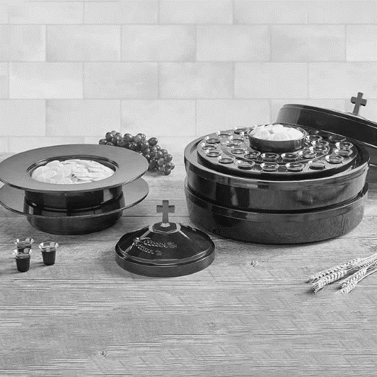

(Distribution of Holy Communion)

**COMMUNION HYMN**

(Please enjoy music offered by our Organist.)

Lutheran Book of Worship—Green Book

**370—Blest Be the Tie That Binds**

(Pastor and Assistant remove Communion Vessels from the Altar.)

P. Let us stand as we are able.

**POST COMMUNION BLESSING**

P. May the body and blood of our Lord Jesus Christ strengthen us and keep us

always in His grace.

**C. Amen.**

**POST COMMUNION CANTICLE**





**PRAYER AFTER COMMUNION**

A. Let us pray,

Holy God,

you have welcomed us to this meal

and fed us with dignity at your table.

Send us now to welcome others

and to be at peace with one another,

through Jesus Christ our Lord.

**C. Amen.**

**BLESSING**

P. God all mighty,

God most merciful

☩ bless you, keep you,

and give you peace.

**C. Amen.**

(We invite you to remain standing if you are able.)

**SENDING HYMN**

(We invite you to sing along with the music offered by our Organist.)

With One Voice—Blue Book

**749—When Love Is Found**

(Assistant extinguishes the Altar Candles half way through the Sending Hymn.)

(Pastor processes out once the Altar Candles have been extinguished.)

(We invite you to be seated.)

**BIRTHDAYS, ANNIVERSARIES,**

**& ADDITIONAL ANNOUNCEMENTS**

(Offered by Assistant and Congregation.)

**BIRTHDAY**

8th Heather Piekarski

**DISMISSAL**

A. Go in peace. Follow Jesus.

**C. Thanks be to God.**

**POSTLUDE**

(Music offered by our Organist as we depart following our Worship Service.)

**Edelweiss**

**LICENSES & EXPIRATION DATES**

Worship Service Content is used via permission through Augsburg Fortress Liturgies Annual License #SB144368. The next Subscription Renewal Date is 2/28/2025.

Our Hymns and Worship Music are used via permission through CCLI One License #11327166. The next Subscription Renewal Date is 1/31/2025.



**WORSHIP MINISTRY**

The most important thing we do each week is gather together as God's people to worship. God is the center and focus of everything we do. Participating in worship is active. Liturgy means the work and actions of the people gathered. Everything we do during the week to prepare for worship, and everything we do as we assist in leading worship is important. We are thankful for all the wonderful work being done. If you are interested in any position let Vicar Vince know so a training can be set-up.

Sign-up sheets are located on the bulletin board between the church offices.



**FAVORITE HYMNS**

Carol is willing to play some of your favorite hymns for the Prelude & Postlude each Sunday during our Worship Service. Feel free to let her know of your suggestions.

**DONATION STATION**

Get on the train and place all purchased items in the specified project donation bins located on the counter by the front doors. See Heather for more information.



**WOMEN OF THE CHURCH**

The next monthly meeting will be held on **Monday, October 7th, at 6PM**.

New members are always welcome to attend! Contact Judy for more information.

**BIBLE STUDY & FAITH DISCUSSIONS**

​​​​​Bible Study & Faith Discussions was started in order to focus on various readings, books, Bible verses, people of faith, and other general topics. Group Members offer various points of view while reviewing the Bible and various aspects of faith while being respectful and supportive of each other. Join us as we start our new curriculum called by heart, **on Tuesdays, at our newer start time of 6PM!**

**FOOD PANTRY & COMMUNITY DELIVERIES**

**Open every Thursday**, and the **last Saturday of every month**, from **10AM to 1PM**. 78 people were served in September. 853 people have been served in 2024. Donations can be dropped in the basket in the Narthex, placed in the outdoor drop-box by the Church Office door, placed in the money jug in the back of the Church, mailed into the Church Office, or placed in the Offering Plate. Volunteers are needed each week. Sign-up sheets are located on the bulletin board between the church offices. If you have questions or need training see Heather, Vicar Vince, or Bonnie.

|  |  |  |
| --- | --- | --- |
| **Thursday, 10/10** | **Thursday, 10/17** | **Thursday, 10/24** |
| Cathie & Garnet | Tori & Garnet | Cathie & Garnet |

Our local North Cape May Acme & Big Lots provide us with Expiring Soon, Recently Expired, and Slightly Damaged Foods & Items weekly. Kathy helps those in need by delivering items each Saturday in the community. Kathy then brings leftover items to the Church for church members in need, and those who visit the food pantry during the week. Additional items are then taken over to the Branches Outreach in Rio Grande. A special thanks to all who donate, pray, & help in any way!

**BULLETIN ENTRY DEADLINE**

The Bulletin is Printed on **Thursdays** during Church Office Hours. Changes need to be submitted to Vicar Vince or Heather no later than **Thursday by 4PM**. Thank you!

**CHURCH OFFICE**

Open **Thursdays from 6PM to 8PM** to serve the Congregation, the Community,

and to continue handling the business of the Church. Feel free to stop in to talk, pick-up or drop off something, pray in the Sanctuary, or for whatever reason.

**COFFEE HOUR**

The Women of the Church will be hosting our next monthly Coffee Hour on **Sunday, October 13th**, following our Worship Service. See Judy or Kathy for more info.

**CHURCH COUNCIL**

Share your comments, concerns, questions, or joys with one of our Church Council Members who can bring them back to our meetings. Visitors are always welcome to attend and listen to what is going on in and around the church. Join us In- Person or on our Conference Call at our next Meeting on **Tuesday, October 15th, at 6PM**.

**S’MORES & SCRIPTURES**

Did you ever look forward to sitting around a fire in the church yard hanging out with some church friends and other folks, enjoying s’mores, and studying scriptures?

We look forward to this monthly fellowship and study time on **Saturday,**

**October 19th, at 7PM**. Please ask Heather or Vicar Vince for more info.



**SUNDAY SCHOOL & CONFIRMATION**

Sunday School is currently on Summer Break. The Program is currently going through a bit of a restructuring process. Most of the young folks that have been attending over the years have now made it to the age in which they will be preparing for Confirmation. As a result, Vicar Vince spoke with a few Pastors and reviewed various curriculum and programs for this. “Here We Stand” is a program that will allow our young folks to go through roughly a 2-year process while focusing on the Bible and Luther’s Small Catechism. We will continue the program on Sundays from **9-10AM**. Of course, there still will be snacks, games, arts & crafts, and other fun things. We will also be asking the parents and families to step in the classroom for a few sessions this year as well. We will get underway with our 2023-2024 Sunday School Year on **Sunday, October 20th**! See Heather, Bonnie, & Vicar Vince for more information and if you are interested in volunteer opportunities.

**PREACHING @ BROOKDALE**

Vicar Vince will be helping out by covering and Preaching at Brookdale

Senior Living in Cape May Court House **Sunday, October 20th, at 1PM**.

**UPCOMING THRIVENT SPONSORED EVENT**

**October 26th**: Walk to End Alzheimer’s on the Ocean City Boardwalk

If you are interested, please reach out to Glen Stewart, BFA, member of St. John Lutheran Church, Ocean City, NJ, and Thrivent Financial Advisor, glen.stewart@thrivent.com, Office 609-736-0006, Text 609-454-6194.

**TRUNK OR TREAT & MOVIE**

True Deliverance Praise & Worship Center and Holy Spirit Lutheran Church invite you to join us for some family fun on **Saturday, October 26th, starting at 3PM**. Come get your candy and treats, enjoy Inside Out 2, and enjoy time with everyone! To participate, or for more information, call 609-741-8009.

**TIME CHANGE**

Fall may have started already, but the time is quickly approaching where we need to remember to fall back. We need to change our manual clocks before going to bed on **Saturday Evening, November 2nd**. That way you can gain that extra hour of sleep!

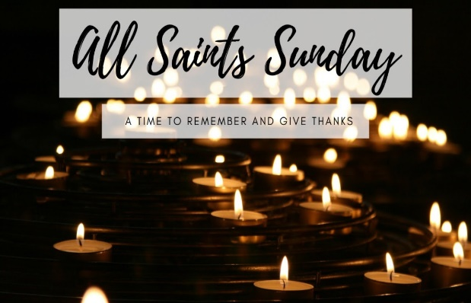

**ALL SAINTS SUNDAY**

On **Sunday, November 3rd** please join us at **10:30AM** for our **All Saints Sunday Worship Service**. Please add names to the All Saints List hanging on the bulletin board between the church offices, or you can call or email Vicar Vince. We want to make sure that we honor the memory of those loved ones that have passed away since last year’s All Saints Sunday during our Worship Service.

**INTERESTED IN BECOMING A NEW MEMBER**

Have you been attending our church for a while? Have you just recently returned to church after being away for a bit? Maybe you transitioned from another church,

or just started to recently attend our church. We are glad to have you, and would love to have you as a member of our Congregation. See Vicar Vince for more info.

Eight folks will be joining our Congregation on **Sunday, November 10th**, during our Worship Service, and join us at the Coffee Hour following to Welcome them.



**OPERATION CHRISTMAS CHILD**

The Sunday School Students will once again be collecting items to pack in the Shoeboxes for Operation Christmas Child in **November**. They will be collecting the following items: coloring books, crayons, markers, colored pencils, small toys, washcloths, individually wrapped bars of soap, toothbrushes, combs, socks, small craft projects, and small stuffed animals. Please no liquid or food items!!!

**HOME COMMUNION MINISTRY**

A Minister is available if you have a loved one, or if you desire services. We look forward in sharing the Word and Holy Communion! Please inform Vicar Vince, Kathy, or the Church Office so plans can be made for visits.

**PRAYER SHAWL MINISTRY**

Prayer Shawls, Lap Quilts, Scarves, and other items have been made with love for those in need. Blessed items are located in the Narthex, and are free for anyone. Members of the group continue working at home on new stitches and patterns. We are blessed to be able to continue collecting newly made items. We currently have a donation station of yarn and other items located in the Narthex. Make sure you check it out and find some new supplies for your next creation!

**OUR LIBRARIES**

New books are added to our library from time to time. Several are borrowed and read and exchanged. Who knows, you might find one particularly interesting and share that with someone as well. Reading is a great way to pass spare time, learn, and explore. You may find some fresh ideas for prayer, ways to grow more spiritually, ways to grow closer to God, or some opportunities to understand our faith more. Visit the library between the church offices and see what books are there!

We also have a hidden extended library located in Vicar Vince’s office on the large green shelves. There are Bibles of various translations, books from his personal collection, books inherited from Pastor Leah, movies, past Bible Study Curriculums, and so much more. Feel free to ask Vicar Vince to be able to check things out!



**TAKING FAITH HOME**

Vicar Vince was introduced to Milestones Ministries weekly guides for faith-filled studies and conversations through a Seminary class. A decision was made to pass these along to you. If you missed a week, or lost your insert, check our website for past issues. Feel free to ask questions and provide feedback to Vicar Vince.

**PRAYER LIST**

Our Prayer List continues to lengthen and we realize the important need for prayers and healing. Sometimes the unfortunate result is that someone has passed away, and the words “The Family & Friends of” appear before someone’s name. However, sometimes we forget names are still on the list and their health has improved or the they are no longer struggling, and they can be removed. Please share the good and bad stories as we continue to pray for strength and healing. Names can be added or removed from the list on the clipboard in the Narthex prior to the Worship Service, by calling the church office, or addressing it on the Conference Call. Please let us know the relation to the person(s) you listed so we can be more mindful with our prayers. Names will stay on the list until removed by the person(s) who requested prayer.

**NEWSLETTER**

We will continue on with our seasonal publications. Information, stories, pictures, and committee reports can be submitted at any time to Vicar Vince in-person or via email at vpie8282@gmail.com. If you did not receive your copy, then extra copies of the Fall Publication are on the bookshelves between the church offices.



**CHURCH DIRECTORY**

You can pick up a copy of your 2024 Church Directory by the Church Office on the bookshelves. We continue to keep it updated throughout the year. Undoubtedly, we probably missed a few changes, and have made a few errors. The printed church directories have spaces for changes in people’s information, new people’s information, notes, and your favorite Bible verses. If you have any changes or updates, please make it a point to inform the Church Office to keep us most up to date and current with all of your information.

**SOUND SYSTEM UPDATE**

Oliver Phillips at Not the DJ, LLC confirmed being able to locate a 16-channel mixer and 4 new speakers. Oliver told the former owner who upgraded their systems that he could refurbish them and use them at our church and it was decided to donate them instead of selling them. Oliver is currently refurbishing them. He was able to determine how much time, wire, and other supplies would be needed. An estimate for the set-up was provided at a cost of $2,200. We budgeted $5,000 for this, and could not have gotten any luckier that things lined up. The $1,100 deposit has been paid and we are hopeful that work will be scheduled in the near future.

**BAPTISM**

We are a church whose unity is in Jesus Christ, who gathers us around word and water, wine and bread. Baptism is a significant part of our faith journey as we come from the baptismal waters to live a new life as children of God. Our baptism sets us out on a lifelong journey that is characterized by our relationship to God, our relationship to our faith community, our relationships in our community and the wider world. Living our baptismal covenant means living a life of growth in the faith practices of discipleship. Please see Vicar Vince for more information.

**FIRST COMMUNION**

Although no particular age for first communion is prescribed by The Use of the Means of Grace, one guideline is offered. Because admission to the Sacrament is by invitation of the Lord to the baptized, "baptized children begin to commune on a regular basis at a time determined through mutual conversation that includes the pastor/vicar, the child, and the parents or sponsors involved, within the accepted practices of the congregation.” Each congregation is encouraged to ask the question of readiness for first communion, establish their own policies regarding age and practice, and accompany that practice with catechesis appropriate to the age of the communicant. If anyone has questions, please see Vicar Vince.



**TITHES, OFFERINGS, & ENVELOPES**

Envelopes are available in your mailbox in the back of the church, or from the Church Office. We do indeed worship God with our tithes and offerings. We hear this in scripture, “Each of you must give as you have made up your mind, not reluctantly or under compulsion, for God loves a cheerful giver.” (2 Corinthians 9:7) Feel free to drop your envelopes in the offering plate, mail them to the church, or drop them off in the locked mailbox. We thank you for all of your continued support in the mission of our church, its ministries, the New Jersey Synod, and various other needs!

**ED GREEN CAPITAL IMPROVEMENT FUND**

We continue raising money for unforeseen costs or repairs.Kathy sells Wawa Tickets for $6, the donation bin is in the back of the church, and we have our Annual Church Rummage Sale. Thanks for your continued donations, prayers, and support!

**PROPERTY USE**

​​​​​Do you know anyone interested in utilizing our Fellowship Hall for a Party or Event?

It is a suggested $50 refundable security deposit, and $250 for facility use. There is no alcohol or games of chance permitted due to ELCA policy. Please contact Vicar Vince or the Church Office with questions, for info, or to reserve a date and time.

**JERSEY JOTTINGS**

Jersey Jottings is a weekly e-newsletter that connects our synod together with weekly prayer, upcoming events, synod and churchwide activities, mission stories, congregational activities, and more. You can also sign up by going to https://www.njsynod.org/stay-connected and filling out the form! You can also get the app on your smartphone in the Apple App Store or on Google Play on your android.

**TRUE DELIVERANCE PRAISE & WORSHIP CENTER**

Reverend Maria Brooks and True Deliverance Praise & Worship Center utilize our facilities from 1-4PM on Sundays. TDPWC helps with the Food Pantry & hosts or assists with other events throughout the year. TDPWC hosts a Prayer Line on Mondays, Thursdays, & Fridays at 5PM on their Conference Call # 1-657-390-7957.



**VICE PASTOR UPDATE**

Some members of our Congregation were able to meet Pastor William Hodgetts

at our recent Church Council Meeting. We might hold a scheduled meet and greet for the Congregation if there are folks that are interested. Please talk to Vicar Vince.



**VICAR VINCE’S DAY OF REST**

A day of rest can have physical, mental, and spiritual benefits. Vicar Vince has been looking at his planner and it is noticeable that this day has not really been present throughout this year. This was discussed with Church Council the last two months, and there was respect in the need for this. It has now been determined that “Mittwoch,” German for mid-week, or Wednesday will be the said and respected day. However, please do not hesitate to reach out if there is an emergency!

**VICAR APPOINTMENT ON MARCH 19TH, 2023**

A Memorandum of Understanding on the Matter of Pastoral Appointment

In Theological Education for Emerging Ministries (TEEM) Candidacy

TO: Congregation Council, Holy Spirit Lutheran Church, Villas

FROM: The Rev. Tracie L. Bartholomew, Bishop, New Jersey Synod

Dear Brother and Sisters in Christ,

This memorandum is in support of your discussions with Vincent Piekarski as pastor of Holy Spirit, Villas. Because this is not the usual pattern for completing the educational and candidacy requirements for ordination, it is my hope that this memorandum will both provide guidelines and engage in conversation with those who are invested in this process.

I would say at the outset that because Vincent is an outstanding candidate for the Ministry of Word and Sacrament, we will all want to do whatever is necessary to assure that his placement serves the mission of the church in the best possible fashion.

The following notes reflect my own understanding of this matter:

(1) **The appointment for Vincent will begin on April 1, 2023**. At this time, Vincent

will assume all responsibilities of a regularly called pastor, including presiding at

the Sacrament of Holy Communion and Baptism at Holy Spirit, Villas.

(2) A pastoral appointment in the TEEM process is an option for completing

seminary educational requirements and the steps of the candidacy process.

Upon completion of the candidacy process and seminary education, the

candidate may receive and accept a call to ordained ministry from the

congregation where the appointment is being served.

(3) This appointment is jointly supervised by the Office of the Bishop and the TEEM

pastor’s seminary. A mentoring relationship with a local pastor is required for the

length of this appointment.

(4) The synod of candidacy origin will be responsible for the approval process.

(5) Upon approval for ordination, the congregation would be expected to extend a

call to the pastoral appointee.

(6) Compensation for the TEEM pastor will be according to the guidelines of the New

Jersey Synod. All normal forms of compensation should be in place for the term

of the appointment, including stipulation that base salary and housing shall be in

accord with synod guidelines for first call at time of ordination.

(7) The ELCA Portico benefit plan for lay persons in full-time church service should

be used for the pastoral appointee up to the time of ordination, whereupon the

benefit package is to be converted to the plan for ELCA clergy.

(8) A decision for Pastoral Appointment is made with the agreement of a synod and

its candidacy committee, and the ELCA, normally represented by the regional

staff person of each in consultation with the seminary and its Director for

Contextual Education.

(9) Pastoral Appointment in a TEEM Candidacy is an option that is to serve the

mission of the Church in a particular and vital way and is not to be viewed or

used as a means to circumvent the normal candidacy process and/or first call

placement process.

In the specific case of Vincent, the New Jersey Synod remains responsible for the candidacy and approval process, and has agreed to this proposal for Appointment at Holy Spirit, Villas.

Continued blessings to both Holy Spirit and Vincent Piekarski as you embark on this journey of mutual ministry. As partners in ministry, we walk with you and rejoice in this new relationship.



|  |  |
| --- | --- |
| **2024 FINANCIAL STANDING** | |
| **AUGUST INCOME** | $4,679.00 |
| **AUGUST SPENDING** | $30,413.68 |
| **AUGUST GAIN OR (LOSS)** | ($25,734.68) |
| **2024 INCOME** | $67,856.67 |
| **2024 SPENDING** | $92,834.08 |
| **2024 GAIN OR (LOSS)** | ($24,977.41) |
| **ED GREEN CAPITAL IMPROVEMENT FUND** | $17,435.88 |
| **FOOD PANTRY FUND (SOCIAL MINISTRY)** | $12,514.73 |
| **CD** | $25,000.00 |

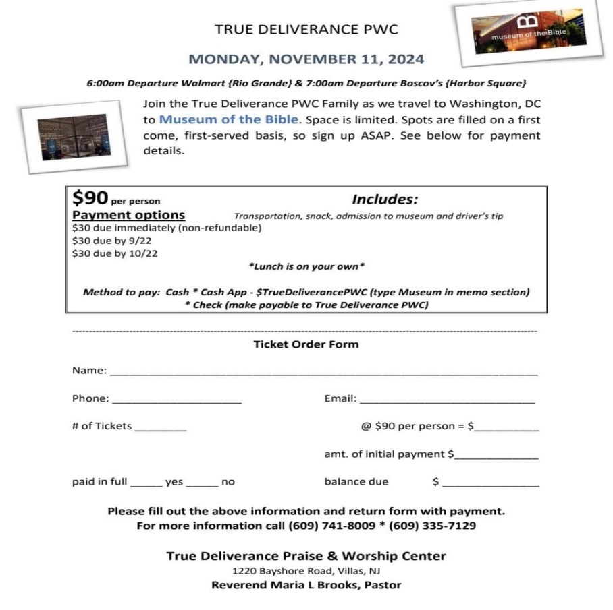

**CHURCH STAFF & VOLUNTEERS**

**VICAR, BIBLE STUDY & FAITH DISCUSSIONS,**

**EVENTS, NEWSLETTER, & WEBSITE**

Vicar Vince Piekarski

**VICE PASTOR**

Pastor William Hodgetts

**ORGANIST & PIANIST**

Carol Amundsen

**CHURCH COUNCIL PRESIDENT**

Mary Melnicoff

**CHURCH COUNCIL VICE PRESIDENT**

Judy Brannan

**CHURCH COUNCIL TREASURER**

Bonnie Millard

**CHURCH COUNCIL SECRETARY**

Vicki Rinier

**CHURCH PROPERTY**

Frank Ford & Wayne Rand

**CHURCH OFFICE, SUNDAY SCHOOL, & FOOD PANTRY**

Heather Piekarski

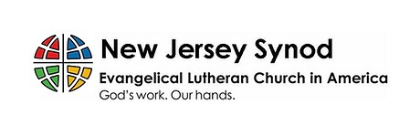

**WHAT IS THE EVANGELICAL LUTHERAN**

**CHURCH IN AMERICA (ELCA)?**

The ELCA was formed in 1987 by the merger of three Lutheran Church bodies –

the ALC (American Lutheran Church), the LCA (Lutheran Church in America),

and the AELC (Association of Evangelical Lutheran Churches).

To learn more, go to the ELCA's website at www.elca.org.

**WHAT IS THE NEW JERSEY SYNOD?**

The New Jersey Synod is a geographical grouping of Evangelical Lutheran Church in America (ELCA) congregations that share the mission and ministry of the Church on the New Jersey territory. It is one of 65 synods in the ELCA. The NJ Synod is comprised of 146 congregations, which include over 45,000 baptized members.