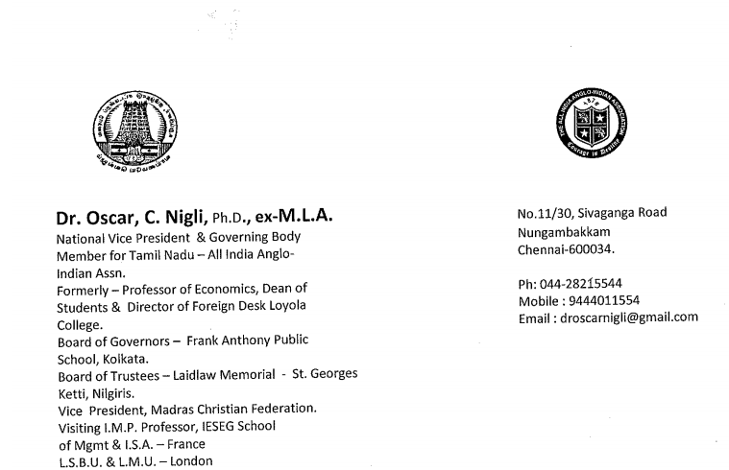
18th June 2021
To,
Mr. Rodney Almeida
President
The Anglo-Indian Association of Melbourne
Australia

Dear Mr. Almeida,

Greetings from the Anglo-Indian Community!

It is my joy and privilege to place on record my deep sense of appreciation rendered by the Anglo-Indian Association of Melbourne, as well as help rendered by you in your personal capacity. Innumerable who have benefitted by this benevolence for over the past year is much appreciated.

Covid 19 in the early part of 2020 affected the livelihood of many Anglo-Indians who lost their job, were not able to pay house rent or pay the huge fees demanded by schools or even their basic rations. The second wave of Covid in 2021 February took its toll of lives. We have lost and continue to loose many Anglo-Indian bread winners. Middle class people have become poor because salaries have been cut by fifty per cent and in other cases up to seventy five per cent making it difficult for families to pay their rentals or school/college fees not forgetting food.

I have been helping out with my personal funds as well as funds from immediate relatives in India and abroad. The Melbourne Anglo-Indian Association came as a Godsend to many suffering Anglo-Indians. We have reached out all over the country with emphasis on Tamil Nadu, neighbouring

: 2 :

Karnataka and Kerala, West Bengal and many other individuals who approached from other parts of the country.

Thank you Mr. Almeida and The Melbourne Anglo-Indian Association for the continual support being given. This support will be required for quite some more while till job opportunities open up and things return to normalcy, the answer to which is difficult to find at this juncture.

Yours sincerely,

Dr. Oscar C. Nigli, Ex-M.L.A.

Dr. Oscar C. Nigli

