


2020 Program Book Advertising Form
A Miss America Preliminary for 71 Years
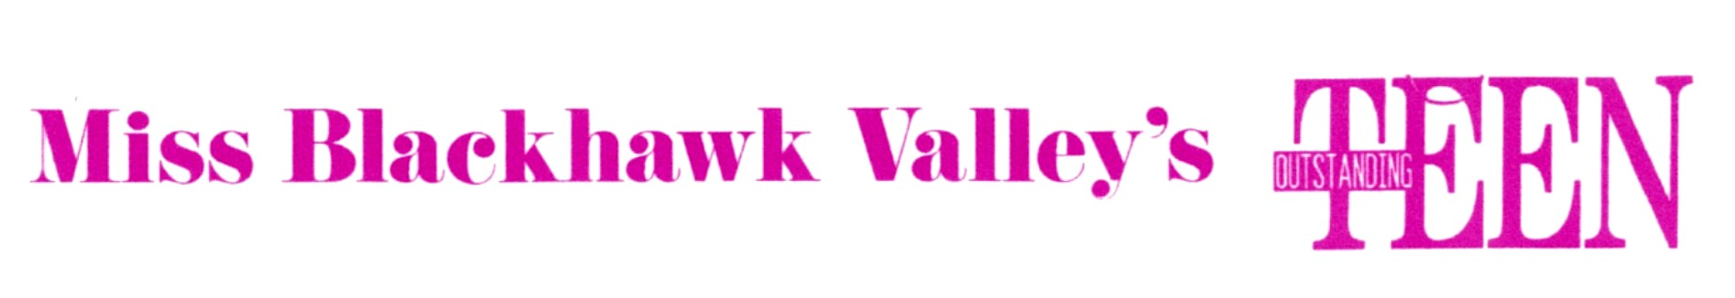
Advertiser or Firm name: ________________________________________________________

Address: _____________________________________________________________________

City: ______________________________________ State: _________ Zip: _______________

Phone: (____) __________________ Authorized signature: ____________________________

_____ Full Page (7 ½ W X 10 L) . . . . . . . . . . . . . . . .$50.00

_____ Half Page (7 ½ W X 5 L). . . . . . . . . . . . . . . . . $ 30.00

_____ Quarter Page (7 ½ W X 3 ¾ L) . . . . . . . . . . . . .$ 20.00

_____ Business card ( 3 W X 2 L) . . . . . . . . . . . . . . .$ 10.00

_____ Lovelines . . . . . . . . . . . . . . . . . . . . . . . . . . .$ 5.00

The following is attached Please submit ASAP
_____ Camera ready ad copy OR _____ Ad instructions for BHV to design
_____ Photograph (s)
_____ Payment of $___________

Please make checks payable to Miss Blackhawk Valley Scholarship Program, Inc.

Sold by ______________________________________________ Date: ____/____/____

Return with attachments to Kodi Kargl or KodiKargl@gmail.com
633 5th Avenue West
Andalusia, IL 61232

- - - - - - Detach section below for your records - - - - - - - - - - - - -
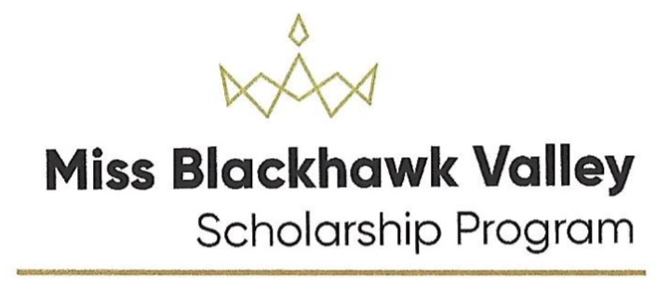

Program Book Advertising 2020
Thank you for helping the young women of the Western Illinois Counties of Rock Island, Henry, and Mercer reach their educational goals.

Size of Ad _________ Number of Photographs _________ Total paid $___________

Pageant representative or Candidate__________________________________ Date: ___/___/___

