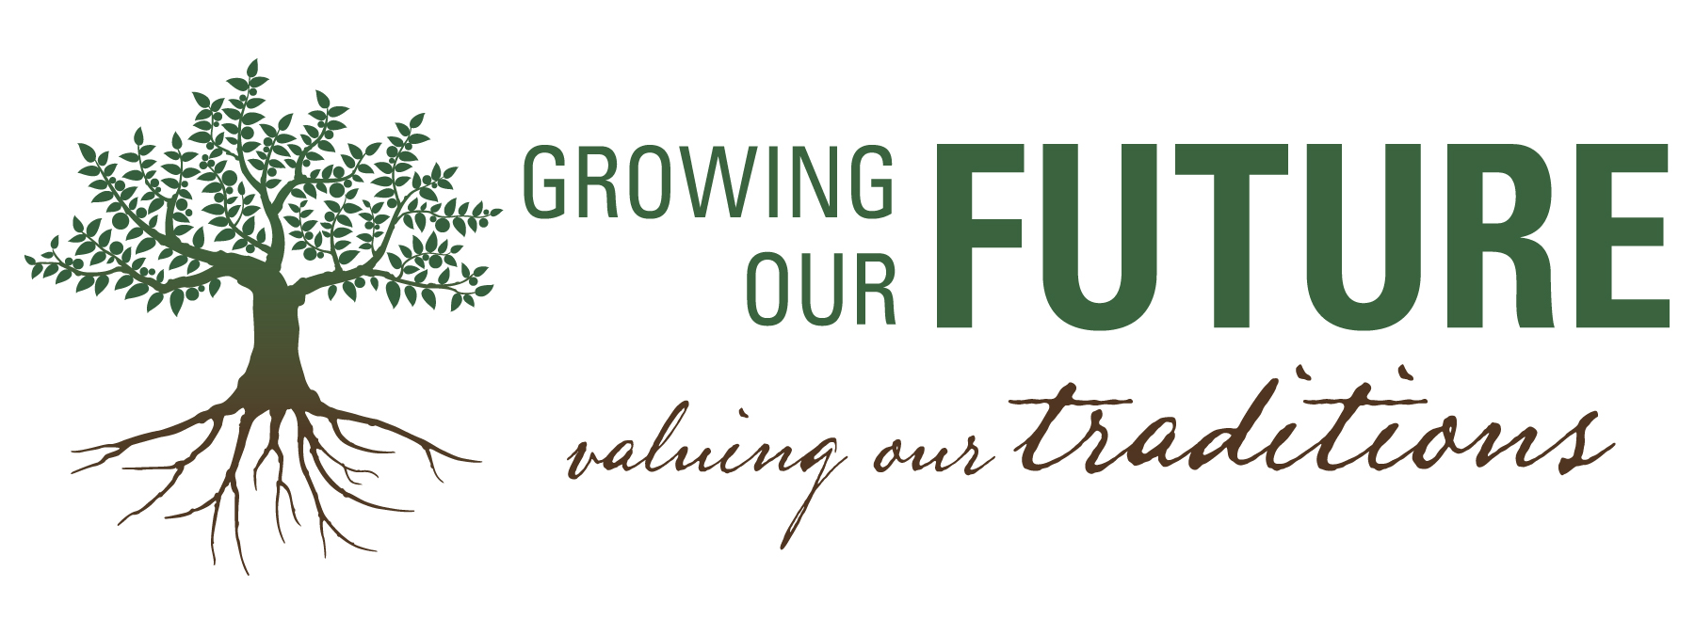
18th Annual Spring Social

pring Social
APRIL 5, 2014 Win River Casino

APRIL 5, 2014 Win River Casino

The Shasta County Farm Bureau presents the 18th Annual Spring Social, Saturday, April 5, 2014, at
our new venue, Win River Casino Event Center. This spacious and comfortable setting will be ideal for an evening of reconnecting with old friends while establishing new connections within the agriculture and business community.

As a local, non-profit, non-governmental organization, the Shasta County Farm Bureau strives to improve the ability of local farmers and ranchers to provide a reliable food source. In this new enhanced setting, we will honor recipients from Shasta County with our annual awards, present scholarships to deserving high school and college students seeking a career in agriculture and offer and evening of inspiration for the future of agriculture.

Supporting this event with a sponsorship is a tremendous way to sustain and promote the future of agriculture right here in Shasta County. Please consider where we would be without local agriculture and indicate your support using the attached form which offers you several levels of sponsorship.

You can help to "Grow our Future and Value our Traditions" by sponsoring this event and make a difference to ensure the future of agriculture in Shasta County.

Please do not hesitate to contact our manager, Tiffany Martinez at (530) 547-7170 or e-mail her at shastacountyfarm1@frontiernet.net, if you have any questions.

Sincerely,
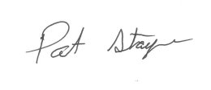
Patrick Stayer
SCFB President
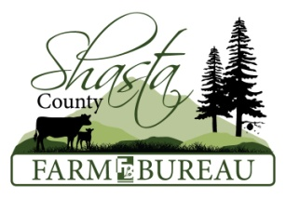

18th Annual Spring Social Sponsor Form

Platinum Level Sponsorship- $750

A paid, 1 year membership to the Shasta County Farm Bureau!

Eight dinner tickets for a gourmet meal with Reserved Seating

Sponsor logo on all posters for Spring Social if form is returned by Jan 31st

Printed recognition on the invitations and event program

Sponsor provided banner placed at event.

A post event thank you advertisement in the Shasta Farm News

A gift basket and 5 Complimentary gun raffle tickets

Gold Level - $500

A paid, 1 year membership to the Shasta County Farm Bureau!

Six dinner tickets for a gourmet meal with Reserved Seating

Printed recognition on the invitations and event program

A post event thank you advertisement in the Shasta Farm News

A gift basket and 2 Complimentary gun raffle tickets

Silver Level - $375

Four dinner tickets for a gourmet meal provided by Win River

Printed recognition in the event program

A post event thank you advertisement in the Shasta Farm News.

Bronze Level - $175

Two dinner tickets for a gourmet meal provided by Win River

Printed recognition in the event program

A post event thank you advertisement in the Shasta Farm News

Purchase Tickets #_________of tickets $30.00 each

Business or Contact Name:________________________ __________________________

Address:__________________________________________________________________

Telephone:______________________ E-Mail:____________________________________

Payment Method (please circle one:) Send a bill Check enclosed
*Tickets for event will not be sent until sponsorship is paid in full

Platinum and Gold Level Sponsors - to be listed on the invitation, please respond by January 31st
We will continue to take sponsors until March 24th

Please make checks payable to: Shasta County Farm Bureau
Mail to: SCFB, P.O. Box 970, Palo Cedro, CA 96073
For more information contact Tiffany Martinez at (530) 547-7170 or shastacountyfarm1@frontiernet.net

