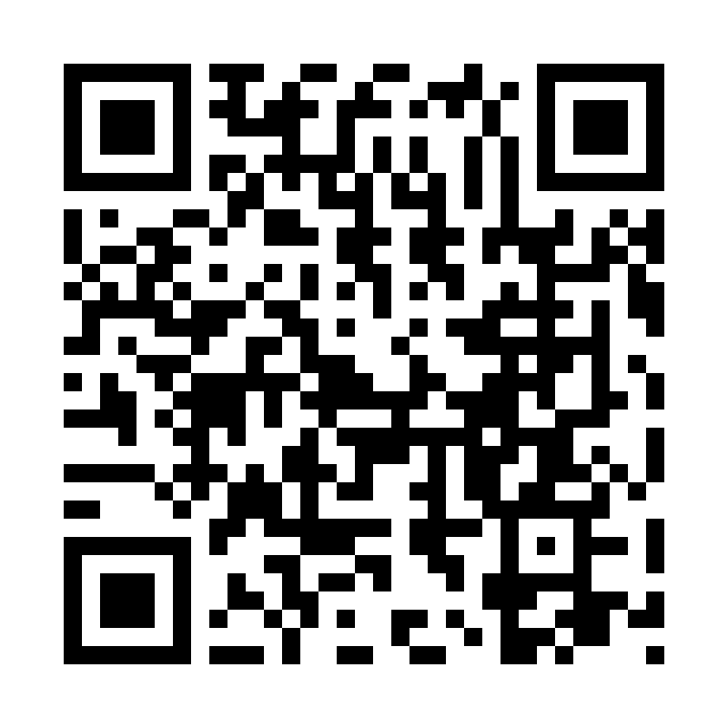
Catholic Church cluster of Davenport
St. Francis of Assisi – Harrington
Immaculate Conception Catholic Church – Davenport
St. Michael Catholic Church – Reardan
St. Kateri Tekawitha Catholic Church – Ford
Sacred Heart Catholic Church – Wellpinit

Mailing Address: Immaculate Conception Catholic Church - Davenport
1310 Adams St., Davenport, WA 99122-9454
(509)725-1761
Office manager: Jackie – icdavenport@dioceseofspokane.org
Send me bulletin updates by Mondays 5pm
Office hours Tuesdays 9:30 - 12
Pastor - Fr. Sean Thomson sthomson@dioceseofspokane.org
QR code is to go to our Immaculate Conception web page
Seeking information about Baptism, Marriage, Anointing of the Sick or Funerals:
Call Fr. Sean (509)688-5784

The Holy Sacrifice of the Mass
Daily Tue./Wed./Fri. Davenport at 9:00am, Thurs. Reardan at 9:00am
Saturday Harrington at 5:30pm Sunday Davenport at 8:30am, Reardan at 10:30am, Ford and Wellpinit at12:30pm (1st-2nd-3rd Sunday in Ford) 2nd [2:30pm]-4th Sunday [12:30pm] in Wellpinit)

Confessions (Before Mass at all mission parishes) or by appointment.
Saturday Davenport at 9:00am to 9:30am, 3:00pm to 3:30pm
Tuesday Davenport at 5:30pm to 6:00pm, with Eucharistic Adoration.
Catechism of the Catholic 736 By this power of the Spirit, God's children can bear much fruit. He who has grafted us onto the true vine will make us bear "the fruit of the Spirit: . . . love, joy, peace, patience, kindness, goodness, faithfulness, gentleness, self-control." "We live by the Spirit"; the more we renounce ourselves, the more we "walk by the Spirit." Through the Holy Spirit we are restored to paradise, led back to the Kingdom of heaven, and adopted as children, given confidence to call God "Father" and to share in Christ's grace, called children of light and given a share in eternal glory The Holy Spirit and the Church 737 The mission of Christ and the Holy Spirit is brought to completion in the Church, which is the Body of Christ and the Temple of the Holy Spirit. This joint mission henceforth brings Christ's faithful to share in his communion with the Father in the Holy Spirit. The Spirit prepares men and goes out to them with his grace, in order to draw them to Christ. the Spirit manifests the risen Lord to them, recalls his word to them and opens their minds to the understanding of his Death and Resurrection. He makes present the mystery of Christ, supremely in the Eucharist, in order to reconcile them, to bring them into communion with God, that they may "bear much fruit."
Jackie says: Jackie Widhalm is our new office manager. She will be available every Tuesday from 9:30—12:00. Mass intentions/ announcements/ events for bulletin deadline will be Mondays at 5pm. I would like to start the Seven Sisters Apostolate in our cluster. Sevensistersapostolate.org is the website for more information.
Mass Intentions Apr. 27 Sat. (5:00pm) For an end to war. Apr. 28 Sun. (8:30am) For an end to war. (10:30am) For an end to war. (12:30pm) For an end to war. Apr. 30 Tues. (9:00am) For an end to war. May. 1 Wed. (9:00am) For an end to war. May. 2 Thur. (9:00am) For an end to war. May. 3 Fri. (9:00am) For an end to war.

