**2024 Virginia Network Women of Color Conference Presidents Panel**

**Dr. Towuanna Porter Brannon**

**President, Virginia Peninsula Community College**

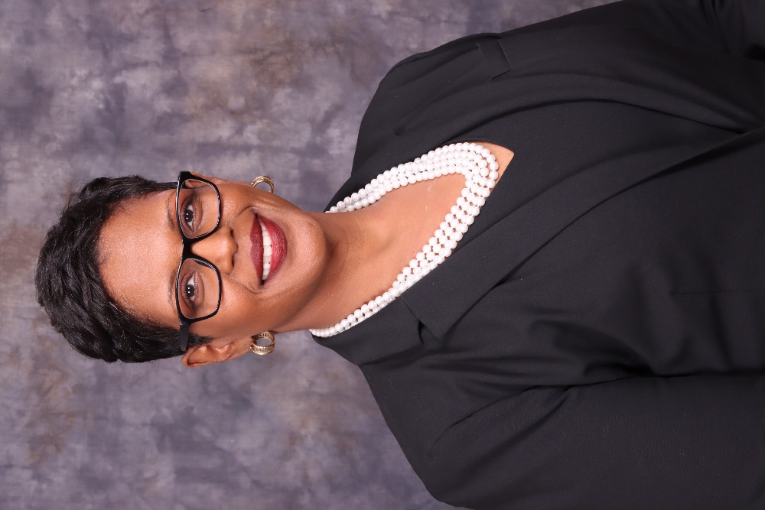**Dr. Towuanna Porter Brannon** is the ninth president of Virginia Peninsula Community College. Dr. Brannon's higher education tenure includes over 25 years in leadership, change management, organizational development, policy design, fundraising, instruction, and the provision of direct support to students at a diverse array of public and private colleges and universities.

During her tenure as president, the college experienced its first enrollment increase in over eight years with significant gains among dual-enrolled high school students and those seeking short-term high-demand workforce credentials. The college established its second workforce development center and will launch a center for excellence in early childhood education, and a maritime skills trade center in 2024.

Over the span of her career, she has been a primary architect in creating policies, programs, and systems designed to improve college access, retention, and completion. Dr. Brannon believes that Virginia’s community colleges are uniquely positioned to deliver high-quality programs that address the Commonwealth’s critical labor needs and help students become economically resilient.

Dr. Brannon, is a native of Brooklyn, New York. She earned her doctorate degree in Executive Leadership, Administration, and Policy from Fordham University, a master’s degree in education, and a bachelor's degree in Human Services from St. John's University in Queens, NY.

**Dr. Paulette R. Dillard**

**President, Shaw University**

**Dr. Paulette R. Dillard** has a rich teaching history having taught biology for over 20 years at various institutions. Prior to her appointment as the 18th President of Shaw University, she

served as Interim President and Vice President for Academic Affairs. During her tenure at Shaw University, she has served as the Dean of the College of Arts and Sciences, Department Chair

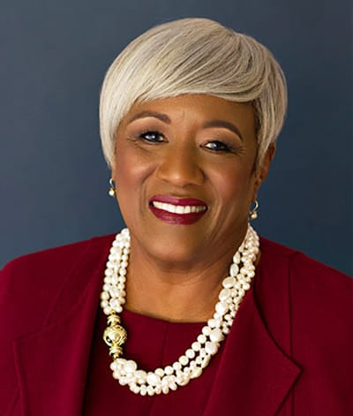for Natural Sciences and Mathematics, and as an Associate Professor of Biology. She also served as Coordinator of undergraduate research infrastructure, and Co-Director of the academic enrichment programs for the National Institutes of Health National Institute on Minority

Health and Health Disparities (NIMHD) funded Research Infrastructure in Minority Institutions

(RIMI) project.

An avid researcher, Dr. Dillard and Shaw University student research interns spent six weeks in

Kingston, Jamaica conducting a study examining the knowledge, skills, and attitudes of Jamaican men of African descent who were diagnosed with prostate cancer. This study was of interest to her as her postdoctoral research was focused on prostate cancer and its disparate impact on men of African descent. She has also worked as a visiting researcher at the National Institutes of Environmental Health Sciences in Research Triangle Park, published her research in peer reviewed journals, and presented at national and international conferences. Dr. Dillard has over 25 years of experience in the field of clinical diagnostic medicine. She began her career as a bench scientist, and quickly ascended to the management ranks being one of only a few women senior executives, and even fewer women of color to reach the rank of Vice President and General Manager in the 1980s. Her ascension and success led her to strive to use her position as one of the few African American women executives to inspire young people to achieve. She has served on the Board of the Nashville Center for Black Family Life, which provided after school programs for children and youth as well as workshops to teach family life skills, and on the Hospital Corporation of American Center for Nonprofit Management Board to assist non-profit agencies funded by United Way with financial management. She has also mentored various students as an Executive in Residence at Paine College, Barber Scotia College and Middle Tennessee State University.

Dr. Dillard currently serves on the Board of the Carolina Small Business Development Fund, the Dorothea Dix Conservancy and has been involved with the Innovation and Entrepreneurship Center and the LaunchRALEIGH initiatives since inception. She also is on the Board of the Capital City Club and serves on the Raleigh Chamber of Commerce Board of Advisors.

Dr. Dillard grew up in Mount Airy, North Carolina. She earned a Bachelor of Science degree in biology at Barber Scotia College in Concord, North Carolina and received a Master of Science degree in biology from Tennessee State University. She went on to earn an MBA from the Jack Massey School of Business at Belmont University and a Ph.D. in Biological Sciences from Clark Atlanta University (CAU), Atlanta, Georgia.

Dr. Dillard was married to the late Reverend Moses C. Dillard, Jr., a renowned musician, preacher, and social activist. She is a member of First Baptist Church, Wilmington Street in Raleigh, North Carolina.

**Dr. Karrie G. Dixon**

**Chancellor, Elizabeth City State University**

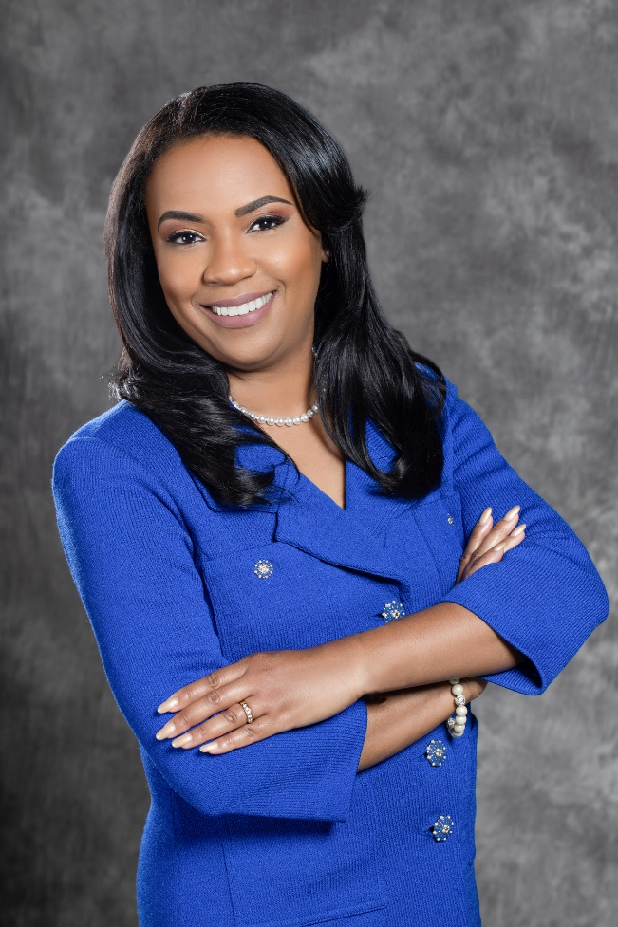**Dr. Karrie G. Dixon** was named the 12th CEO and seventh chancellor of Elizabeth City State University (ECSU) (N.C.) on Dec. 14, 2018. She previously served as interim chancellor since April 9, 2018. Before this appointment, Dixon was a senior administrator at the University of North Carolina System Office since 2008. She was promoted to vice president for academic and student affairs as well as chief student affairs officer, overseeing and shaping systemwide policy to ensure overall success for the more than 220,000 students enrolled across the state. Before joining the UNC System, Dixon served ten years at two other UNC campuses.

Since Dixon arrived at ECSU, enrollment has climbed nearly 40%, and degree program offerings have expanded, which included launching an unmanned aircraft systems degree program, an online master’s degree in education, and an online bachelor’s degree in homeland security. Under her leadership, the university increased its fleet from two to 14 aircraft for ECSU’s signature aviation program.

In 2019, North Carolina Governor Roy Cooper awarded Dr. Dixon *The Old North State Award*, one of the highest honors granted by the State of North Carolina, awarded to “individuals who have shown dedication and service beyond expectation and excellence to the Great State of North Carolina.” She also was named by the HBCU Campaign Fund as one of “The Ten Most Dominant HBCU Leaders of 2020.” In 2023, Dixon was awarded the Toastmaster D117 Award for Communication & Leadership and was recognized as a 2023 Black Business Ink Magazine Power 100 honoree.

Dr. Dixon serves on various local and national boards, including the American Association of State Colleges and Universities Board of Directors, the Association of Governing Boards Council of Presidents, and the Southern Association of Colleges and Schools Commission on Colleges Board of Trustees. In 2020, Dr. Dixon was named to the newly formed national Women in Aviation Advisory (WIAAB) board by the U.S. Dept. of Transportation Secretary Elaine L. Chao. Dr. Dixon is a presidential sponsor for the North Carolina American Council on Education Women’s Network. Dr. Dixon is a charter member of the Black Women Collegiate Presidents and Chancellor.

Dr. Dixon holds a bachelor’s degree from NC State University, a master’s degree from the University of North Carolina at Greensboro, and a doctorate from NC State. She and her husband, Devi, have two daughters.

**Dr. Paula P. Pando**

**President, Reynolds Community College**

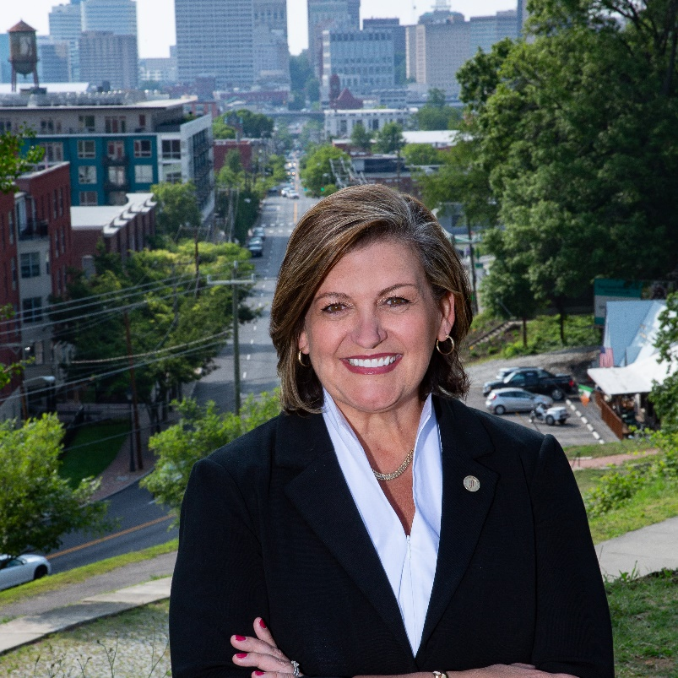**Dr. Paula Pando** is a strategic, forward-thinking educator with nearly 30 years of experience in both public and private higher education. The daughter of immigrants, she is fluent in both Spanish and English and is wholly committed to strengthening lives and communities through the transformative power of an education. In May 2018, Dr. Pando was appointed the fourth president of J. Sargeant Reynolds Community College. Prior to her role as president of Reynolds, Dr. Pando served as the Senior Vice President for Student and Educational Services at Hudson County Community College in New Jersey, where she spent nearly sixteen years of her career. She began her career at Saint Peter’s University in Student Affairs, also in New Jersey.

Dr. Pando’s strong student advocacy and contributions to the field of higher education have been recognized at the local, state, and national levels. Most recently, she was elected to serve on the Board of Directors for the American Association of Community Colleges. She also serves on multiple local boards including the Community Foundation for a greater Richmond, Chamber RVA, and Venture Richmond, among others.

In 2017, she was one of 38 community college leaders selected from across the country for the Aspen Institute’s Presidential Fellowship, a rigorous applied executive fellowship in partnership with Stanford University. In 2021, she was awarded the Dana Hamel Leadership Award, the highest award bestowed by the Virginia Community College System for her leadership in the development of the system’s ambitious six-year strategic plan. In 2023, Dr. Pando was recognized by the Richmond Times Dispatch and Richmond Raceway to the inaugural class of Women Who Drive Richmond in recognition of women driving the region forward, as well as a recipient of the Richmond YWCA Outstanding Woman in Education, 2023.

Dr. Pando was in the inaugural class of the Rowan University Community College Leadership Initiative in 2007, earning a doctorate in educational leadership, and in 2023 was presented with the University’s Alumni Medal for Outstanding Achievement. She earned an M.A. in education administration from Saint Peter’s University, and a B.A. from Stockton University. Dr. Pando is the proud mother of three adult children, Jake, Luke and Isabella and lives with her husband Eric in Glen Allen, VA.