Wedding Policy

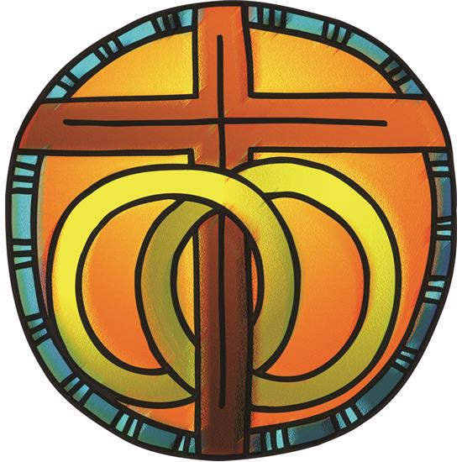

Marriage is a gift of God, intended for the joy and mutual strength of those who enter it and for the well-being for the whole human family. God created us male and female and blessed humankind with the gifts of companionship, the capacity to love, and the care and nurture of children. Jesus affirmed the covenant of marriage and revealed God’s own self-giving love on the cross. The Holy Spirit helps those who are united in marriage to be living signs of God’s grace, love, and faithfulness.
Marriage is also a human estate, with vows publicly witnessed. The church in worship surrounds these promises with the gathering of God’s people, the witness of the word of God, and the prayers of blessing and intercession. – Evangelical Lutheran Worship p. 286

Congratulations on your upcoming marriage! We are excited that you are considering celebrating your marriage at Lutheran Church of the Savior. Marriage in the church is different from a civil ceremony in that it is first and foremost a worship service. Our attention is drawn to God whom we ask to bless, guide, and strengthen our marriage. During the service we hear God’s Word, we offer God our prayers, and we ask the community of gathered witnesses to help support us. At LCS we believe marriage is between two people. We therefore joyfully welcome members of the LBGTQ+ community to celebrate their marriage in our church.
There are challenges to even the best marriages, and for this reason you should seek the guidance of your pastor who can share ways of working through problems and tension in your marriage. For this reason, if you would like our pastor to perform your marriage ceremony you must meet with him/her at least three times for marriage counseling however, the ultimate number of meetings is at the discretion of our pastor. This does not include the wedding rehearsal. The purpose of these sessions is:
- To establish a pastoral relationship as a resource early in the marriage.
- To strengthen the spiritual foundation of marriage.
- To plan the wedding service.
- To answer any questions on what a marriage in the church is.
If you are being married by our pastor, the form of worship will follow the current ELCA worship resources for weddings. Any variations from or additions to the order of service must have the prior approval of the pastor who has final say.
No marriage is conducted at Lutheran Church of the Savior by our pastor until the above outlined marriage counseling sessions have been completed by the couple. These sessions should be scheduled well in advance of the wedding date.

FOR YOUR HELP PLANNING
- All members of the wedding party must be sober during the wedding ceremony. If any member other wedding party is intoxicated the wedding ceremony will not go forward.
- No rice, birdseed, or other items are to be thrown in any part of the building or upon your departure from the building.
- No releasing of birds, butterflies, or other animals during or following the service.
- Decorations should be tasteful and appropriate for worship. They should not block any movement down the aisles, in the altar area, or in the chancel area.
- No pets or animals, except for service animals*, are permitted in our church building.
- Smoking is permitted outside the building at designated smoking areas. Cigarette butts are to be properly disposed of and not left out on the property.
- No smoking is permitted in any part of the church building this includes electronic cigarettes, vaping, and marijuana.
- Alcohol is permitted with advanced approval of the LCS church council.
- Beverages or food items are to be brought into the fellowship hall at the time of the rehearsal or the wedding day.
- Food and beverages are not permitted outside the fellowship hall.
- All marriages held at Lutheran Church of the Savior shall be officiated by either the pastor of LCS or another legally recognized officiant.
- Other clergy/officiants must have the permission of the LCS pastor to perform the wedding ceremony at LCS.
- Facilities are available at the church for the bridal party to dress.
- The wedding license and wedding certificate should be given to the pastor/officiant no later than the rehearsal dinner.
- If you would like a guest book stand/table LCS will provide one upon request.

ARRANGMENTS FOR WHICH YOU ARE RESPONSIBLE
- Prepare a date with the pastor/officiant as soon as possible. Inform him/her immediately of changes in your plans. The wedding service must fit into their personal schedule.
- Set an appointment for the first counseling/planning session. (Three to six months ahead of the wedding date is a good time frame.)
- Rehearsal date and time should be arranged at the first counseling session with the pastor/officiant.
- If you wish to have an announcement of your wedding in the LCS church bulletin and/or newsletter, bring it to the church office the preceding month for inclusion.
- You are responsible for engaging an organist, pianist, or other musicians. Don’t put this off—musicians are in high demand! The LCS organist has first call playing wedding services at LCS, please make arrangements with him/her as soon as possible. If you would like to use another organist, please make arrangements with the LCS organist as soon as possible. See the below musician fee section for more information.
- If you wish to use recorded music, our sound system is available. All music played during the worship service should be appropriate for the context of Christian worship. Music played during the reception should be family appropriate.
- If a printed program is prepared for the wedding, a proof copy should be submitted to the pastor/officiant before printing. The LCS church secretary does not type or print wedding bulletins, unless special arrangements are made. A fee may be requested.
- If you will be including Holy Communion during your worship service, you are responsible for providing the bread and wine, unless arrangements are made with LCS. The LCS pastor must approve your choice.
- Please ask your photographer and guests to refrain from flash photography and video recording during the wedding service (opening greeting to dismissal).
- If you wish to use a unity candle, or unity sand, during the ceremony, you must provide it. The LCS pastor must approve your choice.
- If you wish to have an aisle cloth, please arrange it with your florist.
- You are responsible for making arrangements with the church custodian or LCS representative to get into the building for any preparation before the service.

FEES
Use of the Church Building
There are no fees charged for the use of the church to active members who desire to be married here. The worship space should be returned to its normal arrangement for worship. If there are questions, they should be brought to the LCS pastor.

For non-members a donation is requested for use of the church. This shall be paid prior to the rehearsal.

Custodial services

The LCS custodian is available to assist with clean up following the wedding/reception. Clean up does not include set up or take down from events. You must speak with him/her in advance to make arrangements prior to the service. For all nonmembers a cleaning fee of up to $250, depending on services rendered, shall be paid to the custodian before the rehearsal.

Musicians

The LCS organist has first call playing wedding services at LCS, please make arrangements with him/her as soon as possible. If you would like another musician to play, or if you have other musicians you would like to incorporate into the service, please speak with the LCS organist as soon as possible. There is a fee of $150 is due to the organist at the rehearsal.

There will be a fee of $25 payable to the church organist to familiarize another organist
with our organ.

Sound system operator

If you are using recorded music please make arrangements in advance with LCS. You must return the sound system to its normal settings when the ceremony ends so it will be ready for worship.

Officiating clergy

The pastor of LCS shall officiate at weddings of church members unless other arrangements are made. Other clergy may participate at the discretion of the LCS pastor. Although there is no fee assessed by the pastor for officiating at a wedding to active members of LCS, many people give a monetary gift. While such a gift is appropriate, it is not a requirement. For non-members, there is an honorarium of $200 if the pastor of LCS will be officiating.

If you will have other clergy/officiant leading the wedding service you should speak with them in advance regarding any honorarium policies they have.

*A service animal is any dog that is individually trained to do work or perform tasks for the benefit of an individual with a disability, including a physical, sensory, psychiatric, intellectual, or other mental disability. Other species of animals, whether wild or domestic, trained or untrained, are not considered service animals. – From the Americans with Disabilities National Network (https://adata.org/factsheet/service-animals)

