Sunday, March 26, 2023 start shooting time 9:00 a.m.

PITA Daily Fee of $4.00 will be charged on your 1st event of each the day.

Event #4 Lowell Rogers 100 16 yard Targets

4 classes (A-B-C-D) $50 class winner, $25 Sub Jr., Jr., Lady, Vet, S. Vet.
ENTRANCE.……………………………….………….….…………………...$37.00
WSPITA FEES…..........................................................................................….$ 3.00
OPTIONS: Class Purse (Each class shooting for its own money. 1 pay each 7)…..….…$10.00
Lewis Class (3 classes) 60/40……………….…………………….………...$12.00

Event #5 Spring Yak 100 Handicap Targets

3 yardage groups 19-21.5, 22-24.5, 25-27 $200/100/50 each yardage group
ENTRANCE………………………………………………………......……$37.00
WSPITA Fee……….…………………….……………………. …..………$ 3.00
OPTIONS: WSPITA MAGNUM ………..………..………….………………………$12.00
Yardage Purse (19-21.5, 22-24.5, 25-27) 1 pay each 7 …………………...$10.00
25 Options ($2.50 on each 25, Divided 60/40)…………………...….…… $10.00
50 Options ($3.00 on each 50, Divided 50-30-20)……..….………….…. .$ 9.00
Lewis Class (3 classes) 60/40……………………………...…...……..…...$12.00

HAA Champion
High all around Events 3, 4 & 5

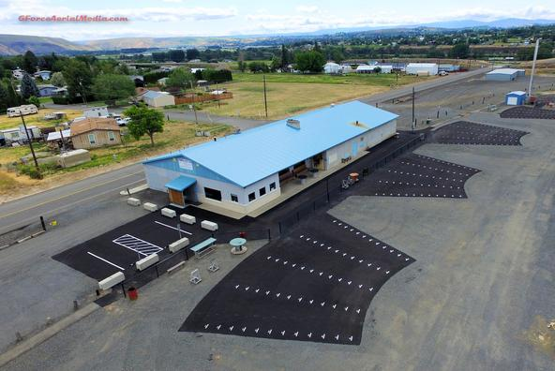

Trophies
Event #1 Roger Hanna Memorial
16 yard A-B-C-D Sub Jr, Jr, Lady, Vet, S. Vet
Event #2 Handicaps - Yardage Champs
Event #3 Doubles A-B-C-D
Event #4 Lowell Rogers
A-B-C-D Sub Jr, Jr, Lady, Vet, S. Vet
Event #5 Spring Yak Handicap Yardage Champs
HAA Champion

Presquad at Presquad.com Spring Yak

This certifies that the Yakima Valley Sportsmen’s Association has been authorized to hold a registered shoot on March 25-26, 2023. The PITA rules will govern the shoot and scores will be included in the official records.

GENERAL INFORMATION
ADA shooting pads and walkways.
PITA Magnums on WSPITA.com
Handicap yardage will be determined by ATA & PITA cards Longest yardage.
This is a PITA Shoot with ATA cross-registration available.
4 Trap banks will be used (8 traps) and a practice trap.
All Orange Top White Flyers
If ties for cash prizes occur, money will be divided high gun system.
All Trophies shot off. High All Around Events 3 - 5
No withdrawal of option money after an event begins.
Errors in score must be corrected before moving to the next post.
Squads will not be called. Please watch the on-deck board for your squad.
Practice trap will be open all day, both days. $6.00 per round.
No shells for sale.
All pay-offs will be made by mail.
Only Club Management will change traps.
RV hook-ups, $15.00 a day

The Burnout Pit will serve breakfast and lunch
Presquad at Presquad.com Spring Yak
Eye and Ears protection must be worn.
Any question call Paul Klingele 509-945-0604 or brakeman63@yahoo.com

