REGULAR MEETING
JANUARY 16, 2020
A Regular Meeting of the Town Board of the Town of Hampton, County of Washington and the State of New York was held at the Town Hall, 2629 State Route 22A, Hampton, New York on the 16th day of January 2020.

PRESENT: David K. O’Brien------------Supervisor
Tamme Taran----------------Councilwoman
Donald Sady-----------------Councilman
Andrea Sweeney------------Councilwoman
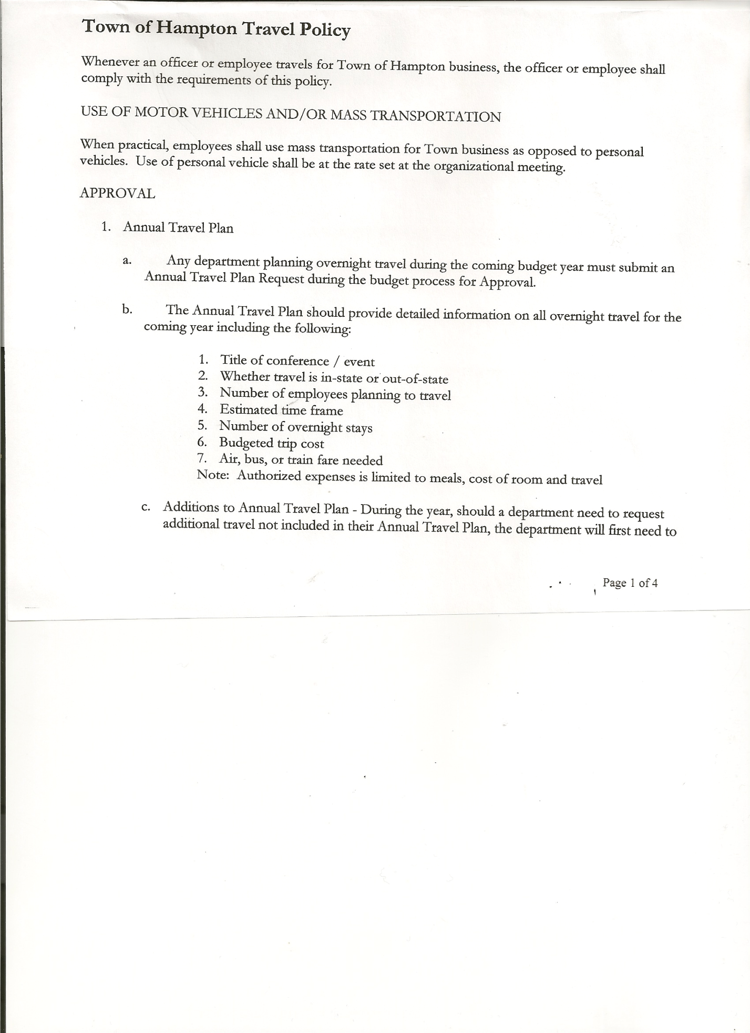
Michael Pietryka------------Councilman
Rebecca Jones---------------Town Clerk
Camilla Shaw----------------Tax Collector/Deputy Town Clerk
Herbert Sady, Jr.-------------Highway Superintendent

Planning Board Member(s): Bonnie Hawley

Also present: Artie Pratt and Leonard Reed

The Regular Meeting was called to order by Supervisor O’Brien at 7:30pm, followed by the Pledge of Allegiance. Location of Fire Exits were given. Quorum of board members present.

Supervisor O’Brien asked for a moment of silence in memory of Donald Rogers.

RESOLUTION NO. 5-2020
APPROVAL OF THE MINUTES
On a motion of Councilman Sady, seconded by Councilwoman Sweeney, the following resolution was ADOPTED: Ayes 5 O’Brien, Sady, Taran, Sweeney, Pietryka
Nays 0
RESOLVED, that the Regular Town Board Minutes for December 19th, 2019, the Special Town Board Minutes for December 30th, 2019 and the Special Board Minutes for January 2nd, 2020 are approved.

Larry Carman, Dog Control Officer submitted his report, which was read by Supervisor O’Brien, copy of report is attached for 12/18/19-01/12/20

Camilla Shaw, Tax Collector – about 215 parcels have been paid. Submitted December 2019 and End of Year (2019) reports to the Board. Also submitted Bank Statement to the Board for review and signatures.

Bonnie Hawley, Chair gave Planning Board Report…
Copy of report is attached
- Next meeting will be January 22nd, 2020 @ 7:00pm at the Town Hall.

Herbert Sady, Jr., Highway Superintendent submitted his report, copy of which, is attached.
- 2020 Road Projects is also attached.
- John Thomas may be interested in doing some culvert work for the Town.
- Received figures for Extended Warranty on the 2020 Western Star from Tracey’s….
$2450.00 5 year 100,000 miles or
$4315.00 7 year 100,000 miles
Herb will check to see if labor is included in above figures.
TOWN BOARD MEETING
JANUARY 16, 2020 PAGE 2

SUPERVISOR’S REPORT/COUNTY UPDATES/COMMUNICATIONS

RESOLUTION NO. 6-2020
BUDGET AMENDMENTS-HIGHWAY FUND
On a motion of Councilman Sady, seconded by Councilwoman Taran, the following resolution was ADOPTED:
By Roll Call Vote: Supervisor O’Brien AYE
Councilman Sady AYE
Councilwoman Taran AYE
Councilwoman Sweeney AYE
Councilman Pietryka AYE
RESOLVED that, the following Budget Amendments to the Highway Fund are approved:
Increase Consolidated Highway Account DA3501 in the amount of $20,852.37 (Income)
Increase Capital Outlay Account DA5112.2 in the amount of $28,191.77 (Expense)
Increase Miscellaneous (Brush&Weeds) CE Account DA5140.4 in the amount of $1,766.98
(Expense)
Increase Uniforms Account DA9089.8 in the amount of $37.83 (Expense)
Decrease General Repairs Personal Services Account DA5110.1 in the amount of $6,072.83
(Expense)
Decrease General Repairs CE Account DA5110.4 in the amount of $3,071.38 (Expense)
Increase Snow Removal CE Account DA5142.4 in the amount of $4,139.63 (Expense)
Decrease Hospital & Medical Insurance Account DA9060.8 in the amount of $4,139.63
(Expense)
RESOLUTION NO. 7-2020
BUDGET AMENDMENTS-GENERAL FUND
On a motion of Councilwoman Taran, seconded by Councilman Sady, the following resolution was ADOPTED:
By Roll Call Vote: Supervisor O’Brien AYE
Councilman Sady AYE
Councilwoman Taran AYE
Councilwoman Sweeney AYE
Councilman Pietryka AYE
RESOLVED that, the following Budget Amendments to the General Fund are approved:
Increase Fines and Forfeited Bail Account A2610 in the amount of $6,882.50 (Income)
Increase Mortgage Tax Account A3005 in the amount of $4,668.99 (Income)
Increase Interest & Penalties on Real Property Taxes Account A1090 in the amount of $717.07
(Income)
Increase Dog Licenses Account A2544 in the amount of $411.00 (Income)
Increase Non-Property Tax Dist by County Account A1120 in the amount of $279.79 (Income)
Increase Justice CE Account A1110.4 in the amount of $6,968.35 (Expense)
Increase Supervisor CE Account A1220.4 in the amount of $437.00 (Expense)
Increase Tax Collector CE Account A1330.4 in the amount of $237.11 (Expense)
Increase Town Clerk CE Account A1410.4 in the amount of $355.41 (Expense)
Increase Central Printing & Mailing CE Account A1670.4 in the amount of $1,695.68 (Expense)
Increase Unallocated Insurance Account A1910.1 in the amount of $703.92 (Expense)
Increase Garage CE Account A5132.4 in the amount of $2,561.88 (Expense)

TOWN BOARD MEETING
JANUARY 16, 2020 PAGE 3

RESOLUTION NO. 8-2020
APPROVAL OF SUPERVISOR’S MONTHLY REPORT
On a motion of Councilman Sady, seconded by Councilwoman Sweeney, the following resolution was ADOPTED: Ayes 5 O’Brien, Sady, Taran, Sweeney, Pietryka
Nays 0
RESOLVED that, the Supervisor’s Monthly report be accepted as submitted for DECEMBER
11/30/19 12/31/19
ACCOUNT BALANCE RECEIPTS DISBURSEMENTS BALANCE
General Fund $ 52,643.20 $ 4,752.13 $ 17,544.50 $ 39,850.83
Highway Fund $ 75,813.45 $ 64,288.41 $ 130,189.46 $ 9,912.40
Equipment Reserve $ 29,853.15 $ 1.27 $ 0.00 $ 29,854.42
Fire #1 $ 20,808.00 $ 0.00 $ 20,808.00 $ 0.00
Fire #2 $ 3,878.00 $ 0.00 $ 3,878.00 $ 0.00
Cemetery $ 1,725.55 $ .95 $ 0.00 $ 1,726.50
Totals $184,721.35 $ 69,042.76 $ 172,419.96 $ 81,344.15
All Board Members present signed Supervisor’s Report.

2019 ANNUAL AUDITS:

RESOLUTION NO. 9-2020
END OF YEAR COURT AUDIT
On a motion of Councilwoman Taran, seconded by Councilwoman Sweeney, the following resolution was ADOPTED: Ayes 4 O’Brien, Taran, Sweeney, Pietryka
Nays 0
Abstained 1 Sady
RESOLVED, to accept the Court Audit for 2019.

RESOLUTION NO. 10-2020
END OF YEAR AUDIT- TAX COLLECTOR
On a motion of Councilman Sady, seconded by Councilwoman Sweeney, the following resolution was ADOPTED: Ayes 5 O’Brien, Sady, Taran, Sweeney, Pietryka
Nays 0
RESOLVED, to accept the Tax Collector Audit for 2019.

RESOLUTION NO. 11-2020
END OF YEAR AUDIT – TOWN CLERK
On a motion of Councilwoman Taran, seconded by Councilman Sady, the following resolution was ADOPTED: Ayes 5 O’Brien, Sady, Taran, Sweeney, Pietryka
Nays 0
RESOLVED, to accept the Town Clerk Audit for 2019.

RESOLUTION NO. 12-2020
END OF YEAR AUDIT – CHIEF FISCAL OFFICER (BOOKKEEPER)
On a motion of Councilwoman Taran, seconded by Councilwoman Sweeney, the following resolution was ADOPTED: Ayes 5 O’Brien, Sady, Taran, Sweeney, Pietryka
Nays 0
RESOLVED, to accept the Chief Fiscal Officer (Bookkeeper) Audit for 2019.

TOWN BOARD MEETING
JANUARY 16, 2020 PAGE 4

RESOLUTION NO. 13-2020
AUTHORIZE TOWN WIDE PROPERTY REVALUATION

MOTION BY: COUNCILMAN DONALD SADY
SECONDED BY: COUNCILWOMAN TAMME TARAN

TITLE: RESOLUTION AUTHORIZING FOR ASSESSOR TO UNDERTAKE A TOWN
WIDE PROPERTY REVALUATION WITH THE PROJECT BEING
COMPLETED IN 2021.

BE IT RESOLVED that the Hampton Town Board hereby authorizes and directs the Town
Assessor to undertake a Town Wide Property Revaluation Project for the purpose of updating and correcting the Town’s Assessment Rolls, and that the project shall be completed for the 2021 Final Assessment Roll and such cost for the project shall not exceed $16,000.00

DATED: January 16, 2020
ROLL CALL VOTE: Supervisor O’Brien AYE
Councilman Sady AYE
Councilwoman Taran AYE
Councilwoman Sweeney AYE
Councilman Pietryka AYE

RESOLUTION NO. 14-2020
RETIREMENT CALENDARS FOR ASSESSOR, TOWN CLERK AND TOWN JUSTICE
On a motion of Councilwoman Taran, seconded by Councilwoman Sweeney, the following resolution was ADOPTED: Ayes 5 O’Brien, Sady, Taran, Sweeney, Pietryka
Nays 0
RESOLVED, to accept (3) months Records of Activities from Victoria Hayner, Town Assessor; Rebecca Jones, Town Clerk and Darlene Sady, Town Justice for Retirement purposes.

RESOLUTION NO. 15-2020
STANDARD WORKDAY and REPORTING RESOLUTION
On a motion of Councilman Sady, seconded by Councilwoman Taran, the following resolution was ADOPTED: By Roll Call Vote: Supervisor O’Brien AYE
Councilman Sady AYE
Councilwoman Taran AYE
Councilwoman Sweeney AYE
Councilman Pietryka AYE
RESOLVED, that the Standard Workday and Reporting Resolution for Elected and Appointed Officials (RS2417-A & RS2417-B) be approved. Copy is attached.

RESOLUTION NO. 16-2020
TOWN HALL USE
On a motion of Councilman Sady, seconded by Councilwoman Sweeney, the following resolution was ADOPTED: Ayes 5 O’Brien, Sady, Taran, Sweeney, Pietryka
Nays 0
RESOLVED, to approve the request from Bonnie Hawley to use the Town Hall on Sunday, January 19th, 2020 for a Hampton Roundtable Meeting.
TOWN BOARD MEETING
JANUARY 16, 2020 PAGE 5

RESOLUTION NO. 17-2020
AUDIT OF CLAIMS
On a motion of Councilwoman Taran, seconded by Councilman Sady, the following resolution was ADOPTED: Ayes 5 O’Brien, Sady, Taran, Sweeney, Pietryka
Nays 0
RESOLVED that the bills have been reviewed by the Town Board and are authorized for payment in the following amounts.
General Fund No. 1 through No. 16 $ 7,142.13
Highway Fund No. 1 through No. 11 $ 12,823.25
Total both funds $ 19,965.38

On a motion of Councilwoman Sweeney, seconded by Councilman Sady, the meeting adjourned at 8:16pm All in favor Aye.

Respectfully submitted,

Rebecca S. Jones, RMC
Town Clerk

