Improve Conversions on Landing Pages

Landing pages are an inseparable part of the web browsing experience: we have all visited one at some point, whether or not we were conscious of the fact. Whenever you click on an online ad, register for a webinar, download a survey or a white paper, it’s likely that a landing page facilitated your experience. It’s not surprising, then, that these types of pages are an essential tool for a marketer, as they help move the potential lead down the sales funnel, converting a visitor into a customer.

What is a landing page?
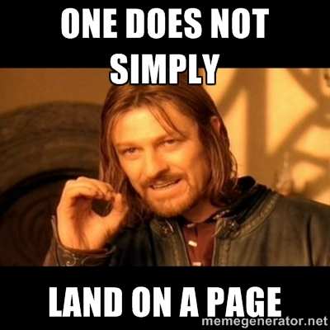
In the realms of marketing and advertising, landing pages are the web pages which are accessible exclusively through a link or a button, and built to serve a specific objective. Social media landing pages, which we will focus on in this post, are commonly accessible by call-to-action buttons on paid social advertising, among other times of digital ads.
Elements of landing pages include a brief description of the offer, a call to action, and a preview of the product or service. In an ideal landing page, both the copy and the page design converge on a single purpose: to drive the customer to a specific action, such as downloading a white paper or registering for a webinar.
Almost as important as knowing the definition of a landing page is knowing what the landing page is not. A landing page should not just be the homepage of your website—there are too many buttons to click, options to choose from, and products and services offered. If the goal of your social ad is to increase traffic to your domain, consider other options and leave landing pages for what they do best—help acquire sales leads.

Why does my social media ad need a landing page?
It might seem like a lot of work: first, you have to toil away at your social media advertising strategy, and now it turns out that’s not enough? In fact, landing pages can help you support the customer experience in areas that ads often fall short: they provide more context for the value add of the initial offer, capture more information about your customers, and allow you to zero in on a specific product or offer.
Landing pages help businesses increase conversions on the social media ads by honing in on the juicy details of the offer. This helps make the ads more effective, since most of them are limited by character and image size on the host social network—the landing page helps elaborate more on the value of the initially advertised offer. It also segments the value proposition into several easy-to-understand parts: for example, your social ad may contain a call-to-action button that simply says “Learn more,” which takes the user to a landing page with an added offer of a free trial. However, it’s important to be consistent with your offers across the advertisements and landing pages, even if the offer is segmented into two or three parts.
Landing pages also provide a better social advertising user experience: a user who noticed your ad while browsing their Facebook News Feed will have a dozen distractions—friends’ updates, photos, birthday and event notifications, etc. By taking the user to a dedicated page, you are removing all the extra noise and helping them focus exclusively on your offer.
Another advantage of using landing pages for social media ads is their increased capacity to capture leads. Major social media networks offer ad analytics for businesses, which include the user’s location, gender, and age group. But capturing the specifics, such as their name, occupation, and email address is a different story. This is where landing pages come in: most of them include a lead capture form that encourages users to fill out their first and last names, email address, company they work for, and their job title. Not only does this help marketers get a better picture of their potential customers, but it also presents an opportunity to contact these customers with similar offers in the future. However, be careful about how much you ask of your customers—the general consensus among conversion experts is that the more information you ask to disclose, the lower your conversion rate will be.

9 tips on using landing pages for your social ads
There are many elements to a landing page, and the best way to find out what helps your business achieve the best conversion rates is to test, test and test. Keep this in mind when you consider implementing any of the following tips—these practices have been effective for other businesses, but your product or service may call for something completely different. Don’t be afraid to trust your instinct, but make sure it’s always backed by conversion data.

1. Keep your copy consistent across ads and landing pages
The last thing you want to do is mislead a potential customer with inconsistent offers. Since the landing page works best as an extension of your advertising, make sure the copy is consistent in both the ad and the landing page. For example, if you’re drawing people in with a 2-for-1 offer in the social media ad, your landing page should give more details on how the customer can get the 2 items for the price of 1.
This social media ad popped up in my News Feed, and lead me to the shop’s homepage—but the offer is site-wide, which makes one of the few exceptions to the “no homepages as landing pages” rule.

2. Acknowledge the social media referral on the landing page
The way brands communicate with customers on social media is often different from any other communication line—there’s room to show off personality, have a sense of humour, and stray off the beaten path for different approaches to interaction. Thus, it’s advantageous for brands to address the referral source on the landing page, especially if you know the customer will be arriving there from a social network. This can be done by including the brand’s official Twitter handle or Facebook page in the body of the landing page copy, or simply open with a line that mentions the network.
This is especially helpful for brands involved in social media marketing or e-commerce, since they know their customers will also likely to look for profit from social channels. Take a look at the way Shopify frames their landing page originating from a Facebook ad:
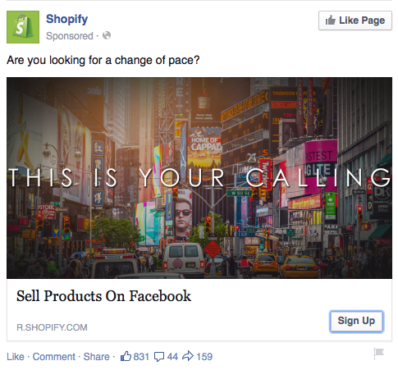

Shopify’s Facebook ad

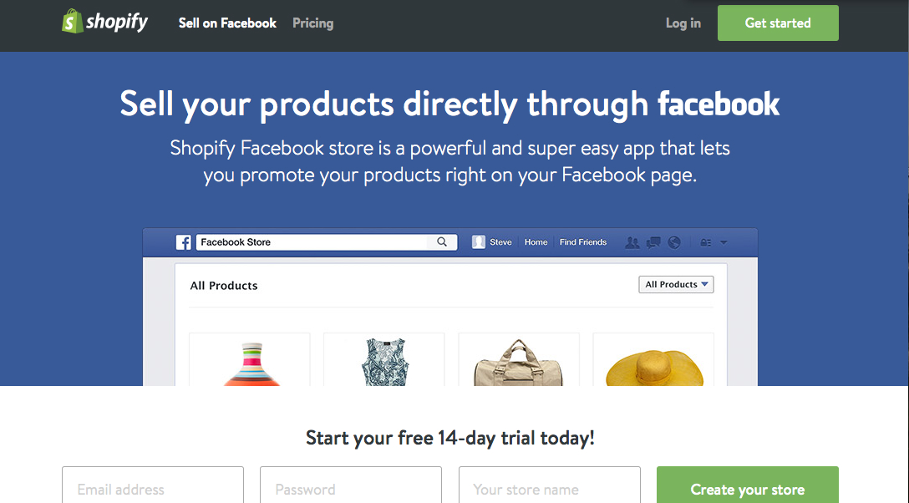

Shopify’s landing page originating from the Facebook ad
In addition to directly addressing the way the Shopify app can be helpful for Facebook marketing, the landing page also contains clever design cues that tailor it to the network. The page’s colour palette is congruent with Facebook’s colour, and the header is designed to look similar to a Facebook search bar.

3. Place essential page elements above the fold
The central part of the landing page is the call to action button—whether you’re encouraging the customer to start a trial, download an asset, or sign up for a webinar, all the design and copy are designed with the single purpose of driving the user to click the button. In order to accomplish this, design your page to have all important elements “above the fold,” or in the portion of the page that is visible in a browser window when the page first loads. If you’re not sure if your landing page presents the information right away, look at the portion above the fold and ask the following questions, from a user’s perspective:
- Where am I? What’s the purpose of this page?
- Do I know what they’re offering?
- Does this page explain what I have to do in order to get the offer?
The first question might seem a bit silly, but you’d be surprised at how many landing pages fail to identify their brand association. Whether it’s a logo, recognizable brand colours, or a headline that mentions your company, your ownership of the page should be explicit. Take a look at the ‘above the fold’ portion of the landing page for our latest white paper on Social Governments:

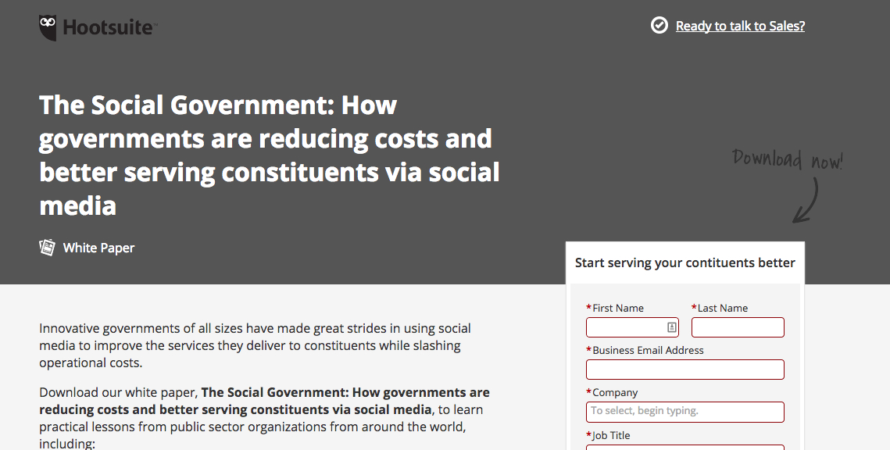

Once the page first loads, I can see that this is a Hootsuite property, I know it’s about social media strategies for government bodies, I can glean that it offers a white paper from the little icon underneath the headline, and I can read the first couple of lines of its description. While I can’t see the call to action button, I see an arrow that shows me how I can access the advertised resource, and the top of the lead capture form. Thesedirectional cues are a great trick to draw the user’s eyes to the important elements, even if they end up below the fold.

4. Don’t reuse copy for multiple ads or landing pages
Since landing pages are such an important part of the lead conversion process, your company needs to pay special attention to the text on the page—which can be a challenge if you don’t have a dedicated copywriter. Thankfully, there are plenty of online resources that can help you optimize copy for the purposes of your landing page. Plus, if done right, your word count for landing page copy shouldn’t be that high anyway.
The main thing to remember is to tailor each landing page to the value prop of social media ads that refer to it, as well as the offer. Don’t reuse copy from other landing pages, even if the chances of the same customers seeing the copy twice are low. Not only does it appear lazy, but it can also hurt your conversion rates, especially if the copy is inconsistent with the offer from the social media ad.

5. Focus your landing page on the value add for the customer
The purpose of landing pages is to gather more leads, but all elements of the page need to focus solely on how the offer can help the visitor, not your business. As such, it’s important to highlight the value of the asset or the offer every step of the way—whether it’s done by cleaning up the copy and removing any jargon-heavy parts, using more possessive pronouns, or including customer testimony. James Scherer of Wishpond advises marketers to “[h]ome in on what the visitor gets, not what they should do.”
For example, if you are designing a CTA button for an offer concerning a cleaning product, encourage customers to “Clean up my kitchen!” instead of “Buy now.”

6. Optimize your call to action button
The CTA button is the crown jewel of your landing page: it’s what the user will be looking for when they first arrive on the page, because it’s what gets them the asset or offer promised in the social media ad. So make sure your CTA button is clearly visible, ideally above the fold, and the copy is consistent with the offer. For example, if the purpose of the landing page is to get users to download a white paper, your CTA button copy should have a variation of “Download now” or “Read now.”
When it comes to the landing page’s CTA buttons, the testing rule is more important than anywhere else on the page. Test the colours of the button, the font of the letters, the actual call to action text, and directional cues around the button itself. You might be surprised what gets you that three-digit spike in conversions—sometimes, it’s something as little as changing a possessive pronoun!

7. Consider trust badges
If the conditions of receiving an offer ask the user to disclose personal information, it’s important that the customer feels safe to do so. In landing page design, this means including trust badges and displaying them in a prominent spot. Ideally, you want these badges to be close to the call to action button, so the customer is reminded of your trustworthiness as a final motivation to consider your offer.
You can also mention your partners or clients that belong to an industry that may be similar to the visitor’s occupation (especially if you target your social advertising to a certain demographic), as a way to show off recommendations from professionals in that field.

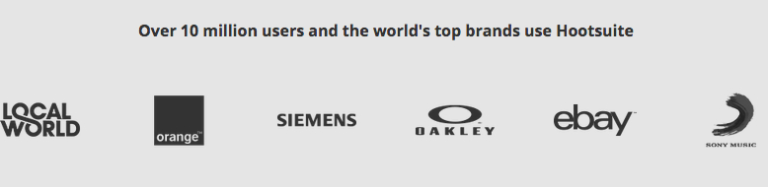
Be aware of the design of these badges: you want to follow brand standards of security brands, as well as your clients and partners, but avoid piling in too many logos or conflicting colours. This might actually take away from the overall impression of your landing page, and that’s the opposite of the effect you want to achieve.

8. Optimize your design assets
In the same vein as the text on the landing page, all design assets should show off your offer in the best light without being too excessive. Follow a simple colour palette, don’t add too many images or videos, and don’t overdo it on the directional cues. With landing pages, less is more—try to include as little extra elements as possible, but make sure all of them contribute to the main purpose of the landing page.

9. Test, test, test
Remember how I said that testing is the most effective strategy to increase conversion rates? Before you implement changes based on any of the tips above, run an A/B testto see if these factors actually influence conversion on your brand’s landing pages. At the very least, test two different versions of the landing page to see how the different changes affect your numbers. However, according to WordStream founder and CTO Larry Kim, if you want to break the top 10% of winning landing pages, the more pages you test, the better are your chances of drastically increasing conversion rates. Kim recommends testing ten (!) landing pages with different offers, messaging and flow to find the winning combination for your business. So, suffice to say, designing landing pages is not for the faint of heart—but if it helps you gather more high-quality leads, these efforts will surely pay off.
__________________________________________
Source: Hootsuite / April 16, 2015
Author: Olsy Sorokina
Retrieved from: https://blog.hootsuite.com/how-to-use-landing-pages-for-social-media-ads/?utm_source=twitter&utm_medium=owned_social&utm_campaign=social_hootsuite&Last_Associated_Campaign__c=701a0000002JXk5&hootPostID=05b730120f6f12e9a24651828e3243de

