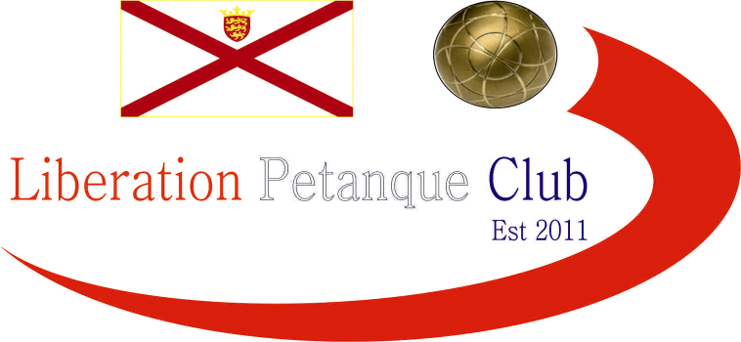

Liberation
Charity Triples Open
2014

With only 8 teams taking part this year some of the bigger teams would have been looking for an easier ride to the final but one team made it a very interesting tournament.

That team was St Mary’s, Richard Sowerby, Keith Baddeley and Gary Cowburn who in round one, despite a late scare (in more ways than one!) beat last years winners Ross Payne, Toby Northern and Brian Harris (Steel Hearts) 12-10 as time ran out.

PC Pes boys (and Doubles Island Triples Champions) Andrew Bellamy, Callum Stewart and Matt Pinel started off in style beating the Carrefour team of Keith Boleat, Helene Retrosi and Brian Corbel 13 – 1.

Alan Lahiffe, Stephen Leathem and Matthew Schofield (Only Boules & Horses) beat Martin and Teresa Koradi and Bob Hillis (OAP’s), with Nathan Wheller, Dawn Buckley and James Gennoe (D J & Nathan) over coming Andy & Lorna Limbrick and Alan Huelin (Pied Tanque).

Round 2 saw St Mary’s suffer the worst possible defeat 13 – 0 to Carrefour, Only Boules & horses had a surprise victory over the PC Pes boys and Steel Hearts got back to winner ways over DJ & Nathan.

St Mary’s couldn’t make their mind up as fresh from a 13 – 0 defeat then beat PC Pes 13 – 2!!! Compatriots Pied Tanque and Only Boules & Horses had a very close game with the later just edging it 13 – 11 for 3 wins out of 3.

Another impressive win for Carrefour 13 - 2 over DJ & Nathan was more than matched by Steel Hearts win over OAP’s 13 - 1.

With the top four qualifying for the semi finals even 2 wins would get a team through so a decent result from St Mary’s would have seen them qualify, but they suffered their 2nd 13 – 0 of the day losing to DJ & Nathan. 2 Fannies in one tournament, yet the beat myself, Ross & Brian and Andrew, Callum & Matt!! Figure that one out.

Only Boules & Horses won 4 out of 4 this time over Steel Hearts and Carrefour won their 3rd match against the OAP’s and with a final flourish PC Pes boys made the top 4 with a 13 – 0 win over Pied Tanque.

1st Only Boules and Horses 4 wins +20
2nd Carrefour 3 wins +17
3rd Steel Hearts 2 wins +15
4th PC Pes 2 wins +9
5th DJ & Nathan 2 wins -1
6th St Mary’s 2 wins -13
7th Pied Tanque 1 win -17
8th OAP’s 0 win -30

The Semi Finals saw Only Boules & Horses again beat the PC Pes boys, but this time a lot more comfortably. Carrefour and Steel Hearts was a much closure affair with scores tied at 7 – 7 beat the Hearts pulled away to seal a final spot.

1st Only Boules and Horses 13 v 3 PC Pes 4th
2nd Carrefour 8 v 13 Steel Hearts 3rd

PC Pes boys sealed a medal with ease over Carrefour with their second 13 - 1 win over them after also beating them 13 – 1 in round 1.

The final was very close and very tense with Only Boules & Horses taking and early advantage before Steel Hearts came back into it. It was tied precariously at 10 – 10 and with Toby putting his second boule right on the coche, for once Alan Lahiffe missed two attempts to fire the boule out. Matthew Schofield then tried to put his teams last boule at the back of the terrain in case Steel Hearts tried to fire their own boule (and the coche with it) but unfortunately gave it too much weight and his boule went out of play.

So with four boules to play and needing three points the win Ross Payne fired his teams own boule and with enough weight to also take the coche out to get the 3 points needed win the tournament in style as the Steel Hearts of Ross Payne, Brian Harris and Toby Northern retained their title.
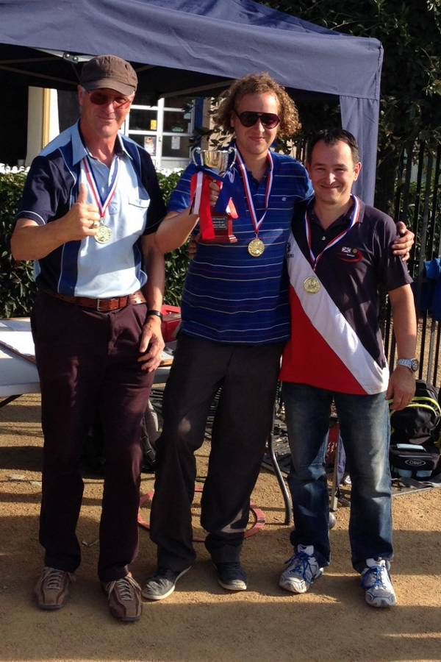
Thank you to those who took part and those who donated, a total of £150 was raised towards Wessex Heart Beat and Variety (Jersey).

Kind Regards
Toby
Chairman
Liberation Petanque Club

 | 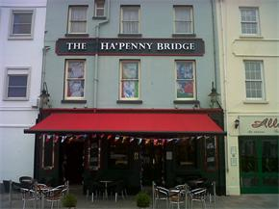

www.elementsmediajersey.co.uk

