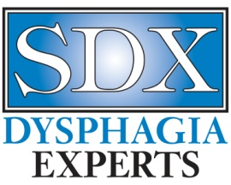

Dear Staff,

SDX supports the use of patient consent forms in accordance with best-practice standards. This provides you and your facility with verification of the education provided to your patient and/or their caregivers regarding the SDX FEES procedure.

SDX believes that information is a necessary part of any rehabilitation procedure. Every patient has the right to education regarding their therapeutic plan of care. More information regarding patient consent can be found at asha.org under Role of the Speech-Language Pathologist in the Performance and Interpretation of Endoscopic Evaluation of Swallowing: Guideline (2004).

Please complete the Patient Consent Form with the patient and/or caregiver(s) prior to their scheduled FEES. SDX does not require a copy of the completed form but we do recommend that it be filed in your patient’s medical chart in the appropriate section.

Thank you for your continued business. We appreciate working with you and your patients. Any questions, please call or email Katrina Woodward at 860-573-0120 or Katrina@swallowingdiagnostics.net .

Respectfully,
Katrina L. Woodward, MS, CCC-SLP, CDP
Vice President, SDX Dysphagia Experts

