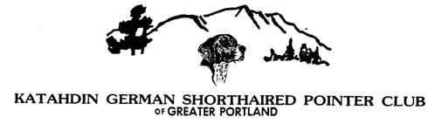

**SENIOR/MASTER**

**MOCK HUNT TEST**

June 29th- Sharpe’s Farm, Hopkinton, NH , 8:00am

Save the date for this wonderful opportunity to TRAIN on “test” grounds! Judges will advise and answer any questions you have “in real time!” This will be run just like a hunt test, we will have a running order, you will run in braces, and have a time limit. entries are limited.

Entry fee-$45,

enter by June 25th, 8:00pm to Cassandra Tompkins, [mydogdays@comcast.net](mailto:mydogdays@comcast.net) or text 978-895-9803

Directions there will be no lunch served, so please bring food for

RT 89 to exit 5, rt9/202 west , just after yourself, and water for your dog as well

The end of the ramp, take immediate

First right onto Little Frost Rd. Turn left,

Follow to the end, turn right, you’ll see

A yellow gate, follow to end