

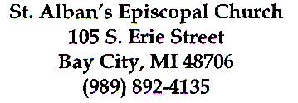
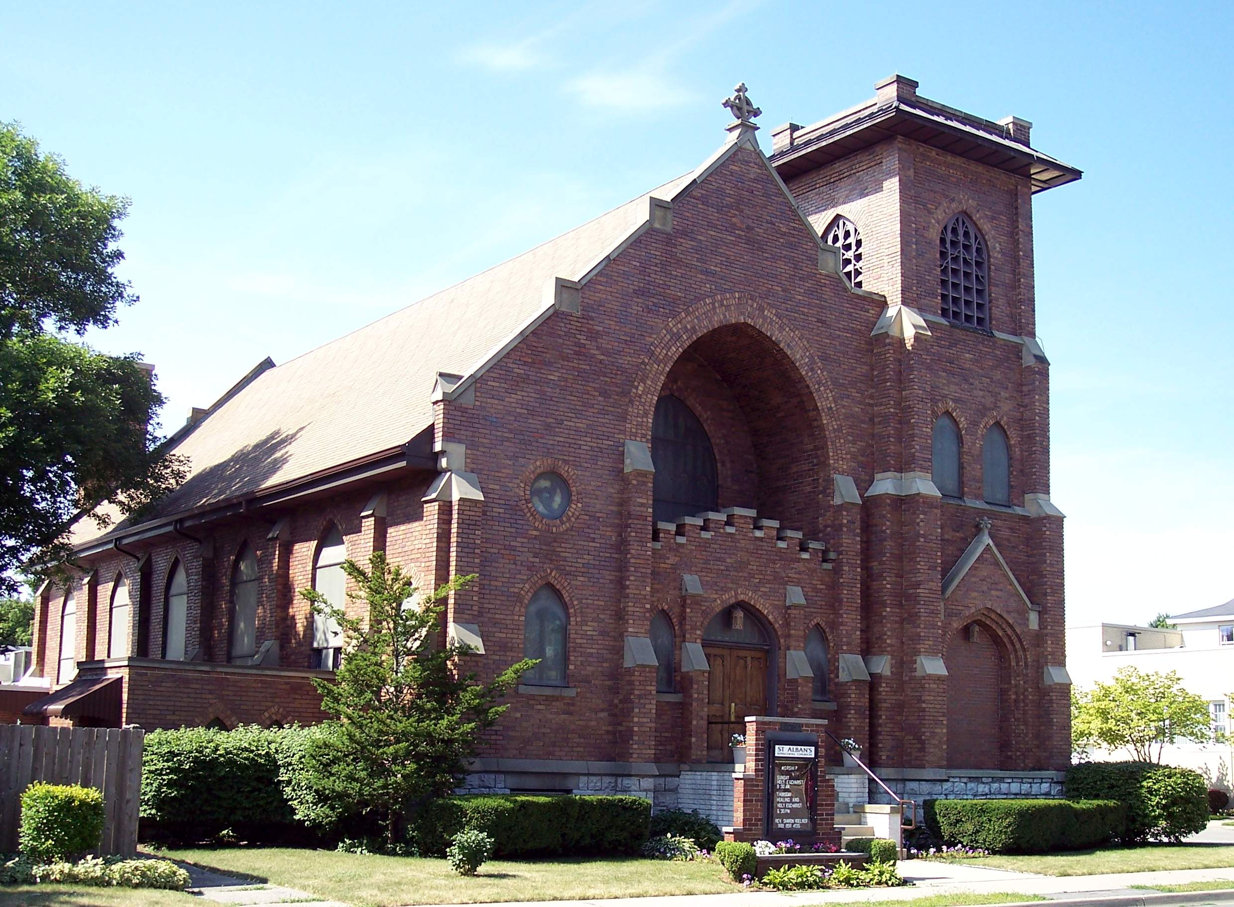

March/April
2014

www.stalbans-baycity.org
CHARLEY’S CORNER
Hi. I’m Charley.
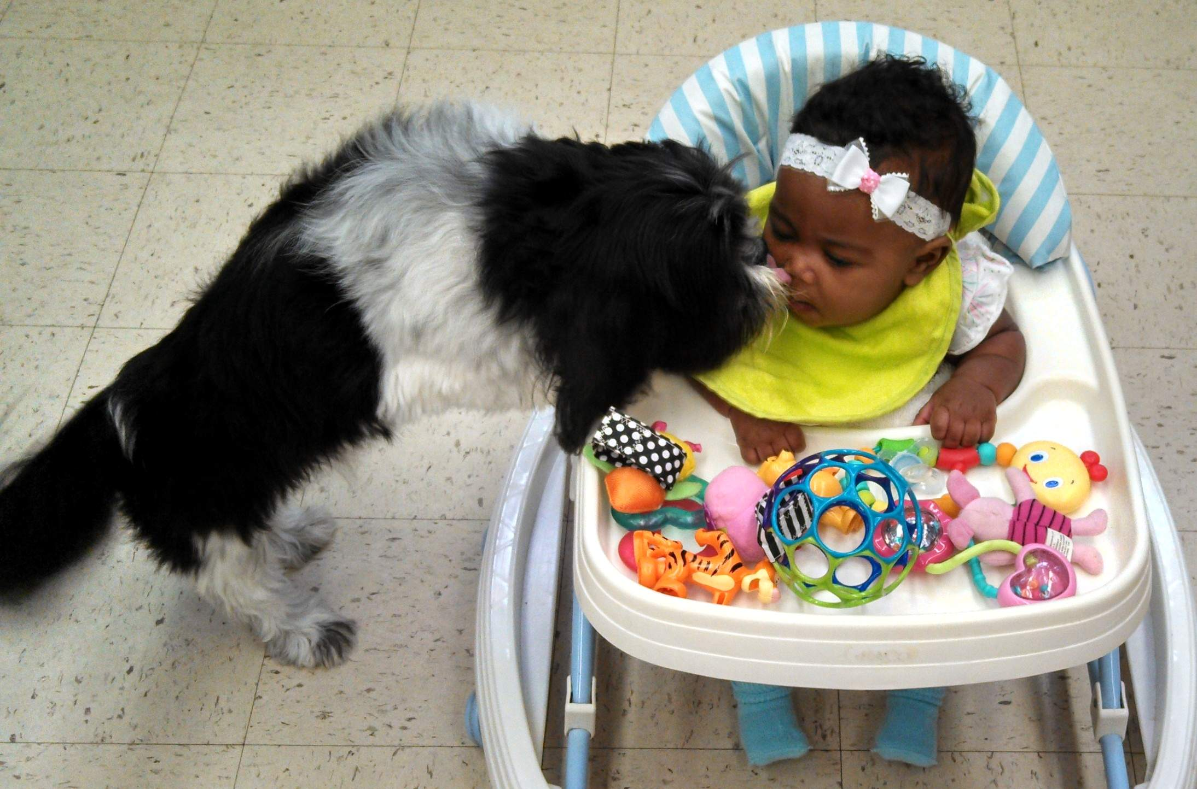
Just lately I’ve noticed that there’s been a lot of stuff going on around my church. Sometimes I’ve been so busy that I haven’t been able to check out everything out and still get my naps into my daily schedule.
Every Tuesday morning I’m at Bible study to greet everyone and to see what snacks they brought with them. You know, a little taste of a doughnut is a wonderful thing. Mom says I shouldn’t eat them, but I think that a little smidgen won’t hurt…and I really do love them! (Mom will never know!)
A few weeks ago I had my picture taken for the new church directory. At first it was fun to be fussed about, but a dog can smile only so long and then I got bored with the whole thing. I guess I must have smiled pretty because people were saying how nice my picture turned out.
But the big news…..we had a murder in the church! I know I’m not supposed to talk about this, but sometimes there are things that a dog just can’t keep to himself. It was a short time ago…don’t know if it was a dark and stormy night…when the dastardly event occurred. Fred the Mouse had been living in Mom’s desk drawer but made the mistake of raiding her snack pantry in the corner of the drawer. That was motive…Fred was sentenced without a trial and met his fate in the mouse trap. Fred is dead.
On a happier note, the sun is out and maybe it will melt the snow so I can do some gardening…it’s so much fun to dig in the dirt!
Love you all!

A View from St. Alban’s
Mother Sharon Voelker

Usually my Christmas poinsettias die off in January and that’s my signal that everything about Christmas is over…the decorations should be put away and it’s time to get into a quiet place to make it through the winter. This year, however, all of my poinsettias are still living! Apparently my skill to kill a houseplant has diminished, or maybe these plants have super survival skills!
Does that mean that winter is never going to end? Will we still have snow in July? Maybe I should stop watering them?? And then I wonder…if I keep watering them, can poinsettias and Easter lilies be compatible?
Maybe this is another lesson in patience for me. It has been said that I tend to be a little lacking in this virtue. Since I can’t get outside to putter around in the yard yet, maybe this is when I should quiet my mind and prepare myself for Lent and Easter. Lent is a good time for me to plant seeds of hope in preparation for a glorious Easter garden. What better way could I spend the last days of winter?
Let me know if you have ever had a poinsettia and Easter lily living at the same time!
Faithfully,
M. Sharon


Last Sunday after Epiphany Year A
“Listen to him!”
Can you hear God’s voice roaring over Peter, James, and John? Such a simple command… given with Godly emphasis to ensure that these followers of Jesus know that Jesus is someone special…someone remarkably unique. Jesus is not just another preacher or healer…he is of God! Listen to what he says.
Listening is something most of us don’t do well, myself included. We are too busy, too distracted, most of the time to focus our attention on the words we hear spoken. We get the general idea of what’s being said and then move on to something that’s more important at that particular time. We fail to get the message because we don’t take the time to listen. And when we don’t get the message, we don’t learn and we can easily lose our direction.
We are approaching Lent…that season in the church year when we devote ourselves and our minds to self-examination and sacrifice. This coming week many of us will be pondering, “What will I give up for Lent?” The list of things is usually quite predictable: I will give up…chocolate, or chewing gum, or smoking, or going to the movies, or teasing my little sister or brother. Sometimes we promise make a special effort to pray more often, to feed the family pet without being asked, to read a good book. We have learned that Lent is the time for us to make a sacrifice. This is another of those man-made “rules” that we obey in the church. There is no instruction in the Bible that requires us to do this. It is something we have created…and it does have meaning for us. There is nothing wrong in making a sacrifice for Lent.
The Jews of our Bible were required to make sacrifices. Their sacrifices were not about giving up, but rather, about giving to. Their sacrifices were given gratefully to the temple so that God would show his favor upon them. And Jesus’s sacrifice of his own life was given gratefully so that God would show his favor upon us.
The purpose of a sacrificial Lent has puzzled me for a long time. Yes, I understand the premise of taking away something I enjoy to be a personal sacrifice. Yet I find it difficult to equate my denial of chocolate for forty days with the sacrifice Jesus made.
Lent is a penitential season. It is to be a quiet time…a time for listening. A time for personal reflection, for opening our hearts to God, for asking forgiveness for those things that have offended God and those who are around us. It is a time for us to examine our souls and to honestly evaluate our thoughts and our actions. It is a time for us to consider how we can become the person God wants us to be.
Yes, Lent can be a season of personal sacrifice. But rather than having our Lent be a time of giving up, let us make it a time of giving to. Already we have made Lent a time for stepping outside our comfort zone…to make us aware that we are deliberately creating a temporary hardship upon ourselves by denying ourselves something we enjoy.
I encourage all of us to leap outside our comfort zones for this coming Lent. In addition to maintaining a prayerful Lenten season, let us also do something out of the ordinary. Instead of reinstating our traditional season of denying ourselves of something that we find to be pleasurable, let us challenge ourselves to do something that is difficult for us. Will it be to mend a broken relationship?...to make a difficult decision and then follow through with it?...to help someone who isn’t very likeable?... to reach out to someone who has no friend? ...or perhaps a wrong that has been created needs to be made right? Let us listen to our hearts…and let us listen to Jesus for his direction.
I’m sure that every one of us can find opportunities for “giving to” in this Lenten season. Jesus has given us many examples to choose from, and God has told us to listen to him. Let us not only listen to what Jesus has told us, but also to act in the ways he has taught us.
Jesus gave himself for us so that we may have the gift of eternal life. What will we give?
M. Sharon


FROM THE TREASURER
Ken Fowler
As most of you know, the church lighting has been converted to the most efficient lights currently available, LED and special florescent tubes. These lights are not only power saving but much brighter than the lights that were replaced.
Jim Martin did the work, with assistance in the Parish Hall from his wife Jan and Candy Martin. Jim’s work qualifies us for an energy rebate from Bay City Power & Light. We spent $5,900.00 of our reserve funds on these special lights. Our rebate for the light conversion and the new dishwasher was $5,400.00. This money was deposited back into our reserve funds.
We send a special “Thank You” to Jim, as well as Jan and Candy for a job well done. Thank you also to Bay City Power & Light.
Now I have some not so good news. For the months of January and February our collections and pledges were below our estimates by $2,250.00. Our total income for these two months was $15,826.00. Our expenses for the same period of time were $22,012.00. This of course required that we use some of our reserve funds. This is not good for us. Some of our expenses will shrink with the arrival of warmer weather. Our collections should increase when the snow storms stop and everyone can attend the Sunday and Thursday Services. In the meantime, keep our finances in your prayers and mail in your pledge when the weather keeps you at home.



Historical Plaque for St. Alban's
Elaine Kirkpatrick

The history of St. Alban's as a part of the Bay City historical picture is very fascinating.
Because of this I am a committee of one exploring the possibility of having our church building included in the National Register of Historic Places. This project is not a short term project but entails much research.
Collection of oral history from our members, collection of pictures, historical information and details of architectural elements are part of the informational gathering. I will attempt to keep our congregation informed of my progress. Our members can help this project by gathering pictures, thinking of stories and other historical information that could be part of this project.



Notes from the Altar Guild
by Montie Curtis

Ash Wednesday ---is the first day of the 40-day period in the Western Christian calendar called Lent. Lent is to remind us of the 40 days Jesus spent in the wilderness being tempted by Satan. It is a time of prayer (conversing with God), fasting (or doing without), and extra giving in some manner. (Also, Sundays in Lent are considered little Easters; therefore, we can still enjoy our coffee hours.)
Ash Wednesday ---gets its name from the practice of placing ashes on the foreheads of Christians. Some faiths just put a spot on your forehead and not a cross. I am not sure when the cross started. Many times ashes are gathered from palms of previous Palm Sundays. The ashes represent the realization of our mortality, recognition that we must repent from our sins, and realization that God has given us eternal life.
As it states on page 264 of our Book of Common Prayer, “The first Christians observed with great devotion the days of our Lord’s passion and resurrection, and it became the custom of the Church to prepare for them by a season of penitence and fasting.”
Purple or Violet is the liturgical color for the season of Lent.
Shalom


What’s happening around Bay City in March and April?
By Katie Curtis

Butterflies in Bloom
February 28-April 20
Dow Gardens, Midland
Experience thousands of colorful butterflies from around the world in the Dow Gardens Conservatory. The fun display is open daily from 10 a.m.- 4 p.m. Admission to Dow Gardens includes admission to Butterflies in Bloom.
Also, be sure to check out “Butterflies in Bloom Late Nights” (March 12, 19, 26 & April 2, 9, 16), when you’re invited to visit the butterflies in the evening hours, extending until 7:30pm on these special days.
Website: www.dowgardens.org
Email: info@dowgardens.org
Phone: 1 (800) 362-4874

"Welcome Spring" Open House Weekend
March 21-22
Downtown Bay City
Downtown Welcomes Spring with Open Houses all over town. Enjoy the true signs of spring with beautiful new ideas and products for the home, fashions to lift your spirits and a bounty of dining options.

Home and Garden Show
March 22-23
9:00am to 6:00pm
SVSU - Ryder Center, Saginaw
Enjoy browsing exhibits and educational seminars! Something for everyone - building, remodeling, home buying, landscape & gardening. Designing, decorating, supplying, entertainment, and more.
Tickets $5 (17 & under attend for free)
Website: www.hbas.org
Phone: 989-793-1120

Ageless Grace: 21 Tools for Lifelong Comfort
Tuesdays: March 25, April 1, 8, 15, 22, 29
10am-11am
Revitalize Yourself office
3rd floor in the Phoenix Building, 721 Washington Ave., Bay City
The twenty-one tools, or exercises, of Ageless Grace focus on healthy longevity of body, mind, emotions and spirit. They can be done by almost anyone of any age or ability. Each of the tools focuses on a different anti-aging strategy based on the results of research in neuroplasticity and gerontology. This includes joint mobility, spinal flexibility, right-left brain coordination, cognitive function, balance, etc. Learn more and watch a sample video at Agelessgrace.com!
Cost: $48 total for 6 classes, Drop in fee for one class is $10
Drop in: $10
If you have questions, contact Nichole Bartel at 989-450-9119

Movie: "Frozen"
Mar 30, 2pm
Temple Theatre, Saginaw
View the popular Disney movie; general admission tickets: $5.00 per adult which will also admit two children, 12 & under free, compliments of Covenant Kids. Radio Disney will be on-site with interactive activities, music, games and, of course, prizes! Doors open at noon.
Website: www.templetheatre.com

Downtown Restaurant Week
Apr 7-13
Bay City
Visit participating Downtown restaurants and check out their $6, $12 & $24 specials all week long! Enjoy breakfast, lunch & dinner specials.

Japanese Tea Ceremony
Apr 12, 2-3:15pm
Japanese Cultural Center and Tea House, 527 Ezra Rust Dr., Saginaw
Observe an authentic tea ceremony demonstrated by hosts wearing kimono and taste Macha green tea and delicious Japanese sweets. Tea house is small, so please call ahead for reservations. $8.00 per person.
Website: www.japaneseculturalcenter.org
Phone: (989) 759-1648

Second Saturday Series: Explore the Masonic Temple
Masonic Temple, Bay City
April 12
Open House beginning 1:00pm
Sponsored by the Bay County Historical Museum
Free to the public

Zehnder's 20th Annual Ragtime Festival
Apr 23 - 26, 2014
Zehnder's Restaurant, 730 S. Main St., Frankenmuth, MI 48734
Enjoy Lunch and Dinner concerts, Vaudeville Night, Friday Night Picnic & Sing-a-Long and Meet with the Artists. Reservations required. Call for pricing.
Website: www.zehnders.com
Phone: 800-863-7999

Please tell me if you know of any upcoming events I should include in my next column! My phone number is 450-1290 and my email is KLCurtis32@yahoo.com.



Web Potential
By Katie Curtis

Why build a website? In a small community, many organizations and businesses do not bother to have an online presence. Those businesses may not have technologically-savvy staff, or they might be able to exist solely on word of mouth, the Yellow Pages, and long-term customers. However, St. Alban's new website and Facebook page exist to draw people in to our church and help us all connect to the changing world around us.
Having a presence online helps parishioners feel connected, especially if they can't make it to church regularly. There is a "News" portion of our website, a Photo Gallery to peruse, and even a place where you can double check the serving schedule (www.stalbans-baycity.org/worship.html).
The website also may help those people who are looking for a home church. If an Episcopalian just moved to the tri-city area, for example, they may search for Episcopal churches online. Our website lists the weekly church service times, and it also displays photos of the friendly faces found at St. Alban's. In a time when we don't have many young people attending our church regularly, it's important to do what we can to show the community that St. Alban's is welcoming, casual, spiritual, and a great place to call home.
Meanwhile, our Facebook page has the potential to reach hundreds of Facebook users within a single click! Our website is for more formal information, and our Facebook page is a way to communicate directly to people. For instance, if St. Alban's publishes a fun photo of a church event on Facebook, then all of St. Alban’s Facebook "followers" (i.e. people who have officially liked St. Alban's page) can view this photo. If a Facebook user such as myself "likes" this photo or comments on this photo, then all of my friends on Facebook can view this photo, too. Therefore, St. Alban's posts can be seen by numerous people in the entire Facebook community. This is exactly what happened when we promoted our last bake sale on Facebook. St. Alban’s followers started “liking” the bake sale post, and that bake sale post was seen by 278 Facebook users within ten minutes! This is why social media exists; to connect people and share information in a positive way. And those of us who maintain the Facebook and website pages make sure to keep identities private. While we may post photos, we never use last names or publish parishioners’ personal information.
If you have a Facebook account and still haven't become a fan of St. Alban's on Facebook, then we encourage you to take a moment and "like" it today! www.facebook.com/StAlbansEpiscopalBayCityMi


Good Books
Read anything you’d like to share and don’t mind if you get it back? Place books for any age on the bookcase in the main hall outside the Parish Hall. If you find something you find interesting, take it home and read it. Bring it back or pass it on.

Who’s There?

To everyone who uses a key to enter the church no matter who you are or when it is,
If you did not have to disable the alarm you know there is someone else in the building. As a matter of courtesy, find them and tell them you are there.
THIS IS VERY IMPORTANT!


Labels for Education

We have applied to be a participant in the Campbell's, 'LABELS FOR EDUCATION' program. If approved there will be a collection bin placed in the Parish Hall. So, please save your Campbell's labels. http://www.labelsforeducation.com/



BIRTHDAYS/ANNIVERSARYS

MARCH APRIL
Gabrielle Glazier 03-10 Kathryn (Kathie) Clark 04-02
Lindsey Spurlock 03-12 Dave Wisniewski 04-04
Rev. William Boli 03-13 Rev. Judy Boli 04-05
Kathy Schultz 03-13 Doug & Marsha Brinks Anniv. 04-06
Linda Hadd 03-16 Sophia A Baker (Brooke's child) 04-11
Janet (Jan) Martin 03-16 Rebecca Emmenecker 04-16
Courtney Wisniewski 03-17 Larry & Karen Nelson’s Anniv. 04-16
Kylie Couture 03-20 Mary SanClemente 04-20
Kenneth (Ken) Fowler 03-22 Caitlin Clark 04-24
Gary & Nancy Walton’s anniv. 03-24 Robert Kennedy 04-25
Ed Borus 03-27 Warren & Joan Sinke's Anniv. 04-25
Joseph Schultz 03-27
Parker Firth 03-29


PRAYER LIST

Rachal R, The SanClemente Family, King Family, Kelly C., Loretta M, Sue M, The Boli Family, Tina & Mary, Cassandra R, Melinda, Grey S, William C, Jessie U, Barbara K, Beth B-M, Rev. Frank Davenport, Charles V, Montie C, Marge D, Pat P, Lindsey S, Robert K, Bob M, Art F, Mark T, Randy H, Kay O, Katie H, Chanda K, Bev. R, Jay A, Ray R, Gary F, Jim M, Christine C, Pat H, Ramie, Bobbi R, Jen S, Warren S, Brad L, Charlotte & Lannon P, and for those known only to God.

OUR ARMED FORCES

For Richard P who is serving in Afghanistan. For Chris L. who is in the Netherlands. For Scott K who is in England. For Brian L, Caleb K, Jessica C, Brad W, V Stephen C, Tyler V, Sam K, Alexis O and Kevin K who are now stationed in the U.S.

We read this list each Sunday during the Prayers of the People. It is printed here so you may include these persons in your own personal prayers. If you would like to add yourself or someone you know, there is a form on the credenza just inside the Erie Street entrance or you may call the office.

St. Alban’s Cooks!

This area is for those of us in our congregation that would like to share recipes. You know who you are! There are more than a few dishes out there that are favorites of many. If you would like to share them please do! They can be handed to me on paper or sent to me via Email at moe_the_large@yahoo.com. If you can't seem to find me give it to Anne. She can get it to me.
Thank You
Mike Moranec
Editor
'The Epistle'
St. Alban's



YEAH! It's SPRING (or almost)! Time to change the way we eat. Not to mention that it's time to drag the grill out of the garage and fire it up.

BACON WRAPPED ASPARAGUS
Yield: 2-3Servings

Ingredients
- 10 fresh asparagus spears, trimmed
- 1/8 teaspoon pepper
- 5 bacon strips, halved lengthwise

Directions
- Place asparagus on a sheet of waxed paper; coat with cooking spray.
- Sprinkle with pepper; turn to coat. Wrap a bacon piece around each
- spear; secure ends with toothpicks.
- Grill, uncovered, over medium heat for 4-6 minutes on each side or
- until bacon is crisp. Discard toothpicks. Yield: 2-3 servings.



BACON CHICKEN SKEWERS
Yield: 6 servings

Ingredients
- 1/2 cup ranch salad dressing
- 1/2 cup barbecue sauce
- 1 teaspoon chili powder
- 2 drops hot pepper sauce
- 1-1/4 pounds boneless skinless chicken breasts, cut into 12 strips
- 12 bacon strips

Directions
- In a large resealable plastic bag, combine the ranch dressing,
- barbecue sauce, chili powder and hot pepper sauce; add chicken. Seal
- bag and turn to coat; refrigerate for at least 2 hours.
- In a large skillet, cook bacon over medium heat until partially
- cooked but not crisp. Drain on paper towels.
- Drain and discard marinade. Place a chicken strip on each bacon
- strip; thread each onto a metal or soaked wooden skewer.
- Grill skewers, covered, over medium heat or broil 4-6 in. from the
- heat for 10-14 minutes or until chicken is no longer pink, turning
- occasionally. Yield: 6 servings.

SHORT NOTES

New E-Mail Addresses
We have new e-mail addresses for office staff.
To reach Anne send to office@stalbanbaycity.org.


Mumbles from Mike

FINALLY!
Winter seems to have passed and spring is on it's way (at least it appears to be).
My seed catalogs have been showing up and my hands aren't freezing to the steering wheel during my morning drive to work.
I look around the yard and see all kinds of objects appearing as the snows disappears. Most of which I would just as soon NOT see. There is going to be a lot of work to get the yard up to snuff this year..
Same goes for around St. Alban's as well. I am sure the Junior Warden is thinking about a Spring Clean-Up Day in the next 3-4 weeks. I for one plan on being there to help out. It is always nice to clean the grounds up after a long winter.
After this past winter it seems that we have NEVER had one so hard. I think it was just a friendly reminder of that fact that we can never know what the weather will be. We can talk, theorize, use computer models and guess all we want. But in the end we DON'T know. The weather is as the weather is. What comes comes.

See you on Sunday!



To everything there is a season,
a time for every purpose under the sun.
A time to be born and a time to die;
a time to plant and a time to pluck up that which is planted;
a time to kill and a time to heal ...
a time to weep and a time to laugh;
a time to mourn and a time to dance ...
a time to embrace and a time to refrain from embracing;
a time to lose and a time to seek;
a time to rend and a time to sew;
a time to keep silent and a time to speak;
a time to love and a time to hate;
a time for war and a time for peace.
ecclesiastes 3:1-8

It's spring fever. That is what the name of it is. And when you've got it, you want - oh, you don't quite know what it is you do want, but it just fairly makes your heart ache, you want it so!
~Mark Twain

Notes from the Friendship Circle
by Montie Curtis

The year is off and running and I don’t know how we’ve gotten to March already! To bring you up-to-date, again this year, the Friendship Circle ladies are guiding the church in gathering non-perishable food items for the Bay County Emergency Food Pantry Network. There was a great collection of items in January and February, and we are continuing through March with the non-perishables. In April, we are being asked to bring in personal items and paper products. (As a reminder, the last Sunday of the month is when we are to bring in our brown grocery bags, and please don’t worry if you can’t fill them full.) By the by, a BIG THANK YOU to Mary San Clemente who takes all the products to Zion Lutheran Church, our collection site, and to her helpers.
In January and February, Friendship Circle members and others in the church worked to cut out tops and bottoms for about 50 pairs of shoes, made from jean material, which will be sent eventually to Uganda. This was done for an organization called Sole Hope. (See www.SoleHope.org) In Uganda, the putting together of these shoes will provide work for those concerned, and the shoes will help free people of foot-related diseases. Thank you so very much to all those who contributed and/or worked so diligently and to Amy Couture who brought the idea to the church in the first place and who provided dinner for the first evening workshop.
At our February meeting, we voted on our goals for the year; we shall decide on “fun activities” at future meetings. The top three goals were: 1) to make a donation towards the renovation of our bathrooms in the parish hall into handicap accessible bathrooms, 2) to purchase a television for the church that will be compatible with our DVD player and sit on our stand to make it portable, and 3) to purchase a few more floor fans for the congregation area and/or sanctuary of the church for use in the hot summer months.
Since our February meeting, the date for our spring bake sale has been changed due to conflicts on the church calendar. Please mark your calendars. The spring bake sale is now Saturday, April 19, 9 am – 1 pm, in the parish hall. Maybe, this will help you with your Easter planning.
The Friendship Circle meets the second Sunday of the month, in the lounge, after church. All women of the church are members, and all are certainly welcome. Come join us and help us make our plans for the future.
Shalom



For, lo, the winter is past, the rain is over and gone;
The flowers appear on the earth; the time of the singing of birds is come, and the voice of the turtle is heard in our land;
The fig tree putteth forth her green figs, and the vines with the tender grape, give a good smell. Arise, my love, my fair one, and come away.
Bible, Song of Solomon

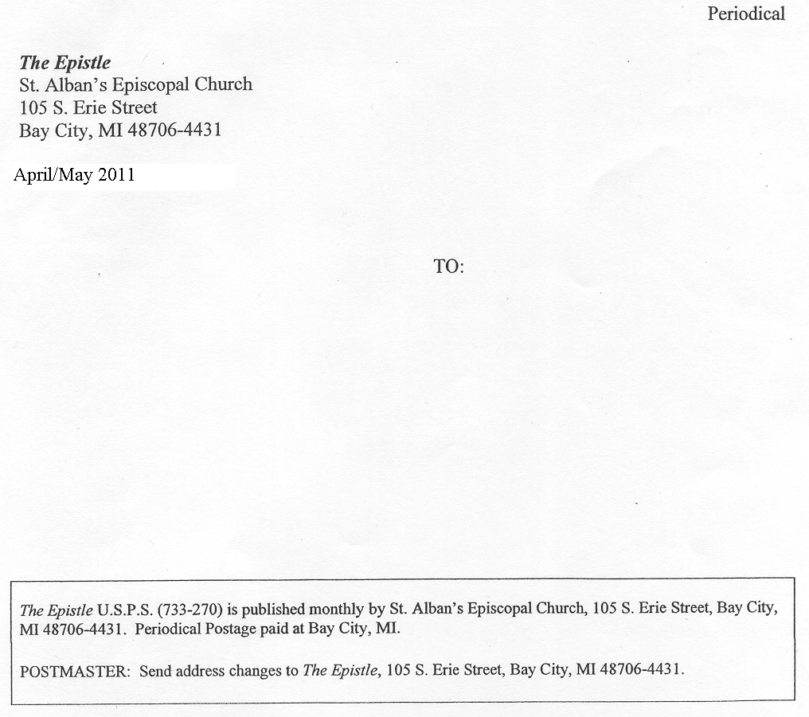
March/April
2014

