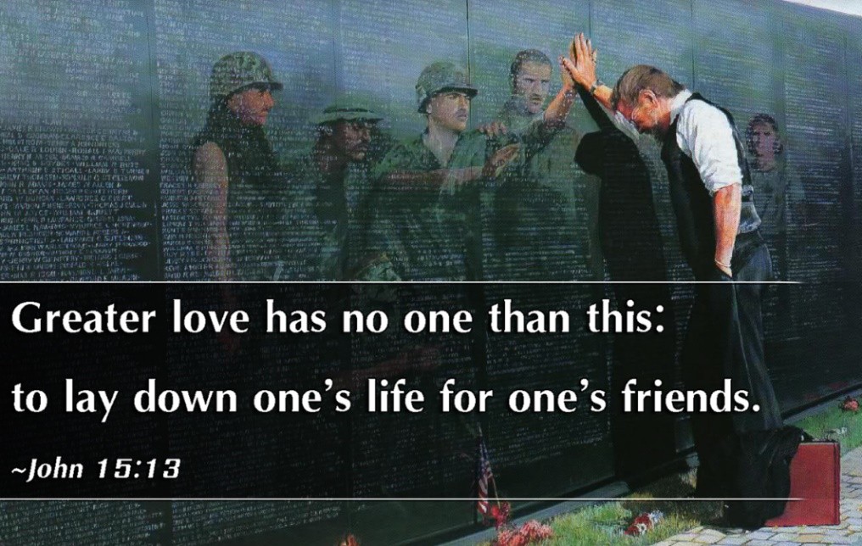

May 29, 2022

7th Sunday of Easter

Carson City United Methodist Church

10:30 am

Greeting/Announcements

Call to Worship

L: The eyes of the Lord are on the righteous, and his ears are attentive to their cry.
P: But the face of the Lord is against those who do evil, to blot out their name from the earth.
L: The righteous cry out, and the Lord hears them, he delivers them from all their troubles.
P: A voice is heard in Uvalde, weeping and great mourning, parents weeping for their children because they are no more.”
L: Our souls are in deep anguish. How long, Lord, how long before you return and make all things new?
P: We remember that you Lord are close to the brokenhearted and you save those who are crushed in spirit.
L: Today we mourn with those who mourn in Buffalo, New York, Laguna California, and Uvalde Texas.
P: We remember that you are always with us Lord, especially now at this time and in this place.

*Hymn: America the Beautiful UMH 696

Opening Prayer: (unison)
Heavenly Father, increase our faith, our hope, and our love this morning. May we be your light in the darkness of the world today. May we be comforters in this time of mourning in our land. We ask this in the name of Jesus Christ our Lord who lives and reigns with you in the unity of the Holy Spirit. AMEN.

Offering

Doxology UMH 95

Offertory Prayer

Sharing of our Joys and Concerns

Call to Prayer: Surely the Presence of the Lord
UMH 328

Pastoral Prayer

Gospel Reading: JOHN 15:12-14

Old Testament: HABAKKUK 1:2-4
Epistle Lesson: 1 JOHN 3:16-18
Contemporary Song: Sanctuary

MESSAGE

*Hymn: Let the be Peace on Earth UMH 431 (x2)

Benediction

CCUMC – Announcements & Upcoming Events:

As a courtesy to others please silence or shut off cellphones

==================================================
Office Closed: Mon, June 20th in observance of Memorial Day
==================================================
Scrap Drive: We are looking for some supplemental money to fund the budget. It has been decided that we will conduct a Scrap Metal Drive for the whole month of May. Here's how you can help:
If you have any scrap metal, appliances, etc. you can take them to the Fair Salvage Company in Sheridan. They will issue you a check. You can call the church office (989)594-3797 to have your items picked up. You can give a special donation for the general fund. Currently, the mortgage is down to $18,500. This means only 3 more payments. We have several items that need repair in the church. As with anything, eventually they wear out. Any little bit will help.
So far we raised $1704.00 If you have any questions, please feel free to call me or any Finance Committee person.
Thank-you for all you do.
==================================================
Graduation Sunday is June 12th. The church needs to know who is graduating from college or high school this year. We would like a picture in addition to obtaining each graduate plans of where they are going and field of study so we can share at our Sunday services. Please turn in to the church office as soon as possible.
==================================================
VBS Supplies needed: white flat sheets, cylindrical oatmeal boxes, tissue paper, pool noodles, boxes, brown packing paper. Please place in tub under the Monumental table.
==================================================
LAST DAY REMINDERS BEFORE FOR SUMMER
Women’s Group: Last meeting is Sun, May 29th
==================================================
Church Picnic: Sun, Aug 7, 2022, following 10:30 am Worship Service. More info coming soon.
==================================================
Christmas 2022 Service: With Christmas Day falling on Sunday for 2022 we would like to go with the following schedule so people can spend Christmas Day with family and friends. Please let us know your thoughts.
- Christmas Candlelight Service: 12/24/22 @ 7 pm
- Christmas Day Service: No Sunday Worship Svc

Frontier Days 2022 Activities:

Sat, June 4, 11:00 am to 1:00 pm @ CCUMC
Picnic Lunch, Whole Pie Sale, Rada Cutlery Sale, Arctic Blast Saved Ice
Proceeds to go towards Mortgage

Sat, June 4, around town
City Wide Yard Sales/Sidewalk Sales – All Day
Marketplace Craft Show, located along Sherman St. 9:00 am to 5:00 pm

Main Street:
Buckaroo Parade 1:15 pm
Grand Parade 1:30 pm

At Dusk:
"Light Up The Night" Balloon Glow
@ Fort Frontier Park
Emergency Vehicle Light Parade (Main Street)

Serving & Supporting Sunday Worship
Audio/Video: Pat Monroe
Children’s Ministry Audio/Video: Colin Fitzpatrick

Joys, Concerns & Prayer Request
For those battling cancers:
Jim Dunlap, Carolyn Nykerk, Ray Seaman, Dillan Abell, Andrew Hogan, Amorena Newman-Wojciakowski

For those who need support, guidance or have health concerns: Mike Decker, Jeff Beechler

Monthly Giving
5/1 $4306.02 5/8 $3382.68
5/15 $2593.14 5/22 $4189.13

Nursery Schedule
5/29 Alex Krantz

Lighting of Candles

Passing of Collections Plate
5/29 Colton & Reagan

Our Church in Ministry This Week
Sun: Women’s Group 6:30-8 pm
Mon: PT Class 6:30-8 pm
Tue & Thu: COA Meal @ Noon

Coloring Page

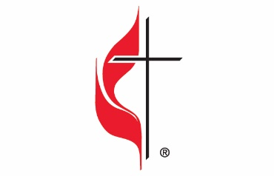

Carson City United Methodist Church
Location: 119 East Elm St., Carson City, MI
Mail: PO Box 298, Carson City, MI 48811
Phone: 989-584-3797 Email: carsoncityumc@gmail.com
Website: carsoncityumc.com
Sunday Worship Service: 10:30 am
Office Hours: Monday-Thursday, 9:00 am-12:00 pm
After hours by appointment
Pastor: Ian McDonald 906-322-5318
Secretary: Bonnie Seaman 989-763-1674

Weekly Sunday Bulletin now available on our website
@ www.carsoncityumc.com

“Jesus, thank You for leading me to You through the cross. I would be lost without You!”

