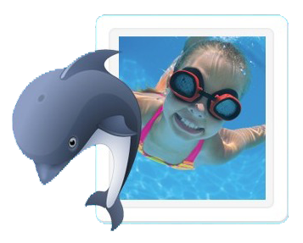
Queensborough Swim Club
1138 Miller Ave., San Jose, CA 95129
Between Rainbow & Bollinger
Pool Hours:
Sun - Thurs 7:00 am - 9:00 pm and Fri and Sat 7:00 am - 10:00 pm
Lifeguards on duty in the summer Mon-Fri from 1 pm - 5 pm.
This is a family oriented pool, safe, very clean, bathroom/showers, barbecue, not crowded, and lots of parking!
Next Membership/Swim Lesson Registration Times:
Sun Feb 21 6:30-8:30pm, Tue Feb 23 4:30-6:30pm, Sun Feb 28 10am-12pm or
drop off application/check or cash in the Club House door mail slot
Email info@qbpool.org for the 2016-2017 Membership Application and more information

Family membership is $495 for the following 12 months after signup.
Membership includes REDUCED RATES on: Swim Lessons, Kid's Night Out, Club House Rental

Swim lessons!
Private and semi-private lessons: Adults and children 3 years and up.
1/2 hour or hour sessions are offered Apr 1 thru Oct 31. Let us know what day(s) and time(s) work for you.
Fees: Private (1 lesson): Members $30/half hour, $50/hour Non-members: $40/half hour, $70/hour
Semi-Private (1 lesson): Members $20/half hour, $30/hour Non-members $25/half hour, $40/hour
Group lessons: Children 3 years and up. Beginner, Advanced Beginner, Intermediate and Advanced lessons.
Weekly sessions (Mon-Fri): Jun 13-Aug 12, Half hour lessons in the morning 9 am – 12 pm
Fees: (5 lessons): Members $45 Non-members: $85
Nine Saturday sessions: Jun 11-Aug 13 (not on July 2), Half hour lessons in the morning 9 am – 12 pm
Fees: (9 lessons): Members $85 Non-members: $150

Kid's Night Out is back!
Friday 6:00-9:30 pm: Apr 29, May 13, June 3, June 17, July 8, July 22, Aug 5
KNO includes SWIMMING (depending on weather), pizza, drinks, crafts and a movie!!
Fees: Members: one child: $15; each addtl child: $10, Non-members welcome for $5 more per child.

Clubhouse rental: Members: $75 for 3 hours ($25 each additional hour and $3 each guest swimmer),
Non-members: $30 per hour, minimum of 3 hours ($30 each additional hour and no swimmers)
Ice Cream Social: Come join us Sunday, May 29 from 1-4 pm and see what we are about!
For Complete Registration Info, email info@QBPool.org or call 408-446-3921

