Pleasant Township Board of Trustees Meeting Highlights
Date __May 9, 2023 Next Resolution No._ _29-----05-9-2023_ _

- Call to Order -- The meeting tonight will also be on WebEx.
- Please stand for moment of silence. --Pledge of Allegiance-----Roll Call
- Minutes to approve- None
- Financial Reports – Motion to pay expenditures.
- Visitors –
- Hanna Poling with the Southwest Messenger via WebEx.
- Jim Organ – Health Insurance Presentation
  - Resolution 29 to move to AETNA insurance effective June 1, 2023 and add $800 per employee per year to the HRA account to offset the increase in the new plan.
- Department Reports
- Franklin County Sheriff’s Report- Deputy Hamilton was not in attendance. He has been promoted to Sergeant, we will have a new deputy attending meetings. We wish Sgt. Hamilton all the best and thank him for his service to the township.
- Road Department- Robert Bausch, Superintendent
- Old Harrisburg pike update – continuing to restore the bank
- Clean up – another successful year.
- Brush mowing- getting ready to start the road ditches
- Tire take back event-will post on township social media
- On Norton Rd. at Lukens– email for you about brush blocking view to pull out. The County has kept it trimmed in the past, but only after the homeowner calls them. Can you notify them?- Yes, Robert will check it out and talk to the County.
  - Pleasant Township is proud of the work of Bill Dawson and a number of other volunteers who have created a Little Tree Library at the Ebenezer Cemetery, to honor our Veterans. Bill is holding a volunteer workday to plant flowers, mulch and beautify the cemetery on Saturday, May 20th, from 9am to Noon. Everyone is welcome. At Noon, a dedication of the library will occur. We look forward to seeing you all there for the volunteer morning, dedication, or both!
- A note for Bill Dawson,-----Honoring our Veterans. The Ebenezer M.E. Cemetery in Pleasant Twp., OH is the final resting place for some of our veterans from several wars dating back to the Revolutionary War. One of the huge century old White Oak trees died over last winter. I am creating a Free Little Library out of the remaining 12' trunk and will add another reading bench and updated beautification. Thank you for sharing and any support you can offer. (invite Hanna to the Tree Library ribbon cutting ceremony May 20th at noon.)
- Fire Dept. – Fire Chief, David Whiting
  - Training
- Boat Training
  - Apparatus
- M-231 went back to Braun for warranty work.
- Boat motor repaired.
  - Printer-getting quotes for a new printer
  - Community Risk Reduction
- Installed several smoke alarms in the community.
- Flower sale
- Staffing

- Resignation letters to be removed from our roster. These two individuals have been part-timers and served the township for many years. We would like to thank them for serving the township and the citizens and wish them the best of luck.
- Resolution _30_______ Jason Mack-part-time since 1994
- Resolution __31______ Joshua Hammond part-time since 2011
- Old Business-
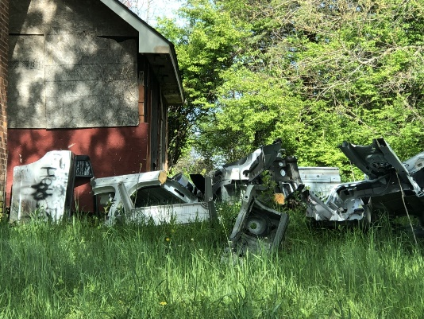
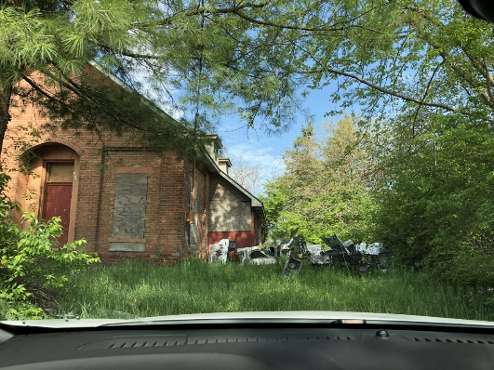
  - David Smith the Zoning Officer asked me to check the corner property at Seaman Rd. and Georgesville-Wrightsville Rd. to see if they have cleaned up the auto parts piled up there. They had not, I sent him pictures and he is submitting it for prosecution.
  - Today, I spoke with Adrian Allen with Franklin County Public Health about the letter stating a septic system is appropriate for a lot in Darbydale. He said that property is suitable for a septic system because the sewer lines are not at that property along with a few other properties that do not have access. It would be cost prohibitive to connect that property to the sewer system unless it could connect at a shorter distance by going through someone else’s property, but they have to agree to do that. I told him there are concerns from properties below that it would cause run off from a septic system. He said if it is installed correctly that would not happen.
  - Received an email complaint about no water at Community Gardens Mobile Home Park on Friday night. I forwarded the email to Michael Santone with the Ohio EPA.
  - Received complaint about a business operating in an area zoned residential on Georgesville-Wrightsville Rd. Advertising prices for hourly rental for pool parties, weddings, etc. Last summer we had many loud music complaints for this address. FCSO was called several times. I sent this to the Zoning Dept.
- New Business –
- Randi -- report on Minutemen Ohio Comp (Managed Care Organization). (Sedgwick is currently our MCO and TPA) Minutemen has the lowest claim cost of the 6 largest MCO’s. Being a smaller organization, they are able to offer a more thorough review of our claims. They are able to keep costs lower by having contractual pricing with providers and continued monitoring of claims to ensure that all procedures/medications are necessary.
Resolution 32 to switch to Minutemen.
- Clerk Updates- Paula
- Miscellaneous correspondence
- Did you get the email from David Donofrio about the auto renewal on June 1, 2023 for the Go Daddy domain for 2 years, total of $39.98? – yes
- Budget due 7-20-23
- Adjourn- 8:40 p.m.

