|  |  |  |
| --- | --- | --- |
| C:\Users\ParkTKD\Dropbox\TKD\케릭터\ParksLogo.jpg  **July 2018**  Volume 6, Issue 3 | Park Times  Long Beach Edition  World Hong Ik Tae Kwon Do  Quarterly News Letter | C:\Users\ParkTKD\Dropbox\TKD\케릭터\TKD Art\attack2.wmf |

Grandmaster’s Message

I've been teaching and practicing Tae Kwon Do for most of my life. I have experienced first-hand the power of Tae Kwon Do to transform individuals and inspire growth in groups. I believe that Tae Kwon Do is useful as a tool to develop discipline, self-confidence, and commitment. I have seen it help kids and adults overcome their insecurities, improve focus, and achieve the goals they set for themselves. Students learn best through experience and muscle memory, so classes focus on mastering basic techniques, using them in group exercises, and mentally preparing for real world situations where they can be used for self-defense.



**\* Summer Camp is July 2 – August 24**

(Register Now!)

**\* August 11 – Annual School Picnic at**

**Lido’s Mushroom Beach**

**\* August 25 & 26 – Demonstration**

**on Long Beach Boardwalk**

**\* Sept 1 - 3 – Closed for Labor Day**

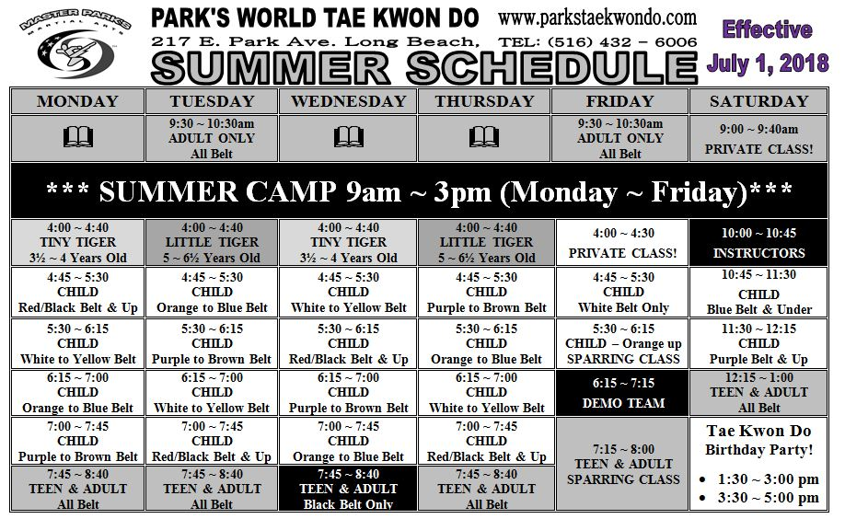

|  |  |  |  |  |  |  |  |  |  |  |  |  |  |  |  |  |  |  |  |  |  |  |  |  |  |  |  |  |  |  |  |  |  |  |  |  |  |  |  |  |  |  |  |  |  |  |  |  |  |  |  |  |  |  |  |  |  |  |  |  |  |  |  |  |  |  |  |  |  |  |  |  |  |  |  |  |  |  |  |  |  |  |  |  |  |  |  |  |  |  |  |  |  |  |  |  |  |  |  |  |  |  |  |  |  |  |  |  |
| --- | --- | --- | --- | --- | --- | --- | --- | --- | --- | --- | --- | --- | --- | --- | --- | --- | --- | --- | --- | --- | --- | --- | --- | --- | --- | --- | --- | --- | --- | --- | --- | --- | --- | --- | --- | --- | --- | --- | --- | --- | --- | --- | --- | --- | --- | --- | --- | --- | --- | --- | --- | --- | --- | --- | --- | --- | --- | --- | --- | --- | --- | --- | --- | --- | --- | --- | --- | --- | --- | --- | --- | --- | --- | --- | --- | --- | --- | --- | --- | --- | --- | --- | --- | --- | --- | --- | --- | --- | --- | --- | --- | --- | --- | --- | --- | --- | --- | --- | --- | --- | --- | --- | --- | --- | --- | --- | --- | --- |
| |  | | --- | | TKD Word Find    Park’s Martial Arts conquers Bear Mountain    **Parents Message**  Tae Kwon Do is Action Philosophy. By practicing Tae Kwon Do one can develop good coordination, gain strength, increase flexibility and improve cardiovascular conditioning to have a strong body. One can build self-confidence, gain better judgment and improve self-control to have a strong mind. While developing a strong body and a strong mind, it is appropriate to learn the valuable tools and lesson in life ordered by the TKD philosophy. TKD philosophy emphasizes good health, happiness, generosity and a sense of value of freedom, justice and peace. All of these inspire both independence and coexistence. TKD is an art of humanity. It is a guide for the information of outstanding character. It is practiced as a modern world sport and a contemporary universal philosophy.  **Students Message**  Don’t get frustrated when learning a new skill, for example a spinning hook kick or a tornado kick. Very few students can learn new skills on their first try. For most of us it takes time for your body and brain to work together. The majority of beginners experience a feeling of inadequacy with regards to performing the movements involved. When learning a new skill in class you may feel like you have 2 left feet or not enough arms. Subconsciously, your brain is still working on it after class, especially while you are sleeping. Sometimes the next time you try it seems to work for you. Sometimes you need to practice more. Every student learns differently, you need to find what works for you. If you are having difficulty learning a skill, try asking a different instructor or Master. It may just take different point of view to perfect your technique.  **Welcome** to all of our new students. When you become a student here at Park’s Martial Arts Tae Kwon Do School, you become a member of our family. |   BLACK BELT  CLUB  DOBOK  DOJANG  DUL  FAMILY  HANA  HONESTY  HUMILITY  JOIN  KICK  MASTER  NERVES  NET  NUN CHUCKS  PERSERVERANCE  RESPECT  SELF CONFIDENCE  SELF CONTROL  SET  TAEKWONDO  Sunday, May 6, 2018   |  |  |  |  |  |  |  |  |  | | --- | --- | --- | --- | --- | --- | --- | --- | --- | |  |  |  |  |  |  |  |  |  |  |  |  |  |  |  |  |  | | --- | --- | --- | --- | --- | --- | --- | | July 2018 | | | | | | | | Sunday | Monday | Tuesday | Wednesday | Thursday | Friday | Saturday | | 1 | 2  Summer Camp | 3  Summer Camp | 4  **School Closed** | 5  Summer Camp | 6  Summer Camp | 7 | | 8 | 9  Summer  Camp  Board Breaking Week | 10  Summer Camp | 11  Summer  Camp | 12  Summer  Camp | 13  Summer  Camp | 14 | | 15 | 16  Summer  Camp | 17  Summer  Camp | 18  Summer  Camp | 19  Summer  Camp | 20  Summer Camp | 21 | | 22 | 23    Summer  Camp | 24    Summer  Camp | 25  Summer  Camp | 26    Summer  Camp | 27  Summer Camp | 28 | | 29 | 30  Summer Camp | 31  Summer Camp |  |  |  |  |  |  |  |  |  |  |  |  | | --- | --- | --- | --- | --- | --- | --- | | August 2018 | | | | | | | | Sunday | Monday | Tuesday | Wednesday | Thursday | Friday | Saturday | |  |  |  | 1  Summer  Camp | 2  Summer  Camp | 3  Summer Camp | 4 | | 5 | 6  Summer Camp | 7  Summer Camp | 8  Summer Camp | 9  Summer Camp | 10  Summer Camp | 11  **Annual**  **School Picnic** | | 12 | 13  Board Breaking Week  Summer Camp | 14  Summer Camp | 15  Summer Camp | 16  Summer Camp | 17  Summer Camp | 18 | | 19 | 20  Summer Camp | 21  Summer Camp | 22  Summer Camp | 23  Summer Camp | 24  Summer Camp | 25  **Board**  **Walk Demo** | | 26  **Board**  **Walk Demo** | 27 | 28 | 29 | 30 | 31 |  | |

**Our Staff**

|  |  |
| --- | --- |
| **Grand Master Su Hyun Park** | |
| Master: Won Chan Jang  Instructor: Maxwell Dexter  Instructor: Alfred Calambo | OM & Instructor: Lisa Dexter  Instructor: Erin Kelly  Instructor: Winter Landmann-Herd |
|  |  |
|  |  |