**Geneforce Power Systems Wiring Diagram - Wiring an External Bypass Switch and Sub Panel for 60A/120V-240V Geneforce Units.**

**Flanged Inlet 60A/120V -240V (*optional for quick disconnect) (male to female cable required)**

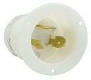 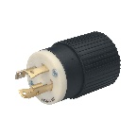

60A/120V-240V Twist Lock Input Plug included

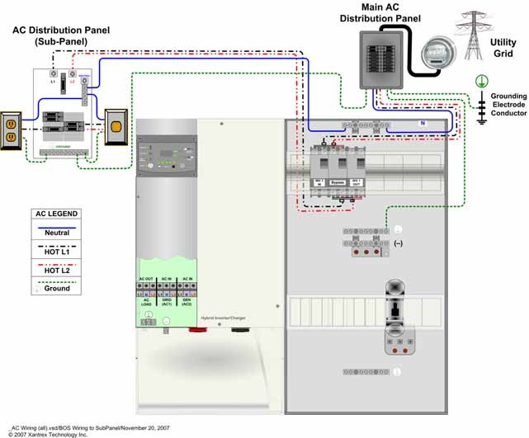 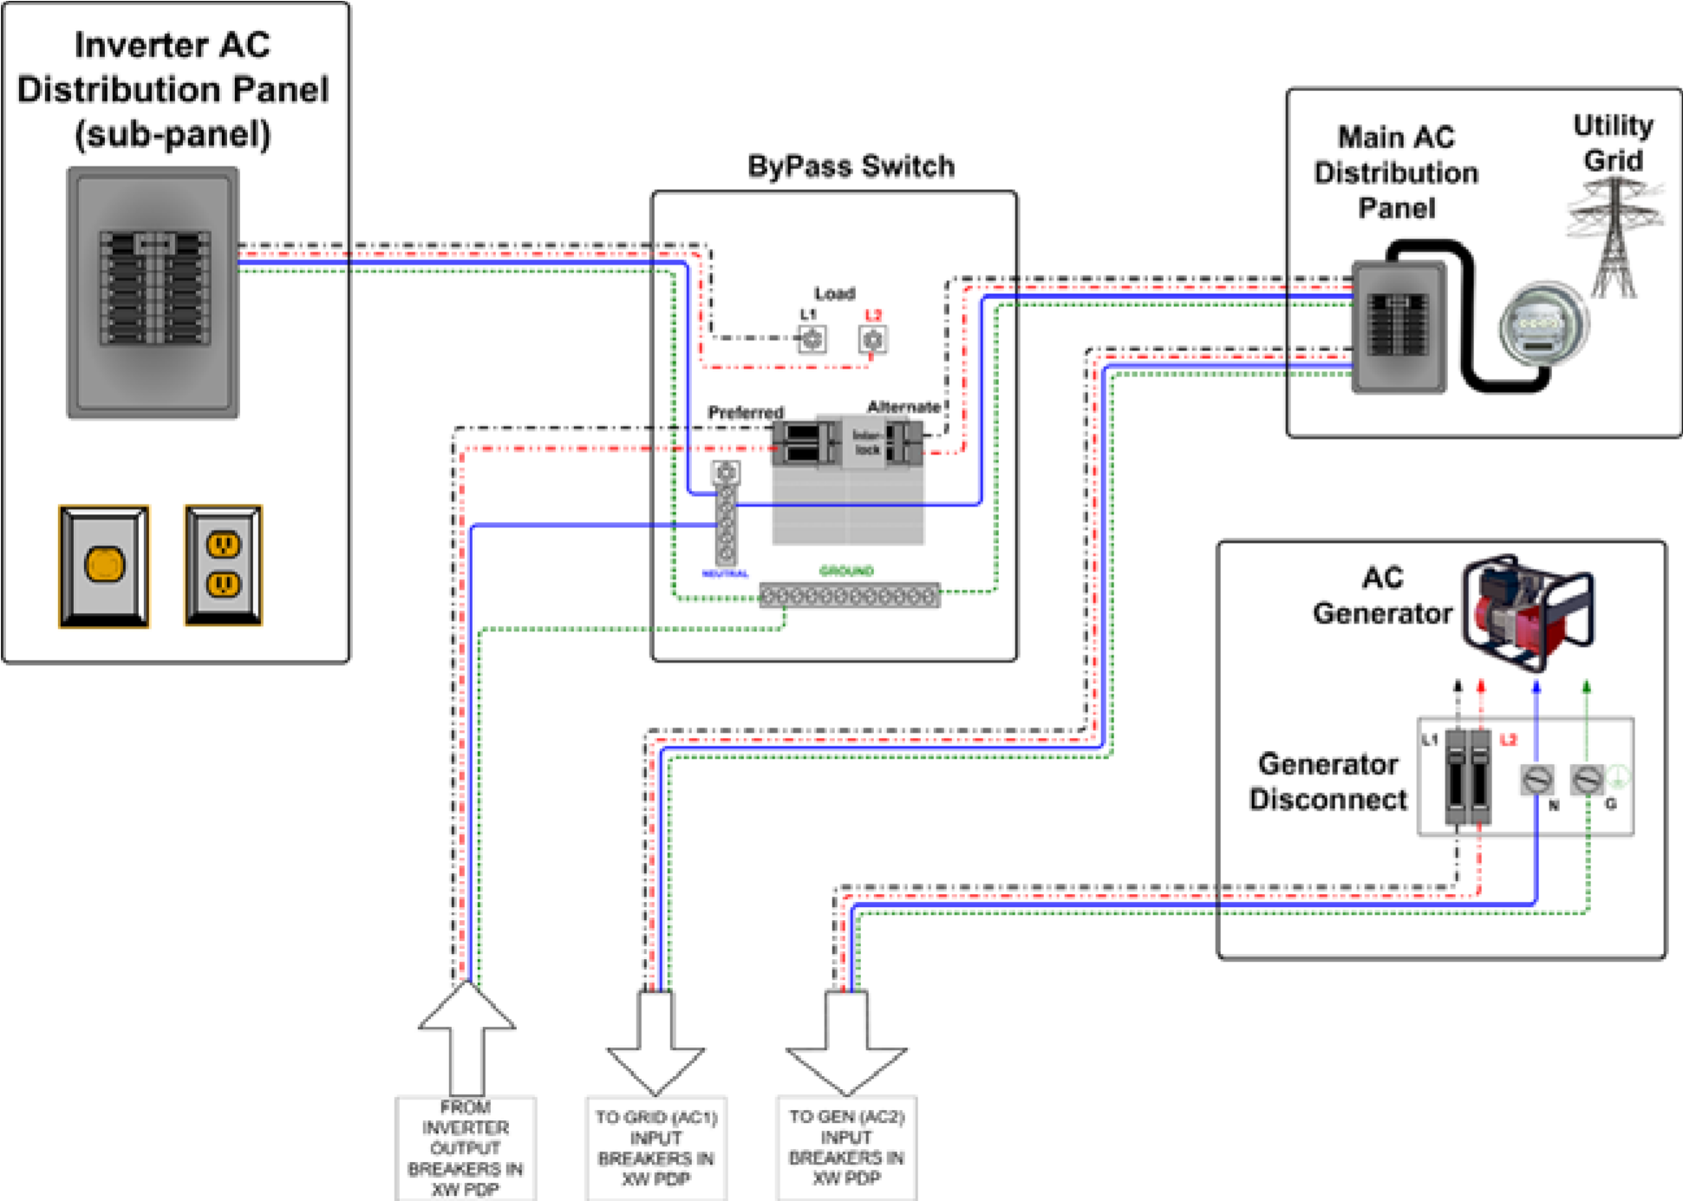

Geneforce recommends Eaton EGSU200ACA ATS or similar. Manual Transfer Switch is optional.

+ ZOOM

AC Input 2 60A/240V Single Pole, 4-Wire 6-4 Cable

AC Input 2 is for optional use. Used for shaving loads or providing redundancy with an auxiliary generator.

**AC Input 1** Eight foot **60A/240V** Input Plug, Single Pole, 4-Wire 6 Ga. Cable Breaker Box Installed in Geneforce

**AC Output** 60A/120V-240V Output Receptacle, Single Pole, 4-Wire 6 Ga. Cable Breaker Box Installed in Geneforce

Auxiliary Gas Generator Optional for Load Shaving and Redundancy.

Automatic Generator Start Switch

**AC Output 120V-240V**

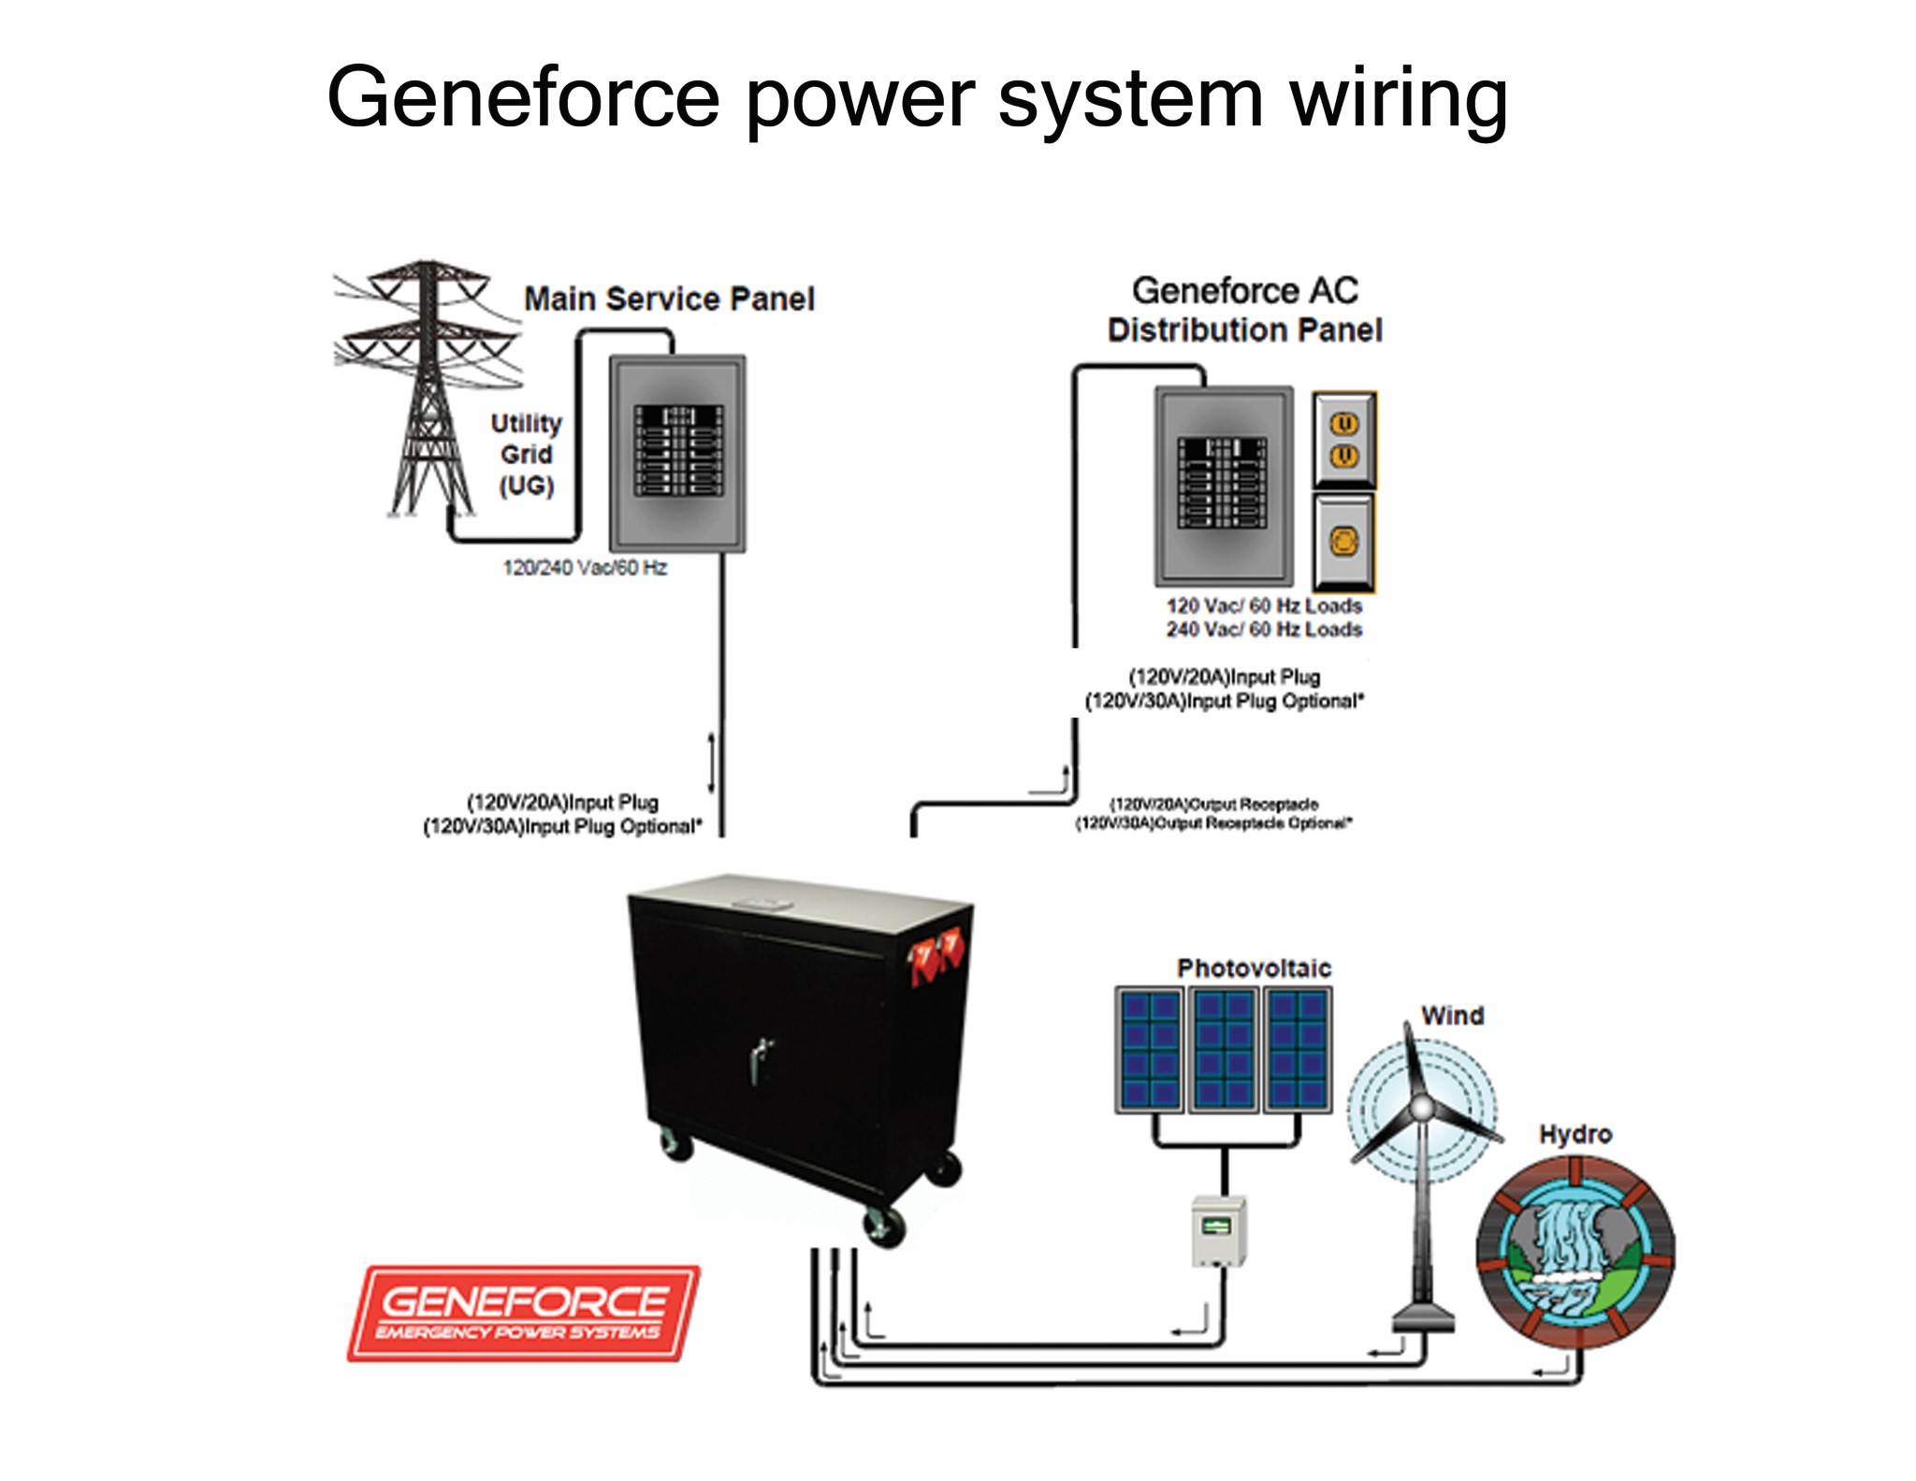

Geneforce Incorporated [www.geneforcepower.com](http://www.geneforcepower.com) Telephone (305) 215-5443 For questions email [techsupport@geneforcepower.com](mailto:techsupport@geneforcepower.com)

6-Gauge **Positive** & **Negative** Cable used for alternative Energy charging.

60A/12V-24V Solar Panel Charge Controller Included

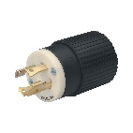 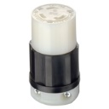 *C:\Users\chinos333\Documents\Geneforce Incorporated\Website Info - gn\website fotos\soow3.jpg*

60A/120V-240V Automatic Transfer Switch /Relay Included. Automatically transfers power to loads during power failures & automatically resumes charging when power is restored.

6-4 Male to Female Cable. Connects to Flanged Inlet at Sub Panel for quick disconnect. Not included.