

2018
Liberation Singles Open
Saturday 7th April 2018

The 2017 Liberation Singles Open saw a record and SELL OUT 40 players take part. It was the Islands first major tournament of the year.
Round 1 saw several big wins, with JPA chairman Andrew Limbrick beating fellow Lethal Limbs team mate Alan Lahiffe 13 – 5, Andrew Bellamy-Burt beat doubles team mate Callum Stewart 13 – 4 and current 2017 champion Mark Nicol start off his defence of the title with a 13 – 3 win over Paul Waters.
The shock of round 1 though was a win for Stephen Stoneman who only started playing on the 28th March beat Liberation Premier League and very experience David Ibitson 13 – 11, what a start to Stephen’s first ever tournament.
Round 2 saw several matches worthy of a final, with Chris Romeril (2012 winner) just losing out 13 – 11 to Seb Renaud. Neil Selby beat Matt Buesnel (2016 Winner) by the same score and Matt Pinel beat Geoffroy Buffetrille 13 – 7.
Alan Oliveria handed (2015 winner and 2017 runner up) Andrew Bellamy-Burt a 13 – 8 defeat and Ross Payne lost 13 – 1 to Paul Bell who has been playing singles less than a year!
Round 3 saw Matt Pinel pushed all the way by Wendy Ritzema 13 – 10. David Ibitson made it back to back wins with a 13-10 win over Brian Harris and Toby Northern beat Alan Lahiffe 13 – 8.
Round 4 saw the first 13 – 0 of the day as two players both with three wins played each other in Mark Nicol and Alan Oliveira, unfortunately Alan failed to score a point.
Matt Pinel made it four straight wins with another close match 13 – 11 over Seb Renaud. Toby Northern moved into contention of a top 8 place with another 13 -8 win, this time over Andrew Bellamy-Burt ending Andrew’s chances of a top 8 finish.
Matt Buesnel also moved into contention beating Geoffroy Buffetrille 13 – 9 ending Geoffroy’s chances of a top 8 place. Callum Stewart beat Keith Boleat 13-12 to make it 3 wins from 4.

The final round saw several players in with a chance of the top 8. In fact several matches mean’t one player went through and the losing player didn’t.
This was the case for Callum Stewart who lost 13 – 3 to Seb Renaud, Toby Northern who lost 13 – 11 to Alan Oliveira, Bob Morel who lost 13 – 12 to Joey Le Clech and Joy Hart who lost 13 – 6 to David Ibitson.
Neil Selby lost his first match but made it through with 4 wins, his opponent Mark Nicol ending the only player with 5 wins. This was because Matt Buesnel beat Matt Pinel 13-10 to qualify in 7th Place.
FINAL SWISS RANKINGS
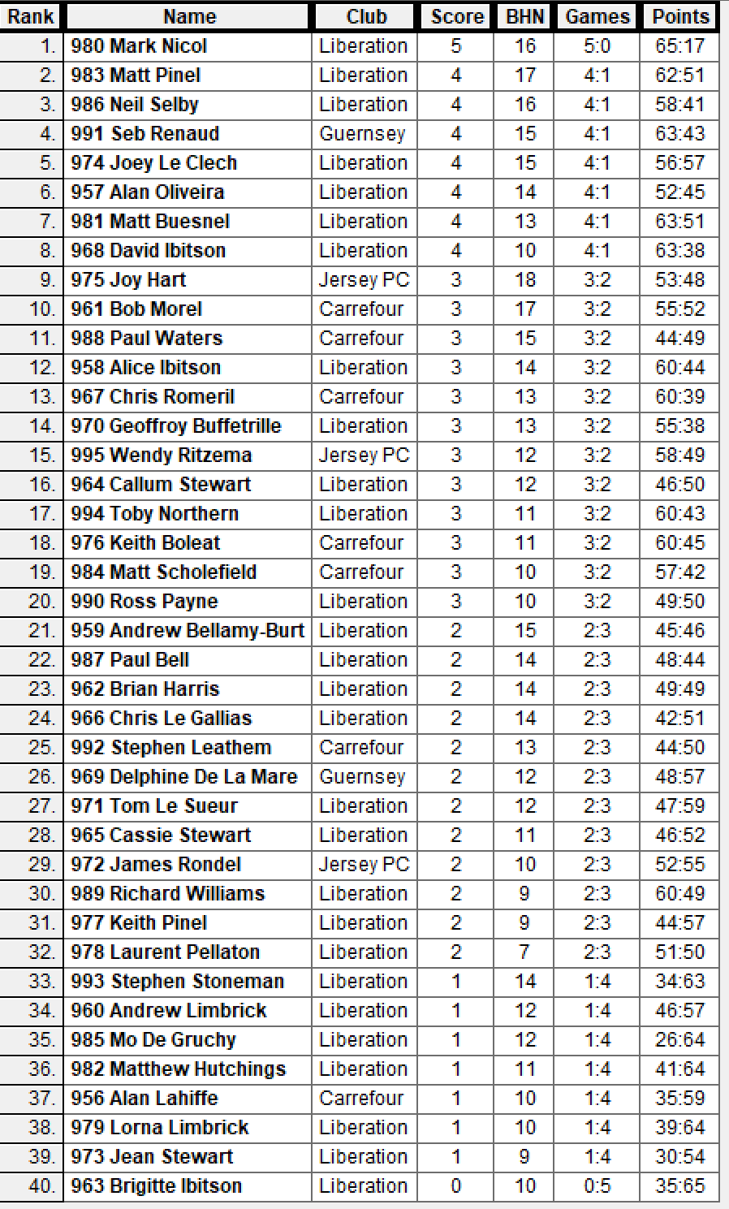

QUARTER FINALS
1st Mark Nicol v David Ibitson 8th
2nd Matt Pinel v Matt Buesnel 7th
3rd Neil Selby v Alan Oliveira 6th
4th Seb Renaud v Joey Le Clech 5th

In the quarter finals Joey Le Clech came from 10 – 4 down against Seb Renaud to make the semi-finals for the second year running.
David Ibitson gave Mark Nicol his toughest match of the tournament, but still resulted in a 13 – 8 loss.
Matt Pinel lost to Matt Buesnel in the 5th round of the Swiss system which mean’t Matt Buesnel made it through to the quarter finals, so to play each other again gave Matt P the opportunity to make amends. It wasn’t to be though, as a few mistakes giving Matt Buesnel the points made the difference.
Alan Oliveria with a number of big scalps, couldn’t quite make it another as Neil Selby made the semi-finals for the first time.
SEMI FINALS
1st Mark Nicol v Joey Le Clech 5th
3rd Neil Selby v Matt Buesnel 7th

With Neil having already won against Matt Buesnel in round 2, 13 – 11 would have been confident of another win. It started off great with Neil racing into the lead and he never looked back as he made the final winning 13 - 10.
Mark Nicol though had a very close match against Joey Le Clech as the latter made it 10 – 10. On the next end Joey was holding one point with Mark all out and Joey elected instead of pushing his front boule up for three, chose an over the top fire (going for a carreaux) for three. The result just one point.
A pour first boule by Joey allowed Mark to take advantage and Joey made the fatal error of firing and missing two boules not realising that Mark then just had to push Joey’s only remaining boule out of the way to take the game. Mark of course did this to survive a real scare. 13 - 11
Matt Buesnel recovered from his disappointment to beat Joey Le Clech 13 – 0 to take 3rd place.

The final was end to end in in the early stages at 6 – 5 to Mark before he pulled away to repeat the score between the two in Round 5, winning back to back titles 13 – 6. Well done Mark Nicol.

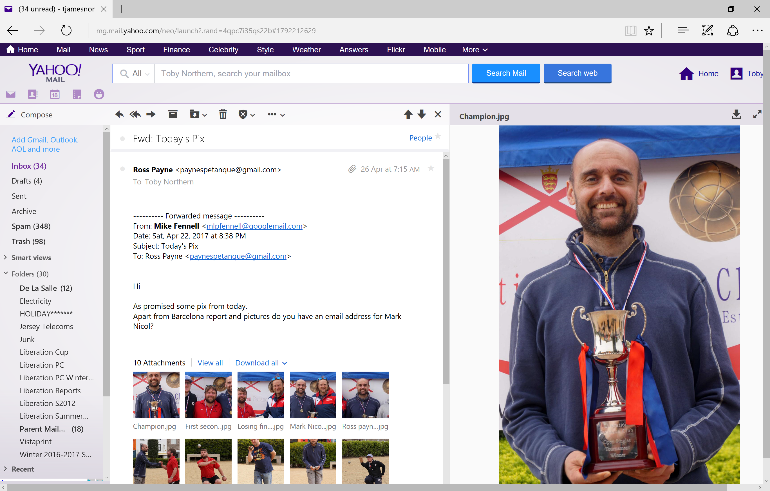
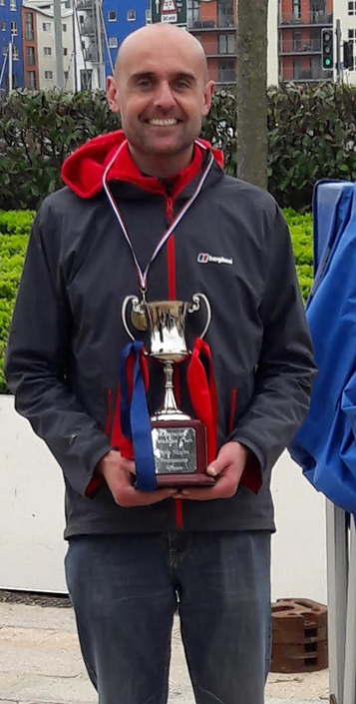
2017 2018

Is it just me or does Mark look younger!!!
Well done everyone for a great tournament and special thanks to all those who worked tirelessly ensuring the tournament when well.

Club email address - liberationpc@gmail.com

Club Website - www.liberationpetanque.co.uk

Kind Regards

Report Editor

Toby Northern

Liberation Petanque Club

SPONSORED BY

