TWENTY-FIFTH SUNDAY IN ORDINARY TIME
SEPTEMBER 22 & 23, 2018
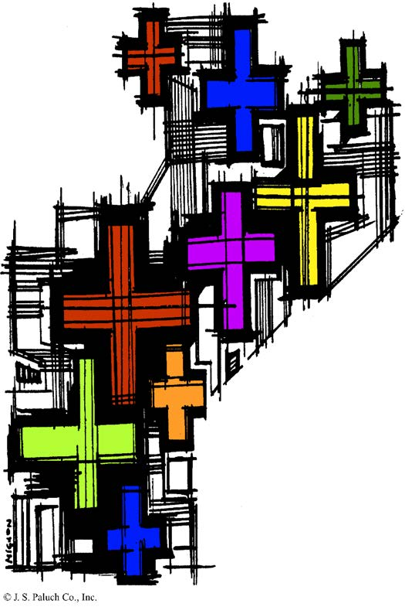
HOW DO WE TREAT THE MESSENGER?

Let’s not be too hasty in defining who is “the wicked one” and who (namely us) is just! We are very quick to label others as evil, because we tend to label ourselves as good guys. We don’t like it when we are brought up short by a prophetic voice that brings us some bad news about our own behavior. We don’t like to be reproached for transgressions of the law or charged with violations of our training.
We may condemn and abuse those who bring us up against these truths about ourselves when, if we were really good, we would thank them for helping to keep us on the right path. This is the way they treated the prophets and the way they treated Jesus. Is this also the way we treat those whose message we don’t like?

AN ACT OF KINDNESS
By Jane Vartanian

One hundred seventy-one years ago, my ancestors in Ireland were dying of starvation as a result of the potato famine. A dreaded rotting of their principal food crop, the potato, was causing at least a million deaths in the small island country. All of the European countries lost their potato crops, but as they had a more varied diet they had other foods to make up for the loss of the potato. Ireland’s diet at the time consisted of potatoes, milk and cabbage, and when one of the three failed, it spelled disaster.
One more million panic - stricken Irish, facing death by painful starvation, migrated to the US, as so many troubled people have done over the years. The loss of these two million people dropped the Irish population by one quarter!
The plight of the starving Irish tugged at the heartstrings of many people around the world, and some took action. One of these groups was a Tribe of Choctaw Indians in the State of Oklahoma. This small group of concerned American Indians understood starvation and hardship and among themselves they collected $170.00 and sent it to Dublin, with instructions to help the suffering Irish people. That $170.00 would be worth $4,400.00 today!
As a result, the two groups of people, the Choctaw tribe of Oklahoma and the people of Ireland have a deep bond. Last year, a Choctaw chief, Gary Batton, visited Ireland to attend an unveiling of a sculpture entitled Kindred Spirits, which commemorates their life-saving gift of thoughtfulness, and this year the Prime Minister of Ireland visited Durant, in Southern Oklahoma, to seal their bond to the small tribe in the US.
“Do your little bit of good where you are; it’s those little bits of good put together that overwhelm the world.” Desmond Tutu
“Kindness is the language the deaf can hear and the blind can see.” Mark Twain

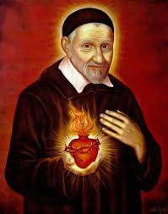

Saint Vincent de Paul’s Story

Feast Day: September 27th.
The deathbed confession of a dying servant opened Vincent de Paul’s eyes to the crying spiritual needs of the peasantry of France. This seems to have been a crucial moment in the life of the man from a small farm in Gascony, France, who had become a priest with little more ambition than to have a comfortable life.
The Countess de Gondi—whose servant he had helped—persuaded her husband to endow and support a group of able and zealous missionaries who would work among poor tenant farmers and country people in general. Vincent was too humble to accept leadership at first, but after working for some time in Paris among imprisoned galley slaves, he returned to be the leader of what is now known as the Congregation of the Mission, or the Vincentians. These priests, with vows of poverty, chastity, obedience, and stability, were to devote themselves entirely to the people in smaller towns and villages.
Later, Vincent established confraternities of charity for the spiritual and physical relief of the poor and sick of each parish. From these, with the help of Saint Louise de Marillac, came the Daughters of Charity, “whose convent is the sickroom, whose chapel is the parish church, whose cloister is the streets of the city.” He organized the rich women of Paris to collect funds for his missionary projects, founded several hospitals, collected relief funds for the victims of war, and ransomed over 1,200 galley slaves from North Africa. He was zealous in conducting retreats for clergy at a time when there was great laxity, abuse, and ignorance among them. He was a pioneer in clerical training and was instrumental in establishing seminaries.
Most remarkably, Vincent was by temperament a very irascible person—even his friends admitted it. He said that except for the grace of God he would have been “hard and repulsive, rough and cross.” But he became a tender and affectionate man, very sensitive to the needs of others.
Pope Leo XIII made him the Patron of all Charitable Societies. Outstanding among these, of course, is the Society of St. Vincent de Paul, founded in 1833 by his admirer Blessed Frédéric Ozanam.

CONFIRMATION
By Dennis Tavares
This Sacrament more perfectly binds us to the Church and enables us to witness and defend Christ, the Church, and our Faith by word and deed through the power of the Holy Spirit. It marks the Soul as belonging to Christ, so the Sacrament cannot be repeated. The ordinary Minister is the local Bishop but Priests can confirm in an emergency. Confirmation is given by tracing a cross on the forehead with blessed oil, called Chrism, while reciting the form “Be sealed with the gift of the Holy Spirit.” Confirmation is given to any Baptized Catholic after instruction in the duties and responsibilities of Christian life. Sponsors should be practicing Catholics knowledgeable about Christian life. All Catholics are obliged to be Confirmed and to grow in knowledge of the Faith. The vast number of Christ’s followers over the last 2,000 years is proof of Confirmation’s effectiveness.

KNIGHTS OF COLUMBUS
COUNSEL 4025 IN FORT BRAGG.

ARE HAVING THEIR SEMI-ANNUAL

TRI-TIP ROAST SALE.

SATURDAY, OCTOBER 13, 2018.
PRICE: $25.00 EACH.
PRE-SALE ORDERS ONLY.
CALL TO ORDER BEFORE OCTOBER 7, 2018

THEY ARE MARINATED, BAR-B-QUE’D.
READY FOR THE TABLE.

PROCEEDS SUPPORT THE COUNCIL’S ONGOING “EDUCATIONAL GRANT PROGRAM” AND MANY OTHER OF THE COUNCIL’S COMMUNITY ACTIVITIES.
FOR MORE INFORMATION OR TO PLACE AN ORDER, PLEASE CALL STEVE BEEMAN AT 964-7352.

WEEKLY COLLECTION
SEPTEMBER 15 & 16, 201.…$1,987.00
DIOCESAN SEMINARIAN.…$851.00
THIS WEEKEND’S SECOND COLLECTION:
YOUTH MINISTRY & RETREATS
NEXT WEEKEND’S SECOND COLLECTION:
ANNUAL MINISTRY APPEAL (AMA)
THANK YOU FOR YOUR SUPPORT &
CHRISTIAN GENEROSITY

READINGS FOR THE WEEK:
Monday: Prv 3: 27-34; Ps 15: 2-5; Lk 8: 16-18
Tuesday: Prv 21: 1-6, 10-13; Ps 119: 1, 27, 30, 34,
35, 44; Lk 8: 19-21
Wednesday: Prv 30: 5-9; Ps 119: 29, 72, 89, 101, 104, 163;
Lk 9: 1-6
Thursday: Eccl 1: 2-11; Ps 90: 3-6, 12-14, 17bc;
Lk 9: 7-9
Friday: Eccl 3: 1-11; Ps 144: 1b, 2abc, 3-4;
Lk 9: 18-22
Saturday: Dn 7: 9-10, 13-14 or Rv 12: 7-12a; Ps 138:
1-5; Jn 1: 47-51
Sunday: Nm 11: 25-29; Ps 19: 8, 10, 12-14; Jas 5: 1-6;
Mk 9: 38-43, 45, 47-48

MEMORIAL TREE
IN THE VESTIBULE OF OUR CHURCH, ON THE SOUTHERN WALL, IS A BEAUTIFUL MEMORIAL TREE. ITS BRIGHT LEAVES REPRESENT PERMANENT MEMORIALS TO THE DEPARTED OF OUR PARISH.
FOR THE SUM OF A ONETIME PAYMENT OF $200, YOU CAN GIVE TO THE PARISH SECRETARY THE CORRECT SPELLING AND DATES OF THE DEPARTED AND IN DUE TIME, THE LEAF IS PRINTED AND ATTACHED TO THE TREE: A PERMANENT REMINDER OF A LOVED ONE WHO IS GONE.
FOR MORE INFORMATION, CALL THE PARISH OFFICE AT 964-0229.

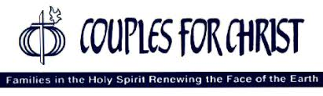
COUPLES FOR CHRIST ARE OFFERING A SEMINAR,
“CHRISTIAN LIFE PROGRAM”
OPEN NOT ONLY TO COUPLES OF OUR PARISH COMMUNITY, BUT TO ALL.
THERE WILL BE AN ORIENTATION IN THE PARISH HALL
ON SATURDAY, SEPTEMBER 29TH AT 4PM.
SNACKS WILL BE SERVED.
SEE YOU THERE!

MASS INTENTIONS
SEPTEMBER 26 - 30, 2018
Wednesday (26)  Thursday (27)  Friday (28)  Saturday (29)  Sunday (30) | 12:05pm  12:05pm  12:05pm  5:00pm  6:30pm  8:00am  10:00am | Flow Macías †  Chito Galván †  Elda & Don Huff †  Rubén Villegas, Sr. †  Fred & Clara White †  Brianda Venegas †  María Buenrostro †  Esperanza Barba  (b-day)  James Pat †  Margaret Conley †  José & Ubaldo Muñoz †

PRAY FOR OUR FAMILY AND FRIENDS THAT ARE IN THE MILITARY SERVICE
Edgar Toscano, Marina González, Alondra Jara, Sonia Jara, Jason Lorenz, Matt Mill y Jared Schroeder

PLEASE PRAY FOR OUR SICK PARISHIONERS

Ricardo Contreras, Florencia Chávez, Refugio Yáñez, Tarcicio Garía, Sofía García, María de Jesús Mendoza, Ana García, Antonio Cazares, Evelyn Costa, Ryan Moore, Eileen Seeman, Marianne Brannan, Lilia Parrish, Nancy Smith, Julián Palomar, Luisa Martínez, Jennifer Vera, John Braet, Kim Koskinen, Margaret Valencia, Matthew Marcoulier, Dennis Tavares, Jose Freitas, Alfredo Sousa, Juana Arreguín, Aron Yasskin, Victoria Walzer, Fidela Yáñez Jara, Erika Ramos, Bill Gibson, Carla Tomas, Erasmo Yáñez, Memo Soria, Patricia Vargas, Fidela Yáñez, Rogelia Serrano, Elvia Flores, Camila Blanco-Cherrez, Yonel Ruíz, Angie Freitas, Russel Bryant, Derrick Heater, Luis Angel, Juan Barrera-Terán, Gabriel Hurtado, Gerald Butler, Helen Reynolds, Toni Clark, Ann Gallagher, Brianna Lopez, Margaret Milliken, Gina Pivirotto, Nick Quin, Mary Servis, Denis Sousa, Victor Venegas, Matty Walker, Charles Lorenz, Rebecca Lorenz, Ofelia Ibarra, Leonardo Naal, Gina Leal.

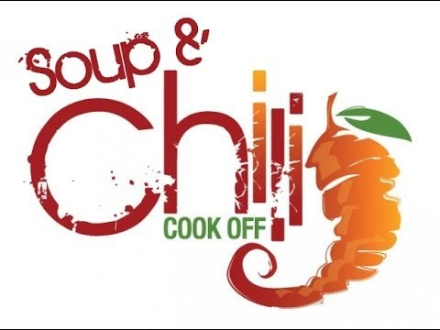

The Fort Bragg Food Bank

PO Box 70, Fort Bragg, CA 95437 * Email: fortbraggfoodbank@mcn.org

CALLING ALL SOUPMAKERS!
We’re looking for talented soup makers to enter our annual Soup & Chili Cook-Off, a fundraiser for the Fort Bragg Food Bank, and hope you will consider joining us.

SOUP & CHILI COOK-OFF 2018
SATURDAY OCTOBER 27
5~7:30 PM PENTECOST HALL

Please let us know if you would like to participate by phone, email or by mailing or faxing (964-9404) the form below.
For more details, call the Fort Bragg Food Bank 964-9404.

URGENT NOTICE
WE ARE UPDATING OUR PARISH REGISTRATION LIST.
TAKE A FORM AND GIVE US YOUR CURRENT INFORMATION.
YOU CAN PUT IT IN THE COLLECTION BASKET, RETURN IT TO THE RECTORY, CALL US AT 707-964-0229 OR
E-MAIL US AT olgcinfb@gmail.com

