**Paul Bunyan Christmas Shoot, 21 December 2014**

By Mike Moran

‘Twas Christmas Shoot morning, I pulled in the drive,

Some folks were unpacking, others soon to arrive.

I picked out a spot and unloaded my gear,

My friends all around me full of coffee and cheer.

I uncased my rifle, checked powder and ball,

Then into the clubhouse for the meeting and all.

Chip Kormas the Booshway was naughty and nice,

Picking targets no bigger than pieces of rice.

A candy cane, tree bough, lollypops and Peeps,

I know what I’ll dream about when I lay down to sleep.

Plus one sheet of paper with three tiny creatures,

And a long range balloon as the tie breaking feature.

The shooting began as is always the case,

And it finished real quick, like some sort of a race.

The score cards were tallied by the chimney with care,

Then prizes selected by each shooter there.

But instead of a table with prizes to show,

A Christmas tree sheltered some presents below.

Wrapped in bright paper each box left no clue,

Of what was inside of each gift that you drew.

But this being Christmas the spirit is strong,

To give joy to others who can’t get along.

Each shooter would donate his fees to the pot,

To support a great program, the Marines’ Toys for Tots.

But to make sure we gave them a healthy amount,

A raffle was held to increase the account.

Our craftsmen, you see, have joy in their hearts,

And give of their talents and their beautiful arts.

Steve Skillman a powder horn, Chip Kormas a pouch,

Dave Rase a horn cup for when you drink on the couch.

On top of all that a member had stated

That he’d match the amount of the money donated

Twenty five shooters showed up that fine day,

Over fifteen hundred dollars was the amount that was raised.

Now kids will get presents and be filled with delight,

Merry Christmas to all, and to all a good night.

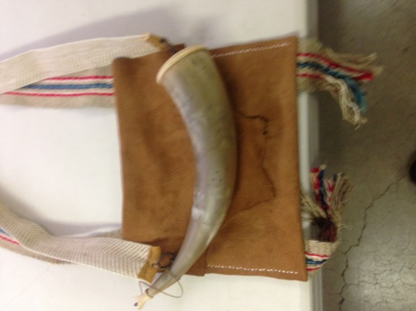

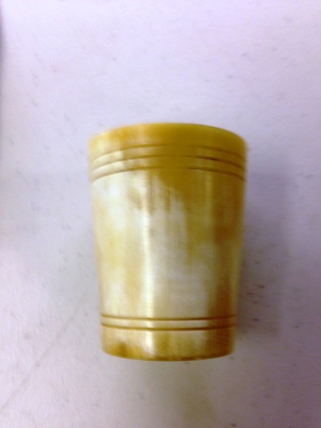

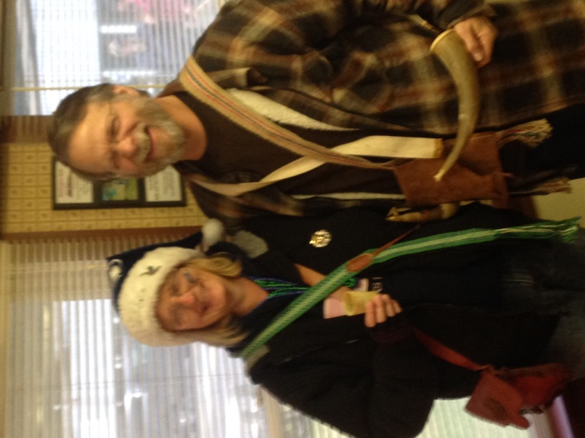

**The Raffle Winners**