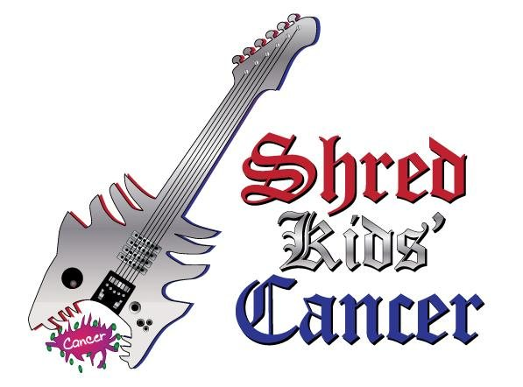
Shred Kids’ Cancer
School Club Application

Applicant Name:__________________________________________________________________________

Phone:_____________________________Email:________________________________________________

Club Name*:_____________________________________________________________________________

School Name:____________________________________________________________________________

School Level (e.g. middle school, high school, college):___________________________________________

Club Advisor Contact Name (if different than applicant):__________________________________________

Advisor Number:_____________________ Email:_______________________________________________

Student Leader Contact Name (if different from applicant):________________________________________

Student Number:_____________________ Email:_______________________________________________

Why do you want to start a Shred Kids Cancer club?:________________________________________

_______________________________________________________________________________________

When do you plan to start your club?:________________________________________________________

How often will your club meet?:_____________________________________________________________

Club Authorized By**:

_________________________________________
School Representative Signature

_________________________________________
Printed Name and Title

Please return this application via email to: shredkidscancer@gmail.com. A representative from Shred Kids Cancer will respond to your completed application approximately 7-10 business days after it is received.

Please note that any fundraising activities conducted by your Shred Kids Cancer club will require an approved SKC Fundraising Proposal Form & Liability Release Agreement. This document can be downloaded from the website at www.shredkidscancer.org.

