JSB Capital Management, LLC
Pro-active Wealth Management

December 15, 2021

Today the Federal Open Market Committee (FOMC), the interest rate establishing body of the Federal Reserve Bank (The Fed), concluded its final meeting of 2021. The outcome was largely expected, and the stock markets responded upwardly as expected based partly on the amount of certainty that the post-meeting statement and news conference provided.
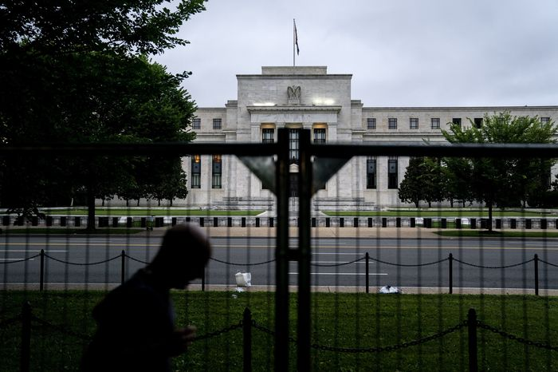
The first part of the FOMC statement (and Chairman Jerome Powell’s press conference afterwards) revealed that The Fed will shrink its monthly bond purchases at twice the pace it previously announced resulting in a total of $30 billion of reductions in monthly bond buying. At this pace, this form of monetary easing will likely end altogether in March 2022. That means The Fed will no longer inject $1.4 trillion per year to stimulate the economy. The accelerated timetable also probably puts the Fed on a path to start raising rates in the first half of next year.
Importantly, The Fed also forecast that it will raise its benchmark short-term rate three times next year which is up from just one rate hike it had projected in September. This is significant because The Fed's key (short-term) interest rate, now pegged near zero, influences many consumer and business loans, including rates for mortgages, credit cards and auto loans.
Those borrowing costs may start to rise in the coming months, though the Fed's actions don't always immediately affect other loan rates. And even if the central bank does raise rates three times next year, it would still leave its benchmark rate historically low, still below 1%.
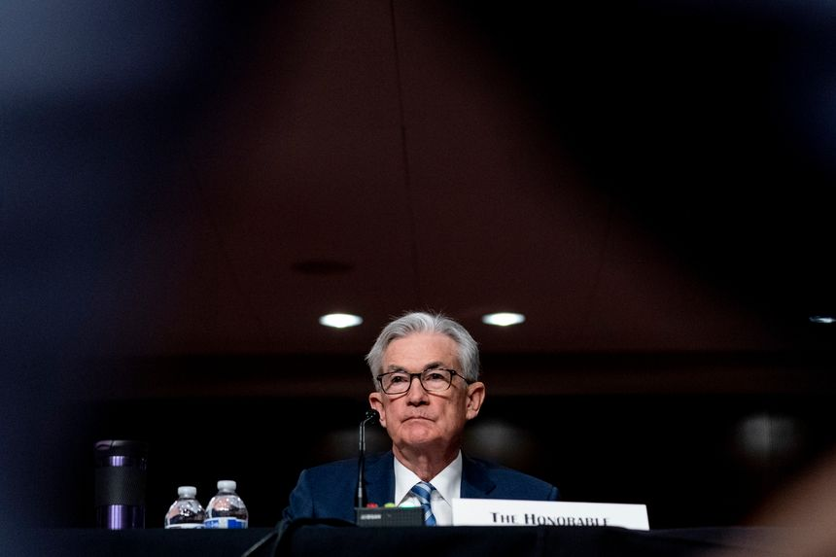
This represents a fairly significant policy change which had been signaled in testimony Chairman Jerome Powell gave to Congress two weeks ago. The shift reflects Powell's acknowledgement that with inflation pressures rising, the Fed needed to begin tightening credit for consumers and businesses faster than he had thought just a few weeks earlier. The Fed had earlier characterized the inflation spike as mainly a “transitory” problem that would fade as supply bottlenecks presumed to be caused by the pandemic were resolved. The “transitory” term has been completely eradicated from any Fed statements and policy now.
Mr. Powell was asked at his news conference what specifically had caused the Fed to pivot to a tighter credit policy. “It was essentially higher inflation and much faster progress in the labor market," he said. “There’s a real risk now," Powell stated, “that inflation may be more persistent and that may be putting inflation expectations under pressure, and that the risk of higher inflation becoming entrenched has increased. I think part of the reason behind our move today is to put ourselves in a position to be able to deal with that risk.”
On Wall Street, stock prices rose gradually and then surged after the Fed issued its statement, and Powell began speaking at a news conference. By the time Powell finished, the Dow Jones Industrial Average had jumped more than 380 points. Remarkably, the tech heavy NASDAQ index surged more than 500 points off of its inter-day low, an almost 4% swing. That is a very rare one day move.
FOMC officials said they expect inflation to cool by the second half of next year and they project a drop to a rate of 2.6%. They cited gas prices which have already come off their peaks and supply chain bottlenecks in some areas that are gradually easing. Additionally, government stimulus payments, which helped spur a spike in spending that simultaneously boosted inflation, aren’t likely to return in the near-term.
The biggest risk to the “rosy” scenario that the markets responded to today would be if the Fed waits too long to raise interest rates causing inflation to surge out of control. It might then induce The Fed to act aggressively to tighten credit (by raising interest rates rapidly) and potentially trigger a recession. Unfortunately, this has been a problem in the past with delayed FOMC reactions to persistent inflation.
For now, Mr. Powell insists that “fundamentally the consumer is really healthy, and we expect personal consumption expenditures to be pretty strong” in the current fourth quarter of this year, continuing into 2022.
Our strategy is to continue with the asset allocation strategy that has successfully provided double-digit growth in the portfolios this year while remaining very focused on historically reliable indicators that forecast looming economic problems that might ultimately lead to a recession.

