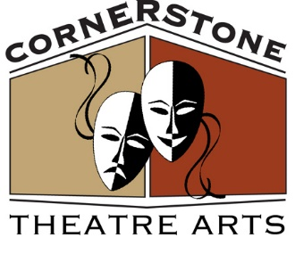
Ken Tschan, Artistic Director
THE GOSHEN MUSIC HALL
223 MAIN STREET
GOSHEN, NY 10924
(845) 294-4188 (BOX OFFICE)
WWW.CORNERSTONETHEATREARTS.ORG
https://www.facebook.com/Cornerstonetheatrearts

PRESS RELEASE
(For Immediate Release)
May 2, 2019

An Inspector Calls at Cornerstone Theatre Arts, Goshen NY
Cornerstone Theatre Arts will present An Inspector Calls written by J.B. Priestley and directed by Bruce Gluckman on June 1, 2, 7, 8, 9, 14, 15 & 16. Fridays and Saturdays at 7pm Sundays at 2pm. “In an industrial city, a young girl commits suicide and an inspector calls on an eminently respectable family, subject to a routine inquiry in connection with the death. The family is closely knit and friendly…or are they?” 1994 Tony Award Best Revival. Reservations are required. Please call (845) 294-4188. $15 Admission is payable at the door. Cornerstone Theatre Arts is located at 223 Main Street, Goshen NY 10924, 2nd floor walk-up. This project is made possible, in part with funding from Orange County Tourism, County of Orange. www.cornerstonetheatrearts.org and https://www.facebook.com/Cornerstonetheatrearts

The cast list is as follows:
PERFORMER CHARACTER
Drew Nardone------------Arthur Birling
Marianne Ciuffetelli------Sybil Birling
Sara Johnson-------------Sheila Birling
Sam Sherlock-------------Eric Birling
Anthony Tether-----------Gerald Croft
Ted Odell-------------------Inspector Goole
Victoria Ford---------------Edna

