Wolf Hollow HOA Newsletter
Hello Neighbors, the board and I are working very hard on a variety of projects to better enhance our neighborhood. This newsletter is the first step in sharing information with you our neighbors and members of the association. Over this first year with homeowner control of the association we hope to establish a few key things.
First, we have setup a wolf hollow neighborhood Facebook page, see details later in this newsletter. Second, we have set up www.wolfhollowhoa.org as a website to better inform you to what is happening in our neighborhood and to keep you up to date and as resource for information regarding the association. Third, we are getting informed about our duties as a home owners association, what we need to be in charge of in regards to maintenance and upkeep as well as what we do not have to maintain. Lastly we are trying to establish some community involvement events to help bring us together as a neighborhood, these may include summer picnic, or event, holiday lights and or decoration contests just to name a few.
Can I get involved? Yes as a board we would love member involvement. Some positions we would love to have volunteers for: newsletter editor, website host/editor, landscape beautification, photo archiver-editor just to name a few. Want to get involved, email me at gregorygoke@gmail.com
You may ask yourself, why do we have a neighborhood home owners association? Our job as voluntary members of the board is to ensure all homeowners are operating under the same set of rules and guidelines as well as manage our home owner’s dues with diligence and care. These dues go to protecting everyone’s rights as home owners, providing community events or community enhancement projects and maintenance of common areas that include the median areas on wolf hollow road and the newly established retention ponds in the neighborhood.
Who is on the board? We currently have 4 members of the board, Greg Goke (President), Chad Coogan (Treasurer), Matthew Greuel (Secretary), Ken Turba (Vice President). All of us are homeowners in the neighborhood with vested interest in keeping our neighborhood the best it can be.
When as a homeowner do I need architectural approval? (Form available on website)
The rule of thumb that is used, is that anything STRUCTURAL would need ACC approval. That would include typical installations of decks, pools and fences as well as play structures, stone walls and PERMAMENT changes to the exterior of the home (additions, arbors, gazebos, etc.).
Non-structural items such as landscaping, patios, painting and even fire pits are personal choice items and we do not legislate choice or taste. Awnings are a grey area, as they can be easily removed from the home so typically do not need approval.

Did you know that Wolf Hollow is a covenant-controlled community?
For those unfamiliar, this means there is a document that outlines the standards to which all lots must conform. These regulations are there to protect both persons and property, while maximizing property values. As a board, we went through the covenants document and while there are numerous covenants, we wanted to clarify several requirements to make sure everyone is aware.(full covenant pdf on the website)
3.1. For all building improvements, the owner must submit their plans to the developer or architectural review committee for written approval. Right now, the developer still has this right. Owners should use the form found on the wolf hollow home owners’ association website to obtain approval. As a note, improvements shall include, but not limited to, play structures, fences, patios, decks, and swimming pools.
3.10 No pit bull or Doberman, in whole or in part, may be kept on any lot or out lot within the property. No freestanding kennels shall be allowed.
3.11 Any permitted accessory structure or building must be sided and roofed like the principal building on the lot.
3.14 Parking of commercial or service vehicles owned or operated by residents within the property is prohibited unless such vehicles are kept in garages.
3.14 Storage of boats, travel trailers, mobile homes, campers, and other recreational vehicles within the property is prohibited unless kept in the garage.
3.14 Parking of more than two (2) vehicles in the driveway or on the street within the property, by the residents or owners of any one lot shall be prohibited
3.18 No plastic or chain-link fences shall be allowed at anytime
3.20 No building or other improvement, or trees, shall be erected, placed, or planted within any utility easement
3.37 No downspouts shall drain onto any sidewalk or driveway
While some of these covenants may seem restrictive, they are in place for the benefit of the community as a whole. Furthermore, covenants like 3.20 or 3.37 are enforceable by the village. Moving existing structures or trees can be expensive so knowing these regulations ahead of time can save both money and a headache.
The previous list does not reference any particular homeowner or situation, we as a board do not want to tell a fellow homeowner that they have violated a rule and must comply, but everyone should look at and understand that the covenant is in place and needs to be followed by all that reside in the Wolf Hollow Neighborhood.
Lastly neighbors, did you know that we now have a neighborhood Facebook page?
Please look us up and like our page to stay up to date on all your neighborhood news from the board.
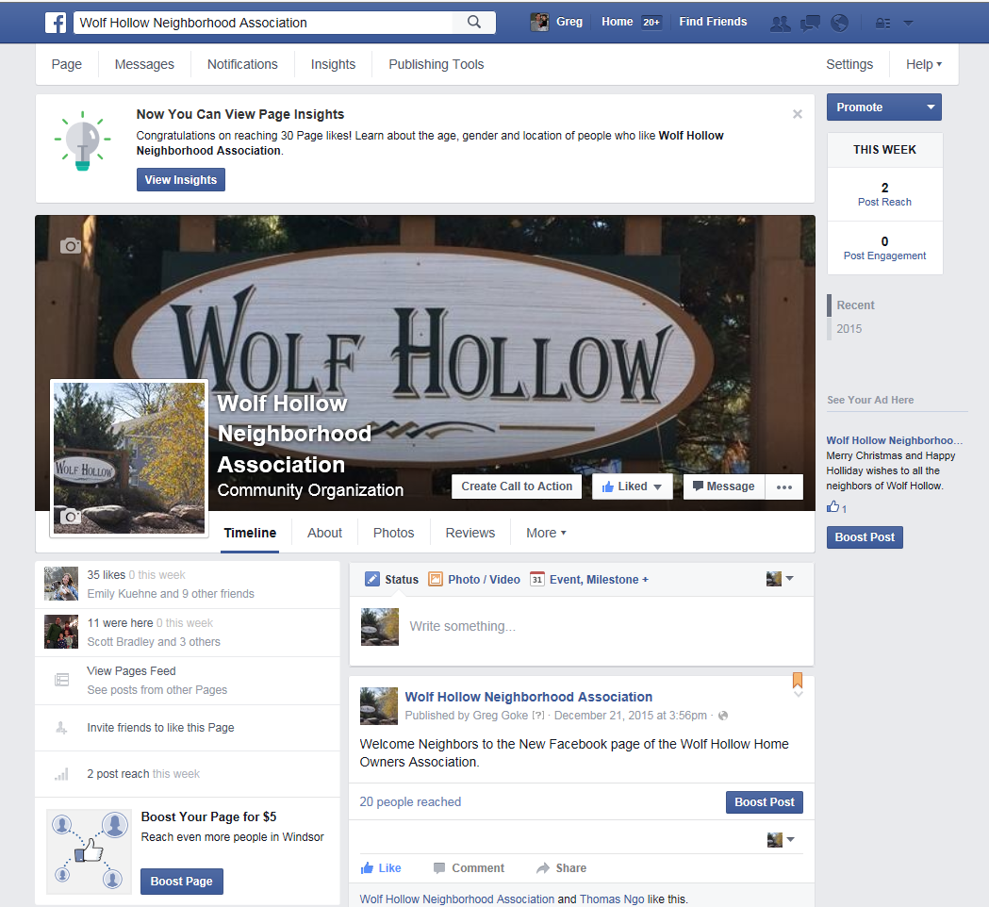
Thank you for your support and involvement.
Sincerely, your President
Greg Goke
gregorygoke@gmail.com
Feb. 2016

