Table of Contents

Introduction Page 2

Study Area and Conditions Page 2

Methods of Observation Pages 2-3

Results Pages 3-4

Club Member Surveys Page 5

Individual Food Plot Examinations Pages 5-7

Notes on Plantings Pages 7-13

Photographs Pages 14-16

Cost Information Page 17

Jump Reports Summary and Graphs Pages 18-21

Camera Observations’, Locations, and graphs Pages 22-26

Observations on the Use of Food Plots and Cover Plantings on Elizabethtown Beagle Club.

John Gibble and Clark Hammaker

Introduction: Beagle clubs and owners of running pens employ various efforts to improve the habitat of their lands for rabbits in order to maintain sufficient game for training and field trials. In addition to routine brush cutting, construction of cover, maintenance mowing, application of soil amendments, and supplemental feeding, many clubs plant a variety of forage, crop, and cover species to enhance rabbit habitat. In November 2009, Elizabethtown Beagle Club was awarded $1,400.00 by the National Beagle Club through the Purina Parent Club Program to establish and evaluate the use by rabbits of a variety of plantings. Observations of use were made by three methods. Game cameras were placed to photograph the use of food plots by rabbits and other species. Club members submitted surveys based on the number and location of rabbits jumped. Food plots were examined for signs of physical use such as browsing, fecal pellets, and other evidence.

Study Area and Conditions: Elizabethtown Beagle Club is located in Lancaster and Lebanon Counties, Pennsylvania. Seventy acres are enclosed with 4-foot vinyl-coated wire. This location receives an average of 44 inches of annual precipitation. The growing season (when soil temperature at 6-inches below the soil surface remains 41 degrees or higher) generally runs from March 28 through October 30. Approximately 85% of the club has a north or northwest exposure. Soils consist of heavy clay with a seasonal high water table. The club grounds are interspersed with large to medium diabase rocks which severely limit cultivation and mechanized land-clearing. Cover consists of cutover timber with the last commercial cutting occurring in 1992. There are numerous paths, clearings, and food plots and the club is bisected by a high-voltage electric transmission line.

The study period generally lasted from April through December, 2010. The winter of 2010 was recorded as having one of the five highest cumulative snow totals and one of the three coldest recorded for this area. There was a week long period of record high temperatures in early March which caused vegetation to reemerge early. This period of high temperatures (75-80 degrees) was followed by an atypical cold, wet spring season that lasted into early June. Snow was observed on May 12, another record for this region. This cold, wet period delayed planting of many crops evaluated in the study. Summer was extremely hot and dry. There were two distinct drought periods, one lasting four weeks from mid-June through late July. The second drought period lasted from early August through mid-September. Temperatures in June and July exceeded 100 degrees for several days. The summer of 2010 was recorded as one of the five hottest in history for this region.

Methods of Observation: Use of food plots was recorded by three methods: Photographic observation by “game cameras”; direct observation by club members of where rabbits were either observed or discovered by their beagles; and observation of evidence of grazing, fecal pellets, and runways.

Cameras: The club purchased three remote game cameras, memory cards, and batteries. Cameras were employed for various lengths of time to watch food plots and record wildlife using those food plots. Cameras were in use from May through October. Captured images were downloaded, examined, and the species photographed was recorded. Club member Clark Hammaker was instrumental in monitoring and maintaining the game cameras, as well as interpreting the data. While cameras provided a “round-the-clock” record of use, there were certain drawbacks that limited their effectiveness. Once vegetation grew to 3 or 4 inches in height, observations of smaller animals became difficult. Also, windy conditions would cause the camera to trigger by the movement of background leaves or branches. For purposes of comparison, cameras were left in some areas longer than others. In some instances cameras were placed on a food plot for a period, moved to another food plot, then moved back to the original food plot. If we were to do this over again we would try to collect data in a more orderly manner, placing cameras for a pre-determined period of time on each food plot to be sampled.

Club Member Observations: Beagle club members were provided with a survey sheet which they could voluntarily fill out after running their dogs. In addition to general information, such as the member’s name, date, and time of day, the survey sheet included a map. Club members were asked to generally map where rabbits were encountered during their training session and provide general comments as to the location of the rabbits jumped.

Direct Observations: A more comprehensive examination of food plots throughout the club was conducted in spring or early summer; late summer or early fall; and again in late October or November.

Plant Species: Plantings included the following: Winter wheat, spring oats, sorghum-sudan grass, orchard grass, tetraploid perennial rye grass, Durana and Patriot clovers, and a commercial brassica mix. Observations were made on new plantings as well as established plantings. Comments on establishment of food plots will be included as a separate section under results.

Results:

A total of 112 photographic images were captured on the game cameras. These included 44 cottontail rabbits, 39 white-tailed deer, 17 groundhogs, 4 turkeys, 6 fox, and 2 house cats. Cameras were placed for various periods of time in different areas. Having cameras placed in some locations for longer periods than at other locations may skew results. Camera placement and view from the camera may have resulted in greater or fewer observations of cottontails. For instance, some food plots had good brush cover surrounding their edges while other plots may have been unattractive to cottontails because of exposure and lack of approach cover. Plot 2 was planted to Patriot clover but was located on the power line right-of-way where approach cover was non-existent. Plot 8 was also planted to Patriot but had better surrounding cover. Cameras observed one rabbit on Plot 2 but had 7 images recorded from Plot 8. Table 1 shows the breakdown of observations by species of animals observed and by plot.

Table 1 Species Observed on Camera by 10 Plots Various Crops

Rabbit Deer Groundhog Turkey Fox Cat

1.Durana 18 3 8 1 0 0

2.Patriot 1 3 1 0 0 0

3.Patriot 10 3 2 1 0 0
4.Winter 7 1 0 0 0 0
Wheat

5.TPRG 0 2 3 2 0 1

6.TPRG 0 11 0 0 0 0

7.TPRG 0 6 0 0 0 0

8.Patriot 7 8 2 0 4 0

9.TPRG 0 2 0 0 0 0

10. Orchard 1 0 1 0 2 0

Club Member Surveys: Five club members submitted a total of 27 survey sheets from May through September, 2010, recording 86 rabbits jumped. In May there were four survey sheets submitted; five for June; seven in July; six in August; and five in September. Table 2 lists rabbits jumped by month based on the survey forms.

Table 2 Rabbits jumped and association with food plots

May(4) June(5) July(7) Aug.(6) Sept.(5)

Total Rabbits 19 16 23 17 11

Rabbits in
Food plots 10 11 15 12 3

Rabbits per
Outing 4.75 4.0 2.57 2.83 2.2

Based on the data in the Table 2, it appeared that in all months except September cottontail rabbits were found in the vicinity of food plots and it can be assumed that food plots increased the predictability of finding rabbits. The inverse association with food plots observed in September may be a result of a seasonal shift in food habits or behavior patterns. The significant reduction in rabbits jumped per outing may be a result of a declining rabbit population or rabbits becoming less associated with areas where they were more easily jumped.

Individual Food Plot Examinations: Observations of use of individual food plots, including those food plots not monitored by camera, lent additional information on the value of food plots to the rabbit population and use by other species. These observations included walking over the food plots checking for signs of browsing (clipped leaves or leaf blades, chewing of basal stems, etc…) and recording other signs of regular use such as fecal pellet deposits. Table 3 enumerates forage and crop species planted and the number of plots planted to each.

Table 3

Crop | # plots | Comments on Use
Spring Oats | 2 | Oats were used as a nurse crop for several plots. Use recorded by the jump survey was high. Signs included stem cutting, browsing on leaf blades, and fecal pellets. Use was high from within 3 weeks of planting to well after fruiting.
Winter Wheat/Rye | 5 | Jump survey use was low. Some fecal pellets observed. Feeding on leaf blades and seed not nearly as high as with oats. One plot infested with chickweed received regular use, rabbit observed feeding on chickweed. Early fall use by rabbits and deer based on direct browse observations.
Sorghum-Sudan Grass | 3 | Planted as cover. Occasional use noted in one plot. Significant fecal pellet store in a second plot. During field trial three rabbits jumped from third plot. Late fall use seemed sparse.
Patriot Clover | 5 | Favored food species supported by jump and camera data. Difficult to assess use by direct observation though groundhog and deer browse heavy during growing season, especially late summer and early fall until frost-kill in November.
Durana Clover | 1 | Highly preferred forage based on camera and jump data as well as browse evidence and fecal pellets.
5-Clover Mix | 1 | Newly established plot required frequent mowing. Little surrounding cover probably limited use. Few fecal pellets observed in July survey.
Orchard Grass | 6 | Regular use throughout growing season. Heavy feeding on basal crowns noted in November. Spring nesting cover, preferred and persistent winter feed.
Tetraploid Perennial Ryegrass | 5 | Camera and jump survey did not indicate heavy use. Stands attained 9-12 inch height which may have impeded camera observations. In July, 4 out of 5 plots displayed signs of use including fecal pellets and browsing. In January 2011 deer had created large clearings through 10-inches of snow to access grass.
Whitetail Wintergreens-Brassica mix | 2 | Planted October 11, 2010, never developed sufficient mass to prove attractive. Deer did browse on some of the growth but no evidence to support use by rabbits.
Birdsfoot Trefoil | 1 | Late in establishment. Drought setback. No use observed.
Mix of oats, orchard grass, durana, tprg | 3 | Attempted to establish several of these plots. Required frequent mowing to reduce competition. Little use observed through summer. Plantings did establish with varied degrees of success in late September.
Patriot/Tetraploid mix | 5 | Moderate use. Poor performance due to high water table on most of these. Two plots had high use based on fecal pellets in May, June, and July. Use seemed associated with adjacent cover.
VA-70 Lespedeza | 3 | One plot was successful with transplants. In fall and winter branch ends browsed and bark stripped from basal crowns. Insufficient stand to determine use.

Discussion: Based on the collected observations, it appeared that establishment of food plots increased the predictability of where rabbits can be found on club grounds. Observations did not indicate that food plots increased the rabbit population on the club grounds. From the jump survey data it appeared that either the rabbit population declined or rabbits shifted their feeding behaviors in late summer and early fall. The jump survey indicated that more than half of all rabbits encountered during spring and summer months were associated with food plots.

Based on the camera and jump survey, clover plantings appeared to best increase the predictability of rabbit locations. The one winter wheat/rye plot observed had 7 rabbits observed, but it should be noted that observations were made after the wheat had matured and it may be more likely that rabbits utilized the cover and fed on volunteer plant species such as chickweed. With wheat and rye there were no stem cuttings or fecal pellet stations observed as with spring oats.

The jump survey indicated that clovers were again the best place to find a rabbit. Orchard grass and oats plots were the next best places to look. The individual food plot examinations supported that clovers, oats, and orchard grasses were popular plantings.

Notes on Plantings:

Patriot Clovers: A ladino and white clover hybrid. Patriot food plots were established in 2006 by frost seeding over winter wheat in March. Patriot performed well when planted on moderately to well-drained soils and frequently mowed. Green-up was observed in April, but mid-summer performance was only moderate. Patriot remained dormant during hot weather and greened up again in September and lasted well into December. Stands of Patriot lasted well for three years when tended. Where challenged by high water table and soil saturation performance was compromised. Several plots deteriorated due to invasive grasses and infrequent mowing. One plot had a great deal of fescue growing on it. A half-strength application of glyphosate herbicide was made in May which greatly reduced fescue coverage while clover coverage was increased (clover foliage burned only and recovered). Patriot clover scored high in the camera survey and jump survey, but indirect evidence was difficult to obtain due to frequent mowing.

Durana Clover: is another Ladino and white clover hybrid. It is advertised to spread rapidly, produce more stolons, and compete with other plantings and invasives. We made one planting of pure Durana clover and mixed it with grasses in other plantings. For the pure stand the area was sprayed with glyphosate herbicide. A cover crop of oats was disked in, then Durana broadcast over the soil surface. Germination was fair. By midsummer Durana clover cover was only about 30% but coverage increased in autumn once cool, wet weather started. Likewise, in the mixed plantings with grasses, Durana had only minor coverage throughout most of the growing season but greatly increased in percent coverage in October and November. Intense use by rabbits, deer, and groundhogs inhibited spread during the growing season. As root stock matured in fall it is anticipated that spring coverage should be much better. Durana scored high in all three survey categories with the highest single plot total for camera observations, jumps, and indirect observations of browse and fecal pellets.

Birdsfoot Trefoil-Trefoil is a low-growing legume with a bushy habit and yellow, pea-like flowers that develop in July. Some trefoil was included in erosion control plantings when logging occurred on the club in the early 1990s and persisted in mowed areas. A recent article in a farming magazine noted that cattle pastured on tall fescue seemed to target associated stands of birdsfoot trefoil and that trefoil acted as an antidote for fescue toxicosis. Birdsfoot trefoil also seems to tolerate extreme wet and dry conditions as well as heavy clay soils. One plot was selected for a pure stand of trefoil. This plot is generally too wet to grow other crops (winter wheat and oats have failed on this plot). It is located on the powerline right-of-way and just several yards from being under a transmission line tower (a hawk perch). The location may have limited use of this site as no rabbits were observed to use this plot. The plot was planted on May 3 by broadcasting seed over disked ground. Germination was slow and seedlings observed in July and August were still unbranched with only a few leaves persisting. Observed in November, seedlings were about 4-inches high, coverage approximately 80%, and it appears the stand will do better next year. This plot was mowed about once a month to discourage competition from ragweed, foxtail grass, and other invasives.

Tetraploid Perennial Ryegrass: TPRG Tonga variety was planted on a number of food plots beginning in the fall of 2008 through 2010. Plantings in October 2008 germinated well, overwintered well, and have exhibited continued good growth. Three areas were frost-seeded, over existing clover plantings in March 2009. The TPRG coverage on these areas has been moderate to good and the plantings, if mowed regularly, appear to coexist well. Plantings were also made in April, 2010 in mixed plots with orchard grass. In mixed grass situations the TPRG seemed easily outcompeted by taller vegetation. We did use left-over seed in spring 2010 which may have depressed germination rates. On October 11, 2010 we made several more plantings using the Boost variety of TPRG. Germination to date has been very good to excellent.
Generally, TPRG was broadcast seeded over well-disked seed beds, ideally just prior to a rain. As noted above, we did try frost-seeding which resulted in moderate results. In October 2010 we used a commercial lawn seeder which consisted of a drop seeder with cultipacker attachments. This seemed to provide good coverage and good germination. However, the seeder was not wide enough to provide full coverage on the paths where it was used and the rate of seed drop was about the same as if we had used a broadcast seeder.

TPRG seems to do exceptionally well on well-drained sites. On poorly drained sites TPRG exhibited acceptable germination and coverage. If mowed regularly, TPRG seemed to be persistent and stands were resistant to invasion. Fertilizers were applied when individual plots developed chloritic leaf blades (pale or yellowed) or if basal leaves appeared rusty. In its first years, TPRG would develop a good network of basal crowns with leaf cover up to 9-inches in height. The leaf blades lay over or become prostrate discouraging competitor weed growth. Our only problem with cultivating good stands was infrequent mowing. When allowed to fully develop to seed head, there was a great deal of mass produced when stands were mowed. This either needs to be chopped finely or raked off, as TPRG did not tolerate being covered and did not sprout through the duff. Where it accumulated, the duff created bare spots which allowed other grasses and weeds to invade.

TPRG scored poorly on the camera survey and poorly on the jump survey. Indirect observations indicated fair to high use, especially later in the season where plots had been heavily browsed and fecal pellets were found in several plots. Use by deer was recorded on the cameras and by indirect evidence. In January 2011 it was observed that deer had dug through 10-inches of snow, creating open patches measuring six to ten feet in diameter to access TPRG.

Orchard Grass: Orchard grass is a long-time favorite pasture grass. It grows to 18-inches in height, producing a pronounced basal clump. We chose orchard grass based on observations of rabbit use in past plantings. Distributor reviews indicate good digestibility and protein content in early spring. We noted that orchard grass greens up in mid-spring, seeds in early July, experiences a pronounced dormancy through early September, re-greens in fall, and then remains greened well into December. Based on observations of browsing, rabbits, voles, deer and other animals will dig through snow to browse on the basal crown throughout winter months. The clumped growth habit in prior plantings appears to provide ideal nesting and nursery cover.

We planted orchard grass on several food plots with the idea of retiring those areas from active cultivation. Generally, after an area was cultivated for several seasons to remove perennial weeds in the soil seed bank, the plot was disked, seeded with oats, disked again lightly, then orchard grass was broadcast. Germination was generally excellent on all plots planted. Depending on the germination rate of the oats, oats were either mowed off when their cover began to close in or after die-off (allowing rabbits to utilize the oat seed). A plot planted in October 2009 exhibited excellent germination. That area was nearly bare except for several isolated brush piles. Based on pellet deposits, browse evidence, and jumps, the area was well-used by rabbits despite the lack of heavy cover.

Plantings in 2010 were barely formal. Because we had a volume of seed, it seemed that orchard grass got thrown all over. Plantings in April germinated well. Several plots were not sprayed with herbicide prior to planting and were not sowed with a cover crop. This resulted in an invasive weed problem that seemed to hold back the seedings. Success was further hampered by the exceptionally hot dry periods in June and July. We were about to write off many of the spring plantings of orchard grass but in October and November, many of these plots seemed to rebound. Others that were having difficulty early in the season were mowed several times allowing the orchard grass to take better hold.
In late June 2010 we had several food plots that had been cleared the prior winter but we were late in getting around to cultivating them. These were seeded with whatever we had on hand, mostly orchard grass and a few handfuls of clover or TPRG. They were first seeded with sorghum-sudan grass. We expected that the grasses wouldn’t germinate well due to the advanced date of planting. Good germination was achieved even under the cover of the sorghum-sudan grass.

In August 2010 part of a newly cleared fence line was broadcast seeded with orchard grass. With a few rain events, germination was very good. Growth appeared satisfactory through the fall until leaf off. When the seasonal high water table came up, a good area of this fence line planting suffered water stress due to ponding and saturation to the soil surface. It remains to be seen if these poorly drained areas will overwinter.

Switchgrass-Cave-in-the Rock variety: Switchgrass can be difficult to establish. Our purpose in planting switchgrass was to provide cover and warm-season forage for rabbits. A club member had tried to establish a stand several years prior but was disappointed that after the first year he had little coverage. Despite repeated cultivation some coverage is developing after five or six years. In our observation plots we planted switchgrass over oats in April, 2010. After the oats died back in early July, the plot was overrun with ragweed, various asters, dock, and goldenrods. A spraying of 2,4d herbicide in July reduced some of the herbaceous weed cover. A fair number of switchgrass seedlings were observed by the end of the growing season. It appears that once green up starts in 2011 these seedlings will increase their coverage.
Again, we broadcast switchgrass seed on the disked test plots. Literature seems to indicate that use of a seed drill is preferred to enhance germination. On some newly cleared areas we simply threw a handful of switch grass over bare soil and amongst brush piles. Some of these areas exhibited moderate germination and seedlings were present at the end of the growing season. Insufficient coverage of switchgrass was achieved to produce any observations on use.

Sorghum-Sudan Grass: This hybrid is a forage plant designed to produce a great quantity of mass in a short period of time. In our climate, the plant matures in late September, producing a small seed head before turning brown and dying off. In some climates, if regularly mowed, the plant can be grown as a perennial forage source. It should be noted that the green plant contains high levels of prussic acid which may disrupt digestion in horses. While suitable for cattle feed, it is not recommended for horses, and its best feed value occurs after lightly frosted.
The club had experimented with this plant in the past, as well as pure sorghum plantings. Generally, hot weather and at least one application of fertilizer were required for any type of success. Usually seeding was too dense resulting in stunted plants. Our use for this plant was a quick source of abundant cover and a means of suppressing weeds in newly cultivated areas.
In 2010 the seed arrived late and was not planted until the third week of June. We figured to get a short growth. Seed beds were disked well, the seed broadcast, and then the area was disked lightly again to cover the seed. To avoid over-seeding we mixed the sorghum-sudan seed with oats about 1:1. Despite the extremely hot weather and total lack of rain, germination was excellent and growth was outstanding. By the end of July several areas had cover 4-6 feet high, by the end of August, some stands were up to 14ft. By early October seed heads had formed and the plants had browned off.
In our jump surveys it was noted that rabbits were using the sorghum sudan grass for cover. During our licensed field trial one patch yielded three jumps in one day. The fecal pellet survey indicated that rabbits were using the cover and browsing on the orchard grass and other plantings that were coming up under the shelter of the sorghum-sudan grass. We also noted that when the seed heads started bowing over, deer would browse on the seed heads.
Based on these observations, sorghum-sudan grass appears to be a valuable planting for a quick cover source which lasts well into the winter months. It also clears the seed bed of weeds for future plantings, and produces a quantity of seed that song birds seem to enjoy. It does appear to thrive in warm weather, and our past poor success likely resulted from planting too early and not applying a fertilizer at planting or shortly after germination.

Winter Wheat/Winter Rye: Traditionally we have used these plants to provide winter food, early spring cover, and early summer grains for food. We also use these as cover crops/nurse crops for clover and grass plantings. The winter wheat we planted in October 2009 appeared to be well stocked with winter rye seed, as well. Cameras placed on the winter wheat plantings and the jump surveys indicated some use of the winter wheat. It also appeared to be lightly browsed in early spring months. Notably, one plot was invaded with chickweed. Often in March, April, and May I would observe a rabbit in this plot long enough to watch what he was eating. Invariably, the rabbit was feeding on the chickweed and not the winter wheat.
Again, we plant these by broadcasting over a well-disked area, then lightly disking again. Germination is usually very good. It appeared that use increased after the seed heads matured in early July. In October 2010 we planted winter rye on several food plots. We did not have time to disk heavily prior to seeding and germination seems to have suffered as a result. This may have been a result of poor contact with the soil or by cool, wet weather.

Oats: We have used oats as a stand-alone crop and as a nurse crop for grass or clover plantings. While a number of varieties are available, we generally buy feed-grade oats from the local mill and plant those with excellent results. Again, as with most, larger seeds, we disk, broadcast, then lightly disk again. Oats were planted in April after the threat of frost was over. This year’s plantings did endure some frosts. Germination on all plots was excellent. Browsing of oats began at the seedling stage. While oats seemed to keep pace with winter wheat and rye growth, and developing seed heads and drying off at the same time in early July, use by rabbits was by far, much greater for the oats than the rye or winter wheat. In all oat stands it was observed that rabbits would cut seed stems as soon as they were formed, section the stems, and then pull the seed heads to the ground to eat them.
In 2009 we had several food plots that had not been planted by mid summer. These were planted with oats and buckwheat. Oats continued to grow well into November and rabbit use was noted until a cold snap when deer browsed all of the remaining seed heads.

Buckwheat: Buckwheat was unavailable in 2010. In 2009 we made several late plantings of buckwheat in mid-July. Germination was excellent and growth was excellent during the warmest summer months. Buckwheat went to bloom within the first several weeks after germination and continued until frost in late October. Rabbit use, based on recollection, seemed highest during the warm, summer months. Deer, however, were observed at all hours of the day using the buckwheat plots. When planting in the spring it may be wise to overlook several food plot opportunities, waiting until late June or early July to seed buckwheat. Literature reports buckwheat to be relatively high in protein and very digestible. Its high moisture content may also be attractive to rabbits during the drier months.

Lespedeza thunbergei, variety VA-70 is a taller plant than sericea. It is being used as a reclamation and wildlife planting in more southern areas. Frank Lynch of Virginia first described this plant to us as it was used as cover and feed in his private running pen. USDA description of this plant recommends use for wildlife as cover, a heavy seed producer, and notes that rabbits, deer, and other herbivores eat the leaves and bark. We obtained seed via Ernst Seed Company. In 2008 a nursery was started to raise seedlings. From that nursery over 500 seedlings were distributed to other clubs and approximately 100 seedlings were hand planted on Elizabethtown Beagle club in 2009. Success of our transplants seemed to be associated with location and soil moisture. In one plot, 3 rows of VA-70 were planted in early summer 2008, and by the end of the 2009 growing season most all seedlings were at least 3 feet tall with a bushy growth habit. In three other plots which were less well-drained, seedlings seemed to languish in 2009. Regrowth in 2010 was spotty on these three plots and plants appeared pale and chloritic. At the end of 2009 deer had nipped the ends of the plants and by the end of winter 2010, the woody portions above ground had been nipped back significantly and the bark around the root base was girdled by either voles or rabbits. In 2010 a number of the seedlings did not re-emerge. Some of this may have been due to the moisture regime. It was noted that late frosts into early May caused emerged leaves to brown and fall off. Direct seeding was attempted in one food plot in 2010. Seed was mixed with other crops (oats, clover, and orchard grass) and planted on April 28, 2010. There appeared to be a 100% failure for the direct seeding attempt. This failure may have been due to using old seed (three years old). The nursery plot off-site was still full of seedlings. A dozen and a half seedlings were potted for several months and installed in another attempt to establish this plant in September 2010. VA-70 may prove to be a valuable winter food source as observed by the winter girdling of the winter-persistent, woody portions of the plant. However, dense stands would be needed to provide a significant volume of winter food.

Brassica: Whitetail Winter Greens: Directions on the bag instructed to plant this turnip/brassica mixture at least 5 weeks prior to heavy frosts. We planted three plots on October 11, 2010. Coated seed was planted with rye as a nurse crop and disked in. Germination was very good. However, development past tertiary leaf stage was inhibited by heavy frosts in mid-November and snow cover in mid-December. Deer were photographed on one food plot eating the young growth but use by rabbits was not observed. Planting in mid-September would be recommended.

Additional Notes on Planting: The study area supports a number of invasive species. Several of these species have little or no effect, or perhaps even a beneficial effect on the rabbit population. Ailanthus altissima or Tree of Heaven is quite common, and though it displaces native woody species, rabbits readily bark young saplings and brush cuttings. Japanese honeysuckle is also very common and provides heavy cover during winter periods and for young rabbits. Privet is a common, invasive shrub on the property. There are specimens of autumn olive and Tartarian honeysuckle colonizing as well.

There are, however, other species which have adversely affected rabbit populations and plantings. Mile-a-Minute vine is a recent invader. By mid-June any cleared areas are readily infested and overcome with this vining weed. Mowing, where possible, keeps the vine from crowding out plantings. Spraying with glyphosate and 2,4d herbicides set back growth considerably but allowed additional seedlings to develop. Spraying should begin in early June and several applications throughout the summer months would be needed. After June a surfactant should be added to the herbicide as the leaves will bead moisture, repelling a majority of the herbicide treatment. Rabbits appear to avoid infested areas. The only wildlife value of this plant is the blue berries it develops in August and September by which birds transport the seed.

Another invasive that overtakes disturbed areas, especially in moist and partially shaded conditions, is Japanese stilt grass. In this study and others, it has been observed that stilt grass is not grazed by wildlife or cattle. The grass proliferates in partially shaded conditions, crowding out and smothering other grasses and forbs. Again, an herbicide with added surfactant is needed for control. Other control measures would include cutting overhanging trees and brush to create more favorable conditions for other ground covers.

Finally, it was recognized that tall fescue may have a severe adverse effect on rabbit populations. It was noted that in areas with good cover and attractive plantings, the presence of tall fescue seemed a reliable predictor of poor rabbit utilization of the area. Tall fescue is known to harbor a fungus that creates gastric and circulatory distress in a variety of herbivores, and also is known to adversely affect reproductive rates and success. Tall fescue has invaded many of our mowed paths and pasture plantings to the point of becoming a dominant cover in these areas. Glyphosate herbicide is a recommended control. The club will be working throughout 2011 to reduce the infestation of tall fescue.

List of Photographs:

- Typical game camera monitoring site. Because wheat and rye plantings are so high, a strip is mowed through the middle to observe animals passing across.
- Photo shows infestation of Mile-a-Minute vine in August, 2010.
- VA-70 Lespedeza. Note larger leaflets, bushier habit than sericea.
- Typical clover plot, freshly mowed and in bloom.
- Ground cover left by CAT mulching head.
- Typical shot of newly cleared food plot.
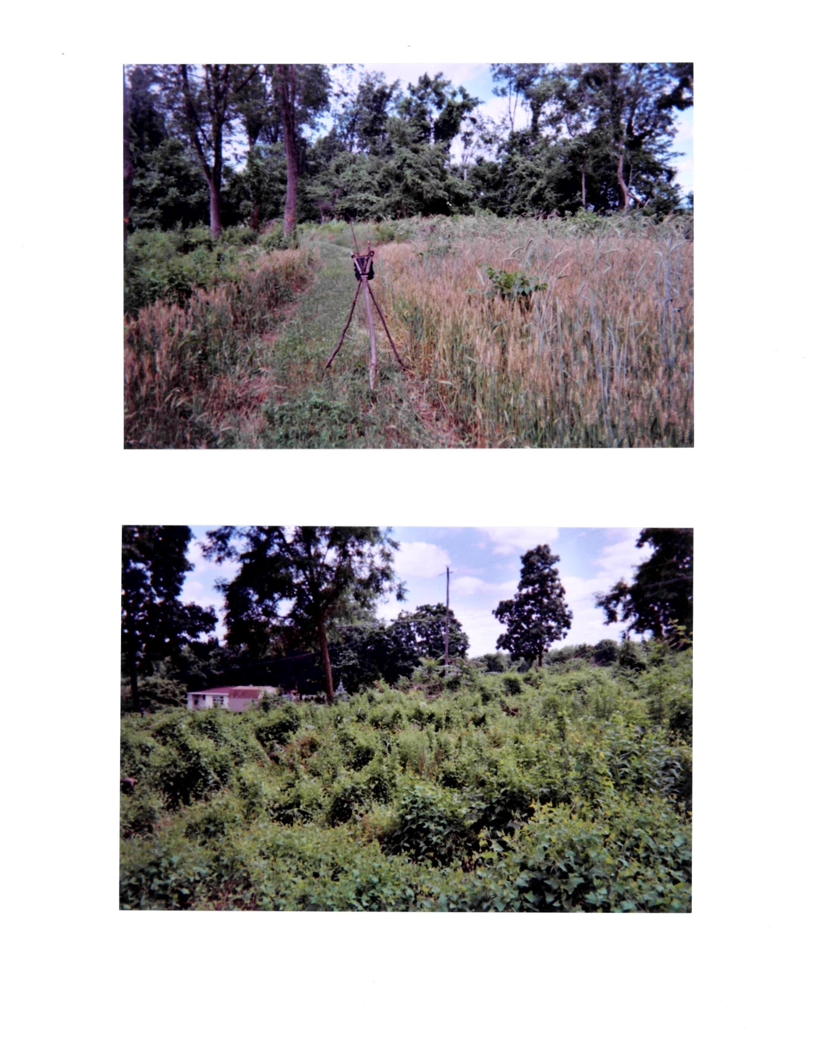
Photographs 1 & 2

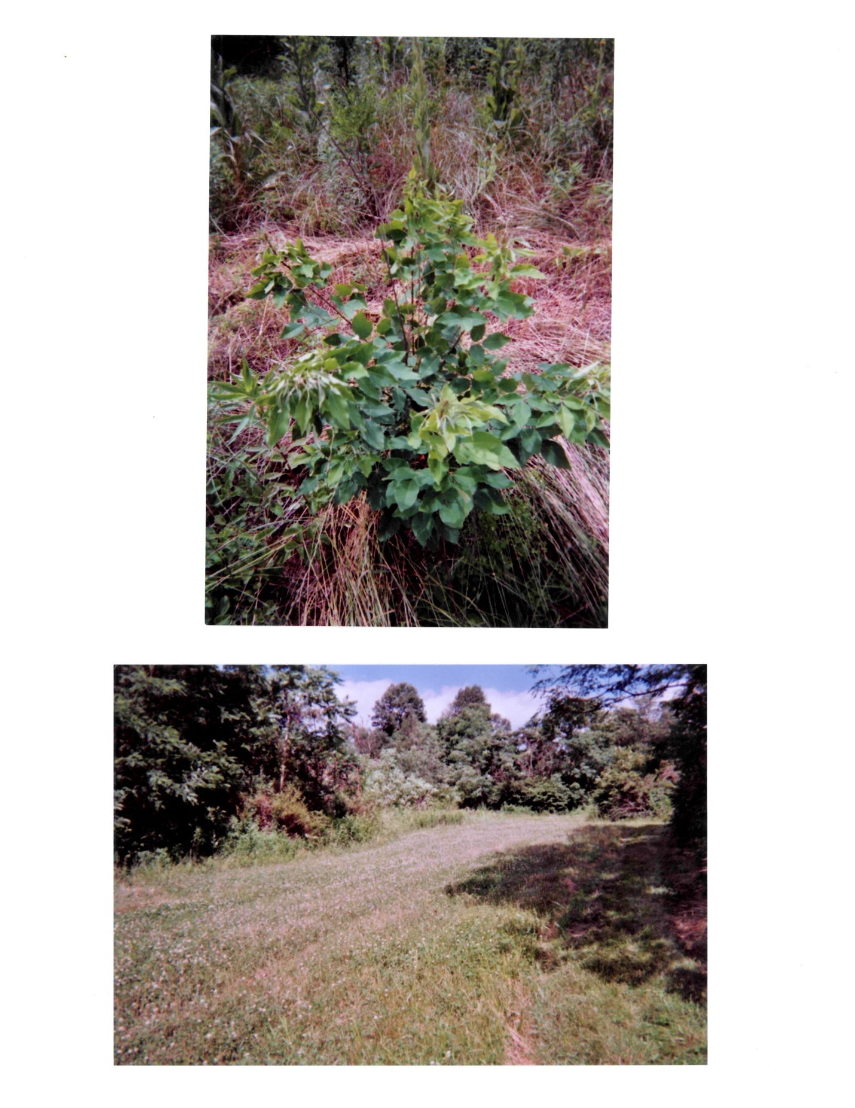
Photographs 3 & 4

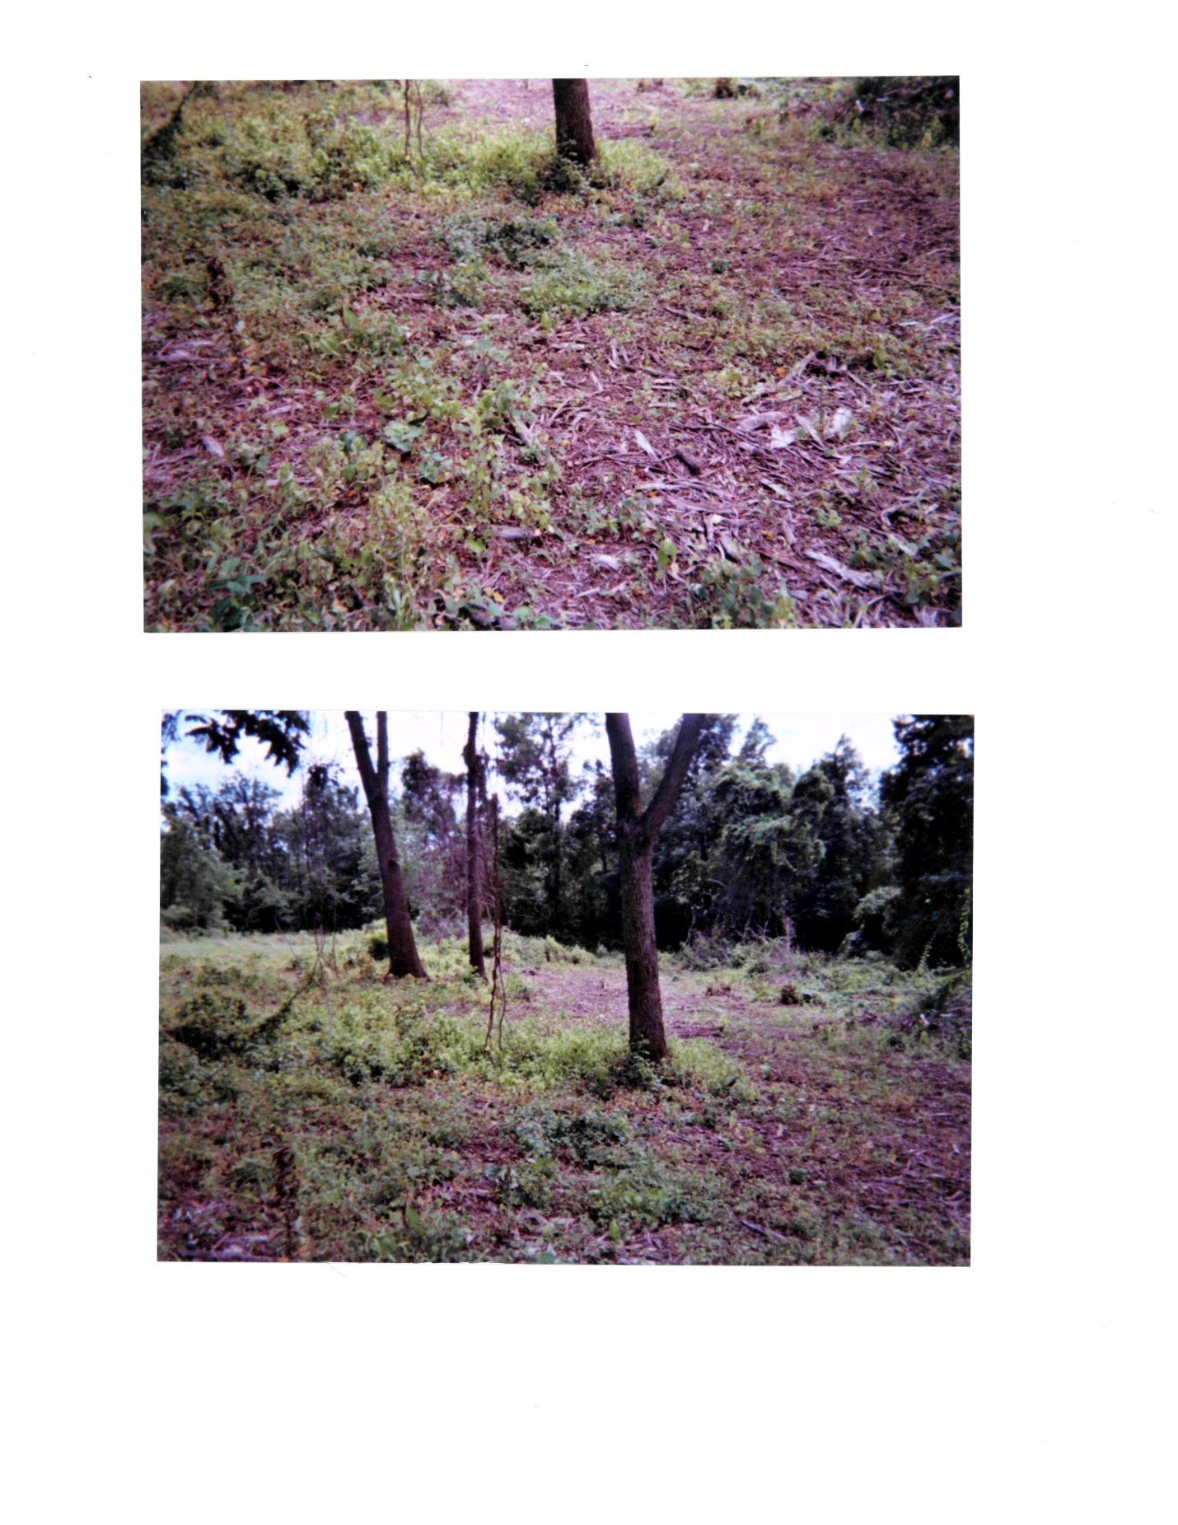
Photographs 5 & 6

Cost Information
Initially $2,800 was provided by the National Beagle Club through the Purina Parent Club Grant Program. As requested in the Grant Proposal, $1,400 was provided to Elizabethtown Beagle Club and $1,400 was provided to Lykens Valley Beagle Club. The following is a listing of expenditures by Elizabethtown Beagle Club related to the grant disbursement:

Land-clearing/Charles Flexer-CAT service $2,000.00
Lime $501.04
Game Cameras (3) $294.78
Herbicide-Bronco Glyphosate (2 @ 1.5 gallons) $148.64
Fertilizer-donated $0.00
Durana Clover 10lb $105.18
Tetraploid Ryegrass-Tonga var. 50lb $110.17
Tetraploid Ryegrass-Boost var. 50lb $85.00
Whitetail Winter Greens-5lb $19.00
Oats-feed grade 150lb $21.50
Rye-winter-donated $0.00
Orchard grass-PennLate var. 50 lb $95.00
Ladino Clover-10lb $35.00
Birdsfoot Trefoil-1lb $5.70
White Dutch Clover-1lb $4.30
Switchgrass-Cave in Rock var.-10lb $56.16
5-Clover Mix-Wildlife Nurseries- 5lb donated $0.00
Sorghum-Sudan grass-12 lb donated $0.00
Batteries for game cameras $32.44

Following are assorted tables from the game camera and jump surveys:

Jump Reports

