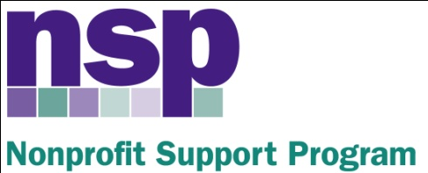

Hartford Foundation for Public Giving
Nonprofit Support Program
Building Evaluation Capacity (BEC) Program
Class of 2017, Session 3

February 24, 2017

AGENDA

DOCUMENTING SERVICE DELIVERY, DATA COLLECTION OVERVIEW, SURVEY DEVELOPMENT

8:30 | Welcome and Gallery Walk
8:50 | Documenting Service Delivery
9:10 | Data Collection Overview
9:15 | Survey Development
9:30 | Survey Critique Activity (Survey Goof – Activity B2, handout B1)
9:55 | BREAK
10:05 | Using Surveys For Evaluation Data Collection: Types and Sampling
 | Sampling Activity
10:55 | Using Surveys for Evaluation Data Collection: Admin and Response
 | Response Rate Activity
11:15 | Work Session: Survey Critique or Development + Initial Thoughts
11:40 | Introduction to Analysis
11:50 | WRAP UP Q/A (final feedback)
HW: Work on INITIAL THOUGHTS (due 3/5/17)
Development of own survey instrument (due by 4/11)

Anita Baker
Evaluation Services
www.evaluationservices.co

