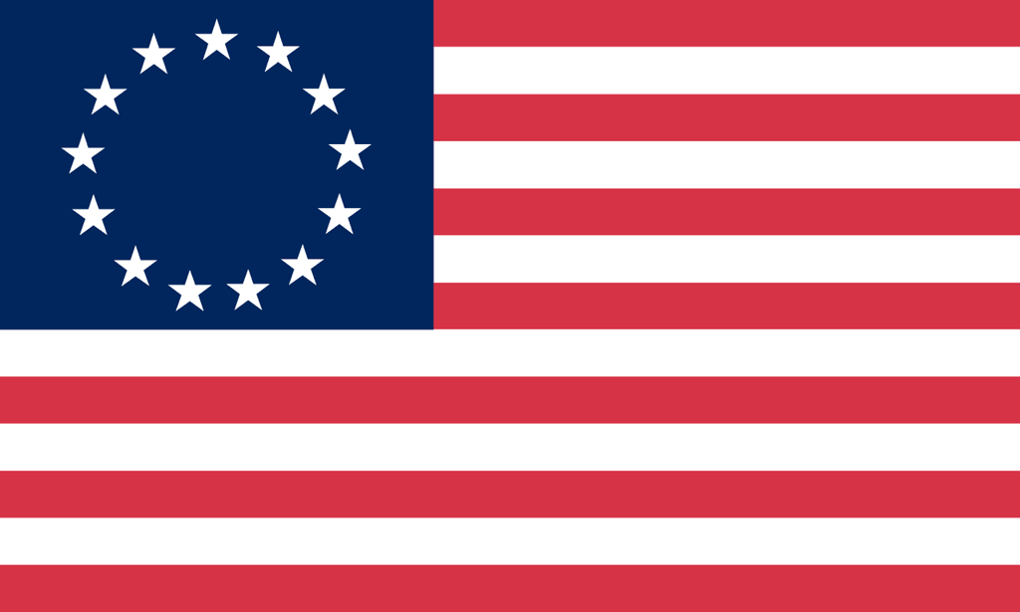U.S. History with Mr. Brown Name _______________________________ Period _____
Unit 1 Map Activity
Directions: Label and color the map
Label: Atlantic Ocean, North America, Caribbean Islands, Europe, Africa, England, France, Spain, Portugal, Netherlands, Iceland, Greenland, and Triangular Trade Routes.

