REGULAR MEETING
JUNE 18, 2020
A Regular Meeting of the Town Board of the Town of Hampton, County of Washington and the State of New York was held at the Town Hall and via Zoom, 2629 State Route 22A, Hampton, New York on the 18th day of June 2020.

Due to the Corona Virus, occupancy inside the Town Hall is limited at this time. Supervisor O’Brien did provide a link to join the meeting via Zoom.

PRESENT: David K. O’Brien------------Supervisor
Tamme Taran----------------Councilwoman
Donald Sady-----------------Councilman
Andrea Sweeney------------Councilwoman – absent
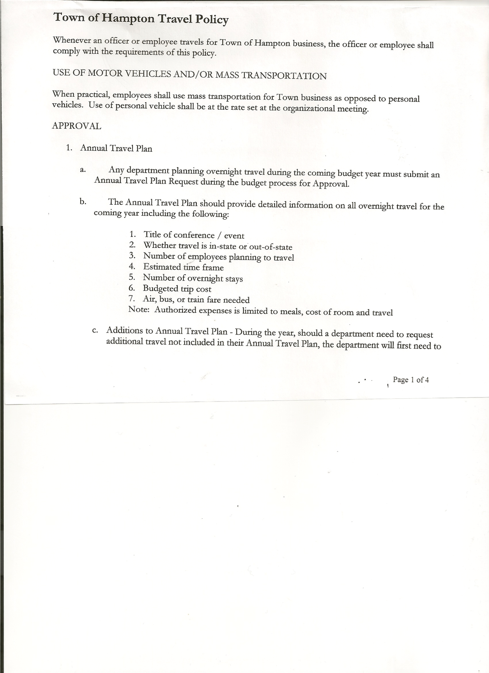
Michael Pietryka------------Councilman – via Zoom
Rebecca Jones---------------Town Clerk
Camilla Shaw----------------Tax Collector/Deputy Town Clerk
Herbert Sady, Jr.-------------Highway Superintendent

Planning Board Member(s): Bonnie Hawley, Chair; Matthew Pratt and Renee Rountree all via Zoom.

Also present: Artie Pratt

The Regular Meeting was called to order by Supervisor O’Brien at 7:30pm, followed by the Pledge of Allegiance. Location of Fire Exits were given. Quorum of board members present.

RESOLUTION NO. 50-2020
APPROVAL OF THE MINUTES
On a motion of Councilwoman Taran, seconded by Councilman Sady, the following resolution was ADOPTED:
By Roll Call Vote: Supervisor O’Brien AYE
Councilman Sady AYE
Councilwoman Taran AYE
Councilman Pietryka AYE
Councilwoman Sweeney ABSENT
RESOLVED, that the Regular Town Board Minutes for May 21st, 2020 and the Public Hearing and Special Town Board Meeting on June 4th, 2020 are approved.

Larry Carman, Dog Control Officer submitted his report, which was read by Supervisor O’Brien, copy of report is attached for 05/21/20-06/18/20.

Tax Collector’s Report – no activity. Submitted Bank Statement to the Board for review and signatures.

Bonnie Hawley, Chair gave Planning Board Report…
- Minutes of their May 13th Meeting are attached.
- Discussing doing another survey. They did one back in 2011, received 90 responses.
- Next meeting will be June 24th at 7:00pm at the Town Hall.

TOWN BOARD MEETING
JUNE 18, 2020 PAGE 2

Herbert Sady, Jr., Highway Superintendent submitted his report, copy of which, is attached.
Fellas will be working on ditching, need to contact Dig Safe NY. CHIPS work is scheduled for July 28, 29 & 30th on the Hickey Road.

Doosan Loader at Capital Tractor, Inc. was discussed. Highway Superintendent Sady found out no penalty for early payoff and no warranty because it is a used machine. Further discussed payment options. Six (6) yearly payments of $9,984.00 and then $1 at the end to purchase it. The following resolution was introduced and contingent upon having another reliable person (other than the seller) check the loader over. First payment to come from the Highway Equipment Capital Reserve Fund and then budget money yearly for the payment.
Copy of the Order of the Highway Superintendent Approving Expenditure from Town of Hampton Highway Equipment Reserve Fund is attached.

RESOLUTION NO. 51-2020
Introduced by Councilwoman Tamme Taran
who moved its adoption
Seconded by Councilman Donald Sady

TITLE: RESOLUTION APPROVING EXPENDITURE FROM TOWN OF HAMPTON HIGHWAY EQUIPMENT RESERVE FUND PURSUANT TO SECTION 6-C OF THE GENERAL MUNICIPAL LAW

WHEREAS, the Town of Hampton (the “Town”) in coordination with the Town of Hampton Highway Superintendent, previously established a capital reserve fund to accumulate moneys to finance the cost of highway equipment acquisition, maintenance and repair pursuant to Section 6-c(2)(b) of the General Municipal Law; and

WHEREAS, the Town highway superintendent desires, in accordance with section 6-c(5) of the General Municipal Law to lease a highway vehicle identified as a 2010 Doosan DL220 Serial Number CWLAXCA0005008 Loader making the first payment from the capital reserve fund; and

WHEREAS, the Town highway superintendent has issued an order, subject to Town Board audit and approval, authorizing such lease pursuant to section 6-c(5) of the General Municipal Law; and

WHEREAS, pursuant to General Municipal Law section 103(6), the Hampton Town Board waives bidding requirements for this lease; and

WHEREAS, the Town Board, upon due consideration, finds the actions contemplated herein to be in the public interest.

TOWN BOARD MEETING
JUNE 18, 2020 PAGE 3

NOW, THEREFORE BE IT:

RESOLVED, that the Town Board hereby audits and approves the expenditure from the Town of Hampton Highway Equipment Capital Reserve Fund for the purchase of 2010 Doosan DL220 Serial Number CWLAXCA0005008 and be it further
RESOLVED, that the Town Supervisor and/or the Town Highway Superintendent be authorized to take any steps necessary to carry out said purchase; and be it further

RESOLVED, that this resolution shall take effect immediately.

DATED: June 18, 2020 Supervisor O’Brien AYE
Councilman Donald Sady AYE
Councilwoman Tamme Taran AYE
Councilman Michael Pietryka AYE
Councilwoman Andrea Sweeney ABSENT
{Seal}
______________________________
Rebecca S. Jones, RMC/Town Clerk
Town of Hampton

SUPERVISOR’S REPORT/COUNTY UPDATES/COMMUNICATIONS

RESOLUTION NO. 52 -2020
APPROVAL OF SUPERVISOR’S MONTHLY REPORT
On a motion of Councilman Sady, seconded by Councilwoman Taran, the following resolution was ADOPTED:
By Roll Call Vote: Supervisor O’Brien AYE
Councilman Sady AYE
Councilwoman Taran AYE
Councilman Pietryka AYE
Councilwoman Sweeney ABSENT
RESOLVED that, the Supervisor’s Monthly report be accepted as submitted for MAY.
04/30/20 05/31/20
ACCOUNT BALANCE RECEIPTS DISBURSEMENTS BALANCE
General Fund $ 60,994.04 $ 2.61 $ 5,152.59 $ 55,844.06
Highway Fund $ 163,182.70 $ 6.80 $ 17,806.23 $ 145,383.27
Equipment Reserve $ 64,862.55 $ 2.75 $ 0.00 $ 64,865.30
Fire #1 $ 42,448.00 $ 0.00 $ 0.00 $ 42,448.00
Fire #2 $ 10,000.00 $ 0.00 $ 0.00 $ 10,000.00
Cemetery $ 1,731.51 $ 2.29 $ 0.00 $ 1,733.80
Totals $343,218.80 $ 14.45 $ 22,958.82 $320,274.43
All Board Members present signed Supervisor’s Report.

TOWN BOARD MEETING
JUNE 18, 2020 PAGE 4

Internet Services info….Following our Special Meeting on June 4th, 2020, Supervisor O’Brien sent out the attached emails. One is on the Buildout Lookup Tool for Spectrum and the other is on the Internet Services.

PUBLIC COMMENTS/COUNCIL COMMENTS
Councilman Pietryka inquired if people knew that the Whitehall Family Health may not reopen. Was curious to the impact it might have on Hampton residents, if any.

Congratulations to the following students from our Town.
Brynna Sady, Class of 2020, daughter of Highway Superintendent Herb Sady & Shelly Sady…Most Outstanding 4 year female student; National Honor Society President; Class President; Ranked 7th in the class; and recipient of several awards. Brynna will be attending SUNY Plattsburgh in the Fall majoring in Elementary Education.

Brynna Perry, Class of 2020, daughter of Budget Officer/Bookkeeper Kim Perry & David Perry, granddaughter of Supervisor O’Brien. Brynna will be attending SUNY Adirondack majoring in Nursing.

Rachel Pietryka, daughter of Councilman Mike Pietryka & Bridget Pietryka for making the President’s List at SUNY Potsdam.

Nick O’Brien, nephew of Councilman Mike Pietryka , and son of newly elected member of the Granville School Board of Education, Michele O’Brien for making the President’s List at Clarkson University.

Congratulations are extended to Michele O’Brien and Sue Perry who were recently elected and reelected to the Granville Central School Board of Education.

The Town Clerk’s report for May 2020 was submitted to the Board. The Town Clerk had Board Members review and sign bank reconciliation statements for the Town Clerk Account and Special Clerk Account dated May 31st, 2020.

RESOLUTION NO. 53-2020
AUDIT OF CLAIMS
On a motion of Councilwoman Taran, seconded by Councilman Sady, the following resolution was ADOPTED:
By Roll Call Vote: Supervisor O’Brien AYE
Councilman Sady AYE
Councilwoman Taran AYE
Councilman Pietryka AYE
Councilwoman Sweeney ABSENT
RESOLVED that the bills have been reviewed by the Town Board and are authorized for payment in the following amounts.
General Fund No. 49 through No. 63 $ 1,985.58
Highway Fund No. 61 through No. 66 $ 3,448.04
Total both funds $ 5,433.62

TOWN BOARD MEETING
JUNE 18, 2020 PAGE 5

RESOLUTION NO. 54-2020
MEETING ADJOURNED
On a motion of Councilwoman Taran, seconded by Councilman Sady, the following resolution was ADOPTED:
By Roll Call Vote: Supervisor O’Brien AYE
Councilman Sady AYE
Councilwoman Taran AYE
Councilman Pietryka AYE
Councilwoman Sweeney ABSENT
RESOLVED that the meeting adjourned at 8:27pm.

Respectfully submitted,

Rebecca S. Jones, RMC
Town Clerk

