**Dresden Melon Festival**

**Craft Show, Flea Market and Farmer’s Market Application**

# **Saturday August 2, 2025**

PLEASE COMPLETE AND RETURN WITH PAYMENT TO:

THE FRIENDS OF THE DRESDEN PARKS INC.-VENDOR APPLICATIONS

31 W 5th STREET, DRESDEN, OH 43821

740-607-7804 rhondaruh@gmail.com

APPLICATIONS CAN ALSO BE EMAILED OR TEXTED WITH VENMO PAYMENT.

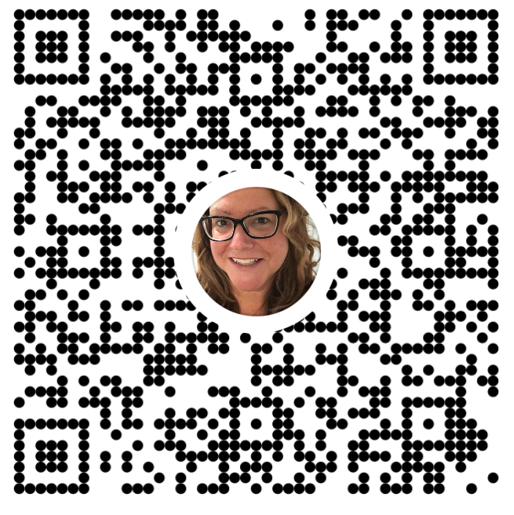

Name: ____________________________________________________________

Address: __________________________________________________________

City: _________________________ State: _______________ Zip: ___________

Telephone: ___________________ Email: ______________________________

## Deadline for application: July 26, 2025

Description of products or services to be sold: __________________________________________________________________

__________________________________________________________________

$25.00 per 15’ X 30’ outdoor space, no electric provided.

Parking for one vehicle provided within festival grounds.

Market hours 9:00am-5:00pm, though you will have option to stay later during evening entertainment.

Due to festival activities and traffic, all vendors must be on festival grounds by 8:45am.

Please make checks payable to: THE FRIENDS OF THE DRESDEN PARKS INC.

Proof of compliance required from the Muskingum County Health Department or the Ohio Department of Health if desiring to sell fruit, vegetables, bread, pastries or other food items which have not been canned.

Signature: _________________________________ Date: _____________

Note: The Dresden Melon Festival and/or The Village of Dresden are not responsible for any damage to or loss of merchandise occurring as a result of the Melon Festival Craft/Flea Market

By signing this application, the Dresden Melon Festival and/or The Village of Dresden has the right to use my name and pictures of my booth and/or products in its promotion of the event.