- IDEAS ESSAY
The Experiment That Made Einstein Famous
One hundred years ago, an extraordinary feat of astronomy proved that the theory of relativity was true

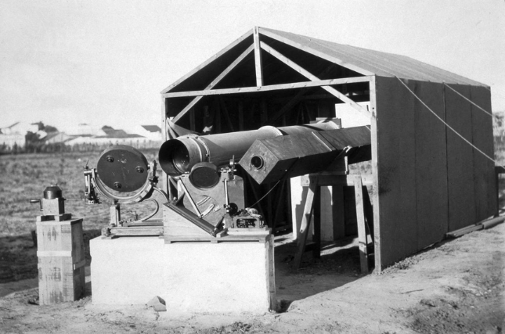
Astronomical equipment used to record the 1919 eclipse in Sobral, Brazil. PHOTO: SSPL/GETTY IMAGES

By Andrew Robinson
Feb. 14, 2019 10:28 a.m. ET

One hundred years ago, at the beginning of 1919, few people outside Germany had ever heard of Albert Einstein. By the year’s end, however, he had become a world-wide celebrity and a symbol of human genius. What made Einstein’s reputation was one of the most important experiments in 20th-century science: a challenging, incredibly precise observation of a solar eclipse that proved his general theory of relativity for the first time.

The special theory of relativity, published by Einstein in 1905, introduced a new understanding of space and time, including the equation that linked energy, mass and the speed of light: E = mc². It was followed 10 years later by his general theory, in which Einstein extended the concept to include accelerated motion and gravity, based on a highly sophisticated mathematical conception of “space-time.”

But for all of its later fame, the theory of relativity made no impact on the general public when first published in 1905. Even some distinguished scientists rejected it. In 1910, the great physicist Ernest Rutherford joked that Anglo-Saxons like himself had “too much sense” to understand such an abstruse theory. To overcome such skepticism, Einstein had to find a way for his ideas to be experimentally confirmed.

His solution had to do with the way that light travels through the cosmos. According to Isaac Newton’s theory of gravity, which had been generally accepted by physicists since the 17th century, light rays are attracted by gravitational forces because light is made of tiny particles that Newton called “corpuscles.” On their journey from a distant star to our eyes on Earth, the trajectory of these particles would be very slightly curved or “deflected” by the gravity of the sun.

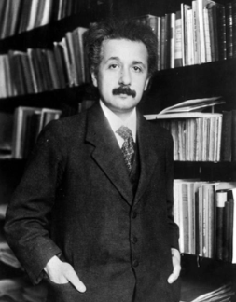
Albert Einstein ca. 1905, the year he published the special theory of relativity. PHOTO: TOPICAL PRESS AGENCY/GETTY IMAGES

Einstein agreed with Newton’s idea, but in 1915-16 he used his general theory of relativity to recalculate the deflection of light and found that it would actually be twice the amount predicted by Newton. If the magnitude of the actual deflection could be measured, it would show whose theory of gravity was correct, Newton’s or Einstein’s. “The examination of the correctness or otherwise of this deduction is a problem of the greatest importance, the early solution of which is to be expected of astronomers,” wrote Einstein.

The first opportunity to test Einstein’s predictions would come on May 29, 1919, when a total solar eclipse would allow telescopes to observe starlight as it passed the rim of the darkened solar disc. Exceptional care would be required, given that Einstein’s calculated deflection was only 1.7 seconds of arc—that is, a displacement of a mere sixtieth of a millimeter on a photographic plate.

The opportunity was seized by the British Astronomer Royal, Frank Dyson, and a leading Cambridge astronomer, Arthur Eddington, who had become a convinced advocate of general relativity. In 1917, even as World War I was raging, Dyson persuaded the British government to budget £1,000 for a team of four astronomers led by Eddington to observe the coming eclipse. Two would be stationed on Principe, an island off the coast of West Africa, and the other two in Sobral, a city in northeastern Brazil.

Both expeditions faced formidable technical problems, from monkeys interfering with the telescopes to high temperatures (which distorted the photographs) and cloudy skies. As Eddington, in Principe, recorded in his diary, “The first 10 photographs show practically no stars. The last six show a few images which I hope will give us what we need; but it is very disappointing.” The measurements on one plate agreed with Einstein’s predicted deflection, and another provided at least some further confirmation. Eddington sent Dyson a noncommittal telegram: “Through cloud. Hopeful.”
Once back in England, Eddington developed four more Principe plates. He detected in them Einstein’s value for the deflection of starlight, though within a rather large margin of error. Fortunately, the Sobral plates provided conclusive support for Einstein’s theory.

In November 1919, Eddington presented his conclusions to a joint meeting of the Royal Society and the Royal Astronomical Society in London. The greatest names in British physics, astronomy and mathematics attended, though not Einstein himself, who remained in Berlin. J.J. Thomson, discoverer of the electron and president of the Royal Society, declared that “this is the most important result obtained in connection with the theory of gravitation since Newton’s day. If it is sustained that Einstein’s reasoning holds good…then it is the result of one of the highest achievements of human thought.”

Almost immediately, the British proof of a German theory was seen—in Britain, at least—as a sign of hope for international reconciliation after World War I. But in defeated Germany, Einstein’s theory of relativity was regarded with growing and often anti-Semitic suspicion, culminating in the publication of “A Hundred Authors against Einstein” in 1931. As Einstein wrote in 1921 to a German colleague, “The English have behaved much more nobly than our colleagues here.”

Few people, English or otherwise, have ever fully understood general relativity. Einstein himself was baffled that the theory had elicited such “passionate resonance” and made him an international celebrity. But of the theory itself there is no doubt: In the century since 1919, general relativity has been confirmed again and again by increasingly accurate astronomical measurements. Today it accounts for both the amazing accuracy of the Global Positioning System and for our understanding of the evolution of the universe since the Big Bang, 13.8 billion years ago.

—Mr. Robinson is the author of “Einstein: A Hundred Years of Relativity” (2015). His new book on Einstein will published later this year by Yale University Press.

