0-

**GSPCI Newsletter Pointer Post May 15, 2013**

**German Shorthair Club of Indiana**

Presidents Message:

I hope that everyone has had an opportunity to get out and enjoy a somewhat normal spring. Cindy and I have just purchased 5.5 acres and our getting ready to move into what we will call Guerrini Apple Farm. Our Home is a small 3 bedroom with a basement and most importantly 2 large barns. You can bet that I will be making use of all that space! With the coming of spring I would be remiss if I didn’t mention that it is a perfect time to get in a little training whether it be basic commands or if you can find them some bird work. I have included a couple of articles on training that I thought might be interesting to everyone. Looking ahead at our calendar we have several events that have been schedule Sunday August 11th at 12:00. We will shoot 100 targets so plan on bringing enough shells. You can either bring a lunch or eat before you come. Our annual picnic will be hosted by Cindy and me at our new house, in one of the barns it will take place on Sunday July 28th starting at 1:00PM. It will be a pitch in affair so bring your favorite dish and lawn chairs the club will provide the hamburgers and hot dogs. I will provide directions and more info later. Some of the members have expressed a wish to have a couple of events outside of the area of dogs, one member suggested that about the club sponsor a fishing tournament open to club member families only. If anyone is interested please e-mail me and we can try to put something together. I will need at least 10 members to show up so if interested please get in touch with me ASAP. Any other events that you can come up with then please share them with me. Some of you have also inquired about bringing in a trainer like we did last year for a training seminar if you have a name of some one that you would like to hear then again, please e-mail me. Well I hope that everyone’s spring is going well and that each of you has a chance to enjoy the out of doors with your family and friends. Please remember to give me some feed-back on the fishing idea and the training seminar. I hope to see everyone soon Vince

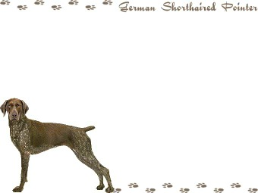

Board Members

**President** - Vincent Guerrini

[guerrini.vince@gmail.com](mailto:guerrini.vince@gmail.com)

**Vice President** – Kirk Johnson

**Secretary/Treasurer** - Debra Moline

[runmom1435@aol.com](mailto:runmom1435@aol.com)

**Board of Directors**

Larry Harris Mark Holzinger Ron Ferris

Laura Getzen Matt Cosgrove John Kennedy

Chris Weber Giles Hoyt Brittany Moline

Indiana Hunting Seasons

Deer Firearms: November 12th – November 27th Deer Muzzleloader: December 3rd – December 18th Deer Late Archery: December 3rd – January 1st, 2012

Wild Turkey (Archery Only): December 3rd – January 7th, 2012

Squirrel: August 15th – January 31, 2012

**Ruffled Grouse (Private Owned Lands): October 1st – December 31st**

**Ruffled Grouse (Public Lands): October 1st – November 11th**

**Pheasant (cock only): November 4th – December 18th**

**Quail (North of SR 26): November 4th – December 18th**

**Quail (South of SR 26): November 4th – January 15th, 2012**

Rabbit: November 4th – February 15th, 2012

Crow: December 13th – March 1st 2012

**“B R A G G I N R I G H T S”**

Our Hunt Test was a SUCCESS!!!! The weather ended up holding off from the anticipated storm headed our way. It was great to see everyone working the dogs we have worked so hard training and then to see it pull together so nicely.

C:\Users\Laura\AppData\Local\Microsoft\Windows\Temporary Internet Files\Content.IE5\9W9VH1NS\MC900329538[1].wmf

[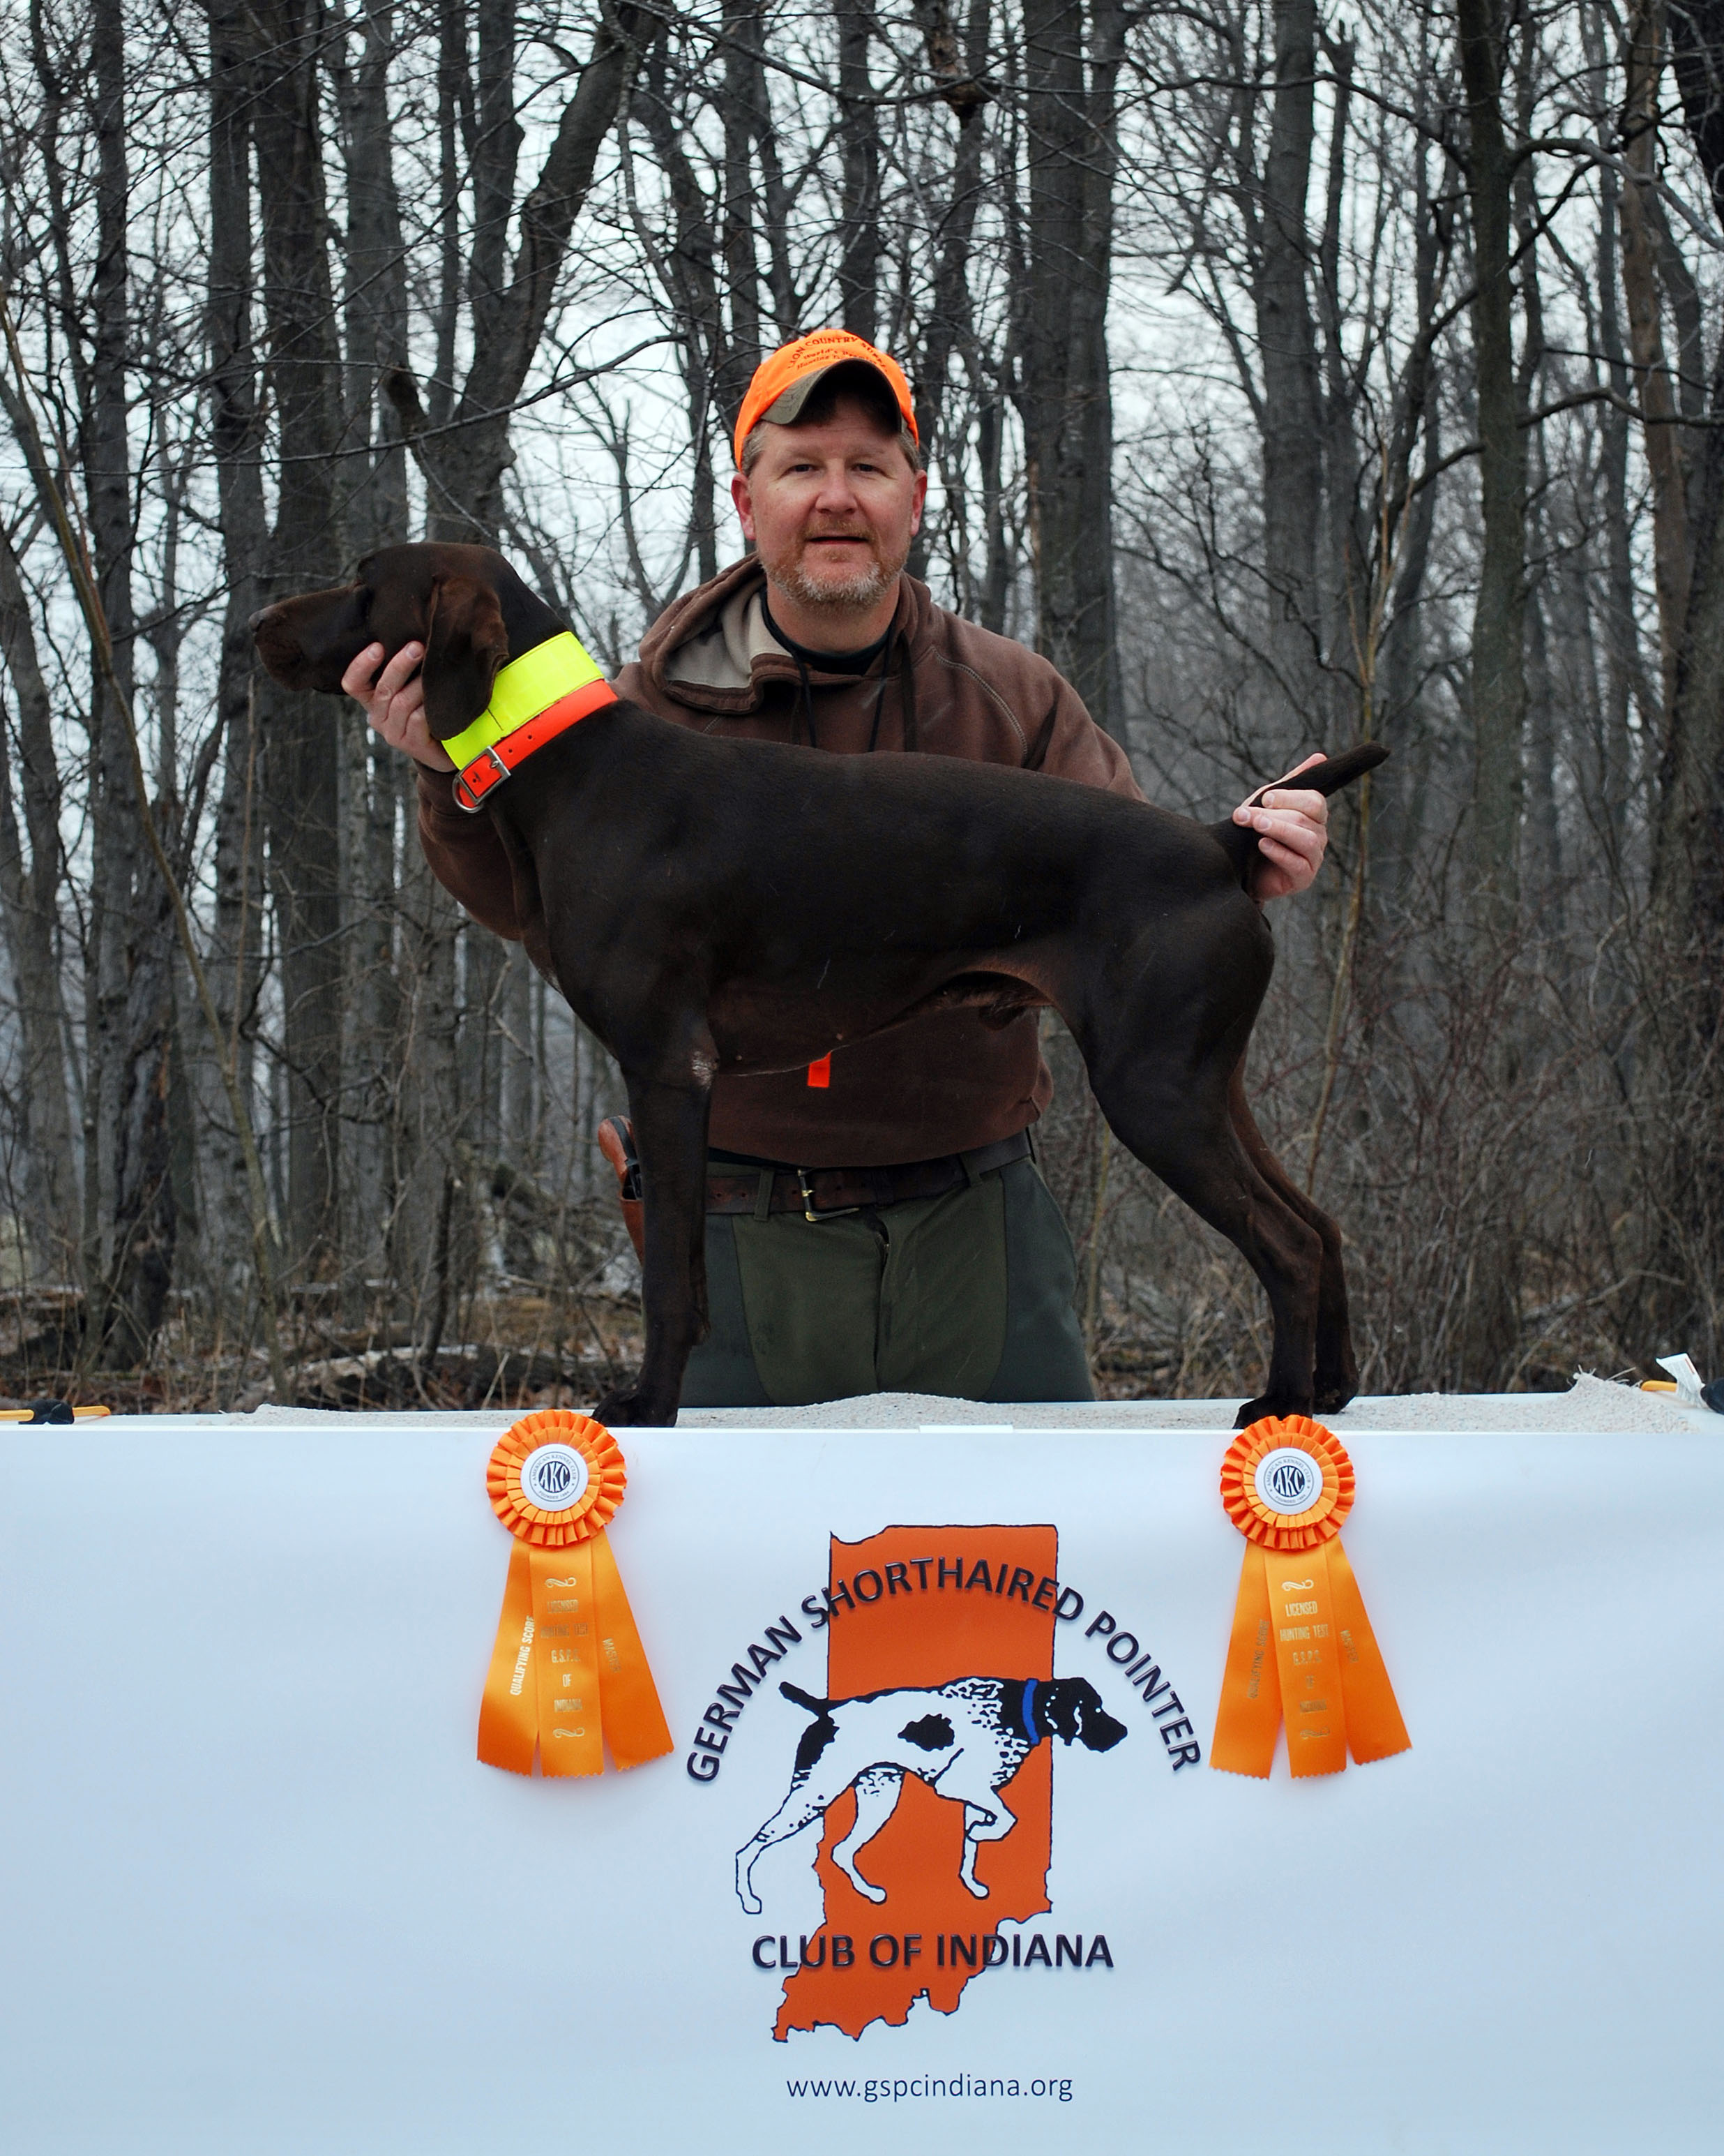](http://www.gspcindiana.org/site%20attachments/hunt%20test%20ribbon%20pix/emmett%20troy%20day%202.jpg)

**Congratulations** to Troy Wood & Emmett! Troy put a lot of work into even right into days before the Hunt Test. Very Nice Job Troy!

[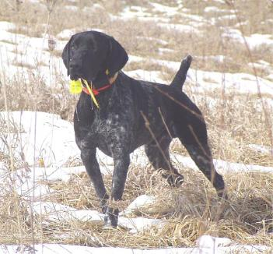](http://www.facebook.com/photo.php?v=10102531922942989)

**R.I.P.**

Ron Ferris' loss of his 11year old friend and hunting companion  
ARKO VOM GERSTENER WEH JH DI   
He was imported in December of 2002. A true model of great breeding, amazing companionship and brilliant hunting skills!

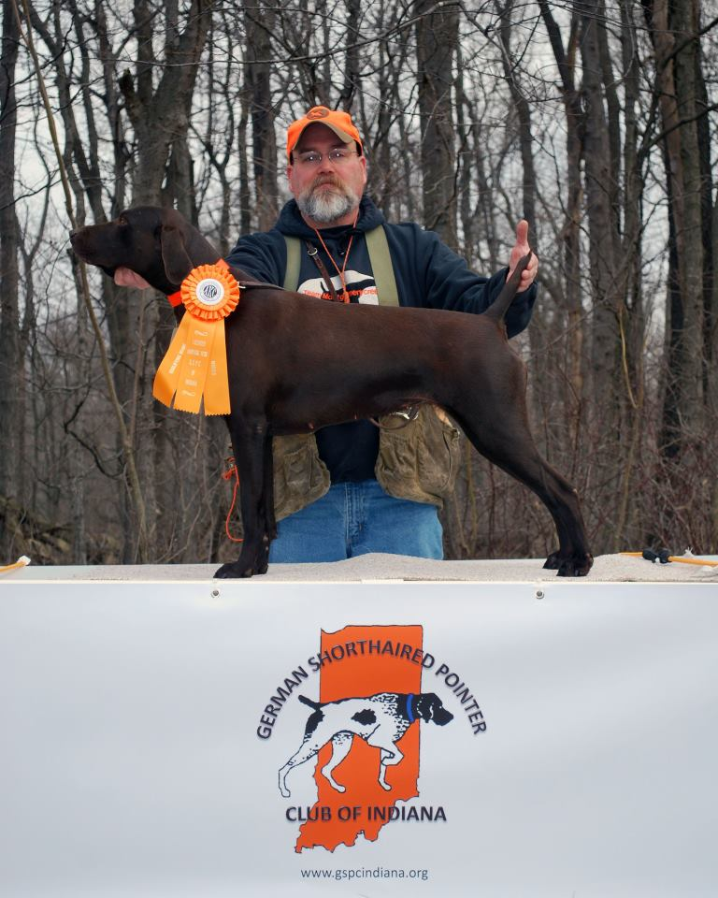

Another Great Job Mr. Conley!

Elexis Von Montgomerycreek SH

Consistantly making strides in producing amazing dogs!

[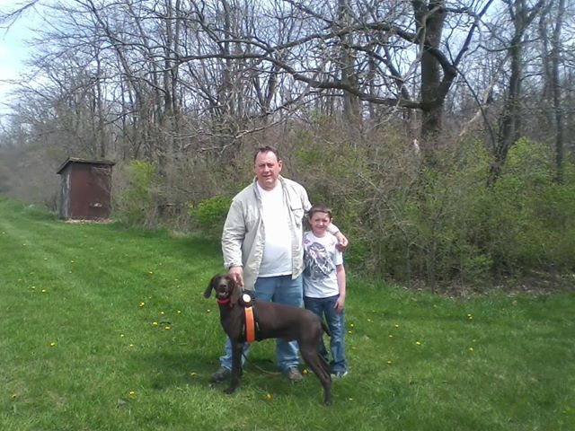](https://www.facebook.com/photo.php?fbid=484831588255500&set=a.451384604933532.101598.100001859887678&type=1&relevant_count=1)

[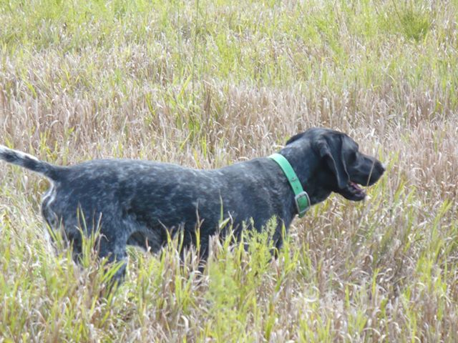](https://www.facebook.com/photo.php?fbid=595471790466112&set=a.585923538087604.137131.100000098885300&type=1&relevant_count=1)Kirt holding a nice point.

Vince putting to proof the importance of,

Training-Training-Training!

Nice Back!

Troy Wood, Tim Conley & Joe Klase keeping those training sessions alive.

[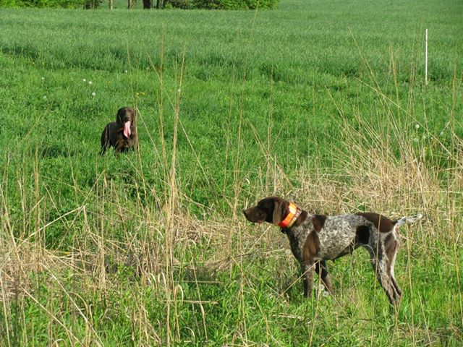](https://www.facebook.com/photo.php?fbid=489383681133624&set=a.489382641133728.1073741825.100001859887678&type=1&relevant_count=1)

Joe Klase & Hunter had the high scores of the day! Hard work pays off.

If you have a bragg that wasn’t included that doesn’t mean you were excluded. Please send any wins or Braggs you would like to have featured please email them to Laura Getzen, Newsletter Editor [markorlaura@comcast.net](mailto:markorlaura@comcast.net).

**Start-To-Finish**

A new gun dog puppy is a huge responsibility, and it’s not short term.

The vet check-ups, the settling of your pup in his new home and your grandiose plans of training–with a new pup, you’re taking on a nine- to 12-year commitment (or more) to health care, nutritional needs, socialization, exercise, training and overall nurturing for your new buddy and hunting partner.

|  |
| --- |
|  |

Handling your pup’s first few weeks correctly is critical to helping her reach her full potential as an adult.

There is no "off season" in these considerations. We’re talking a year-round, long-term commitment.

Sorry if it sounds like I’m coming at this on the strong side, but I’ve seen too many great prospects left standing in the kennel or turned in for adoption. Most of these cases could have been avoided, but let’s look at this from a positive angle.

You got this pup because you enjoy the outdoors and hunting, and I guarantee if you approach it from that perspective, you’ll not see caring for your new hunting partner as work. I’m also sure you’ll realize that the benefits of a healthy, well-trained hunting partner yield rewards beyond belief.

Let’s begin with a hodgepodge of puppy-related topics and suggestions that will help lay a solid foundation for your pup and the plans you have for him.

**OFF TO A GOOD START**

Proper socialization boils down to using your head when introducing your pup to new stuff.

Just home from the breeder, your pup is likely a little homesick and obviously doesn’t understand our vocabulary, so go easy in the beginning.

Give him time to take in the sights, smells and sounds of his new surroundings. These early experiences set up the process of socialization, eventually progressing through all aspects and levels–from the home or kennel to the backyard, people, other dogs and travel kennels.

There are also the pre-hunting considerations, like introduction to fields, water, birds, gunfire, boats and so forth. Each is critical to the development of a solid, self-confident and productive hunting partner, and this is all dependent on the groundwork you begin during your pup’s first few weeks in his new home.

If you plan to keep your dog in the house, crate training is your No. 1 objective, and it is important to teach your pup the crate is his safe place. Crate training goes hand in hand with house training and the general learning of good behavior.

When you begin crate training, pick a time after play/exercise when your pup has had time to eliminate and might be ready for a nap. I suggest you place the kennel in the laundry room or another room off the beaten path with fewer distractions.

At first you can expect the pup to fuss a little, but don’t fall victim to his whining. Just go about your business; letting him win here puts the pup in control. Left alone, your pup will soon be fast asleep and begin to understand this "cave" is his safe and comfortable place.

Potty training also goes hand in hand with crate training. The first thing you do upon letting the pup out of his crate is take him to a certain spot in the yard to eliminate.

Other key times for trips to the backyard are shortly after feeding, or when you see the pup posturing as some indication of his intent.

Most pups soon associate the act with the designated spot in the yard and begin to let you know when they need to go out. The more regimented and attentive you are, the sooner this association happens, while unnoticed accidents tend to take the process in the wrong direction.

**THOUGHTS ON TRAINING**

|  |
| --- |
| Pup with members of the Socialization Committee. Be sure all family members are consistent with commands to keep the project on track for developing a future field champion. |

Dogs are pack animals that expect and respect a leader in their social order. It is important you establish yourself as that leader who sets up clear rules and expectations of behavior. By doing this, you help your pup understand his place, and this establishes a positive attentiveness. The pup’s frame of mind will be calm, self-controlled and in learning mode.

A few simple rules at the get-go make training easier down the road. As you begin, be firm but gentle until the pup begins to understand the parameters of what you are trying to communicate. Punishing him would only cause confusion.

Be consistent, include all family members in the overall plan and be sure they know command sounds and what is expected at each stage of progress. Encourage family members to give a command only once and to follow through with each.

We should reward a pup for the correct response or behavior with praise, but don’t overdo it. Too much praise can overwhelm and wash out what was learned. Rather, it is often best to repeat the command right away, giving your pup the opportunity to perform correctly again. The correct response followed by a little more praise to reinforce this response results in a stronger understanding or "fix" in the learning process.

This is true in all training and is especially important with younger pups. Appropriate praise with the correct response, and subtle pressure with no response or an incorrect response–it is through these consistent parameters that our pups begin to react correctly and dependably. Remember, too much pressure or too much praise both work against you.

It doesn’t matter if you’re training for the next national champion, a hunting partner or simply a good citizen house pet; the fundamentals are the same and are the key to your success.

**COMMAND BASICS**

Begin by overlaying the pup’s chosen call name as a cue to gain his attention, and get him to come to you when called by means of a "come" command. Treat training is an acceptable way to get these steps of training underway in a hurry. Get the pup’s attention, show the treat and begin to overlay the name as he starts to you, then give him the small treat and a little praise on arrival. In later sessions after the pup is heading your way, you can start to associate "come" as a sound cue to establish it as a command. Only later, once the pup understands "come" as a command, can you apply any sort of pressure when he doesn’t respond correctly. Any time you plan on giving a command or advancing the understanding of a command, I recommend you first make sure you are in control. In this case, a long lead is your best option, so if your pup decides to play "catch me if you can," you’re able to reel him in for an assisted correct response, plus a little praise for getting it right.

**STICK WITH IT**

My intentions in this article are only to point out the importance of correct socialization and the fundamentals of training to get you started. Nothing I’ve said here is rocket science, but rather, all common-sense concepts. So if you’re good with the basics, you can find plenty of detail in the great books or videos listed on the Bookshelf or DVD pages in this magazine. Other great sources for help in the basics are the local dog clubs or classes offered in your area. Above all, stick with your program. The rewards that a solid training effort with a great prospect can bring you over the years are almost unimaginable.

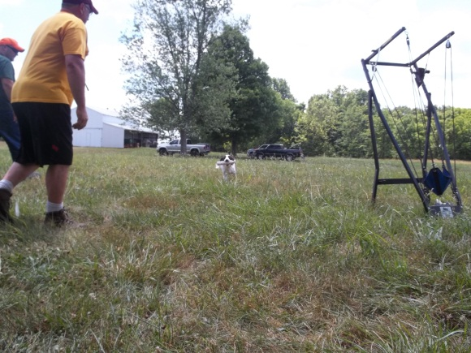

**Bird Dog Training Overview**

**T**he training of a bird dog pup is something that is a time-consuming exercise that if done right, will bring you as much joy and pride in life as anything you will ever undertake. Many folks see a fine, trained gun dog in action and assume that they could never accomplish that kind of performance with a dog that they own. I am here to tell you that I have been there. I still find myself in that frame of mind from time to time when I am privileged to witness an exhibition of outstanding bird dog [work](http://www.eric.ed.gov/ERICWebPortal/search/detailmini.jsp?_nfpb=true&_&ERICExtSearch_SearchValue_0=EJ645663&ERICExtSearch_SearchType_0=no&accno=EJ645663) between a top handler and a great dog in the field. I am also here to tell you that when we see one of these awe inspiring teams of man and dog in action you must look at them and in comparing them to your situation, realize that there is only one thing that separates a good dog from a great dog or even a "meat dog" from a pot-licking idiot. That thing is time.

Training your bird dog will take devotion and a steadfast determination in order to get the dog at its maximum potential. Like any other training you will do in life, say educational training like getting a degree from [accredited online colleges](http://www.accreditedonlinecolleges.com/) for instance, you will have your ups and downs, but sticking to it and taking the time everyday to practice the learned [skills](http://opi.mt.gov/GetAnswers/questions/171/Accepted+degrees-Online+Colleges) will help you and your dog to become a great team. If you will devote some time every day to working with your pup on three basic commands, "whoa", "come" and "heel" and work toward getting to the point where the dog will unfailingly obey those three commands no matter where he is or what he is doing, you will have a fine bird dog. "Whoa" is by far the most important of the commands. It simply means, "stop, DO NOT move until I release you". The dog must obey this command when it is given no matter how far away he is from you or what he is doing. It is useful in the yard, it is essential when the dogs are working birds and it can even save the dog's life in traffic.

If you can "whoa" your dog at anytime, you can then go to him and correct anything else that he has done wrong. If he is hunting too far ahead, you can use it to stop him. If he flushes some birds out on his own, you can use it to stop him and train on that offense in the very spot where he blew it. If he insists on goofing around with a shot bird he has picked up, if you can whoa him, YOU can go to him and get the bird from him and if you do it right, he will get the idea that bringing the bird to you and getting stroked is better than dinking around with it away from you. You MUST use this command to keep you dog from messing up the point of your buddy's dog when it finds birds and your dog comes up on it in the field or you probably sooner or later find yourself with one less buddy. If you can stop your dog, it is a then simple matter then to get him to come to you when you want him and most importantly if you can stop your dog and have him stand still in one place, it is much easier to go to him and stroke and love him up for a job well done.

"Come" is simply that. It means "stop what you are doing and come in where I can get my hands on you". It's uses are plain to see. For instance, if the dog will come unfailingly when called, retrieve training is a snap. If the pup does scoop up a shot bird and starts to dawdle off with it, if you can first "whoa" him to stop going in the wrong direction and then tell the dog to "come", you will get every bird you shoot delivered right to hand. "Heel" simply means "walk by my side until I tell you to do something else". It uses are also easy to see. Anytime you want to go somewhere with the dog with the dog under control, this is the way to do it. Trained properly, a dog will heel unfailingly without a lead so that you can have both hands free to carry things like your gun and all the birds he pointed for you. It is also important to remember to have a release command such as "ok!" for each of these commands. It lets that dog know that he has performed correctly and is now free to hunt for you again. Always take lots of time to stroke and praise the dog in a pleasant voice when he does perform correctly. Good dogs are born wanting to please and if you can show the dog in clear terms what pleases you and repeat that scenario over and over again many times over months and months, the dog will become positively addicted to doing the correct action if you let him know that by doing so, you think he is the greatest dog in the world.

Bird dog training is really just that simple. Even the best field champion you will ever see is doing nothing more than obeying these 3 commands very well AND using an extreme amount of talent to it's greatest potential to find and point birds for his boss. Most breeds of bird dogs today are being bred with more bird finding and hunting talent than ever before. All you have to do is spend a lot of time with your dog to get him to apply that talent for YOU so that the two of you will be a solid bird hunting team. Neither of you is able to get a bird without the other, but together a team whose performance might even some day earn you honors on the field trial course, but will certainly gain you many new "hunting buddies" come bird season each year.

If you can devote half an hour a day to a dog that is less than a year old and then an hour, 3 days a week to the dog when it is older, you will end up with a fine bird dog that will be a joy for many years.

**Closing Club Notes**

**Lets Get Together**

Our annual picnic will be hosted by Cindy and me at our new house, in one of the barns it will take place on ***Sunday July 28th starting at 1:00PM.*** It will be a pitch in affair so bring your favorite dish and lawn chairs the club will provide the hamburgers and hot dogs. I will provide directions and more info later. Some of the members have expressed a wish to have a couple of events outside of the area of dogs, one member suggested that about the club sponsor a fishing tournament open to club member families only. If anyone is interested please e-mail me and we can try to put something together.

**Sporting Clay Shoot**

Arrangements have been made at the Indiana Gun Club to have a Shorthair Sporting Clays Shoot on **Sun. Aug. 11th at 12:00** noon. It is 100 targets. No lunch is planned. Bring a lunch or eat at home before coming. Please make plans to come.

**Facebook’ers**

*It has been a slow month for facebook, but we are pushing it up again.*

*It’s been very helpful that some of the members have continuously shared pictures and training successes on their timeline. Please go onto the GSPCI FB page and post there as well, that continues to promote how active we are with our dogs!!!*

Again, Monthly, until further notice, I need everyone to message Laura Getzen on Facebook a picture of your GSP. Be Fun with it. You have, every month, from the 1st to 24th to send me pictures on Facebook to Laura Getzen or email them to [markorlaura@comcast.net](mailto:markorlaura@comcast.net). Then I will post all of the pictures by the 25th of every month for a “LIKE” Contest. The contest will last until the last day of the month. Whoever gets the most “LIKE” ‘s will be our profile picture for the upcoming month. The winner will be posted on the 1st of every month for that month! This will generate buzz for the club. This will be a great way to get our club in people’s faces monthly. The greatest advertisement is word of mouth, so let’s have fun with this and get beautiful, funny, stunning, showy and hunty pictures. Pass the word to your friends! There is one catch, to enter; you must be an active member of the German Shorthair Pointer Club of Indiana.

**Like, Send and Post those Pictures!!!!!**

**Breeders**

Please make sure you email Christy Featherson if you have any litters available or coming. Christy is listed on AKC website as a Breeder Referral. Also for ***members only***, post your litters to the “German Shorthaired Club of Indiana” Facebook page.

Christy Featherston [artemisgsp@aol.com](mailto:artemisgsp@aol.com)

**Volunteers**

During the events we host or attend there is always room for help. May be it food, cleaning up, setting up or just offering. Contact is easy to make to offer any assistance where needed. There is no specific list for this, or maybe there is and were all on it!

Give where you can and lets all do our part to help things pull together. We have many members who already help and volunteer for many things we do. So a BIG Thank You to them and lets continue to all support and help with our efforts!

**New members!**

The German Shorthaired Pointer Club of Indiana is a club dedicated to the celebration and advancement of the German Shorthaired Pointer. Lets continue inviting and pursuing new leads for new memberships. We have chosen to be more than just dog owners, we have joined into a family that shares the common interest in making ourselves and our german shorthairs the active sportsmen they were breed to be.



Other informative sites; <http://www.bdarn.com/calendar/> <http://www.nstra.org/> <http://www.gspca.org/> <http://www.centralindiananavhda.com/> <http://www.glennsvalley.org/>