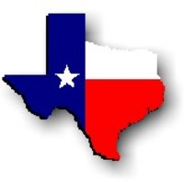Texas History with Mr. Brown Name ____________________ Period _____
Chapter 3 Texas’s Regions
Picture Search p. 44 - 66
Directions: Use the pictures, maps, graphs, Info boxes, and their captions to find the following information.

1) Even the weeds in Texas are artistic. Texas author _____________________
2) How many lives were lost to the Indianola Hurricane?
3) When and where was the worst single tornado strike in Texas?
4) How many Texas counties were flooded in 1988?
5) What kind of plant is pictured on p. 45?
6) ______________________ was a Texan who devoted his life to studying the physical geography and geology of Texas.
7) Weather in Texas ranges from snow and freezing temperatures in the __________________ to scorching heat in ______________ Texas.
8) What city has the lowest average temperature in Texas?
9) What city has the highest average temperature in Texas?
10) Because some fertile farming areas get too little water ___________________ must be used to get water to the crops.
11) What are the three types of region in the United States?
12) __________________________ is a 1,825-foot granite mountain on the border of Gillespie and Llano Counties in the Great Plains region of Texas.
13) Why does Enchanted Rock make weird noises?
14) The Colorado River received its name from the Spanish word for ___________________.

15) The Nueces River was named for the _______________________ that grew along its banks.
16) What river contains the Falcon and Amistad dams?
17) In which Texas region is the Piney Woods?
18) In which Texas region is the Edwards Plateau?
19) In which Texas region is the Cross Timbers?
20) Caddo Lake in the Piney Woods subregion of the Coastal Plains is known for what three things?
21) Where did Spanish and Mexican settlers live before the Texas Revolution?
22) In some counties of that area the Hispanic population is up to _____%
23) Most of the North Central Plains region is relatively:
24) The Pecan tree is native to more than __________ counties in Texas.
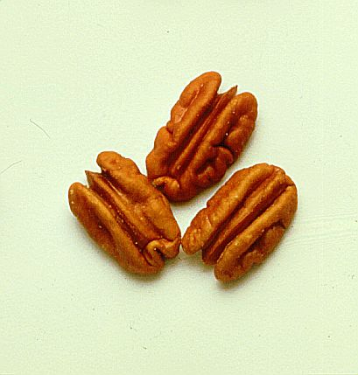
25) What is the only nut grown for profit in Texas?
26) The vast, treeless High Plains subregion of the Great Plains is broken by
_____________________________, which was formed by erosion.
27) Under how many counties does the Edwards Aquifer extend?
28) A Sole-Source Aquifer provides ________ percent or more of the drinking water for a particular area.
29) The ______________________ Mountains in the Mountains and Basins Region rise high above the surrounding desert.
30) At the Balcones Escarpment, the __________________ breaks sharply into the Hill Country.
31) Which Texas metropolitan area has the highest population?
32) Can a city collect taxes from people who live outside of it’s city limits?
33) Much of Houston’s economy is related to technology and the _________________ industry.
34) What is the 8th largest city in the U.S.?
35) In 1875 a large number of immigrants came to the Brazos Valley from:
36) Citrus and _________________ are key Texas crops.
37) Who started the company Electronic Data Systems?

