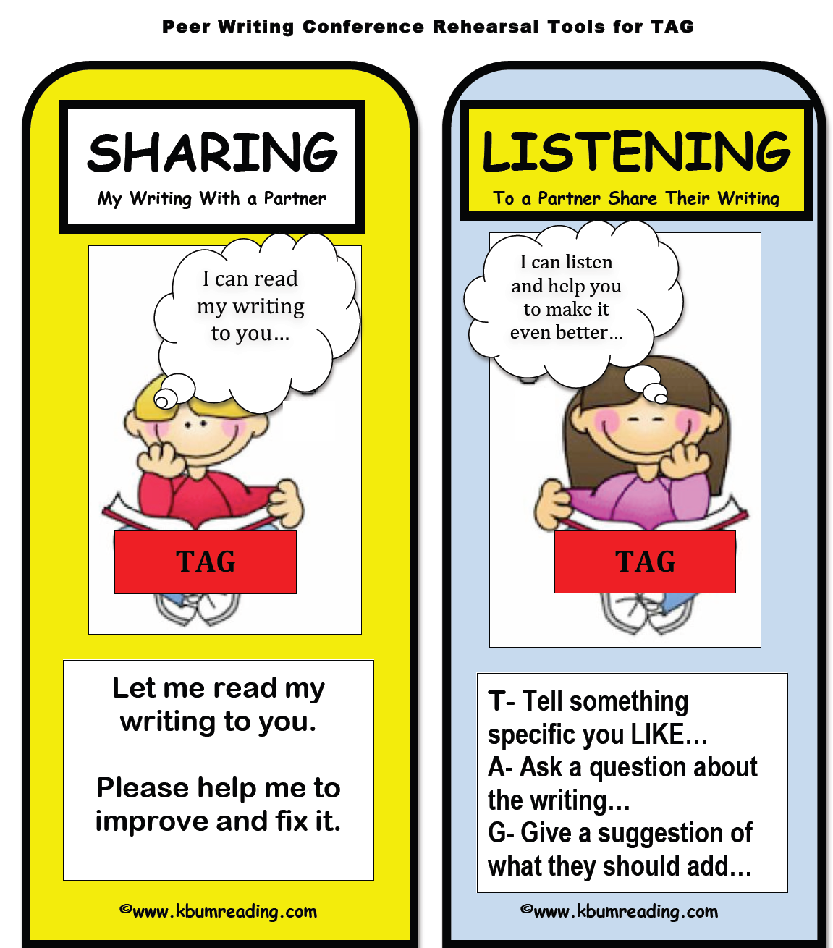

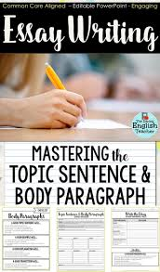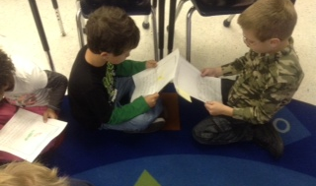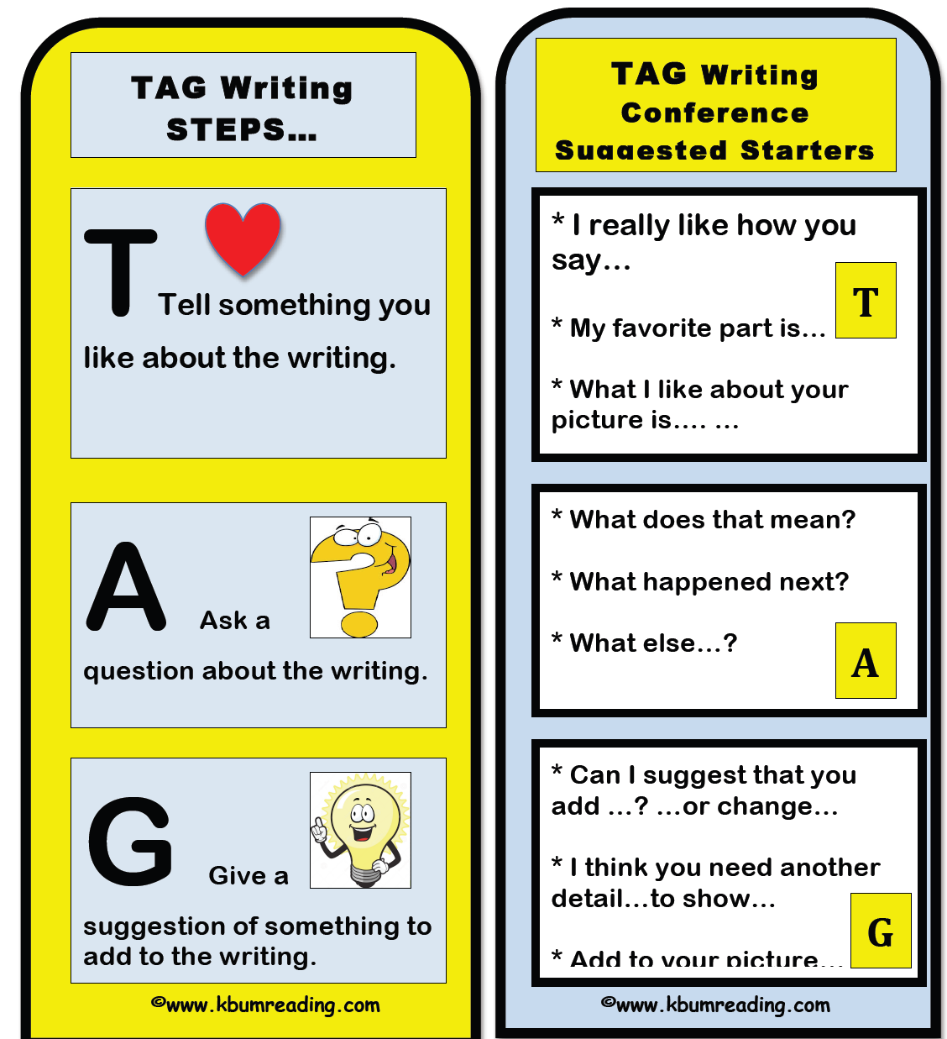

**Give**

**Give a suggestion about what you think they can make better.**

**\*Can I give you a suggestion that you can add ______.**

**\*I think you should fix ____.**

**\*You should add those details / facts _______.**

**LISTEN to their writing:**

**Tell**

**Tell the writer something you liked about their writing.**

**\*I really like how you …**

**\*My favorite part is …**

**\*The best thing about your writing is…**

**Ask**

**Ask the writer a question**

**about their writing.**

**\*What happened after that?**

**\*How were you feeling here?**

**\*Who is this in the picture? Can you label that?**

TAG STEP by STEP

for

Student Sharing:

TAG STEP by STEP

for

Student Listening:

**3 Revise and / or Edit your writing.**

**2 Listen to their compliment and answer their question.**

1. **Read your writing to your TAG Partner.**