**RSAI Position Paper**

**Transportation Equity: A 2020 Legislative Priority**

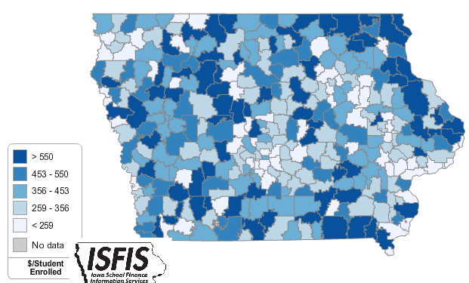**Background:** In the 1950s, Iowa had over 4,000 school districts. Students walked to their neighborhood school and transportation costs were nonexistent for Iowa school districts. As budgets have tightened and enrollments declined, Iowa now has 327 districts (FY 2020) with varying square miles per pupil and hugely varying transportation costs.

Iowa’s foundation formula does not recognize the sparseness of population, square mileage or route miles for school districts, the number of students transported, or variance in road or geographic conditions. Transportation costs are paid out of the school general fund.

**Recent Progress:**  in the last two years, the legislature has made strong gains in closing this gap:

* [SF 455](https://www.legis.iowa.gov/legislation/BillBook?ga=87&ba=sf455) enacted in 2018 provided $11.2 million to 143 districts with the highest transportation costs in the state, a good start, but did not provide certainty.
* [HF 307](https://www.legis.iowa.gov/legislation/BillBook?ga=88&ba=hf307) enacted in 2019 provided $19 M in transportation as a supplement in the formula beginning in FY 2020, estimated to benefit 190 districts and buy all districts with excessive transportation expenditures per pupil down to $381. ($51 above the 2017-18 state average.) This supplement will grow by the SSA rate annually.

**Current Reality:** the following describes transportation inequities from DE’s FY 2018 Transportation Report:

* FY 2018 State cost per pupil was $6,667. There were 45 Iowa school districts that required at least 10% of that general fund cost per pupil for transportation.
* The range in transportation expenditures varied from a low of $18.84 to a high of $ 1,196.64 per student enrolled. With transportation funding in the formula, that range from high to low has been closed to $381 per pupil. Square miles per district range from a low of 2 to a high of 555 square miles, and route miles range from a low of 745 to a high of 978,903 miles.
* Property tax characteristics, including low valuation per pupil and corresponding higher tax rates, create challenges for districts with low tax capacity to pay for buses out of PPEL or Sales Tax funds, further stressing the general fund budget. When districts have larger transportation costs, both taxpayer and student inequities worsen.
* General fund dollars spent on busing would otherwise pay for staff and teachers (salary, benefits, training, support), curriculum, programs, technology, and energy. Lack of resources in these areas creates an unequal educational opportunity for students in rural districts.

**RSAI supports formula and transportation equity:**RSAI supports formula and transportation equity.The Legislature should accelerate the commitment to close the $165 gap between the state and district cost per pupil within ten years and continue transportation equity support, bringing down all districts to no more than the state average per pupil transportation cost, without requiring burdensome reporting requirements from school districts.

Margaret Buckton, RSAI Professional Advocate [margaret@iowaschoolfinance.com](mailto:margaret@iowaschoolfinance.com), (515) 251-5970