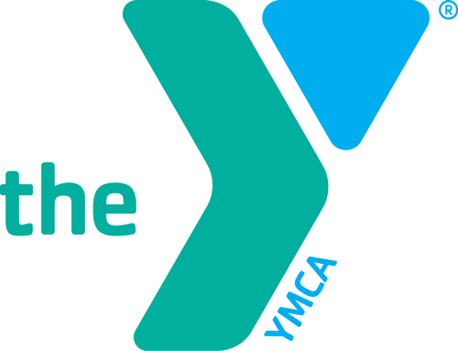
YMCA Weight-Loss Challenge 2017
Information and Rules

Note: Winners will be determined by team’s total AVERAGE PERCENTAGE of weight lost, not the total number of pounds lost.

- AT LEAST 2 participants per team. All participants must sign a waiver. Registration Deadline is January 1st, 2017.

- Entry fee of $30 for members and $60 for non-members must be paid at time of registration to be included in the challenge.

- During the 10-week challenge, non-members who are participating in the challenge will get free use of the YMCA facility and group fitness classes. The YMCA will provide you with a card to present to the front desk staff when you come in to work out.

- ALL TEAM MEMBERS WILL NEED TO COME TO THE YMCA ON MONDAY, January 2nd FOR THE FIRST WEIGH-IN.The YMCA is open from 5:30 am – 8:00 pm Monday-Friday, Saturdays 8:00 am - 5:00 pm and Sundays 12:00 pm– 5:00 pm.

- WEIGH-IN PROCEDURE:

- ALL TEAM MEMBERS MUST WEIGH-IN AT THE YMCA THE FIRST AND LAST MONDAY DURING THE 10-WEEK CHALLENGE. THE OTHER MONDAYS ARE OPTIONAL. CALL-INS WILL NOT BE ACCEPTED!
- WEEKLY PRIZES WILL BE AWARDED TO THOSE LEADING THE CHALLENGE, BUT YOU MUST WEIGH-IN THAT WEEK TO PARTICIPATE!
At the end of the 10-week challenge, the team that has lost the most weight (BY PERCENTAGE) will win the CASH PRIZE.

Additional Info:
*Persons not currently a YMCA member will receive a 6-month adult membership offer.
* If individuals want to participate, but do not have a team, we will place them on a team.

For those participants who did not win, but are interested in joining the YMCA upon completion of the 10-week challenge, the YMCA will give a discounted membership option.

You can also find us On Facebook: “Tri-County YMCA of the Ozarks”
Or
Checkout our website: www.lakeymca.org

