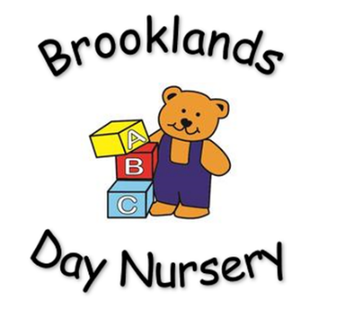

**Brooklands Private Day Nursery**

**Equal opportunities and Inclusion Policy**

Aim: At Brooklands Nursery, we welcome everyone irrespective of their gender, beliefs, origins and practices.

Rationale: To provide a fully inclusive, high-quality care and play provision.

Procedure:

At Brooklands Nursery everyone is encouraged to develop self-esteem, confidence and motivation in all areas of their lives. All staff will ensure that both boys and girls have full access to a wide variety of activities and equipment and are equally encouraged to enjoy and learn from them.

Being situated in a culturally diverse community we adopt a clear understanding of all major cultural and religious events and participate in celebrating a spectrum of festivals.

The implementation of the equal opportunities policy supports us in:

* Creating an environment in which individuals feel valued.
* Meeting children’s diverse needs.
* Ensuring equal access to all areas of the curriculum for the children in our care.
* Promoting the belief that everyone can and should achieve to their highest potential in all areas of the taught and ‘’hidden’’ curriculum.
* Working with vulnerable families.
* Providing materials and equipment to promote learning that is appropriate and reflects diversity.
* Supporting quality for children with disabilities or SEN.
* Taking in to consideration any religious, cultural or medical requirements.

Children’s individuality is celebrated within our nursery this is reflected through our planning systems, admission policy, and SEN policy and through multi agency working. Systems are in place to allow the regular exchange of information between parents/carers and the nursery.

Admissions

Our admissions policy highlights our willingness to integrate children of all abilities in to the setting including those with special needs. We welcome the opportunity for both parent and child to visit prior to accessing a place at the nursery, this enables us to comply with the Equality Act 2010 and discuss the ways in which we can meet the child’s needs, and every effort will be made to obtain suitable specialist equipment, aids or resources. In terms of access, we may be required to make reasonable adjustments as appropriate. At Brooklands Nursery we are committed to valuing and acknowledging each child’s individuality and helping them to feel positive about themselves. Every effort will be made to effectively support children and families of children with English as an additional language.

Identification and Assessment of all children

As per usual practice, the child’s key worker will be responsible for observing and recording individual progress.

This monitoring is essential in identifying strengths and difficulties that a child may present; it ensures that appropriate support is put into place.

In line with the SEN Code of practice, any concerns regarding a child’s development MUST be shared with the manager/setting SENCO. Bethany Allen (Nursery Manager) is the designated nursery Special Educational Needs and Disabilities Co-Ordinator, if felt necessary these concerns will be shared with the child’s parent/carer and permission may be sought to involve the area SENCDO or other professionals as appropriate.

This is referred to as the ‘Graduated Approach’; please consult the SEND Policy for further details.

Behaviour

Staff and other adults in the nursery should be seen to behave in a manner, which demonstrates mutual respects for one another. All staff and adults are aware of the nursery policy on behaviour and should be a good role model. Adults should take every opportunity to encourage children to behave appropriately and to deal with incidents positively.

Discrimination and offensive behaviour towards the gender, beliefs, origins and practices of others is prohibited within our nursery. Any person believing that this policy is not being complied with should bring their concern to the attention of the Nursery Manager.

This policy will be reviewed every 12 months by management.