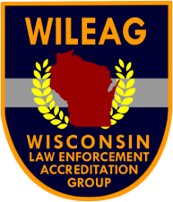
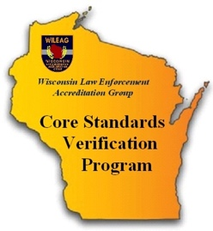
Wisconsin Law Enforcement
Accreditation Group, Inc.

Challenging Wisconsin’s Law Enforcement Agencies to Achieve Excellence

Core Standards Verification Program

Application

Agency Name:

Address:

City: State: Wisconsin Zip:

Government Chief Executive Officer:

Title: Telephone:

Email:

Agency’s Chief Executive Officer:

Title: Telephone:

Email:

Agency’s Accreditation Manager:

Title: Telephone:

Email:

Payment in the amount of $100.00 to cover costs attendant to our agency’s application for accreditation is due when applying. This payment is exclusive of on-site costs associated with the assessment and annual dues.

Remit Payment to: WILEAG

Send Payment to: Rebecca Grill, Treasurer

PO BOX 44152

West Allis, WI 53214

The commitment our agency must make in working with the Governing Board toward certification is understood and accepted. Also, we are prepared to provide information promptly concerning our agency that the Governing Board requires in making its relationship with the Governing Board. Our agency can terminate its applicant status at any time upon written notice that it is withdrawing from the accreditation process.

For the Agency:

By:

Signature

Printed Name

Title

Date:

