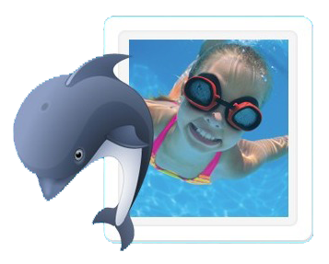
Queensborough Swim Club
1138 Miller Ave., San Jose, CA 95129
Between Rainbow & Bollinger
Pool Hours:
Sun - Thurs 7:00 am - 9:00 pm and Fri and Sat 7:00 am - 10:00 pm
Lifeguards on duty in the summer Mon-Fri from 1 pm - 5 pm.
This is a fun family oriented neighborhood non-profit pool (since 1964!), safe, very clean, HEATED,remodeled patio and pool, bathroom/showers, barbecue, not crowded, and lots of parking!
Membership/Swim Lesson Registration:
Mail application/check or drop off application/check or cash in the Club House door
mail slot OR come to our FREE Ice Cream Social (please RSVP) on Sunday June 3 from 1-4 pm
OR visit QPOOL.ORG OR email info@qpool.org for the 2018 Membership Application
Memberships available
Family (2 adults & up to 3 children for 12 months) $650, Life Time (2 adults & up to 3 children) $5000,
Senior (2 adults only, both over 62 years old) $275 (each additional child over 3 children is $25 each)
Membership includes REDUCED RATES on: Swim Lessons, Kid's Night Out, and Club House Rentals
Swim lessons!
Private and semi-private lessons: Adults and children – 2 years to 99 years.
1/2 hour or hour sessions are offered. Let us know what day(s) and time(s) work for you.
Fees: Private (1 lesson): $30/half hour, $50/hour
Semi-Private (1 lesson): $20/half hour, $30/hour
Group lessons: Children 3 years – 13 years
Beginner, Advanced Beginner, Intermediate and Advanced lessons.
Weekly sessions (Mon-Fri): Jun 11-Aug 10, Half hour lessons in the morning 9 am – 12 pm
Fees: (5 lessons): Members $50 Non-members: $90
Nine Saturday sessions: Jun 9-Aug 11 (not on June 30), Half hour lessons in the morning 10:30 am – 12 pm Fees: Members $12/lesson $96/9 lessons Non-members: $17/lesson $136/9 lessons
Kid’s Night Out (KNO) is back!
Friday night 6 pm – 9:30 pm
Fridays in June, July, and August
KNO includes lifeguarded SWIMMING, pizza, drinks, dessert, crafts and a movie!!
Fees: Members: one child: $20; each addtl child: $15, Non-members welcome for $5 more per child.

Clubhouse rental: Members: $75 for 3 hours ($25 each additional hour and $5 each guest swimmer),
Non-members: $30 per hour, minimum of 3 hours ($30 each addtl hour and no swimmers)
Ice Cream Social: Come join us Sunday, June 3 from 1-4 pm and see what we are about!
For Complete Registration Info, visit QPOOL.ORG, email info@qpool.org or call/leave message at 408-446-3921

