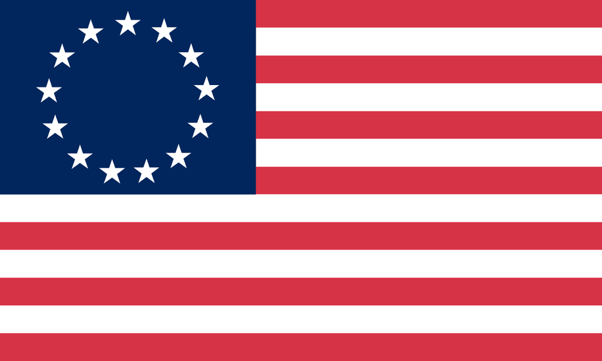U.S. History with Mr. Brown Name _______________________________ Period _____
Vocabulary Quiz ch 5.1 to 5.2
Directions: Complete each group of terms with the correctly related vocabulary term.

1) __________________________  Negligence  Disregard  Inattentiveness | 2) __________________________  Constitutional rights  Privileges  Freedoms | 3) __________________________  Trainee  Novice  Beginner
4) __________________________
Congress
Legislature
Governing Body

Directions: Match the vocabulary term with the correct description

5) _____ John Peter Zeneger  6) _____ Edmund Andros  7) _____ John Locke  8) _____ Benjamin Franklin  9) _____ George Whitfield  10) _____ Jonathan Edwards | A: Publisher of New York Weekly Journal who was put on trial for criticizing the New York governor  B: One of the best known preachers of the Great Awakening who terrified listeners with images of God’s anger and promised salvation  C: Great Awakening preacher who raised funds to start a home for orphans  D: Royal governor of the dominion of New England  E: Famous American Enlightenment thinker  F: English philosopher who argued that people have natural right of life, liberty, and the pursuit of happiness
11) _____ Great Awakening  12) _____ Enlightenment | A: A movement that promoted ideas of science and reasoning over religion which led to development of the concepts of freedom and rights  B: A religious movement in the colonies during the 1730’s – 1740’s. Preachers said that inner religious emotion was more important than outward religious behavior

