Hello Working Dog Enthusiast!
I am your Carolina Working Group Association (CWGA) Trophy Chair for 2019 and I am super excited to share with you what we have up for sponsorship!

Please take a moment and consider sponsoring these beautiful trophies and rosettes for your breed, Juniors and All Groups too!

For the morning show and both Puppy and Veteran Sweeps, we have local Carolina hand-made pottery by McNeill Pottery in Seagrove, NC. Love their beautiful work!! Here are some examples of what they make in the color chosen for our show! These are all the same color, the indoor photos are dark.

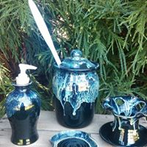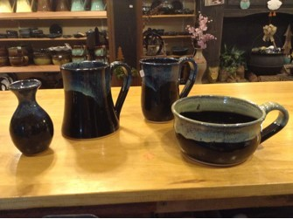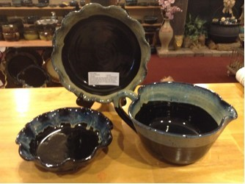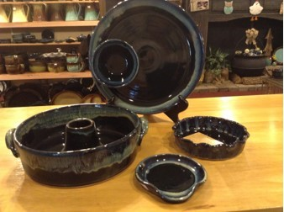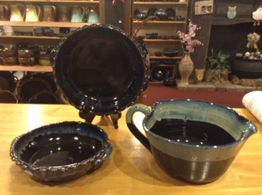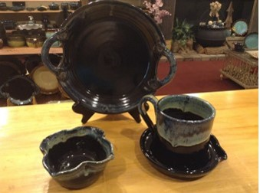

The rosettes chosen for both shows are the beautiful hand made Regal Rosettes anyone would be proud to hang on their wall!
Here are some examples of the work they do in the size chosen for our Show! If these Rosettes are not sponsored, the ribbons will be the normal MBF.

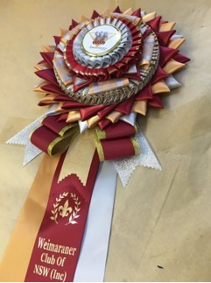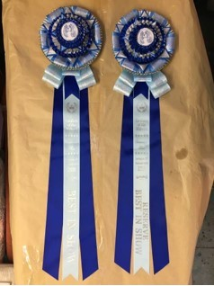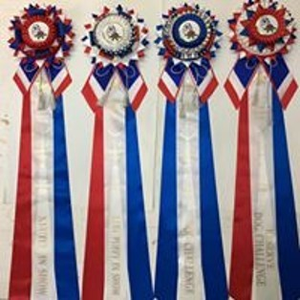

Juniors Is a very special personalized piece of local Carolina handmade pottery by RiverStone Pottery in Lake Whylie, SC.
“Best Jr handler CWGA 5-30-19” will be stamped on this dish, and it will be awarded along with a Beaded show lead made by Davis Acres.

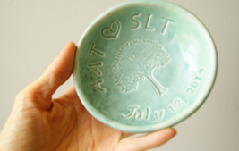

The Second Show trophies are local South Carolina handmade braided and beaded Show Leads made by Davis Acres at a very special CWGA price. Breed Leads will be lead color of your choice with the beads matching as close as possible to the award being won; BOB, BOW, BOS and Selects with Metal, Glass and Rhinestone beads. Winners Dog and Bitch will be plain leads the color of your choice. Here are some examples of the Show Leads!

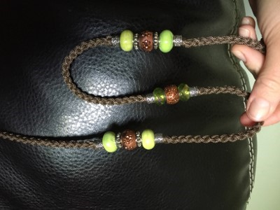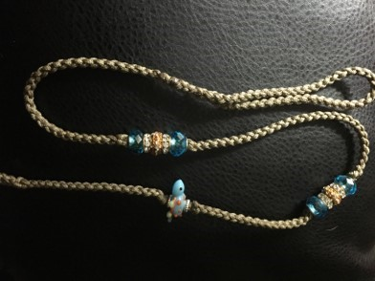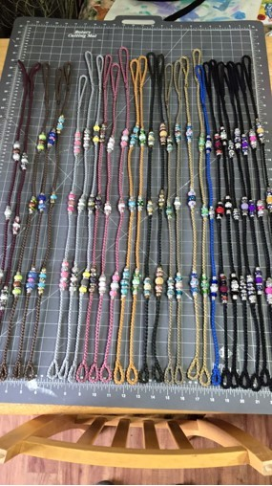

**PRICING**
SHOW 1
Each Breed
 | Rosette | Cost | Sponsor | Paid | Trophy | Cost | Sponsor | Paid
BOB |  | 25 |  |  | Creamer and Garett Mug | 20
BOBOH |  | 16 |  |  | Wendy Mug | 10
BOW |  | 16 |  |  | Toothbrush holder | 12
BOS |  | 16 |  |  | Garret Mug | 10
SD |  | 7 |  |  | Tea Glass | 9.5
SB |  | 7 |  |  | Tea Glass | 9.5
WD |  | 7 |  |  | Soap Dish | 5
WB |  | 7 |  |  | Spoon Rest | 5
BVS |  | 20 |  |  | Pair of Tea Glasses | 19
BVOS |  | 16 |  |  | Wendy Mug | 10

Groups |  |  | Rosette | Cost | Sponsor | Paid | Trophy | Cost | Sponsor | Paid
WORKING GROUP |  | G1 |  | 25 |  |  | Lg Square/Rectangle Tray | 38
 |  | G2 |  | 25 |  |  | Serving Platter | 26
 |  | G3 |  | 25 |  |  | 11" Pie Plate | 22.5
 |  | G4 |  | 25 |  |  | 2 lb Serving Bowl | 15
NOHS WORKING GROUP
 |  | G1 |  | 25 |  |  | Chip N Dip piece | 26
 |  | G2 |  | 25 |  |  | Batter Bowl | 23.5
 |  | G3 |  | 25 |  |  | Bacon Cooker | 20
 |  | G4 |  | 25 |  |  | 2 lb Vase | 15
VET SWEEPS GROUP
 |  | G1 |  | 25 |  |  | Tea Pitcher | 32
 |  | G2 |  | 25 |  |  | Black Dog | 20
 |  | G3 |  | 25 |  |  | Honey Pot | 15
 |  | G4 |  | 25 |  |  | Lotion Dispenser | 11

JUNIORS | BJ |  | 20 |  |  | Personalized flat Ring Dish and Beaded Show Lead |  | Lead Donated by Jessica Davis | X
 |  |  |  |  |  | "CWGA Best Junior Handler date" | 20
 | RBJ |  | 16 |  |  | Double Cluster Beaded Show Lead | 12

SHOW 2
**Important** When sponsoring Show leads for your breed: Please Specify color of lead; Fawn/Brown/Black/Charcoal Gray/Light Silver Gray and Length; 16”/22”/28”/30”

 | Rosette | Cost | Sponsor | Paid | Trophy | Cost | Sponsor | Paid
BOB |  | 25 |  |  | 16"/22"/28"/30" F/BRN/BLK/CG/LG Beaded Show Lead BOB Colors | 10
BOBOH |  | 16 |  |  | 16"/22"/28"/30 F/BRN/BLK/CG/LG Beaded Show Lead BOBOH Colors | 10
BOW |  | 16 |  |  | 16"/22"/28"/30 F/BRN/BLK/CG/LG Beaded Show Lead BOW Colors | 10
BOS |  | 16 |  |  | 16"/22"/28"/30" F/BRN/BLK/CG/LG Beaded Show Lead BOS Colors | 10
SD |  | 7 |  |  | 16"/22"/28"/30" F/BRN/BLK/CG/LG Beaded Show Lead Select Colors | 10
SB |  | 7 |  |  | 16"/22"/28"/30" F/BRN/BLK/CG/LG Beaded Show Lead Select Colors | 10
WD |  | 7 |  |  | 16"/22"/28"/30" Plain F/BRN/BLK/CG/LG Braided Show Lead | 3
WB |  | 7 |  |  | 16"/22"/28"/30" Plain F/BRN/BLK/CG/LG Braided Show Lead | 3
BPS |  | 20 |  |  | Pair of Tea Glasses | 19
BPOS |  | 16 |  |  | Wendy Mug | 10

Groups |  |  | Rosette | Cost | Sponsor | Paid | Trophy | Cost | Sponsor | Paid
WORKING GROUP |  | G1 |  | 25 |  |  | Beaded Show Lead | 15 | Jessica Davis - Nevaeh Bullmastiffs
 |  | G2 |  | 25 |  |  | Beaded Show Lead | 12
 |  | G3 |  | 25 |  |  | Beaded Show Lead | 12
 |  | G4 |  | 25 |  |  | Beaded Show Lead | 12
NOHS WORKING GROUP
 |  | G1 |  | 25 |  |  | Beaded Show Lead | 15 | Jessica Davis - Nevaeh Bullmastiffs
 |  | G2 |  | 25 |  |  | Beaded Show Lead | 12
 |  | G3 |  | 25 |  |  | Beaded Show Lead | 12
 |  | G4 |  | 25 |  |  | Beaded Show Lead | 12
PUP SWEEPS WORKING GROUP
 |  | G1 |  | 25 |  |  | Tea Pitcher | 32
 |  | G2 |  | 25 |  |  | 1/2 Recipe Bunt Pan | 22.5
 |  | G3 |  | 25 |  |  | 2 lb Serving Bowl | 15
 |  | G4 |  | 25 |  |  | Sm Mixing Bowl with Spout | 12

JUNIORS | BJ |  | 20 |  |  | Personalized flat Ring Dish and Beaded Show Lead |  | Lead Donated by Jessica Davis | X
 |  |  |  |  |  | "CWGA Best Junior Handler date" | 20
 | RBJ |  | 16 |  |  | Double Cluster Beaded Show Lead | 12

Sponsoring is first come first serve … I will let you know if something is already taken. Yes please feel free to forward this email to friends who you think would have interest in sponsoring some trophies, especially if they plan to come or have shown with us in the past, and they DO NOT need to be a member of the CWGA! Spread the word and share with your breeders!

*** IMPORTANT***
To sponsor please email or me directly
Please specify Show One or Two, What Breed, Group or Jr you are sponsoring, rosette and/or the trophy name. ** Do include how you would like your sponsorship to read in the catalog. I will email back confirmation, your total and where to send your payment.
**Important** When sponsoring Show leads for your breed: Please Specify color of lead; Fawn/Brown/Black/Charcoal Gray/Light Silver Gray and Length; 16”/22”/28”/30”

**Please do not hesitate to ask me any questions, this is a large email, I do not mind, and I will return your email or call as soon as I can.**

Blessings!
Jesi Davis, LVT
CWGA 2019 Trophy Chair
Nevaeh Bullmastiffs
JESSICA.LD@LIVE.COM
704-771-6817

