INDIAN ASSOCIATION OF PHYSICS TEACHERS
NATIONAL STANDARD EXAMINATION IN BIOLOGY 2018 -19
Date of Examination: 25TH November, 2018
Time: 1400 to 1600 Hrs
Q. Paper Code:
Write the question paper code mentioned above on YOUR answer sheet (in the space provided), otherwise your answer sheet will NOT be assessed. Note that the same Q. P. Code appears on each page of the question paper.
Instructions to Candidates –
- Use of mobile phones, smartphones, ipads during examination is STRICTLY PROHIBITED.
- In addition to this question paper, you are given answer sheet along with Candidate’s copy.
- On the answer sheet, make all the entries carefully in the space provided ONLY in BLOCK CAPITALS as well as by properly darkening the appropriate bubbles.
Incomplete/ incorrect/carelessly filled information may disqualify your candidature.
- On the answer sheet, use only BLUE or BLACK BALL POINT PEN for making entries and filling the bubbles.
- The email ID and date of birth entered in the answer sheet will be your login credentials for accessing performance report. Please take care while entering.
- Question paper has 80 multiple choice questions. Each question has four alternatives, out of which only one is correct. Choose the correct alternative and fill the appropriate bubble, as shown.
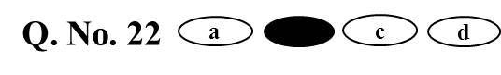
- A correct answer carries 3 marks whereas 1 mark will be deducted for each wrong answer.
- Any rough work should be done only in the space provided.
- Use of non-programmable sicncetific calculator is allowed.
- No candidate should leave the examination hall before the completion of the examination.
- After submitting your answer paper, take away the Candidate’s copy for your reference.

Please DO NOT make any mark other than filling the appropriate bubbles properly in the space provided on the answer sheet.
Answer sheets are evaluated using machine, hence CHANGE OF ENTRY IS NOT ALLOWED.
Scratching or overwriting may result in a wrong score.
DO NOT WRITE ON THE BACK SIDE OF THE ANSWER SHEET.

Instructions to Candidates (continued) –
Read the following instructions after submitting the answer sheet.
- Comments regarding this question paper, if any, may be sent by filling the google forms only at https://goo.gl/forms/QejaYHl65N9AHBUe2 till 27th November, 2018.
- The answers/solutions to this question paper will be available on our website – www.iapt.org.in by 2nd December, 2018.
- CERTIFICATES and AWARDS –
Following certificates are awarded by the IAPT to students successful in NSEs
(i) “Centre Top 10%” that will be sent to NSE centre by post.
(ii) “Statewise Top 1%” that can be downloaded after Feb -15th, 2019 from iapt.org.in
(iii) “National Top 1%”. Certificates can be downloaded after Feb -15th, 2019 iapt.org.in
- Result sheets can be downloaded from our website in the month of February. The “Centre Top 10%” certificates will be dispatched to the Prof-in-charge of the centre by February, 2019.
- List of students (with centre number and roll number only) having score above MAS will be displayed on our website (www.iapt.org.in) by 22nd December, 2018. See the Eligibility Clause in the Student’s brochure on our website.
- Students eligible for the INO Examination on the basis of selection criteria mentioned in Student’s brochure will be informed accordingly.
- Students qualified for OCSC (Biology) – 2019 will be awarded gold medals.

- Green world hypothesis suggests that despite many primary consumers feeding on plants, the terrestrial ecosystems maintain their greenery. The herbivores are able to consume only a small part of plant biomass because of several inhibiting factors. Some of the factors are listed below :
- Plants have defences against herbivores.
- Abiotic factors limit herbivore feeding.
- Disturbances in breeding cycle limit herbivore feeding.
- Intraspecific competition limits herbivore feeding.
Which of the following is true?

- Statements 1,2 and 3 are the inhibiting factors.
- Statements 1,2 and 4 are the inhibiting factors.
- Statements 1,3 and 4 are the inhibiting factors.
- Statements 2,3 and 4 are the inhibiting factors.

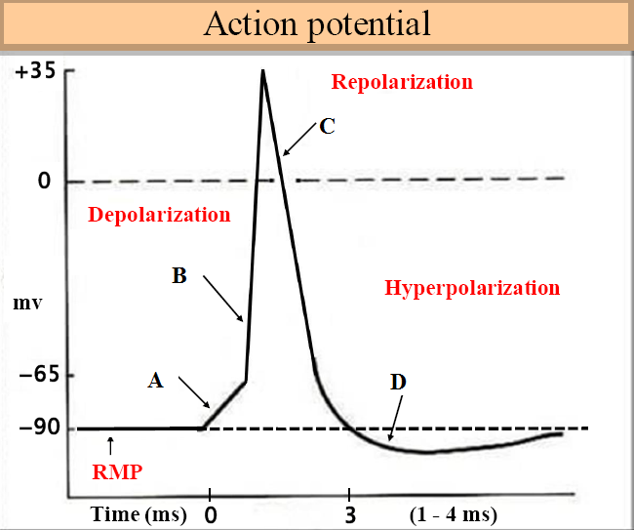
- Match the alphabets (A, B, C and D) with the events (i, ii, iii and iv) seen during action potential.

i) Voltage gated K⁺ channels remain open after the potential reaches resting
level.
ii) Closure of Na⁺ and opening of K⁺, voltage gated channels.
iii) Local potential change, depolarization to threshold.
iv) Opening of voltage gated Na+ channels.

- A – iv, B – i, C – iii, D - ii
- A – iii, B – iv, C – ii, D – i
- A – i, B – ii, C – iii, D – iv
- A – ii, B – i, C – iv, D – iii

- The first groups of animals to develop a lung adequate to support their respiratory requirements without use of supplementary organ for gaseous exchange were;
a) amphibians
b) reptiles
c) mammals
d) aves

- With respect to keratin, which of the following is NOT a correct statement?
- It is the structural protein of hair, wool, nails, claws ,beaks and feathers .
- It is a component of vertebrate skin.
- It is a globular protein that protects animal body from external injuries.
- Its hardness vary with the degree of cross linking by disulphide bridges between neighbouring chains.

- Spina bifida is a congenital defect of the vertebral column. An increased risk of this defect is primarily associated with low level of -
- Vitamin A
- Vitamin B
- Vitamin C
- Vitamin E

- With respect to mitochondria and chloroplast which of the following statements is
NOT true?
a) They possess a circular chromosome.
b) They reproduce within the cell.
c) They divide at the same time as the cells in which they are situated divide.
d) They employ chemiosmotic energy transduction to fuel the biochemical
reactions that take place within their structures.

- The presence of homologous structure in two different organisms, such as radius and ulna in forelimb of a human and a bat, indicates that -
a) humans and bats are polyphyletic species.
b) the evolution of human and bat is convergent.
c) humans and bats form a monophyletic clade.
d) humans and bats did not evolve from a common ancestor.

- Tattooing is a permanent coloration of the skin in which a foreign pigment is deposited with a needle into the _______________.
- epidermis
- dermis
- hypodermis
- connective tissue
- An angiosperm ‘A’ and a gymnosperm ‘G’ have 100 chromosomes in the cells of their meristem. What would be the correct number of chromosomes in the endosperms of the seeds of A and G?
- A =300; G=300
- A=200; G=200
- A=100; G=300
- A=300; G=100

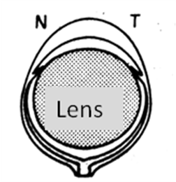
- Schematic eye is represented in the figure. Which of the following statements is true?

- It shows adaptation for acquiring maximum dim light.
- It peculiarly shows high resolution power of retina.
- It represents a typical diurnal animal.
- Small distance between the retina and lens permits projection of larger and clearer image.

- A bone scan is a diagnostic tool where small amount of a radioactive tracer compound is injected intravenously and the degree of uptake of the tracer is measured by a scanning device. Normal bone tissue is identified by a consistent grey colour. Darker or lighter areas also known as “Hot spots” and “Cold spots” respectively may indicate bone abnormalities. By considering this fact, which of the following conditions would produce hot spots on X ray sheet?
- Decalcified bone.
- Paget’s disease (disease that disrupts displacement of old bone tissue with new).
- Bone cancer.
- Degenerative bone diseases.

- There are two forms of UV radiations, UVA (315 – 400 nm) & UVB (280 – 315 nm) that have different effects on health. Which of the following statements is true?
- UVA is not absorbed by the ozone layer and is responsible for tanning.
- UVB is not absorbed by the ozone layer and is germicidal in action.
- UVA is most absorbed by ozone layer and is responsible for cataract formation.
- UVA is not absorbed by ozone layer and is responsible for sun burn and skin cancer.
- Select the correct match for items in part A to that in part B among the following :
PART A PART B
P) Receptor mediated endocytosis i) Entry of maternal antibodies across
placenta
Q) Phagocytosis ii) Entry of HIV in helper T cell.
R) Bulk phase endocytosis / Pinocytosis iii) Vital defence mechanism
S) Transcytosis iv) Absorptive cells of kidneys &
intestine.

- P – ii, Q – i, R – iii, S – iv
- P – i, Q – ii, R – iv, S – iii
- P – ii, Q – iii, R – iv, S – i
- P – iii, Q – iv, R – ii, S – i

- Structural features of two types of cells; P and Q of vascular tissue of a dicot plant are given below;
P :- Presence of nucleus, membrane bound organelles and large number of mitochondria .
Q :- No nucleus , cytoplasm is in the form of thin layer, few small mitochondria, no ribosomes, no Golgi bodies.

Cells P and Q are :

- P–xylem parenchyma ; Q–xylem trachieds
- P–companion cell ; Q –Phloem fibres
- P–Companion cells ; Q–sieve tube elements
- P–companion cell ; Q –Xylem parenchyma .

- The products of hydrolysis of chitin which is a major component of exoskeleton of insects is ;
a) galactosamine which is an amino sugar.
b) glucosamine which is an amino sugar.
c) deoxyribose sugar which is a pentose sugar.
d) fatty acids and glycerol.

- White coat color in guinea pigs is recessive (b) to black (B). Ovary from black homozygous guinea pig is transplanted into a white ovarectomized female. If this white female is mated with a white male the offspring will be,
a) black with the genotype BB.
b) white with the genotype bb.
c) black or white with genotype Bb OR bb.
d) black with the genotype Bb.

- In the context of the following figure, which of the statements below is true?
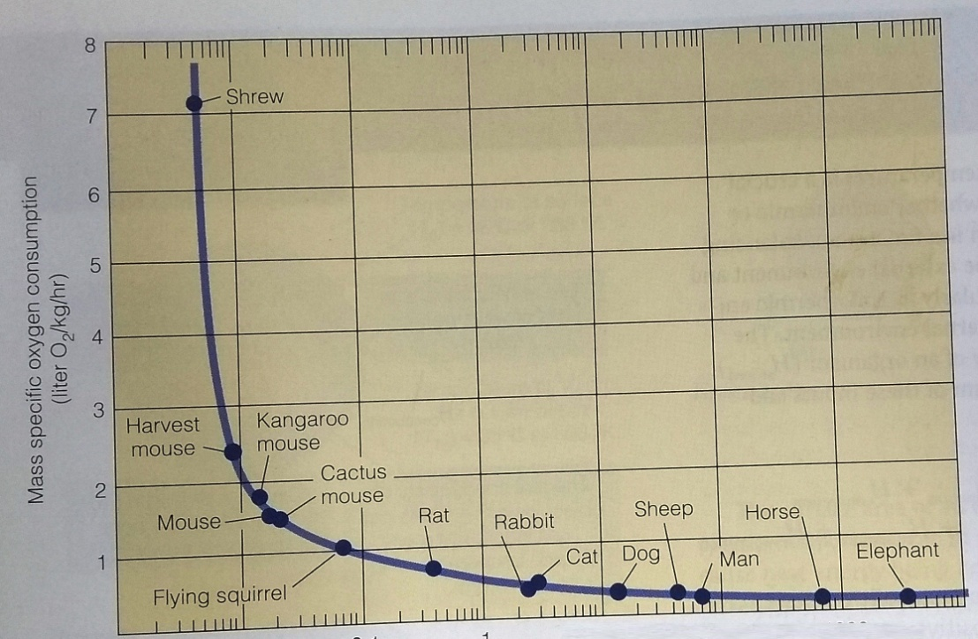

Log (body mass)

- Mass specific metabolic rate decreases with increased activity.
- Mass specific metabolic rate increases with decreasing body mass.
- Mass specific metabolic rate increases with decreased area / volume.
- Mass specific metabolic rate decreases with increase in food consumption rate.

- Kangaroo rat is a xeric vertebrate which has higher metabolic rate than lizards. It usually does not drink water. Which of the following features is NOT shown by this mammal?
- It produces highly concentrated urine.
- It shows lower basal metabolic rate than a non-desert mammal.
- It utilises metabolic water and spends the day in burrows which have temperature of 25°C.
- It has cutaneous permeability to absorb moisture from the damp burrows during day and from cold sand at night.

- Glyoxysomes are single membrane-bound cytoplasmic organelles in eukaryotes. Which of the following statements is NOT true for glyoxisomes?
a) glyoxysomes are specialised type of peroxisomes.
b) they play a major role in the mobilisation and utilisation of stored nutrients in
germinating seeds.
c) they are found in vertebrates liver and play a major role in converting glucose
to glycogen.
d) they play a major role in the conversion of fatty acids in to carbohydrates.

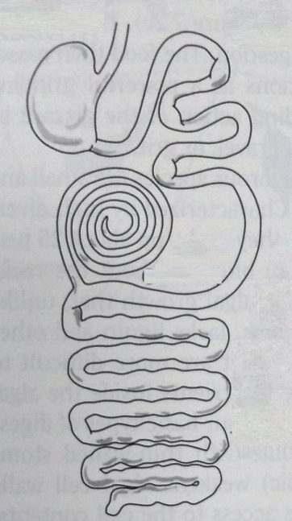
- The diagram below represents the digestive system from ____________ group of animals.

a) ruminant herbivore
b) non-ruminant herbivore
c) bird
d) carnivore animal

- When a small piece of fresh liver is dropped into a beaker of hydrogen peroxide solution, it results in rapid generation of gas bubbles. This can be attributed to:
1. action of an enzyme catalase that breaks down H₂O₂ into H₂O and O₂.
2. action of peroxisomes in hepatocytes, whose enzymes break down H₂O₂ to
release oxygen.
3. Increased H₂O₂ production by superoxide dismutase activity in peroxisomes.
4) H₂O₂ acting on glycogen from liver cells releasing CO₂.

a) 1and 2
b) 4 only
c) 3 only
d) 2 and 3

- Function of non-kinetochore microtubules is ;
- To help the chromosomes to get arranged at the equator.
- To elongate the cell during anaphase.
- To help the separation of chromatids during anaphase.

Which of the statement/s is/are correct?
- i only
- ii only
- iii only
- i and iii
- The diagram below represents pattern of expansion and reduction of major terrestrial plant groups identified as P, Q, R and S during the 400 million years of plant evolution. If S represents Angiosperms, P, Q and R respectively represent:
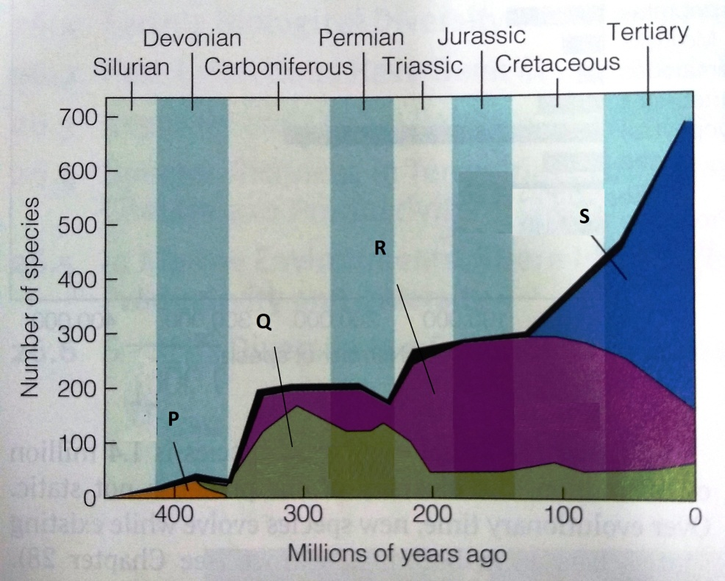

- P – Pteridophytes, Q – Psilopsids, R- Gymnosperms
- P - Gymnosperms, Q – Psilopsids, R- Pteridophytes
- P – Pteridophytes, Q – Gymnosperms, R- Psilopsids
- P – Psilopsids, Q – Pteridophytes, R - Gymnosperms

- If photosynthesizing algal cells are provided with CO₂ with heavy isotope of oxygen (¹⁸O₂); which of the following, produced by the algae will NOT contain ¹⁸O₂?
- PGA
- PGAL
- Glucose
- O₂

- Which of the following statements about allosterically regulated enzymes is correct?
- Activator binds to the active site of an enzyme.
- Inhibitor binds to the active site of an enzyme.
- Activator binds to the active sites and stabilise the active form of an enzyme.
- Activator binds to the regulatory site of an enzyme and stabilizes the active form.

- The following four sites (a – d) were being considered for the construction of an international airport. The species composition of the four sites are given below. Construction on which of the sites (a, b c and d) will not take a huge toll on biodiversity ?
Site | Number of species in various categories
Site | Least concern | Uncertain status | Rare | Endangered | Endemic
a | 58 | 11 | 02 | 00 | 05
b | 103 | 20 | 01 | 00 | 01
c | 49 | 00 | 02 | 02 | 14
d | 126 | 09 | 04 | 07 | 08

- Which of the following features are mostly observed in self pollinating flowers?
- Inconspicuous flowers.
- Presence of nectaries.
- No fragrance.
- Short style.
- Versatile anthers.

- i, iii and iv
- only iii
- ii and iv
- iv and v

- Apoptosis can be induced in a plant organ or the whole plant by a burst of :
a) Gibberellins.
b) Ethylene.
c) Cytokinins.
d) Auxin.

- If unabsorbed by plants, nitrates may leach through soil into water bodies like river but ammonium ions are less likely to reach water bodies through soil because ,
- Ammonium being a cation gets adsorbed by soil clay particles that are negatively charged.
b) Ammonium ions react with water to form ammonia and escape.
c) Ammonium ions are more readily absorbed by plants.
d) Ammonium nitrates are formed which do not dissolve in water and get
precipitated.

- In corn plants, a dominant allele ‘I’ inhibits kernel colour, while the recessive allele ‘i’ permits colour. At a different locus, the dominant allele ‘P’ makes kernel purple while ‘pp’ makes kernels red. If plants heterozygous at both loci are crossed, what will be the phenotypic ratio of purple : red : colourless ?
- 3:1:12
- 12:4:0
- 9:4:3
- 3:4:9

- The distribution of four types of bacteria grown in four different undisturbed tubes containing culture media is shown below. P, Q R and R respective indicate:
P
Q
R
S

- Aerobes, anaerobes, facultative aerobes and microaerophilic organisms.
- Anaerobes, aerobes, facultative aerobes and microaerophilic organisms.
- Microaerophilic organisms, aerobes, anaerobes and facultative aerobes.
- Anaerobes, aerobes, microaerophilic organisms and facultative aerobes.

- A cross between a pea plant (Pisum sativum) with long stem and axial flower with short stem and terminal flowers produce twenty-one seeds. From these seeds, 11 plants grew into plants with long stem and axial flowers while 10 grew into short stem with axial flowers. The genotype of the parents must be.
- TTAA* ttaa
- TtAA* ttaa
- TTAa* ttAa
- TtAA* ttAA

- From a culture of mammalian cells, a cell in M phase is made to fuse with a second cell in G1 phase. The second cell will go into :
- S phase instantly.
- M phase skipping S phase.
- M phase after quickly completing S phase.
- G2 phase after quickly completing S phase.

- A man with haemophilia has a daughter of normal phenotype. She marries a man who is not haemophilic. If the couple has four sons, what is the possibility that all four will be born haemophilic?
- 1/4
- 1/32
- 1/16
- 1/8

- A wild type fruit fly (heterozygous for grey body colour and normal wings) is mated with a black fly with vestigial wings. The offspring have the following phenotypic distribution: wild type = 998; black vestigial = 994; grey vestigial = 208; black normal = 200.
What is recombination frequency between the two given alleles?
- 17%
- 15%
- 20%
- 25%

- The percentage composition by volume of gases at various stages of respiration in humans is tabulated below.
 | P | Q | R
Oxygen | 16.4 | 20.95 | 13.8
Caron dioxide | 4.0 | 0.04 | 5.5
Nitrogen | 79.6 | 79.01 | 80.7

P, Q and R respectively represent:
- Expired air, alveolar air and inspired air.
- Alveolar air, inspired air and expired air.
- Inspired air, alveolar air and expired air.
- Expired air, inspired air and alveolar air.

- Rejection of a transplant is an immune response of the type-:
  - B-lymphocyte mediated humoral.
  - Humoral, helper T lymphocytes mediated.
  - Cell mediated involving cytotoxic T lymphocytes.
  - Cell mediated involving memory T lymphocytes.

- Which of the following insects have 2 pairs of functional wings, shearing mouthparts and incomplete metamorphosis ?
  - Butterfly
  - Mosquito
  - Cockroach
  - Dragonfly
- According to finding from the Human Genome Project, there are about 25000 genes but there are many more different polypeptides. Which of the following processes might explain the discrepancy between number of genes and polypeptides?
- Mutations.
- Post-translational modifications.
- Crossing over during meiosis.
- Alternating splicing of RNA transcripts.

- 1 & 2
- 2 & 4
- 1, 3 & 4
- 3 and 4

- In comparison to the mountain goats adapted to climbing rather than running, similar- sized pronghorns that are adapted to run fast, have a 5 times greater rate of oxygen consumption. This is possible due to the following adaptations with an exception of :
  - Larger surface area in the lungs
  - Greater cardiac output
  - Larger and more abundant erythrocytes
  - Higher volume and density of mitochondria

- The following is a list of events in synthesis of protein from a DNA template.
- mRNA attaches to the ribosome.
- The amino acid is attached to the growing polypeptide by a peptide bond.
- mRNA migrates from the nucleus to the cytoplasm.
- An aminoacyl tRNA binds to its specific codon on mRNA.
- mRNA is transcribed from its DNA template.

Identify the correct sequence from the following options.
- v – iii – i – iv – ii
- v – ii – i – iii – iv
- v – iii – iv – ii – i
- v – iii – ii – iv – i

- If a plant is made to grow in a solution of biogenic nutrients supplemented with cytokinins it will:
  - become stunted.
  - become etiolated.
  - senescence faster.
  - become bushy.
- Porpoise (Phocaena spp.) is a group of small toothed whales found in Polar regions. The mammal is adapted to low temperature conditions. Following four schematic diagrams show possible arrangement of blood vessels in longitudinal section of their flippers. Which one of them is the most appropriate for maintaining optimum body temperature?
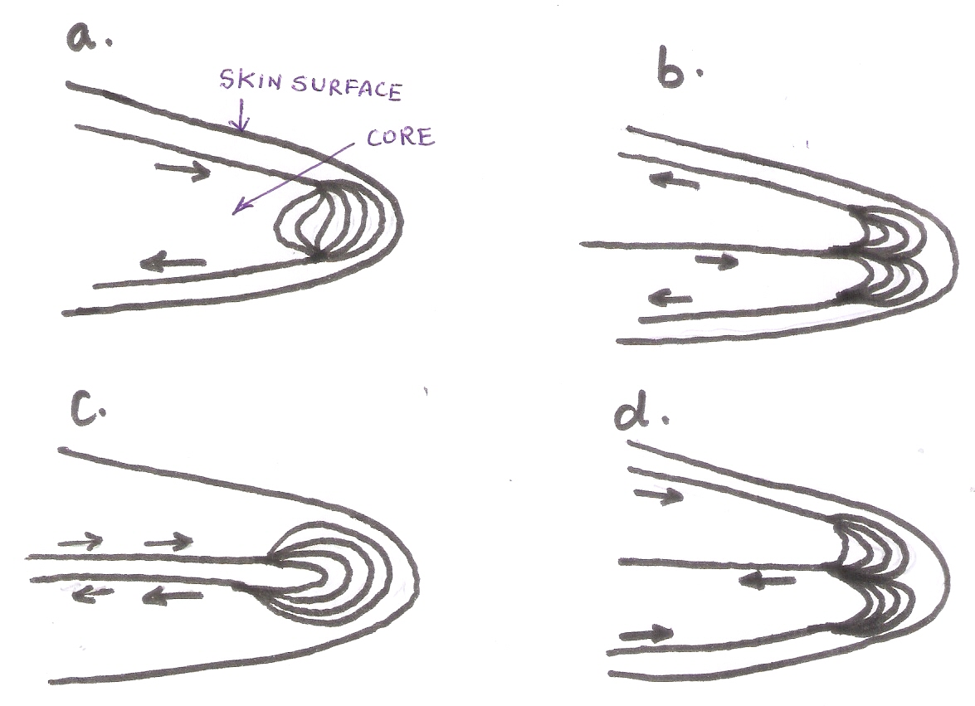

- The two graphs given below explain percent of human population present in each age group for two different countries. The population survey has been carried out in year 1990. Which statement/s correctly describe/s the graphs?
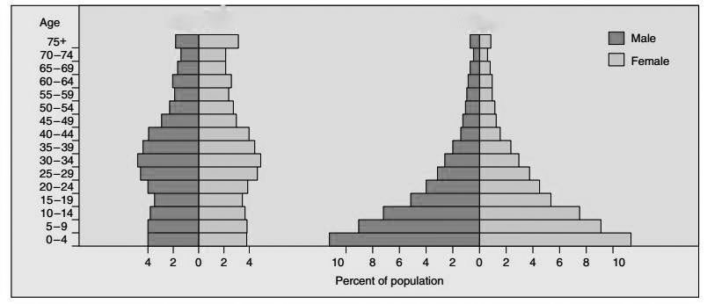
Population I
Population II

- Population I is related to poorly developed country while II is from highly developed country.
- Population I shows that more births occurred during 1945 to 1964.
- Population I has substantially higher percent population in age group 30-34 as compared to population II.
- Population II shows that female to male ratio is substantially reduces as the age increases.

- To initiate the inflammatory response, histamine that trigger dilation and increased permeability of nearby capillaries, is released by the injured cells in connective tissue called:
  - Macrophage
  - Fibroblasts
  - Chondrioblasts
  - Mast cells

- Lichens are known to be very sensitive to air pollution because they :
  - Fail to photosynthesise in high concentration of CO₂.
  - Do not produce mucilage to buffer against toxic gases.
  - Are unable to excrete toxic substances they absorb.
  - Cannot reproduce in air polluted with suspended particulate matter.

- Study of Gonyaulax polyedra, a dinoglagellate showed 3 peculiar diurnal cycles X, Y and Z. They respectively most likely represent:
Note that dark line in the graph indicates night.
Y
X
Z
Activity
hours

- photosynthesis, respiration and luminescence.
- cell division, photosynthesis and luminescence.
- migration, respiration and luminescence.
- reproduction, respiration and cell division.

- Assume that weight of fruit is being influenced by alleles occupying different loci and that the minimum weight of fruit is 20g ;with 2 g being added by each dominant allele. If maximum weight is 36g, how many gene loci must be involved?
  - 3
  - 4
  - 6
  - 8
- Birds like Albatross, spend months at sea drinking sea water. Their osmoregulation strategy includes:
    - Excreting salts through nasal glands.
    - Having uric acid as excretory material.
    - Having an active ornithine cycle.
    - Having more juxta-glomerular nephrons in kidneys.

- i & ii
- i & iii
- iii & iv
- ii & iv

- An inverted pyramid of biomass is expected for
  - tropical rain forest.
  - Grassland.
  - open ocean.
  - dessert.

- Carbon dioxide is a bye product of aerobic respiration. End Tidal CO₂ (Et CO₂) is maximal concentration of CO₂ at the end of exhaled breath. Normal wave of exhalation is shown below.
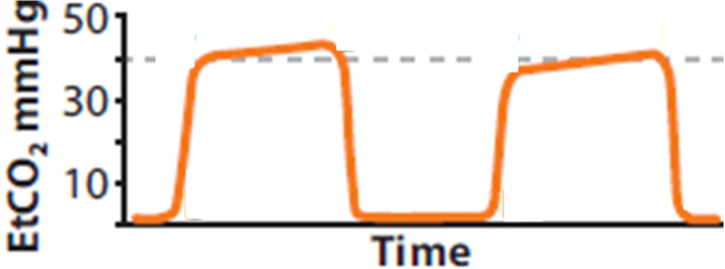

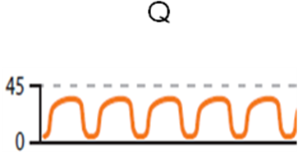
The following types of waves P and Q respectively indicate:
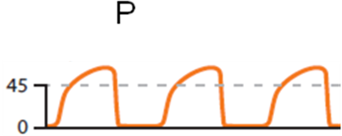

- hypoventilation and bronchospasm.
- hyperventilation and asthama.
- bronchospasm and hyperventilation.
- bronchospasm and hypoventilation.

- On an average a climax ecosystem has more organic matter in the form of
  - primary producers.
  - consumers.
  - decomposers.
  - dead organic biomass of all the above.
- Mechanism involved in volatilization of ammonia by land snail Helix is shown.
P, Q and R respectively indicate:
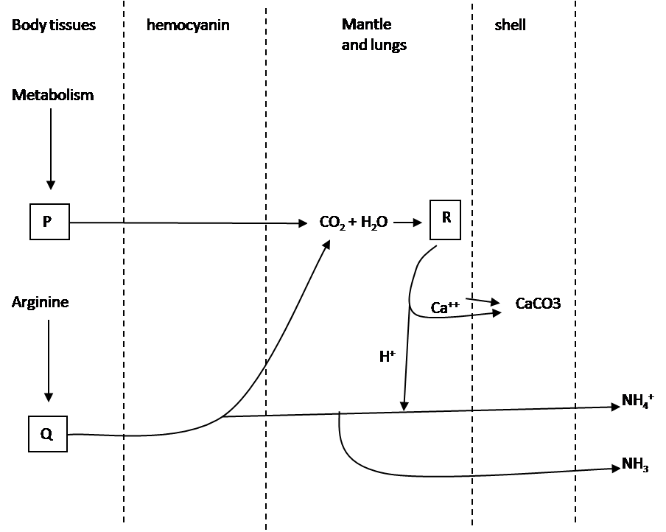

- urea, uric acid and bicarbonate.
- carbonic acid, urea and carbonate.
- ATP, arginase and bicarbonate.
- CO₂, urea and carbonic acid.

- A toad was offered bumble bees as food. The toad got stung by the bees. Subsequently the toad avoids feeding on insects with black and yellow colouration. This is an example of:
- Habituation.
- Sensitization.
- Associative learning.
- Innate behaviour.

- Endocrine glands play major role in working of ovarian cycle. Following events have to occur in specific sequence in female mammals, especially humans. The correct sequence of given events must be:
P: FSH stimulates granulosa cells to convert androgen to estrogen by
aromatase action.
Q: LH stimulates theca cells of ovarian follicle to secrete androgen.
R: Estrogen promotes growth of endometrium.
S: GnRH stimulates secretion of FSH and LH from anterior pituitary cells.

- P → Q → R → S
- S → Q → P → R
- R → P → Q → S
- S → R → P → Q
- In an experiment, extract of brain tissue was subjected to differential centrifugation. It resulted in 5 different zones of separation, 1-5. Zone 3 was found to be rich in acetyl cholinesterase activity while zone 5 was rich in succinate dehydrogenase activity. These zone most likely respectively represent:
- Myelin sheath and nuclei.
- Synaptic vescicles and golgi bodies.
- Mitochondria and myelin sheath.
- Mitochondria and synaptic vesicles.

- During embryo sac development in angiosperms, haploid megaspore continues to divide to form mature female gametophyte. It has 7- celled structure with
8 nuclei, where 6 nuclei are haploid and other two polar nuclei fuse to form diploid structure.
In Lilium, one of the two polar nuclei is triploid. Therefore, primary endosperm nucleus formed will be:
- 3n
- 4n
- 5n
- 2n

- Anita was studying flower morphology in her school lab. She collected one flower from her school garden and dissected it. She took cross section of ovary and found that ovules were arranged inside the ovary as shown below:

She could correlate the seed arrangement in ____________ fruit with the collected specimen.
- Tomato
- Green pea
- Cucumber
- Bell pepper

- In an enzyme catalyzed reaction, it is possible to reverse the inhibition of a reaction by increasing the substrate concentration in which of the following case/cases?
- Competitive inhibition.
- Non-competitive inhibition.
- Uncompetitive inhibition.
- Allosteric inhibition.
- A proper illumination is necessary to observe details of specimen mounted on a slide while using compound light microscope. It is achieved with the help of mirror. The correct path of light during microscopic observation is:
- Light source → Mirror → Condenser lens → iris diaphragm → Objective lens → specimen → Eye piece lens → Eye.
- Light source → Mirror → Iris diaphragm → Condenser lens → specimen → Objective lens → Eye piece lens → Eye.
- Light source → Condenser lens → Mirror → Iris diaphragm → specimen → Objective lens → Eye piece lens → Eye.
- Light source → Mirror → Iris diaphragm → specimen → Condenser lens → Objective lens → Eye piece lens → Eye.

- Rohit’s teacher gave him a freshly prepared slide of a vertical section of some unknown plant sample, to observe. Rohit found some non-lignified cells which were longitudinally elongated and tapering at both the ends. These ends were overlapping with next cells. The cells showed clustered perforations which were distributed uniformly over the cell surface. There were no chloroplasts in these cells. The specimen most likely represented _________
- Stem of Gymnosperm.
- Leaf of monocot.
- Root of dicot.
- Sporophyte of hornwort.

- Human circulatory system is made up of complex network formed by arteries, arterioles, capillaries, venules and veins. The graph given below shows variation in parameter ‘P’ against different types of blood vessels. ‘P’ represents:
P
Elastic
arteries
Muscular arteries

Arterioles
Capillaries
Venules
Veins
Vena cava

- Vessel diameter
- Total cross sectional area of vessels
- Average blood pressure
- Velocity of blood flow

- During one study on rate of decomposition, litterbag experiment was carried out on three tree species P, Q, and R from same forest. In this experiment, 30 litterbags were filled with 5.0 gms of senescent leaf litter for each tree. These bags were made of fine mesh to allow decomposers to access litter but do not let the decomposing material to fall out. These bags were buried in the litter layer of the forest. During a year, five bags of each species were removed at 6 intervals and their contents were dried and weighed. At the end of the experiment, the percent of mass remaining was found to be 75%, 50% and 45% respectively for given three species. The most appropriate reason for this difference is:
- The moisture content of leaves of ‘R’ species must be higher than others.
- The lignin content in ‘P’ is maximum among all three species.
- The difference in types of decomposers involved in process leads to variation in rate of decomposition.
- The mass of dead decomposers also added in case of species ‘P’.

- Southern flying squirrel ‘Glaucomys volans’ shows variation in their daily activity period throughout the year. As shown in the graph, the time of the day when squirrel becomes active varies considerably.

16:00
16:30
17:00
17:30
18:00
18:30
19:00
19:30
20:00
J
F
A
M
M
J
J
A
S
O
N
D
J
Months
Time of day

The reason is:
- The squirrel starts its daily activity with nightfall.
- The delayed activity period in April – July corresponds to breeding season.
- Higher temperature during day time in spring season leads to late beginning of activities.
- The activity starts early at the beginning of the year due to more availability of food.

- Following statements are made about Non-coding DNA. Mark the statement that is INCORRECT.
- Non-coding DNA can be transcribed into functional non-coding RNA molecules.
- Non-coding DNA can contribute towards evolution of Genome.
- Non-coding DNA may predispose individual to cancer.
- Non-coding DNA can be the causative agent of Tuberculosis.

- While cloning a Eukaryotic gene in Prokaryotic expression vector-
- gene of interest is inserted in a cloning vector with active prokaryotic promoter.
- mRNA of gene of interest is inserted in a cloning vector with active prokaryotic promoter.
- cDNA of gene of interest is inserted in a cloning vector with active prokaryotic promoter.
- gene of interest is inserted in a cloning vector with active prokaryotic enhancer sequence.

- The number and types of vertebrae in a few mammals are tabulated below:

Type of vertebrae | Number of vertebrae
 | Animal I | Animal II | Animal III
Cervical | 1 | 7 | 7
Thoracic | 7 (abdominal) | 12 | 13
Lumbar | 7 (abdominal) | 5 | 6
Sacral | 1 | 5 | 4
Caudal | 0 | 4 | 30

Animals I, II and III most likely are:
- I: Human II: Frog III: Rat
- I: Frog II: Human III: Rat
- I: Human II: Rat III: Frog
- I: Frog II: Rat III: Human

- Taq DNA polymerase is routinely used in PCR, what is its unique property?
- Taq DNA polymerase can polymerize ss DNA in 5’ → 3’ direction.
- Taq DNA polymerase can polymerize ss DNA in 3’ → 5’ direction.
- Taq DNA polymerase does not denature at high temperatures.
- Rate of DNA replication is much higher in presence of Taq DNA polymerase.

- In the famous experiments by Griffith, heat-killed smooth (S) strain of Pneumococci were mixed with the non-virulent rough (R) strain of Pneumococci and then injected into healthy mice (Experiment 1). In further experiments, the filtrate obtained by homogenizing the heat-killed smooth strain was treated with three different enzymes and then mixed with the nonvirulent R strain. These mixtures were injected into healthy mice to study the effect (Experiments 2 – 4). The results of these experiments are given in the table below.
Experiment | Heat-killed S strain treated with | Effect on mice after injecting the mixture of Heat-killed treated S and the nonvirulent  R strain
1 | No enzyme | Mouse died
2 | Enzyme M | Mouse remained healthy
3 | Enzyme N | Mouse died
4 | Enzyme O | Mouse remained healthy
M, N and O could be:

- DNAase; RNAase; Protease
- Protease; DNAase; RNAase
- DNAase; Protease; Nuclease
- Lipase; DNAase; Protease

- Oxygen-hemoglobin saturation curve can be obtained by plotting the amount of oxyhemoglobin present at different partial pressures of oxygen. The dashed line indicates the oxygen saturation curve obtained for a healthy individual (body temperature 37°C and blood pH 7.4).
Hemoglobin saturation %
20 40 60 80 100
Oxygen pressure (mm of Hg)
P
50
100

In which of the following conditions, will the curves P be obtained?

- pH 7.2 and temperature: 37°C.
- pH 7.6 and temperature: 20°C.
- pH 7.2 and temperature: 40°C.
- pH 7.4 and temperature: 40°C.
- Which of the following is the property of a Stem cell?
- They can differentiate into all possible types of cells and are found only in embryonic tissue.
- They can differentiate into other types of cells and they are capable of dividing and renewing themselves for long periods.
- Stem cells are unspecialized and they cannot be grown in laboratory conditions.
- All the above.

- In an experiment to study the effect of a certain compound ‘X’, actively respiring plant cells were treated with ‘X’ after some time of the start of the experiment. The pH gradient across the mitochondrial membrane was monitored throughout the experiment. Compound X was known to specifically target mitochondrial ATP synthase and lead to complete inhibition of the enzyme. Which of the following graphs would be the expected outcome of this experiment? The arrow in the graph indicates the time of addition of compound ‘X’.
pH gradient across membrane
Time
pH gradient across membrane
Time
pH gradient across membrane
Time
pH gradient across membrane
Time
a)
b)
c)
d)

- Colorimetry has widest applications in biological sciences. While measuring the growth (rate) of a bacterial culture, which phenomenon is taken into consideration?
i. Absorption of light by the bacterial media.
ii. Absorption of a specific wavelength of light by the bacterial cells.
iii. Scattering of light by the bacterial cells.

Mark the correct option.
- i and ii
- ii and iii
- i only
- iii only
- Ananya wanted to isolate and study organelles involved in packaging and transporting of proteins to various locations in a cell. Her colleague had carried out the following experiment: she ground a piece of spinach leaves and carried out differential centrifugation. A scheme of the protocol she followed along with the centrifugation speed (in g) at every step is given below:
1500g
800g
Fraction 1
Fraction 2
Leaf homogenate

9000g

50000g
Fraction 3
Fraction 4

The fraction that would give Ananya the purified fraction of the organelle of her interest would be:
- 1
- 2
- 3
- 4

- Classification of a few animals is shown in the cladogram. The characters M, N and O respectively represent:
O
N
Ray finned fish
Sharks
Amphibians
Primates
Rodents
Birds
Crocodilians
M

- Vertebrae, sweat glands, amniotic egg.
- Bony skeleton, hair, eggs with shell.
- Vertebrae, amniotic egg, feathers.
- Notochord, four legs, amniotic eggs.
- In an experiment to test the component of a bacteriophage that might be the hereditary material that enters a bacterial cell to direct the assembly of new viruses, the following two experiments were performed:
Experiment 1: Virus were labeled with radioactive phosphorus (³²P) → labeled virus were allowed to infect unlabeled bacteria → mixture was agitated to detach viruses from bacterial cells → centrifugation was carried out to form bacterial pellet while viruses remained in the supernatant as indicated in tube 1.
Experiment 2: Virus were labeled with radioactive sulfur (³⁵S) → labeled virus were allowed to infect unlabeled bacteria → mixture was agitated to detach viruses from bacterial cells → centrifugation was carried out to form bacterial pellet while viruses remained in the supernatant as indicated by tube 2.
1X
1Y
Tube 1
2X
2Y
Tube 2

Radioactive ³²P and ³⁵S are expected to be found maximally in which of the following parts of the tubes?
- 1X and 2X
- 1Y and 2X
- 1Y and 2Y
- 1X and 2Y

- Pure water seems to be colorless in visible region of the electromagnetic spectrum. This is because-
- When a beam of visible light falls on it, the energy spectrum does not cause any change in the molecule.
- No energy is absorbed.
- Water molecules lack chromophore.
- All of the above.

- A living, colorless, unstained organism can be best viewed using:
- Brightfield light microscope.
- Darkfield light microscope.
- Fluorescent microscope.
- Scanning electron microscope.

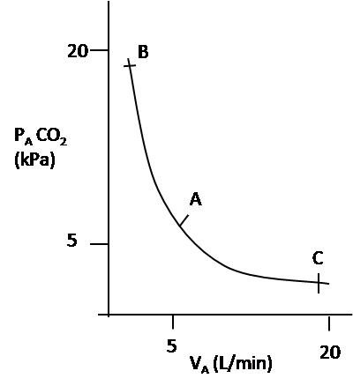
- The graph depicts the relationship between alveolar ventilation and partial pressure of carbon dioxide in alveolar air. Regions AB and AC respectively represent:

- acidosis and alkalosis.
- acidosis and hypoventilation.
- alkalosis and hyperventilation.
- alkalosis and hypoventilation.

- Some bacteria form a slimy, viscous layer covering the cell wall. This layer is known as capsule. These capsules are beneficial to the bacteria because:
    - they attract other bacteria to form colonies.
    - they enable bacteria to stick to the surface.
    - capsules contain water which protects the bacteria against dessication.

- i and ii only
- ii and iii only
- iii only
- i, ii and iii

_______________________ X _____________________

