SPECIAL MEETING
OCTOBER 10, 2019

A Special Meeting of the Town Board of the Town of Hampton, County of Washington and the State of New York was held at the Town Hall, 2629 State Route 22A, Hampton, New York on the 10th day of October, 2019.

PRESENT: David K. O’Brien-----------Supervisor
Tamme Taran----------------Councilwoman – came at 8:50pm
Donald Sady-----------------Councilman
Andrea Sweeney------------ Councilwoman
Roger Weeden---------------Councilman
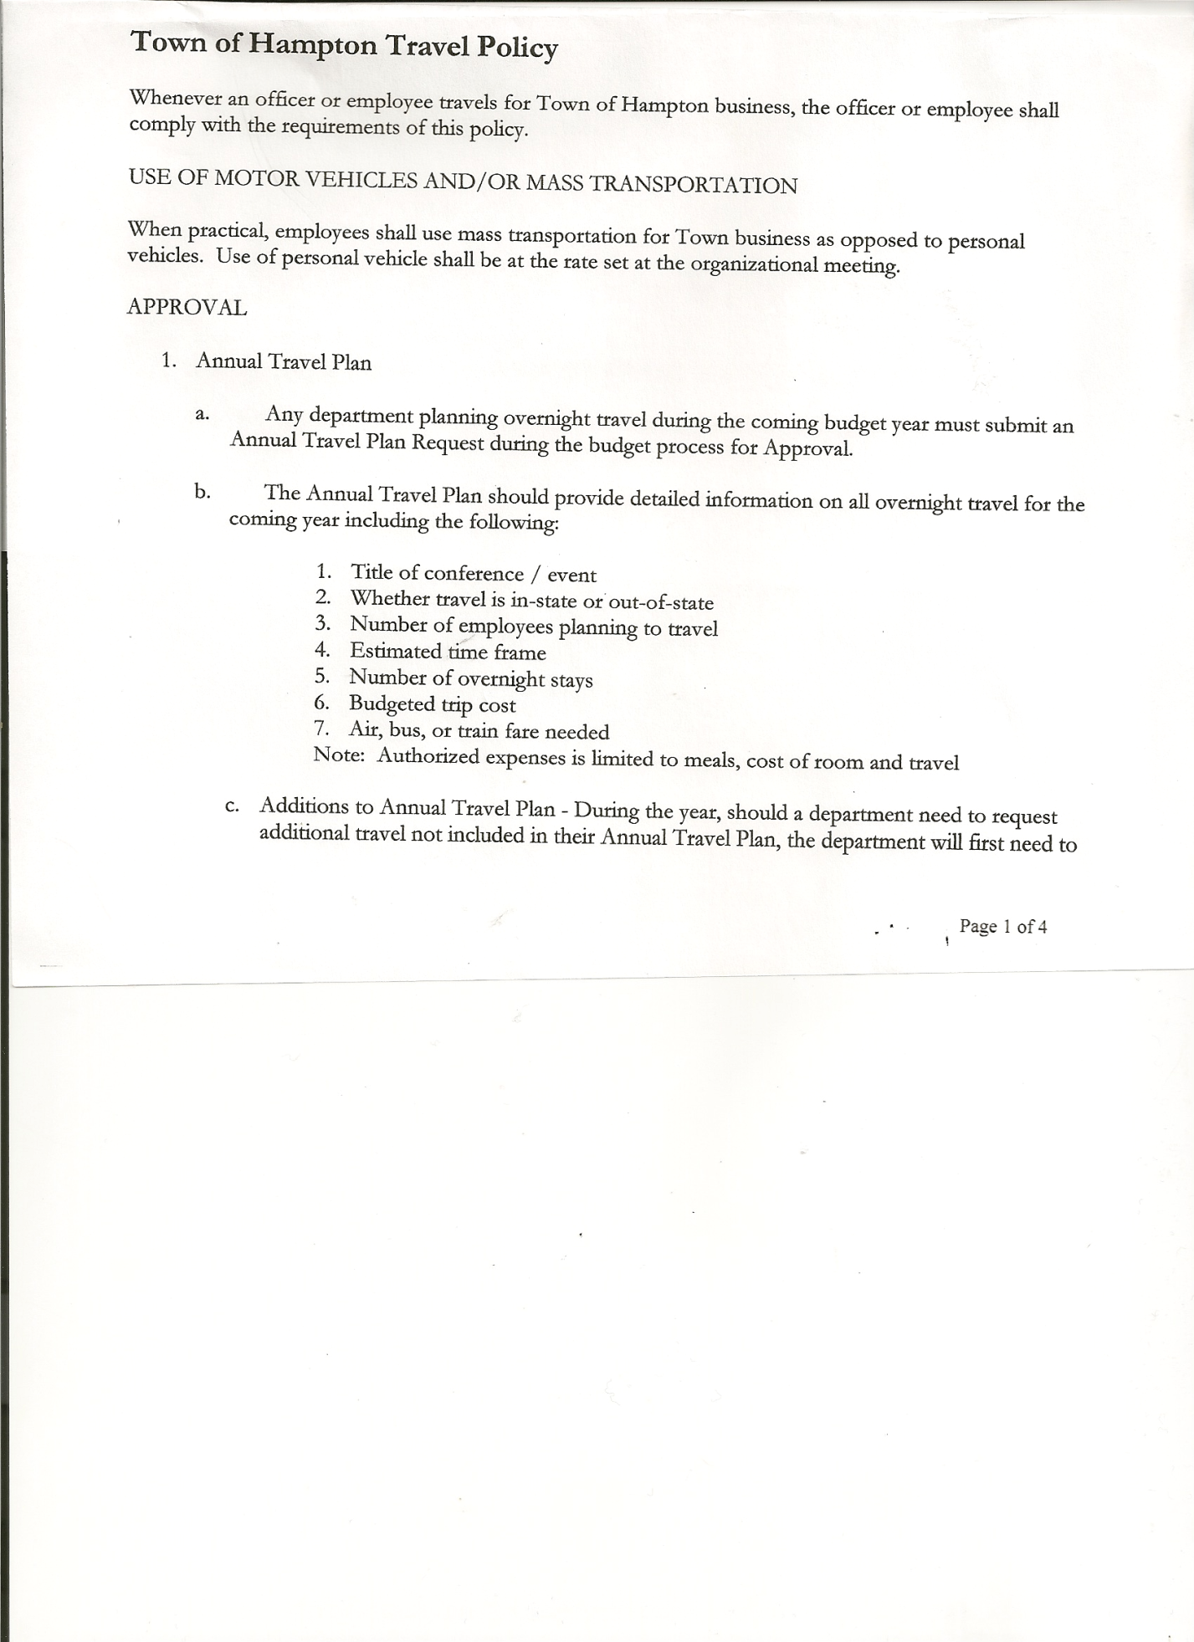
Rebecca Jones---------------Town Clerk
Camilla Shaw----------------Tax Collector/Deputy Town Clerk
Herbert Sady, Jr.-------------Highway Superintendent
Kim Perry---------------------Budget Officer/Bookkeeper

Planning Board Members: Bonnie Hawley, Chairperson; Ginny Kinsey, Matthew Pratt and Renee Rountree

Also present: See attached list

The Special Meeting was called to order by Supervisor O’Brien at 7:00pm, followed by the Pledge of Allegiance. Location of Fire Exits were given. Quorum of board members present.

Town Clerk Jones read the Legal Notice of the Special Meeting (copy attached), which was published in Manchester Newspapers (The Granville Sentinel and Whitehall Times) on 10/03/19.

Supervisor O’Brien will be recording meeting for absent Town Board Member, Tamme Taran.

In regards to a cover for the handicap ramp at the Town Hall, the following resolution was introduced to apply to the Justice Court for funding.

RESOLUTION NO. 87

MOTION BY: Councilman Donald Sady
SECONDED BY: Councilman Roger Weeden

RESOLUTION: Support of the Justice Court Assistance Program 2019-2020 Grant Application for the Town of Hampton Justice Department.

WHEREAS, the State of New York Unified Court System is soliciting applications from local governments under the Justice Court Assistance Program to assist local Justice Departments with needed equipment, automation, furniture, supplies and training.

TOWN BOARD MEETING
OCTOBER 10, 2019 PAGE 2

WHEREAS, the funding available under the State of New York Unified Court System would facilitate local efforts in upgrading the Town’s Justice Department.

RESOLVED, that the Supervisor of the Town of Hampton is hereby authorized and directed to file an application with the Justice Court Assistance Program not to exceed $9,000.00 in grant funding.

DATED: October 10, 2019 Supervisor O’Brien - AYE
Councilman Sady - AYE
Councilwoman Sweeney - AYE
Councilman Weeden - AYE
Councilwoman Taran - ABSENT

Letter received from Washington County Real Property Tax Services. Board of Assessment Review member Alfred Washburn needs to be reappointed. The following resolution was introduced.

RESOLUTION NO. 88-2019
BOARD OF ASSESSMENT REVIEW
On a motion of Councilman Weeden, seconded by Councilwoman Sweeney, the following resolution was ADOPTED: Ayes 4 O’Brien, Sady, Sweeney, Weeden
Nays 0
Absent 1 Taran
RESOLVED, to reappoint Alfred Washburn to the Board of Assessment Review for the term 10/1/19 to 9/30/24.

RESOLUTION NO. 89-2019
AUTHORIZATION TO PRE-PAY CHIPS BILL
On a motion of Councilman Sady, seconded by Councilman Weeden, the following resolution was ADOPTED: Ayes 4 O’Brien, Sady, Sweeney, Weeden
Nays 0
Absent 1 Taran
RESOLVED, that David O’Brien, Town Supervisor, be authorized to pay the bill for CHIPS when it is received. Will then be put on the next Warrant and will be marked paid.

TOWN BOARD MEETING
OCTOBER 10, 2019 PAGE 3

RESOLUTION NO. 90-2019
PUBLIC HEARING ON PRELIMINARY BUDGET FOR 2019
On a motion of Councilman Sady, seconded by Councilwoman Sweeney, the following resolution was ADOPTED: AYES 4 O’Brien, Sady, Sweeney, Weeden
NAYS 0
ABSENT 1 Taran
RESOLVED, to set the Public Hearing on the Preliminary Budget for 2020 for October 24th, 2019 at 6:45pm.

RESOLUTION NO. 91-2019
PUBLIC HEARING ON HAMPTON FIRE DISTRICT NUMBER 1
On a motion of Councilman Sady, seconded by Councilman Weeden, the following resolution was ADOPTED: AYES 4 O’Brien, Sady, Sweeney, Weeden
NAYS 0
ABSENT 1 Taran
RESOLVED, to set the Public Hearing to discuss the proposed contract between the Town on behalf of the Town of Hampton Fire Protection District Number 1 and the Hampton Volunteer Fire Company for October 24th, 2019 at 6:55pm.

RESOLUTION NO. 92-2019
PUBLIC HEARING ON HAMPTON FIRE DISTRICT NUMBER 2
On a motion of Councilman Weeden, seconded by Councilman Sady, the following resolution was ADOPTED: AYES 4 O’Brien, Sady, Sweeney, Weeden NAYS 0
ABSENT 1 Taran
RESOLVED, to set the Public Hearing to discuss the proposed contract between the Town on behalf of the Town of Hampton Fire Protection District Number 2 and the Hampton Volunteer Fire Company for October 24th, 2019 at 6:57pm.

Discussed Highway Department Budget for 2020.
Highway Superintendent Herb Sady is requesting additional funding for paving (maintenance
on blacktop roads) and general repairs contractual expense for Highway Equipment.
Herb explained he is going to try a new approach this winter season with the sand and salt on the roads. Dirt roads will be a combination of sand and ¾” stone vs salt. Salt will be used on paved roads only.

Town Board members and members of the Community present discussed the pros and cons of Paving vs Dirt Roads.

Town Board Members are in agreement that maintenance of highways and Equipment Reserve Fund are important increases for the 2020 Budget.

TOWN BOARD MEETING
OCTOBER 10, 2019 PAGE 4

Town Board Members want to continue discussion on the 2020 Budget at its regular meeting on October 17th, 2019, therefore the following resolution was made in regards to the Public Hearing on the Budget.

RESOLUTION NO. 93-2019
DATE CHANGE FOR PUBLIC HEARING ON BUDGET
On a motion of Councilman Weeden, seconded by Councilman Sady, the following resolution was ADOPTED: AYES 4 O’Brien, Sady, Sweeney, Weeden NAYS 0
ABSENT 1 Taran
RESOLVED, to change the date of the Public Hearing on the Budget from October 24th, 2019 to October 31st, 2019 at 7:00pm.

RESOLUTION NO. 94-2019
BUDGET WORKSHOP MEETING-CANCELLED
On a motion of Councilman Sady, seconded by Councilman Weeden, the following resolution was ADOPTED: AYES 4 O’Brien, Sady, Sweeney, Weeden NAYS 0
ABSENT 1 Taran
RESOLVED, to cancel the Budget Workshop Meeting for October 24th, 2019.

RESOLUTION NO. 95-2019
REPEAL PREVIOUS RESOLUTIONS
On a motion of Councilman Sady, seconded by Councilman Weeden, the following resolution was ADOPTED: AYES 4 O’Brien, Sady, Sweeney, Weeden NAYS 0
ABSENT 1 Taran
RESOLVED, to repeal Resolutions #90, #91 and #92. (Public Hearing on Budget and Public Hearings on Fire Districts #1 and #2). Public Hearings on Fire Districts #1 and #2 will be set at the regular monthly meeting on October 17th, 2019.

On a motion of Councilwoman Sweeney, seconded by Councilman Sady, the meeting adjourned at 9:04pm. All in favor Aye.

Respectfully submitted,

Rebecca S. Jones, RMC
Town Clerk

