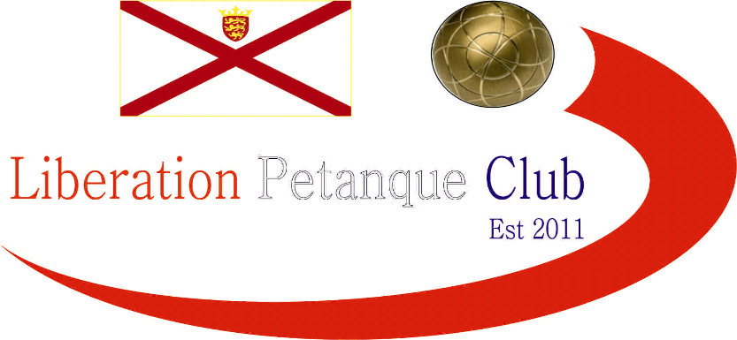

**Summer 2024**

**End of Season**

**Report**

What another great season it has been again this season with more new faces creating waves amongst the experienced members, we hope you all enjoyed it.

**Premier League Singles Champion**

**Geoffroy Buffetrille**

Winning his 7th Premier League title after a neck and neck battle all the way through the season with Toby Northern who finished Runners Up.

Third place went to Ross Payne

Commiserations to Alex and Jean Stewart and Joey Le Clech who were relegated.

**Singles Division 1 Champion**

**Wendy Ritzema**

Wendy stole the show this Summer taking the Division 1 title in her maiden playing season in the Singles league by 10 whole points and a points difference of +103! To join an exclusive club. This mean’t Jim had to settle for second place.

Third Place and the last promotion place went to John McGaw

Commiserations to Branden De La Haye, Cassie Stewart Le Gallais and Francis Corbally on relegation.

**Premier League Double Champions**

**Geoffroy Buffetrille & Matthew Buesnel**

Well, it could have gone to three teams in the last two weeks but both Andrew Bellamy-Burt & Callum Stewart and Neil Selby & Ross Payne both blew their chances of catching Geoffroy & Matt.

Neil Selby & Ross Payne Runners up with third place going to Daniel Deveau & Toby Northern.

Commiserations to Keith White & Mo De Gruchy, Alex Stewart & Brian Harris and Gary Cowburn & Wendy Ritzema who all dropped down to Division 1.

**Division 1 Double Champions**

**James Rondel & Ross Churchill**

Wow, undefeated title win for James & Ross who took the division 1 title by some way with Colin Myers & Steve Simpkin runners up and Alan Mitchell & Mike Robinson in third place.

Commiserations to Craig Healey & Tommy Walsh who were relegated.

**Club Singles Cup Winner**

**Andrew Bellamy-Burt**

Andrew Bellamy-Burt beat Geoffroy Buffterille in the final, his fifth win, with Toby Northern taking third.

**Club Doubles Cup Winners**

**Keith White & Mo De Gruchy**

Neil Selby & Ross Payne won this years Doubles Cup with a very close final over Lorna Limbrick & Brian Harris. John McGaw & Nick Pallot taking third.

**Club Super 7’s Cup Winner**

**Daniel Deveau**

Daniel Deveau won his first ever competition beating Ross Payne in the final with Callum Stewart taking third.

**Club HandyCap Cup Winner**

**Keith White**

Another win for Keith taking back to back titles beating Toby Northern in the final with Callum Stewart third.

**Club Precision Shooting Cup Winner**

**Geoffroy Buffetrille**

Geoffroy Buffetrille took his fifth title beating Brian Harris in the final and Ross Payne finished third for the third year running.

**Liberation Singles Open Winner**

**Toby Northern**

**Liberation International Singles Open Winner**

**Damien Hureau**

All the way from France and a legend of the sport!

**Liberation International Doubles Open Winners**

**Damien Hureau & Patrick Neuville**

France & Belgium

**Liberation International Triples Open Winners**

**Damien Hureau & Benny Bel Lafkih and Eli Gjenstoe**

Benny & Eli winning it for the second year running with Damien.

**Player of the Seasons**

# Find out at the End of Season Presentation

# 

**None club tournaments won by members**

**Island Singles Championship (Men)**

**Toby Northern**

**Island Doubles Championship (Men)**

**Geoffroy Buffterille with James Gennoe**

**Island Doubles Championship (Women)**

**Wendy Ritzema with Christine Eccles**

**Island Mens Triples Championship**

**Andrew Bellamy-Burt, Jake Romeril & Laurent Pellaton**

**Island Open Triples Championship**

**Geoffroy Buffterille , Matt Buesnel & Laurent Pellaton**

**Guernsey Singles Championship**

**Toby Northern**

**Carrefour Doubles Championship**

**Geoffroy Buffetrille & Laurent Pellaton**

**Carrefour Triples Championship**

**Andrew Bellamy, Callum Stewart & Geoffroy Buffetrille**

**Carrefour Indoor Open**

**Brian Harris & Colin Myers**

# Special Thanks

# Club Committee – Toby Northern, Matt Ryan & Geoffroy Buffetrille

# Other Helpers –Laurent Pellaton for their hard work on the terrains and support throughout the season. Dawn Buckley and Mo De Gruchy for the International Open. Gary Cowburn and Wendy Ritzema and Daniel Deveau and anyone else who has helped out setting up the terrains for competitions/leagues etc and running competitions, very much appreciated.

# *Well, I hope you have all enjoyed the season and are looking forward to playing again in the Winter 2024 / 25 season.*

# Kind Regards

# Toby Northern

# Chairman

# Liberation Petanque Club