Week 13

LEVITICUS

More Than Conquerors—Energized for the Call.

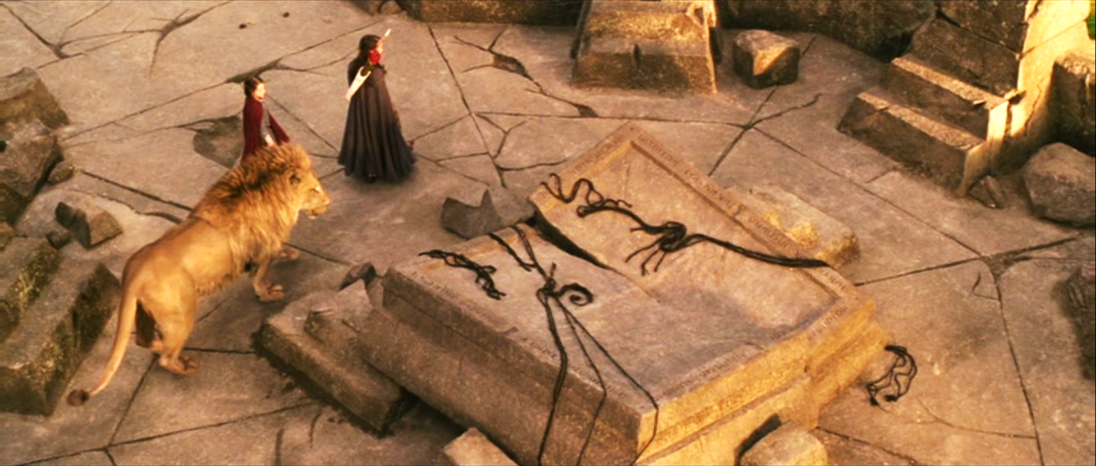
The Stone Table from The Lion, the Witch and the Wardrobe

(If you have never read [or can’t remember well] CS Lewis’s book, The Lion, the Witch and the Wardrobe, this might be a good read for this lesson. The movie is nowhere near as good.)

Lecture on ENERGIZED FOR THE CALL

Brief outline of Leviticus by topic. (to be distributed in class)

BIG IDEA 1. The reality of evil – its vigor and vitality

Job 1:6-7
Ephesians 1: 12
1 Peter 5:8

What do you think: Is the world getting better? Are we on the right track?

Washington Post asks the question: “The World Is Getting Better: Why Don’t We Believe It?
[W]e would be remiss to discount how much progress has been made in the quarter-century since Bush’s speech. According to the World Bank, the rate of extreme poverty fell from 37 percent in 1990 to about 10 percent last year. The Food and Agriculture Organization reports that the rate of undernourishment fell from 18.6 percent to 10.9 percent during that same window. A major study by the University of Washington’s Institute of Health Metrics and Evaluation found that life expectancy increased by 5.8 years for men and 6.6 years for women between 1990 and 2013. Doctors have made extraordinary strides in reducing the mortality rates of polio, measles and malaria. And the threat of a nuclear war, as well as that of a war between great powers, has declined significantly. (January 26, 2016)

Liebnitz famously said, “We live in the best of all possible worlds.” Do you agree? What is the result of believing this approach?

Remember “Disintegration?” Have you every heard of “entropy?” What does this observation from thermodynamics have to say about the “pre-set goodness of the world?”

BIG IDEA 2: God’s people not exempted – not even the holiest

Abraham
Jacob
Moses
Aaron
The people themselves—Name some examples

Deuteronomy 24: 16 The fathers shall not be put to death for the children, neither shall the children be put to death for the fathers: every man shall be put to death for his own sin. See also Ezekiel 18:4.

BIG IDEA 3. Evil is overcome. Disintegration reversed and symphony restored.

Look at Leviticus offerings. What did you learn from the charts?

Chapter 1: How are offerings made? And what do they teach us?

What would be the monetary or comparable VALUE of a bull or a goat or a lamb in today’s terms?

BIG IDEA 4: EVIL IS OVERCOME THROUGH Atonement

Is atonement necessary? WHY? What is the relationship with forgiveness?

Worksheet:

Write down all the words that you can think of that relate to
SALVATION or ATONEMENT.
BIG IDEA 5: Atonement images

1. Sacrificial Atonement – OT sacrificial system
Man forfeited life; therefore, shedding of blood Heb 9:12, 22, 10.4-12

2. Penal suffering –(public law concept) -- legal
Isaiah 53 – sin forfeits life/ law requires punishment
The chastisement of our peace was upon him
Substitution before the bench of God’s justice

3. Debt canceled; marketplace analogy
What do we owe God?
bond written in ordinance against us – Parable in Mt 18.21ff—the Lord’s Prayer in Matthew.
the idea of redemption – buys back; Col 2.13, 1 Peter 1.18

4. Ransom – power struggle between God and Satan for hostages – we are passive as hostages
Col 2.15, Matt 20. 28, Mk 10:45; Rev 5.4f

5. Passover sacrifice
Like blood over doorpost saved Israel from death;
So the blood of Jesus shed and seen spares those who depend on it from the wrath of God

6. The theological issue is this: What does atonement accomplish? For guilt or just the sense of guilt? Objective or subjective Atonement? Is it for God or for us?

Subjective: Abelard: the change takes place in man; that is X made is so that we could believe that God loves us – Jesus makes God’s love believable. God’s attitude does not change

7: Gustav Aulen: Christus Victor Divine conflict and victory in which X fights the devil and beats the evil powers of the world to which man is in bondage and in Him God reconciles the world to himself
Because Christ [X] subdues the evil powers the whole world comes into a new relationship with God.

8. Satisfaction theory: Propitiation Rom 3.24-25; Heb 2: 17; 1 Jn 2.2 & 4: 10

Heb 8. 13-10:14 – Compares Levitical offerings to Christ’s once for all shedding of his blood.

Heb 9: 22—without the shedding of blood there is no remission of sins

Heb 9: 26 -- [appeared not to offer blood that was not his own]…he has appeared once for all at the end of the age to remove sin by the sacrifice of himself.

1 Cor 10: 16—The cup of blessing … is it not participation in the blood of Christ?

Eph 2:13—You who were once far off have been brought near by the blood of Christ

1 Pt 1.2, 18-19—sanctified by the Spirit to be obedient to J C and to be sprinkled with his blood;
you were ransomed from futile ways… not with perishable things like silver or gold, but with the precious blood of Christ, a lamb without defect or blemish.

1 Jn 1: 7 … the blood of Jesus Christ cleanses us from all sin

Romans 3.25 … whom God put forward as an “atoning sacrifice” (propitiation) by his blood, effective through faith to prove that he is righteous

2 Cor 5: 17-21 God made him, who had no sin, to be sin for us that through him we might become the righteousness of God

Heb 2: 17 therefore he had to become like his brothers in every way … to make a sacrifice of atonement (propitiation) for the sins of the people.

1 Jn 2.2… and he is the “atoning sacrifice” [propitiation] for our sins and not for ours only, but also for the sins of the whole world.

1Jn 4.10 In this is love, not that we loved God, but that he loved us and sent his son to be the “atoning sacrifice” [propitiation] for our sins.

The Bible Project

Assignment for week 14:

What progress have you made on Psalms reading regarding rescue from Egypt and redemption in general? Bring your homework on this for discussion next week.

Review DISINTEGRATION LESSON (two weeks) for class review next week.

READ: Numbers 20-21, Deuteronomy 1-3

The whole book of Joshua

Give special attention to Josh 5:2-9, Aachan’s sin; Joshua 24: 13-15: Deut 11: 26-32; 27: 9-26 & 28; Joshua 8: 30-35

MARKERS:

Joshua 2 & 6 Rahab story
Joshua 5 Circumcision
Joshua 6 Jericho
Joshua 7 Aachan discipline
Joshua 9 Deception by Gibeonites
Joshua 10 Southern campaign
Joshua 11 Northern campaign
Joshua 13 Failure to complete conquest
Joshua 24 Choose this day

