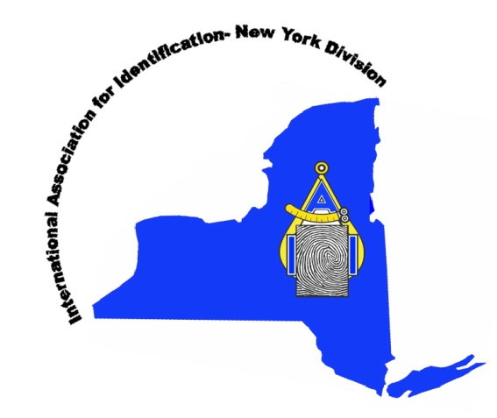
New York State Division of the
International Association for Identification
Mail Completed Application to:

New York State Division
of the IAI
P.O. Box 761
Yaphank, NY 11980

MEMBERSHIP APPLICATION

I hereby make application for ____ ACTIVE ____ ASSOCIATE MEMBERSHIP (see bottom of application) in the New York State Division of International Association for Identification, in accordance with its Constitution and By-Laws, and agree to be bound therewith.
$20.00 Annual Dues with this Application

Application Date: ________________
Last Name: ___________________________ First Name: ___________________________ MI: ______ Date of Birth: ______________
Home Address: _________________________________________

_________________________________________
Home Phone#: _______________________ Cell Phone# _____________________ E-Mail Address: ________________________________
Rank or Title: ____________________________________________

________ Fingerprint Identification _______ Questioned Documents _______ Crime Scene Investigation
________ Forensic Photography _______ Firearms & Tool mark _______ Laboratory Analysis
________ Forensic Art _______ Forensic Science _______ Tenprint Examiners
________Footwear / Tire Tracks _______ Bloodstain Pattern Analysis _______ Criminal Justice

Business Name: ___________________________________________
Business Address: _________________________________________
_________________________________________
Business Phone: _________________________________ Email: _______________________________
Recommended by: ____________________________________________________________________________ Member in good standing
ACTIVE MEMBERS. Sec. 2 The Active membership; of the Association shall consist of Superintendents, or Officer, in charge of Bureaus of Identification, Sheriffs, Chiefs of Police, and all other persons engaged in the science of identification and investigation, and who are bona fide employees of and receiving salaries wholly, or in part, from National, State, County or Municipal governments or sub divisions thereof. Any active member shall not lose his/her active status because of retirement or change of position so long as he maintains continuous membership.

Associate Members. Sec. 3 All reputable persons, wholly or partially engaged in any of the various phases of the science of identification or investigation, and who are not qualified for Active membership, are eligible to become Associate members . They shall in all respects be subject to the same rules, fees and charges, and entitled to the same rights and privileges, as Active members, except that they shall not be entitled to the office of Vice President or President.

Revised: August 2017

