President
John Romano

Vice-President
Sue Connors

Past President
Charles DeStefano

Orator
Michele Caira Nortonen

Recording Secretary
Lynne Martell

Financial Secretary
Walter Palino

Treasurer
Cheryl Caira

Trustees
Alicia Johnson
Diane Garrity
Lennie Malvone
Julie Sbraccia-Manos
Janet Engrem

Mistresses of Ceremony
Laura Caira
Mary Kiesinger

Sentinel
Cheryl Licciardi

Deputy
Betty Sandquist

April 2021 Newsletter

Sons of Italy Events
04/22/21 – Wilmington Sons of Italy Installation
05/15/21 – Wilmington Sons of Italy Blood Drive (flyer attached)
06/2021 – Grand Lodge Calendar Raffle
07/25/21 – Wilmington Sons of Italy Car Show (save the date)
08/23/21 – Grand Lodge Golf Tournament (save the date)
09/20/21 – Italian Heritage Golf Tournament (save the date)

Installation for 2021-2022
Installation of new officers will take place at a virtual ZOOM meeting on Thursday, April 22,2021 at 7:00 pm. A link will be sent via e-mail.
President – Sue Connors; Vice President – Alicia Johnson; Past-President – John Romano; Orator – Lennie Malvone; Recording Secretary – Lynne Martell; Financial Secretary – Walter Palino; Treasurer – Cheryl Caira; Trustees Janet Engrem, Karen Scalzi, Pia Romano, Judy Agnes, Linda Caruso; Mistresses of Ceremony – Michele Caira Nortonen, Mary Kiesinger; Sentinel – Cheryl Licciardi. Roncalli Board – Aldo Caira, Jr., Charles DeStefano, Lynne Martell, Lennie Malvone.

Donation request should be made using the form on the web site so that we have all the necessary information. Just click on donation request forms on the first page at http://www.wilmingtonsoi.org

The Grand Lodge monthly meeting minutes are available to view and download from the “News” tab on the Grand Lodge Website (www.osiama.org)

W ILMINGTON SONS OF ITALY DIAPER DRIVE WILDLY SUCCESSFUL

We received this lovely letter from Paula Stalker thanking us for the diaper drive.
I just wanted to reach out to you to thank you and everyone at the sons. You have no idea the joy you have brought this week alone. I was able to go to Emmaus house with 30 boxes of diapers on Monday, on Tuesday I was able to bless 3 moms in need (one of them cried). My car is packed for tomorrow to go to the Finex house with diapers for them. This is the best part of my day. To be able to provide such a basic need to small babies who are just victims of their environment.

One mom I blessed yesterday is fighting non-Hodgkin’s Lymphoma. She cannot work and her husband barely makes enough to pay the bills. She can now rest assured because she will not ever have to worry about providing diapers for this 5lb 2-ounce precious baby that had to be delivered early so mom can fight for her life. I could not do this alone. You guys literally made this happen for her baby Emma.

Over the years I have come to know the amazing group of people at the sons that really and truly make a difference in this world. I cherish each and every one of you.

I have seen so many things I wish I could I see but I also have seen the best in mankind. You guys restore my faith in people.

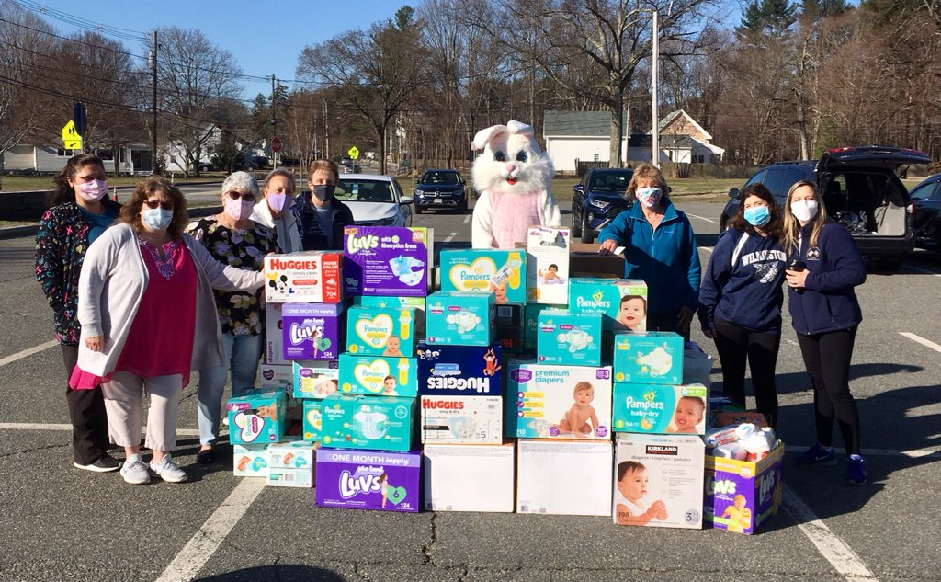
Over the course of the month of March, the Diaper Drive Committee, led by SOI Trustee Janet Engrem has worked tirelessly to collect diapers to help Paula Stalker and the Gifts of Love. The Diaper Drive culminated this weekend with a Drive By event at the Town Common Parking Lot where friends, neighbors, family, Sons of Italy members and passers-by dropped off diapers, made donations and even got to take a photo with the Easter Bunny! Not to be deterred by the COVID-19 Pandemic, the superstar group from the Wilmington Sons of Italy filled up 4 pickup trucks, 3 SUV's and 1 Mini Van with diapers and wipes as well as collected over $1000 in donations to help mothers in need!

The committee consisted of 8 young women of the Wilmington Sons of Italy, who for several months met over Zoom to plan out this month-long event and then executed it to perfection! My hat is off to Janet Engrem, Julie Sbraccia Manos, Michele Caira Nortonen, Deb Cipriani, Linda Corriveau, Edi-Jo Cooper, Lisa King, and Alicia Johnson (AKA Peter Rabbit), along with their sidekicks who deserve Honorable Mention: Paul Tivnan, Paul Cipriani, Pat Tivnan, Kevin Engrem, Lennie Malvone, John Romano, and Marylin Manos.

Special thanks to those who donated goods and services, sponsored, allowed us to put a collection box in their place of business, matched gifts and more; which without you all this event would not have been possible: DaMore Law, Vertuccio & Smith Funeral Home, Tremezzo's,Tremezzo's Pizzeria, Josie's Bakery, Hair Xtreme, Wilmington Town Hall, Shawsheen Elementary School, Designs By Don, East Celebrity Elite Cheer, Integrity Electrical, Wilmington 4th of July Committee, North Shore Yard Sign, Wilmington Fit Body Boot Camp, Texas Roadhouse - Methuen, and Toni’s Cookies. A special shout out to the Shawsheen 3rd Graders who held signs on Saturday morning in front of the school to encourage people to stop by the Town Common and donate diapers!

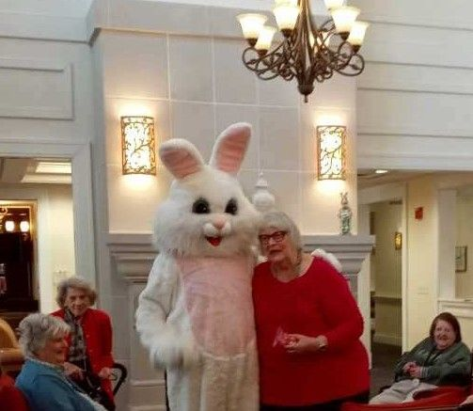
We are also grateful to all those who donated diapers and wipes or made a cash donation. With your support, the Gifts of Love will be able to help many, many mothers, and their children during this most difficult time.

The Easter Bunny also visited Windsor Place and we received the following:
Last Saturday Alicia Johnson visited our assisted-living elders, on behalf of the Sons of Italy, in your Easter Bunny costume. I cannot tell you the enormous JOY it brought to our seniors. 😊 I am enclosing some photos for you to share with your group, if appropriate.
Thank you so very much for allowing her to borrow the costume and bring such happiness during a difficult Pandemic time.
Best regards,
Christine Chiasson
Activity Director
Windsor Place of Wilmington

Then the Easter Bunny toured the town stopping at Yentile’s Farm (twice) putting smiles on the faces of many youngsters. Another stop at Advinia, a few houses and then the Easter Egg Hunt on the Town Common where once again, children were filled with delight!

Update on Correspondence:
We received Thank you notes from:
- Paul and Sarah Tortorici for our expression of sympathy and generous donation to the Tewksbury Knights of Columbus in memory of their father, and our brother Vinnie Tortorici.
- Lee Farrah for our get well wishes and the Market Basket gift card.
- Wilmington Community Fund for our $500.00 quarterly donation to the food pantry.
We received a message from our State President, Denise Furnari. She commended us for being able to organize events during the pandemic. She also contributed $50.00 to the diaper drive.
We received Donation Requests from:
- C&E Trust for their Golf Tournament on August 23, 2021 at the Hopkinton Country Club. $150.00 pp and sponsorships are available. This will be referred to the Roncalli Board.
- The Wilmington Memorial Library is asking us to fund the New England Aquarium pass once again for $650.00. It was used 44 times during 2020 which is less than usual but not bad. The council voted to fund the pass.
- Vinny Oliva and Tewksbury VFW Post 8164 is hosting a Golf Tournament on Monday July 12, 2021 and is looking for sponsorship. This request will be referred to the Roncalli Board.
Karen reported that we received three Graduate Scholarship requests.
Janet reported that the Diaper Drive far exceeded our expectations.

Blood Drive – will be held on Saturday, May 15, 2021 in the Parking Lot of the 4th of July Building from 9am – 3pm, by the Children’s Hospital Bloodmobile. There will only be on-line sign ups.
Contact Julie 978 284-3260 or sbracciamanos@comcast.net
BLOODMOBILE ¬ Histories will be done off the bus as allowable ¬ Limited number of staff and donors on the Bloodmobile ¬ Reduced donor schedule by appointment only ¬ Disposable, single use reading materials and pens. You may be asked to wait in your car until it is your turn to be taken for donation.
DONOR SCREENING Prior to entering the Donor Center or Bloodmobile, donors will be pre-screened with the following questions and asked to reschedule their appointment either 14 or 28 days after symptoms resolve if they answer ‘yes’ to any of the questions below: ¬ Do you have fever, cough, sore throat, muscle aches, difficulty breathing, chills, or new onset of loss of taste or smell? (14-day deferral) ¬ Have you been diagnosed with or tested positive for COVID-19? (28-day deferral) ¬ Have you lived with a person who has had COVID-19, or have you had significant exposure to someone who has had COVID-19? (28-day deferral).
To book your appointment, visit: www.halfpints.childrenshospital.org or call us at (617)355-6677

Scholarships
Our lodge Scholarship’s deadline was April 1, 2021 but the Grand Lodge Scholarships are still available with a deadline of April 15, 2021.

Grand Lodge – The Scholarship Commission of the Grand Lodge of Massachusetts through the Charitable and Educational Trust will award a minimum of twenty (20) scholarships, at a maximum of $1,000.00 each to properly qualified students who anticipate entering college in the fall of 2021.
Scholarship Awards are limited to members of the Senior Class of any secondary school planning to attend an accredited four-year degree granting institution (except for the vocational/technical award to be granted, which may be a two-year degree or certificate granting institution) in the fall of 2021.
Scholarships will be awarded to both affiliates and non-affiliates:
- Affiliate Applicants are members, in good standing, of the Junior Division or Grand Lodge of Massachusetts for a minimum of two years, or the child or grandchild of a member, in good standing, of the Grand Lodge of Massachusetts for at least two years at the time the application is filed.
- Non-Affiliate Applicants are those that do not meet the above Affiliate criteria.
- Applications will be processed into these categories by the Scholarship Commission based on the information provided on the application and verification against the Grand Lodge membership records.
- One principal award shall be granted to a properly qualified student planning to pursue their education in a recognized and accredited vocational or technical school, which may be a two-year degree or certificate granting institution.

The 2021 Application can be downloaded from our website (www.osiama.org). Or you may contact Karen Scalzi for a copy (978-423-0960) or e-mail kcscalzi@gmail.com.
NOTE THAT PREVIOUS VERSIONS OF THE APPLICATION WILL NOT BE ACCEPTED!
Deadline is APRIL 15, 2021.

A Letter from Our President
Dear Brothers and Sisters:
I am honored to have served as your president for the last 4 years. I feel that my council has worked extremely hard during this time to provide events and activities for the membership and should be proud of our service during the last year throughout the pandemic.
During the past four years we have donated over $200,000 dollars to various charities, events and activities which is truly amazing. This includes donating $100,000 to the Town to pay for the Wilmington Sons of Italy Gazebo at the New Yentile Park, a new sign on the Town Common and over $20,000 in scholarships. We have purchased new uniforms for virtually all the High School Sports Teams, Supported the Band Program, Strings Attached and the Theater Arts Group at the High School. We have supported the Special Olympics, continued funding the Wrestling Tournament, provided quarterly donations to the Wilmington Food Pantry, became members of the S.O.I. Garibaldi Meucci Museum, and supported Grand Lodge Charities. We provided donations on behalf of our members who have participated in walk-a-thons, Polar Plunges, and other similar events. We expanded our collaboration with the Band Parents and teamed up to work collaboratively with the Boy Scouts Troop 126, WOW, The Wilmington Farmers Market, Junior Rotary Club, The Parish of the Transfiguration Youth Group, and the Wilmington Library to enhance their programing and/or to expand ours or to provide donations for their events.
We have also carried on the tradition of our lodge to donate to virtually every local sports group, parent group, local charities, and some not so local charities that our membership was part of to help those in need to or to help provide better programming and to spread the good name and good will of the Wilmington Sons of Italy.
We also provided some nice activities and events for our membership including continuing our bocce league, bowling league, Easter Bunny Breakfast, Italian Heritage Golf Tourney, Comedy night, Children’s Christmas Party, bringing back our Adult Christmas party with a fancy catered meal and live entertainment, bingo nights - both live and virtually during the pandemic, creating a Car Show with the Dominators Car Club and now including the Wilmington Farmers Market, taking over Breakfast with Santa Claus from the Town Rec. Department, doing a yearly Yard Sale/Flea Market and continuing to participate in trivia nights, corn hole and bocce tournaments etc.
I am very proud of our Council members for stepping up and creating new events and fundraisers over the last 4 years to raise awareness and money/product for Gifts of Love with our Annual Diaper Drive, a Breast Cancer Awareness Dance, an Alzheimer’s Disco night, the creation of our Outreach Committee providing gift cards for food, clothing and presents at Christmas, Thanksgiving and Easter to families in need and our Wilmington Veteran’s, as well as providing dinners to our Frontline Workers during the worst part of the COVID-19 Pandemic!
Our Cultural and Heritage Committee also put together a fabulous program in-conjunction with the Wilmington Memorial Library during Italian Heritage Month in 2019 and while the pandemic short circuited it in 2020, I know it will be back stronger than ever soon.
Sadly, this past year we lost our lodge founder, our true leader and inspiration and my good friend, Laura Caira. She will always hold a special place in my heart, and I truly thank her for her friendship, leadership, guidance, and encouragement. It was Laura who welcomed my family into our lodge, and she recruited me to become an officer and encouraged me to run for president and served on my council. Rest in Peace My Friend!
I would be remiss if I did not thank the Roncalli Board of Directors for whom without their support many of the events, activities and donations mentioned above would not be possible!
Lastly, I ask that all of you support our incoming President Sue Connors and her Council the way you all have supported me and my council. I know Sue will continue to lead our lodge to do great work for our membership, our order, and our community!

Sincerely,

John

John
(617) 750-9749 Jromano45@gmail.com
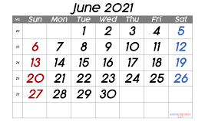
The Grand Lodge of Massachusetts is pleased to announce our annual Calendar Raffle, which will be held during June 2021. This fundraiser helps to support the Grand Lodge and provides your lodge with an excellent incentive to raise funds, as $3.00 of every ticket sold by your lodge will be reimbursed to you via a per capita credit.
Here is how it works:
• A $20.00 ticket purchase gives you 34 chances to win a share of $6,400.00.
• There will be a drawing every day in June 2021 with prizes ranging from $125.00 - $600.00 (see daily prize amounts below).
• Four “early-bird” drawings of $125.00 will take place from all tickets received at the Grand Lodge office on or before May 15, 2021.
• All winning tickets are placed back in the drum for the next drawing.
• A list of daily winners will be posted on the Grand Lodge website (www.osiama.org)
Prizes $600 on first and last day. $125 daily. $250 on Saturdays. $300 on Sundays.
John has tickets. Contact John jromano45@gmail.com (617) 750-9749

Sunshine – Report sunshine information to Joan Foresteire (978-658-6284)

We send our best wishes to our members with April Birthdays and Anniversaries!

Please pray for my Mom and our sister, Civitina (Judy) Bombino.

Congratulations to Joan Foresteire on the birth of her great granddaughter, Harper Elizabeth Hodges.

We send our condolences to Marie’Anne and Rob Durst on the death of Marie’Anne’s mother, Rosemary Peraglia Colavito.
We send our condolences to Chris Appiani on the death of his father, Leon Appiani.

**** Note from the Recording Secretary – Please remember to send e-mail or address changes to Lynne_martell@comcast.net or call me (978-694-1632) with any address changes if you do not have e-mail.

