REGULAR MEETING
MAY 18, 2023

The Regular Meeting of the Town Board of the Town of Hampton, County of Washington and the State of New York was held at the Town Hall, 2629 State Route 22A, Hampton, New York, on the 18th day of May 2023.

PRESENT: David K. O’Brien------------Supervisor
Donald Sady----------------- Councilman
Tamme Taran----------------Councilwoman
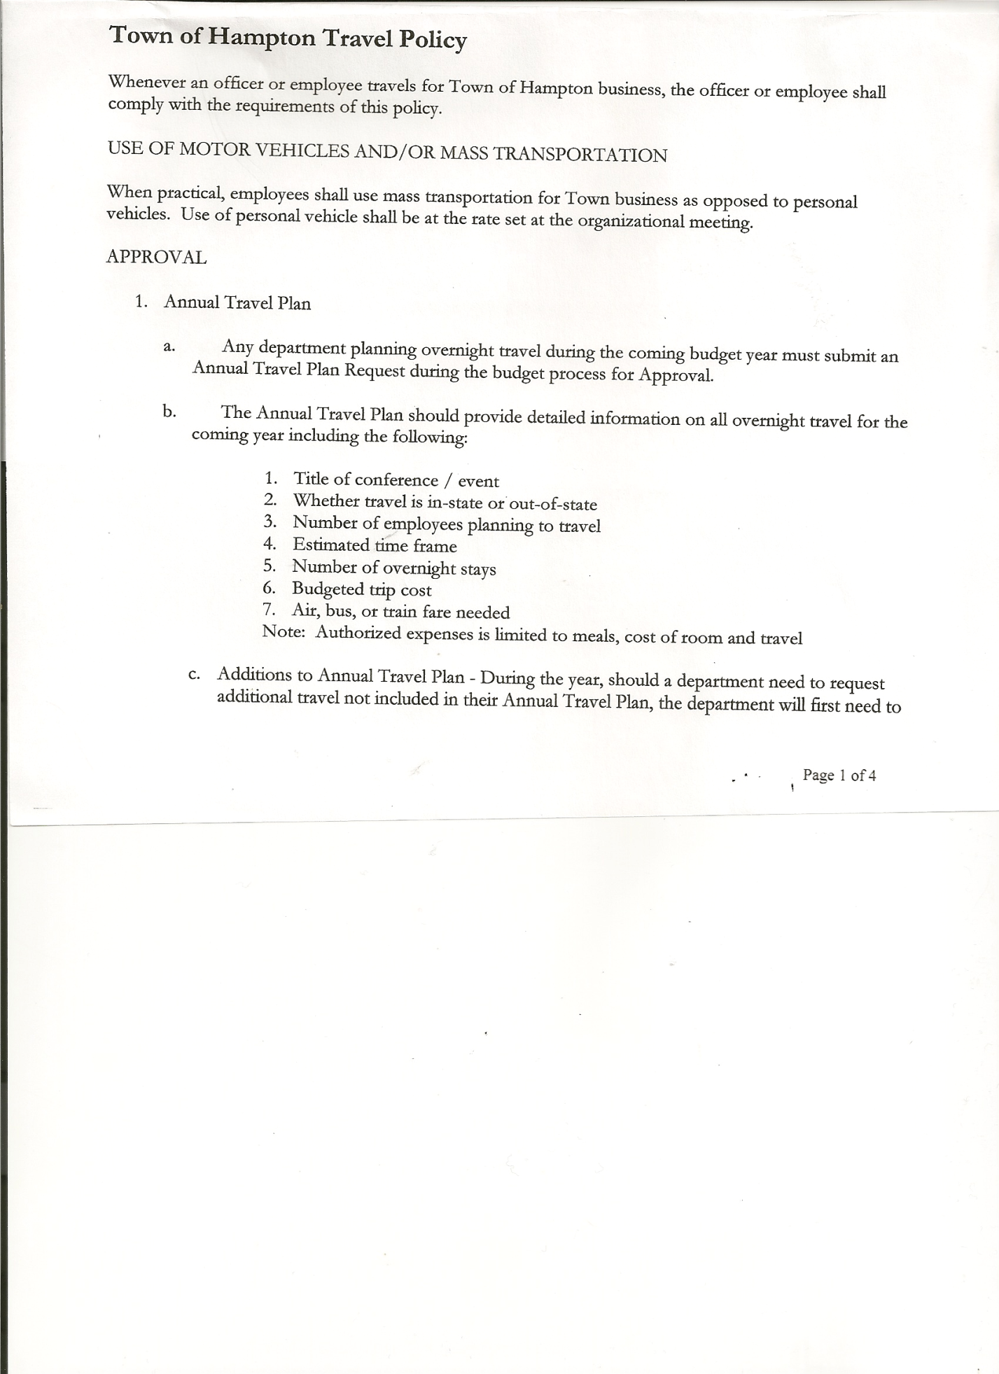
Michael Pietryka------------Councilman
Andrea Kugler---------------Councilwoman
Rebecca Jones---------------Town Clerk
Camilla Shaw----------------Deputy Town Clerk
Tyler McClure---------------Highway Superintendent

Planning Board Member (s):… Bonnie Hawley, Chair; and Matthew Pratt
Others present at the Town Hall: EJ Conzola, Whitehall Times Reporter and Artie Pratt

The Regular Meeting was called to order by Supervisor O’Brien at 7:30pm, followed by the Pledge of Allegiance. Location of Fire Exits were given. Quorum of board members present.

RESOLUTION NO. 51-2023
APPROVAL OF THE MINUTES
On a motion of Councilwoman Taran, seconded by Councilwoman Kugler, the following resolution was ADOPTED: AYES 5 O’Brien, Sady, Taran, Pietryka, Kugler
NAYS 0
RESOLVED, that the Regular Town Board Meeting Minutes for April 20, 2023 are approved.

Dog Control Officer, not present no report given.
Supervisor O’Brien received from NYS Ag & Markets, the Municipal Shelter Inspection Report, which was completed on 5/4/23, that dog shelter services were rated “Satisfactory”.

Tax Collector Report for April was given, and a copy is attached. Balance due to Washington County Treasurer and Supervisor were made and balance in checkbook is zero. The Town Clerk/Collector had Board Members review and sign bank reconciliation statements for the Tax Collector Account dated April 30th, 2023.

Bonnie Hawley, Chair Planning Board…copy of the minutes of their meeting held May 10, 2023 are attached. Next Planning Board meeting is planned for June 14, 2023.

Tyler McClure, Highway Superintendent submitted his report, copy of which, is attached.
The paving project for this year will be on the South Road and Hills Pond Road. An Agreement to Spend Town Highway Funds will be completed for the June meeting.

TOWN BOARD MEETING
MAY 18, 2023 PAGE 2

RESOLUTION NO. 52-2023
APPROVAL OF SUPERVISOR’S MONTHLY REPORT
On a motion of Councilman Sady, seconded by Councilwoman Taran, the following resolution was ADOPTED: AYES 5 O’Brien, Sady, Taran, Pietryka, Kugler
NAYS 0
RESOLVED that, the Supervisor’s Monthly report be accepted as submitted for APRIL
03/31/23 04/30/23
ACCOUNT BALANCE RECEIPTS DISBURSEMENTS BALANCE
General Fund $ 77,553.76 $ 8,039.58 $ 7,734.01 $ 77,859.33
Highway Fund $300,851.90 $ 7.31 $ 30,991.64 $ 269,867.57
Equipment Reserve$149,965.30 $ 3.70 $ 0.00 $ 149,969.00
Fire #1 $ 46,371.00 $ 0.00 $ 0.00 $ 46,371.00
Fire #2 $ 15,361.00 $ 0.00 $ 0.00 $ 15,361.00
Cemetery $ 1,767.62 $ 1.57 $ 0.00 $ 1,769.19
Totals $591,870.58 $ 8,052.16 $ 38,725.65 $ 561,197.09
All Board Members present signed Supervisor’s Report.

OLD BUSINESS
Staso Road….an Application for the Discontinuance of a Highway and a resolution approving such were handed out to Board members for their review. There will be further discussion at the June meeting. Supervisor O’Brien will send out information on the possible closure of Staso Road.

Les Losaw, Bookkeeper/Supervisor’s Clerk inquired about switching from Quickbooks to Fund Accounting Software. The initial cost is $4200 with an annual maintenance fee of $1000.00. Quickbooks subscription fee is going up to $1200.00. Following a discussion, the board decided not to switch at this time.

RESOLUTION NO. 53-2023
AUDIT OF CLAIMS
On a motion of Councilwoman Taran, seconded by Councilman Sady, the following resolution was ADOPTED: AYES 5 O’Brien, Sady, Taran, Pietryka, Kugler
NAYS 0
RESOLVED that the bills have been reviewed by the Town Board and are authorized for payment in the following amounts.
General Fund No.57 through No. 71 $ 4,478.15
Highway Fund No.44 through No. 60 $ 15,124.64
Total both funds $ 19,602.79

The Town Clerk’s report for April 2023 was submitted to the Board. The Town Clerk had Board Members review and sign bank reconciliation statements for the Town Clerk Account and Special Clerk Account dated April 30th, 2023.

TOWN BOARD MEETING
MAY 18, 2023 PAGE 3

RESOLUTION NO. 54-2023
MEETING ADJOURNED
On a motion of Councilman Sady, seconded by Councilwoman Taran, the following resolution was ADOPTED: AYES 3 O’Brien, Sady, Taran, Pietryka, Kugler
NAYS 0
RESOLVED that the meeting adjourned at 8:13pm.

Respectfully submitted,
Rebecca S. Jones, RMC
Town Clerk

